Use of Natural Extracts on Synthesis of Nanoparticles: A Bibliometric Analysis
Renny Nazario-Naveda^{1, a)}, Jonathan R.-F.^{1, b)}, Santiago M. Benites^{1, c)}, Moises Gallozzo-Cardenas^{2, d)} and Daniel Delfin-Narciso^{3, e)}
¹Facultad de Ingeniería y Arquitectura, Universidad Autónoma del Perú, Lima 15842, Perú.
²Facultad de Ciencias de la Salud, Universidad César Vallejo, Trujillo 13002, Perú.
³Grupo de Investigación de Ciencias Aplicadas y Nuevas Tecnologías, Universidad Privada del Norte, Trujillo 13007, Perú.
^{a)} Corresponding author: renny.nazario@autonoma.pe
^{b)}srojasfl@autonoma.edu.pe
^{c)}santiago.benites@autonoma.pe
^{d)}mmgallozzo@ucvvirtual.edu.pe
^{e)}daniel.delfin@upn.edu.pe
Abstract. A bibliometric analysis was conducted on the use of natural extracts in nanoparticle synthesis. A total of 1,440 English-language documents indexed in the Scopus database were collected between 2009 and 2025. The bibliometric analysis shows that the use of natural extracts in nanoparticle synthesis has grown steadily. The rapid adoption of new techniques and underexplored plant sources has allowed many publications to achieve high impact in a short period of time. India, Iran, and China lead in scientific production, and among the most relevant authors are figures such as such as Maaza and Nasrollahzadeh. The most influential journals include the Journal of Biological Macromolecules, Materials Today: Proceedings, and RSC Advances, characterized by their high impact and track record. Three dominant lines of research have been identified: green synthesis of metal nanoparticles, biomedical applications, especially with antimicrobial and antioxidant approaches, and the use of metal oxides in environmental photocatalysis.

Introduction
One of the major problems behind traditional nanoparticle synthesis is that, although effective, it usually depends on chemical reagents that act as reducers, stabilizers or solvents, and that, at the end of the process, leave potentially toxic residues. These wastes not only pose risks to human health, due to many of their applications, but also generate a considerable environmental impact if not managed carefully [1,2]. The search for a sustainable solution leads to the development of novel synthesis processes for the manufacture of nanoparticles, where the use of natural extracts helps to reduce the harmful and toxic residual components of traditional methods [3]. Bioactive components, such as anthocyanins, carotenoids, betalains and chlorophyll, present in fruits, leaves and roots of various plant species, act as reducing and stabilizing agents, influencing the size, shape and stability of nanoparticles [4,5]. Therefore, interest in natural extracts is not just an academic fad, but a concrete response to this tension between technological efficiency and environmental responsibility in a context where sustainability is increasingly relevant.

Along these lines, the scientific community has shown a growing interest in the subject, which is reflected in the diverse plant sources used for nanoparticle synthesis, as well as in the variety of applications [6,7]. For example, Khan et al. compared the chemical and biological synthesis of silver nanoparticles, demonstrating that those obtained from Azadirachta indica extract were not only effective as antimicrobial agents, but also showed more favorable properties even with larger particle sizes [8]. Mayedwa et al. and Diallo et al. used Aspalathus linearis extracts to synthesize metal oxides such as NiO, PdO and SnO₂, obtaining materials with remarkable structural and electrochemical properties [9,10]. On the other hand, Begum et al. identified that polyphenols present in black tea extracts were responsible for the efficient formation of gold and silver nanoparticles, while extracts without these compounds did not generate any reaction [11]. Chandrima et al. took this line a step further, integrating biosynthesized TiO2 nanoparticles and Averrhoa carambola extracts into biodegradable chitosan films, with promising results for food packaging applications [12]. In turn, Nasrollahzadeh et al. demonstrated the efficacy of Thymus vulgaris extract to synthesize copper oxide nanoparticles, applied as recyclable catalysts in N-arylation reactions [13]. Finally, Kane et al. synthesized ZnO using Adansonia digitata extracts, highlighting its structural and thermal properties [14]. These antecedents show that plant extracts not only act as reducing and stabilizing agents, but also influence the morphology, functionality and final applicability of nanoparticles.

Although the use of natural extracts for nanoparticle synthesis has gained ground, it still faces significant challenges, such as the composition of plant extracts, which can vary greatly depending on the species, plant part, climate, or extraction method, directly affecting the reproducibility and stability of the resulting nanoparticles. Given this scenario, it is necessary to understand how this line of research has evolved within the scientific field and where it is headed. In this context, the objective of this research is to conduct a bibliometric analysis on the use of natural extracts in nanoparticle synthesis, in order to identify the main trends, most influential authors, countries, and institutions, as well as the most developed and emerging lines of research in this field. Through the study of indexed scientific production, we seek to understand how this area has evolved in terms of collaboration, impact, and thematic focus, highlighting especially the role that plant extracts play as reducing and stabilizing agents in more sustainable synthesis processes. This analysis will allow not only mapping the current state of knowledge, but also recognizing gaps, opportunities and possible future directions for the development of cleaner and more efficient technologies based on green chemistry principles, opening the way to new green routes with high potential in areas such as biomedicine, catalysis, electronics and sustainable packaging.

methodology
A bibliometric analysis was performed on the use of natural extracts in the nanoparticle synthesis process using original and conference articles retrieved from Scopus. Scopus is a multidisciplinary database that collects scientific articles, books, conference proceedings, among other documents since 1996. It offers tools to evaluate the impact of research through citation metrics, allowing the analysis of the performance of authors and publications in a specific area of knowledge. These metrics facilitate the identification of emerging trends and potential collaborators [15]. A search was conducted for documents in English, between 2009 and June 2025, using the following keywords: “natural” AND “extract” AND “synthesis” AND “nanoparticles” AND “stabilizer” OR “reducing agent”. Table 1 summarizes the results of a search in Scopus. 1440 documents published in 520 sources were identified, 1329 were original articles and 111 conference articles, with an average age of 3.77 years. For data processing and bar graphs, tools such as Microsoft Excel (version 16) and Origin-Pro (version 9.0) were used; the trend theme and conceptual structure graphs, as well as the tables, were obtained using Biblioshiny by RStudio (version 4.3.3), while for the visualization of co-authorship and co-occurrence networks, VOS-viewer (version 1.6.15) was used.
TABLE 1. General information about Scopus search.
Description | Results
Timespan | 2009-2025
Sources | 520
Documents | 1440
Document Average Age | 3.77
Keywords plus | 8464
Author's Keywords | 3385
Authors | 6600
Co-Authors per Doc | 5.36
International co-authorships % | 30.83

Results and Analysis
Figure 1 shows the scientific production on the use of natural extracts in the nanoparticle synthesis process from 2009 to June 2025. A sustained growth in research is observed with a marked increase in scientific production since 2016. This evolution indicates that the approach has gone from being an emerging alternative to consolidating as a recognized line of research, driven by the interest in more sustainable processes and functional applications in areas such as medicine and materials science [16]. Furthermore, the exponential increase in accumulated publications suggests a very high growth rate, in accordance with the low average age of the documents of 3.77 years.

Figure 1. Scientific production in the period 2009-2025.

TABLE 2. Most relevant documents in the literature on the use of natural extract in the nanoparticles synthesis process.
Documents | DOI | Year | Local Citations | Global Citations | Normalized Local Citations | Normalized Global Citations
Thovhogi N, 2015, J Alloys Compd | 10.1016/j.jallcom.2015.06.076 | 2015 | 15 | 201 | 6.18 | 2.18
Jayaprakash N, 2017, J Photochem Photobiol B Biol | 10.1016/j.jphotobiol.2017.03.013 | 2017 | 14 | 233 | 13.24 | 4.43
Begum Na, 2009, Colloids Surf B Biointerfaces | 10.1016/j.colsurfb.2009.01.012 | 2009 | 14 | 509 | 3.00 | 2.50
Diallo A, 2015, J Alloys Compd | 10.1016/j.jallcom.2015.05.242 | 2015 | 12 | 212 | 4.94 | 2.30
Mayedwa N, 2018, Appl Surf Sci | 10.1016/j.apsusc.2017.12.116 | 2018 | 10 | 212 | 13.28 | 4.98
Yuvakkumar R, 2014, Mater Sci Eng C | 10.1016/j.msec.2014.04.025 | 2014 | 9 | 292 | 9.82 | 4.49
Thema Ft, 2015, J Alloys Compd | 10.1016/j.jallcom.2015.05.279 | 2015 | 8 | 151 | 3.29 | 1.64
Thovhogi N, 2016, J Alloys Compd | 10.1016/j.jallcom.2015.09.063 | 2016 | 8 | 172 | 6.02 | 2.23
Thema Ft, 2015, Mater Lett | 10.1016/j.matlet.2015.08.052 | 2015 | 8 | 367 | 3.29 | 3.99
Karan T, 2022, Z Naturforsch Sect C J Biosci | 10.1515/znc-2021-0298 | 2022 | 6 | 37 | 27.00 | 1.64

Table 2 presents the most relevant documents on the use of natural extracts in the synthesis of nanoparticles. The document with the most citations in the specific area of this analysis is the one published by Thovhogi N. (2015), who used Hibiscus Sabdariffa flower extract for the manufacture of CeO2 nanoparticles [17]. Also highlighted are the most recent studies by Karan T. (2022), Mayedwa N. (2018) and Jayaprakash N. (2017) with high normalized local citations (27.00, 13.28 and 13.24 respectively), suggesting an emerging impact on the biosynthesis of metallic nanoparticles such as Ag, NiO and PdO; using extracts from different sources such as tamarind fruit, turmeric and rooibos plants (Aspalathus linearis) [9,18,19]. While at a global level the work of Begum Na. (2009) is the most cited (509), showing that the methods used in the synthesis of gold and silver nanoparticles with aqueous solution of black tea leaves are still valid [11]. Likewise, along with the documents by Mayedwa N. (2018) and Jayaprakash N. (2017) is that of Yuwakkumar R. (2014) with 292 global citations and a normalization of 4.49, his study on the fabrication of ZnO nanocrystals by green synthesis and its antibacterial applications, has served as a reference in different multidisciplinary areas of the scientific community [20]. On the other hand, it is important to recognize the frequent presence of these publications in journals such as Journal of Alloys and Compounds, and Materials Science and Engineering C, highlighting the interdisciplinary nature of this area of research, where older works dominate in global impact, while recent ones gain relevance at a local level.

TABLE 3. Most relevant sources in the literature on the use of natural extract in the nanoparticles synthesis process.
Sources | h-index | g-index | m-index | TC | NP | YP_start
International Journal of Biological Macromolecules | 15 | 28 | 1.364 | 796 | 31 | 2015
Materials Today: Proceedings | 15 | 27 | 1.5 | 808 | 42 | 2016
RSC Advances | 15 | 24 | 1.364 | 774 | 24 | 2015
Scientific Reports | 14 | 34 | 1.4 | 1392 | 34 | 2016
Environmental Science and Pollution Research | 13 | 21 | 1.083 | 653 | 21 | 2014
Journal Of Alloys and Compounds | 12 | 13 | 0.75 | 1747 | 13 | 2010
Materials Science and Engineering C | 11 | 12 | 0.917 | 1217 | 12 | 2014
Applied Nanoscience (Switzerland) | 10 | 12 | 1 | 358 | 12 | 2016
Ceramics International | 10 | 13 | 0.769 | 618 | 13 | 2013
Colloids And Surfaces B: Biointerfaces | 10 | 11 | 0.588 | 1145 | 11 | 2009

Table 3 shows the scientific journals that are setting the pace in research on nanoparticle synthesis with natural extracts. Among the most notable are: International Journal of Biological Macromolecules, Materials Today: Proceedings and RSC Advances, sharing the highest h-index of 15 and topics related to biosynthesis methods using extracts of varied organic origin for the manufacture of metallic nanoparticles and their characterization [12,21]. Observing the total citations (TC), Journal of Alloys and Compounds, probably due to its age, stands out with 1747 total citations [22]; while Scientific Reports follows with 1392, despite having a slightly lower h-index of 14 [23]. On the other hand, Materials Today: Proceedings has the highest m-index (1.5), indicating that, proportionally, it is gaining attention faster than the others since its inception in 2016. In general, it is seen that the more established journals maintain a constant impact, while some younger ones are growing strongly in this research niche.

TABLE 4. Most relevant authors in the literature on the use of natural extract in the nanoparticles synthesis process.
Author | h-index | g-index | m-index | TC | NP | YP_start
Maaza M. | 22 | 30 | 2 | 3054 | 30 | 2015
Nasrollahzadeh Mahmoud | 12 | 12 | 1.091 | 1019 | 12 | 2015
Sajadi S. Mohammad | 11 | 12 | 1 | 958 | 12 | 2015
Veisi Hojat | 9 | 9 | 0.818 | 828 | 9 | 2015
Benelli Giovanni | 8 | 8 | 0.727 | 319 | 8 | 2015
Ismail Enas | 8 | 9 | 0.8 | 344 | 9 | 2016
Khatami Mehrdad | 8 | 8 | 1 | 569 | 8 | 2018
Govindarajan Marimuthu | 7 | 7 | 0.636 | 134 | 7 | 2015
Manikandan E. | 7 | 7 | 0.636 | 1275 | 7 | 2015
Mohamed Hamza Elsayed Ahmed | 7 | 8 | 1 | 413 | 8 | 2019

Table 4 reveals the most influential authors in research on nanoparticle synthesis using natural extracts, where Maaza M. clearly stands out with an h-index of 22 and more than 3000 total citations, demonstrating not only a constant scientific production (30 publications) but also a significant impact on the field since 2015 through collaborative works [24,25]. Authors such as Nasrollahzadeh Mahmoud and Sajadi S. Mohammad, although with more modest indices, show a solid trajectory with 1019 and 958 citations respectively, due to the numerous joint works in green synthesis [13]. It is striking that researchers such as Khatami M. and Mohamed H. E. A., with a recent trajectory (2018 and 2019), achieve a notable annual impact (m-index = 1), their work on biosynthesized ZnO nanoparticles and the study of their antimicrobial properties have been highly referenced [26,27]. The table reflects a dominance of authors who began their production around 2015, with Maaza M. leading in volume and influence, while others, with fewer articles, but greater efficiency in citations per year, emerge with new approaches that are attractive to the scientific community.

Figure 2a provides a comprehensive view of global scientific output on the use of natural extracts for nanoparticle synthesis, highlighting geographic and collaborative patterns. India has established itself as the central hub of this scientific output, with over 450 publications between 2009 and 2025. The number of Single Country Publications (SCP) compared to those with Multiple Country Publications (MCP) is notable. Authors such as Roopa Dharmatti and Chinmay Phadke, among others, stand out for their work on the biosynthesis of gold nanotriangles as carriers of anticancer drugs [28]. Authors such as Rajendran V., Kumar S., and Barhoum A. stand out for their recurrence in international collaborations [10,29,30]. Iran, in second place in scientific production, stands out for important national works such as that of Dadashpour et al., where they evaluated the anticancer activity of biosynthesized silver nanoparticles [31]. The significant contribution of these countries reflects not only their installed capacity but also well-defined lines of research such as green synthesis, structural characterization by UV-Vis and FTIR spectroscopy, and applications in medicine.

Likewise, Figure 2b not only presents the co-authorship network by country, but also adds a temporal dimension: the yellow nodes represent recent collaborations, while the purple ones correspond to older works. India, Iran, and China not only lead in volume, but also as articulators of international nodes. The most recent collaborative clusters revolve around universities such as King Saud University, the University of Malaya, and Dibrugarh University, from countries such as Saudi Arabia, Malaysia, and India, with themes that have diversified toward the biosynthesis and functionalization of nanoparticles [32]. The South African node is also notable, with a significant association with Asian and other African countries [33,34]. The yellow color in countries such as Peru, Sudan, Morocco, Ethiopia, and the United Arab Emirates suggests a recent emergence with interests in international collaboration. The network shows a high density of scientific activity concentrated in Asian groups, extending to the Americas, Africa, and Europe, with emerging centers in Saudi Arabia, Spain, and Brazil. The inclusion of Latin American countries suggests a growing interest in the technological valorization of their native biodiversity. In Peru, for example, the use of pomegranate or blueberry peel extract has been documented in the synthesis of silver nanoparticles with antimicrobial properties [35,36].

 | 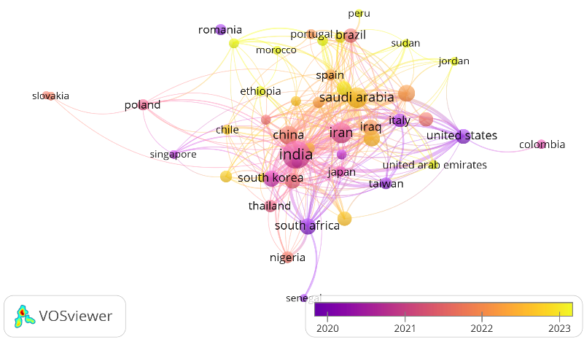
(a) | (b)
Figure 2. a) Scientific production by country by authorship and b) Scientific collaboration network between countries (performed in VOS-viewer).

The keyword co-occurrence network is presented in Figure 3. This clearly shows how the different lines of research on the use of natural extracts for nanoparticle synthesis are grouped into two clusters clearly differentiated by their word density. The red cluster, for example, is clearly anchored in terms such as “synthesis (chemical),” “metal nanoparticles,” “scanning electron microscopy,” and “x-ray diffraction.” This suggests a more technical and structural focus of the field, focused on methods for the synthesis and physical-chemical characterization of nanoparticles, as well as their efficiency, catalytic activity, and environmental applications. In contrast, the green cluster revolves around terms such as “plant extract,” “nonhuman,” “drug synthesis,” “cytotoxicity,” and “staphylococcus aureus,” which points toward research more oriented toward biomedicine and pharmacological applications. This is where studies exploring the bioactivity of nanoparticles synthesized with plant extracts come in, especially in antimicrobial, therapeutic and toxicological contexts.

Figure 4 presents a trending topic graph that reveals how research into the use of natural extracts for nanoparticle synthesis has evolved in different directions over almost a decade. A progressive shift is observed from early work focused on metallic nanoparticles such as silver and gold to more recent studies incorporating metal oxides such as copper oxide and palladium nanoparticles, pointing to a diversification of the materials of interest, opening new lines of research that could be linked to industrial catalytic applications. The terms "eco-friendly synthesis" and "oxide nanoparticles" have gained prominence especially since 2020, reflecting a clear focus on sustainability and interest in materials with photocatalytic properties, such as zinc oxide. This suggests an emerging line of research connecting green chemistry with environmental remediation, where the use of plant extracts not only serves a reducing function but also amplifies the functional activity of nanomaterials in processes such as pollutant degradation. On the other hand, the increasing mentions of “antibacterial activity” and “antimicrobial activity” confirm the importance of these nanoparticles in biomedical applications. Here, it is possible to infer a thematic convergence between synthesis and biological validation studies, particularly in the treatment of resistant infections. This type of research has gained traction especially in post-pandemic contexts, where the biocompatibility and antimicrobial efficacy of materials obtained through natural means become highly relevant [37]. Finally, the terms “natural extracts” and “green synthesis” remain the backbone, being constant in frequency and impact throughout the analyzed period. Demonstrating that green synthesis has consolidated its role as an essential methodological approach in the development of nanomaterials.

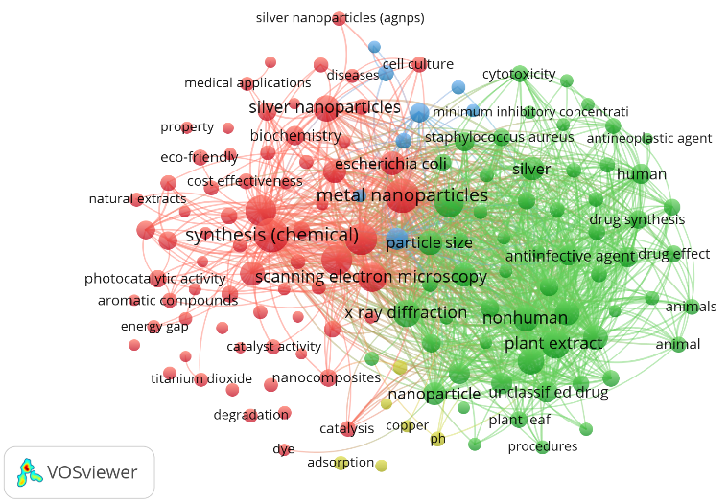
Figure 3. Index keyword co-occurrence network (performed in VOS-viewer).

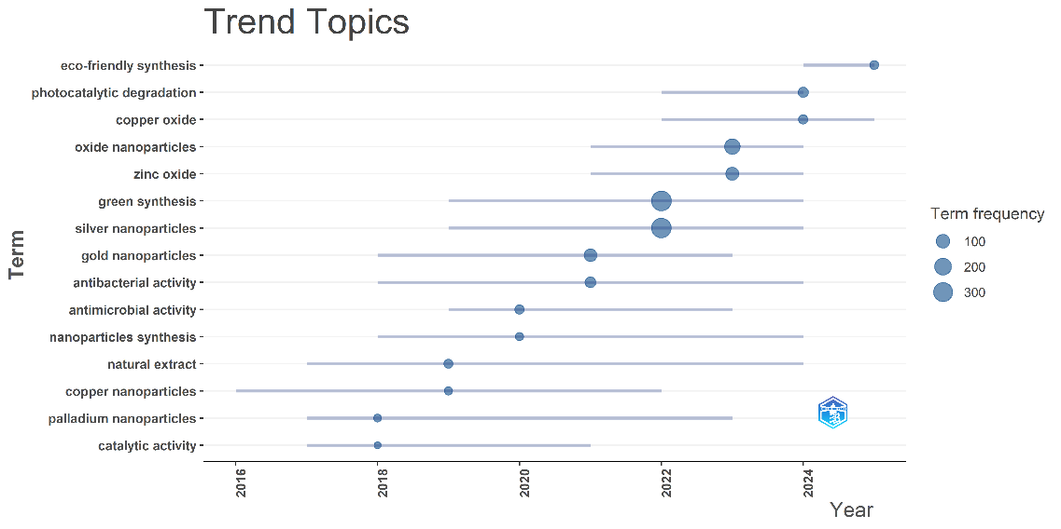
Figure 4. Trending Topics (performed in Biblioshiny with R-Studio).

CONCLUSION
The bibliometric analysis conducted shows that the use of natural extracts in nanoparticle synthesis has established itself as one of the fastest-growing areas, with a significant growth rate from 2009 to June 2025. Many publications have achieved high impact indices in less than a decade, demonstrating the rapid adoption of new techniques, procedures, and applications. India, Iran, and China lead the scientific output with a significant amount of national research. Among the most relevant authors are figures such as Maaza and Nasrollahzadeh, where research lines focused on physical-chemical characterization, biological applications, and green synthesis of nanoparticles coexist. Among the most notable journals are International Journal of Biological Macromolecules, Materials Today: Proceedings, and RSC Advances, characterized by their high impact and trajectory. The keyword network describes an area that ranges from the technical to the applied, with a strong presence of terms linked to biocompatibility. The identified clusters reveal three dominant lines: green synthesis of metallic nanoparticles, biomedical applications with an antimicrobial and antioxidant focus, and the use of metal oxides in photocatalytic processes for environmental remediation. The results highlight not only the maturity of the field, but also its potential to impact important research areas such as health, environment and industry.

References

- Ameen, F., Alsamhary, K., Alabdullatif, J. A., & ALNadhari, S., A review on metal-based nanoparticles and their toxicity to beneficial soil bacteria and fungi. Ecotoxicol. Environ. Saf., 213, 112027 (2021).
- Courtois, P., Rorat, A., Lemiere, S., Guyoneaud, R., Attard, E., Levard, C., & Vandenbulcke, F., Ecotoxicology of silver nanoparticles and their derivatives introduced in soil with or without sewage sludge: A review of effects on microorganisms, plants and animals. Environ. Pollut., 253, 578-598 (2019).
- Ahmed, S., Ahmad, M., Swami, B. L., & Ikram, S., A review on plants extract mediated synthesis of silver nanoparticles for antimicrobial applications: a green expertise. J. Adv. Res., 7(1), 17-28 (2019).
- Magalhães, D., Gonçalves, R., Rodrigues, C. V., Rocha, H. R., Pintado, M., & Coelho, M. C., Natural pigments recovery from food by-products: Health benefits towards the food industry. Foods, 13(14), 2276 (2024).
- Villagrán, Z., Anaya-Esparza, L. M., Velázquez-Carriles, C. A., Silva-Jara, J. M., Ruvalcaba-Gómez, J. M., Aurora-Vigo, E. F., ... & Martínez-Esquivias, F., Plant-based extracts as reducing, capping, and stabilizing agents for the green synthesis of inorganic nanoparticles. Resources, 13(6), 70 (2024).
- Singh, P., Kim, Y. J., Zhang, D., & Yang, D. C., Biological synthesis of nanoparticles from plants and microorganisms. Trends Biotechnol., 34(7), 588-599 (2016).
- Marslin, G., Siram, K., Maqbool, Q., Selvakesavan, R. K., Kruszka, D., Kachlicki, P., & Franklin, G., Secondary metabolites in the green synthesis of metallic nanoparticles. Materials, 11(6), 940 (2018).
- Khan, K., & Javed, S., Silver nanoparticles synthesized using leaf extract of Azadirachta indica exhibit enhanced antimicrobial efficacy than the chemically synthesized nanoparticles: A comparative study. Sci. Prog., 104(2), 00368504211012159 (2021).
- Mayedwa, N., Mongwaketsi, N., Khamlich, S., Kaviyarasu, K., Matinise, N., & Maaza, M., Green synthesis of nickel oxide, palladium and palladium oxide synthesized via Aspalathus linearis natural extracts: physical properties & mechanism of formation. Appl. Surf. Sci., 446, 266-272 (2018).
- Begum, N. A., Mondal, S., Basu, S., Laskar, R. A., & Mandal, D., Biogenic synthesis of Au and Ag nanoparticles using aqueous solutions of Black Tea leaf extracts. Colloids Surf. B Biointerfaces, 71(1), 113-118 (2009).
- Diallo, A., Manikandan, E., Rajendran, V., & Maaza, M., Physical & enhanced photocatalytic properties of green synthesized SnO2 nanoparticles via Aspalathus linearis. J. Alloys Compd., 681, 561-570 (2016).
- Chandrima, M., Sunooj, K. V., Bosco, S. J. D., Raghu, S., Reddy, K. K. K., Navaf, M., & George, J., Synergistic interaction of green-synthesized titanium dioxide nanoparticles and Averrhoa carambola extract in chitosan films. Int. J. Biol. Macromol., 287, 138539 (2025).
- Nasrollahzadeh, M., Sajadi, S. M., Rostami-Vartooni, A., & Hussin, S. M., Green synthesis of CuO nanoparticles using aqueous extract of Thymus vulgaris L. leaves and their catalytic performance for N-arylation of indoles and amines. J. Colloid Interface Sci., 466, 113-119 (2016).
- Kane, A. O., Ngom, B. D., Sakho, O., Zongo, S., Ndiaye, N. M., Ndlangamandla, C. L., ... & Maaza, M., Biosynthesis of ZnO nanoparticles by Adansonia Digitata leaves dye extract: Structural and physical properties. MRS Adv., 3(42-43), 2487-2497 (2018).
- Cañedo Andalia, R., Rodríguez Labrada, R., & Montejo Castells, M. Scopus: la mayor base de datos de literatura científica arbitrada al alcance de los países subdesarrollados. Acimed, 21(3), 270-282 (2010).
- Shahzadi, S., Fatima, S., Shafiq, Z., & Janjua, M. R. S. A., A review on green synthesis of silver nanoparticles (SNPs) using plant extracts: a multifaceted approach in photocatalysis, environmental remediation, and biomedicine. RSC Adv., 15(5), 3858-3903 (2025).
- Thovhogi, N., Diallo, A., Gurib-Fakim, A., & Maaza, M., Nanoparticles green synthesis by Hibiscus sabdariffa flower extract: main physical properties. J. Alloys Compd., 647, 392-396 (2015).
- Karan, T., Erenler, R., & Moran Bozer, B., Synthesis and characterization of silver nanoparticles using curcumin: cytotoxic, apoptotic, and necrotic effects on various cell lines. Z. Naturforsch. C, 77(7-8), 343-350 (2022).
- Jayaprakash, N., Vijaya, J. J., Kaviyarasu, K., Kombaiah, K., Kennedy, L. J., Ramalingam, R. J., ... & Al-Lohedan, H. A., Green synthesis of Ag nanoparticles using Tamarind fruit extract for the antibacterial studies. J. Photochem. Photobiol. B: Biol., 169, 178-185 (2017).
- Yuvakkumar, R., Suresh, J., Nathanael, A. J., Sundrarajan, M., & Hong, S. I., Novel green synthetic strategy to prepare ZnO nanocrystals using rambutan (Nephelium lappaceum L.) peel extract and its antibacterial applications. Mater. Sci. Eng. C, 41, 17-27 (2014).
- Thakur, V., Narula, D., Sharma, A., Kaur, M., & Sharma, P., Investigation on green synthesized nanocomposites of magnetite using Salvia hispanica for antibacterial activity. Mater. Today Proc. (2023).
- Diallo, A., Ngom, B. D., Park, E., & Maaza, M., Green synthesis of ZnO nanoparticles by Aspalathus linearis: structural & optical properties. J. Alloys Compd., 646, 425-430 (2015).
- Ashraf, J. M., Ansari, M. A., Khan, H. M., Alzohairy, M. A., & Choi, I., Green synthesis of silver nanoparticles and characterization of their inhibitory effects on AGEs formation using biophysical techniques. Sci. Rep., 6(1), 20414 (2016).
- Thema, F. T., Manikandan, E., Dhlamini, M. S., & Maaza, M. J. M. L., Green synthesis of ZnO nanoparticles via Agathosma betulina natural extract. Mater. Lett., 161, 124-127 (2015).
- Thema, F. T., Manikandan, E., Gurib-Fakim, A., & Maaza, M., Single phase Bunsenite NiO nanoparticles green synthesis by Agathosma betulina natural extract. J. Alloys Compd., 657, 655-661 (2016).
- Khatami, M., Alijani, H. Q., Heli, H., & Sharifi, I., Rectangular shaped zinc oxide nanoparticles: Green synthesis by Stevia and its biomedical efficiency. Ceram. Int., 44(13), 15596-15602 (2018).
- Aldeen, T. S., Mohamed, H. E. A., & Maaza, M., ZnO nanoparticles prepared via a green synthesis approach: Physical properties, photocatalytic and antibacterial activity. J. Phys. Chem. Solids, 160, 110313 (2022).
- Dharmatti, R., Phadke, C., Mewada, A., Thakur, M., Pandey, S., & Sharon, M., Biogenic gold nano-triangles: Cargos for anticancer drug delivery. Mater. Sci. Eng. C, 44, 92-98 (2014).
- Anbu, P., Murugan, K., Madhiyazhagan, P., Dinesh, D., Subramaniam, J., Panneerselvam, C., ... & Benelli, G., Green-synthesised nanoparticles from Melia azedarach seeds and the cyclopoid crustacean Cyclops vernalis: an eco-friendly route to control the malaria vector Anopheles stephensi?. Nat. Prod. Res., 30(18), 2077-2084 (2016).
- Zaater, A., Serhoud, M. O., Ben Amor, I., Zeghoud, S., Hemmami, A., Rebiai, A., ... & Barhoum, A., Exploring the potential of a Ephedra alata leaf extract: phytochemical analysis, antioxidant activity, antibacterial properties, and green synthesis of ZnO nanoparticles for photocatalytic degradation of methylene blue. Front. Chem., 12, 1367552 (2024).
- Dadashpour, M., Firouzi-Amandi, A., Pourhassan-Moghaddam, M., Maleki, M. J., Soozangar, N., Jeddi, F., ... & Pilehvar-Soltanahmadi, Y., Biomimetic synthesis of silver nanoparticles using Matricaria chamomilla extract and their potential anticancer activity against human lung cancer cells. Mater. Sci. Eng. C, 92, 902-912 (2018).
- Borah, R., Saikia, E., Bora, S. J., & Chetia, B., On-water synthesis of phenols using biogenic Cu2O nanoparticles without using H2O2. RSC Adv., 6(102), 100443-100447 (2016).
- Aisida, S. O., Ugwu, K., Akpa, P. A., Nwanya, A. C., Nwankwo, U., Bashir, A. K. H., ... & Ezema, F. I., Synthesis and characterization of iron oxide nanoparticles capped with Moringa Oleifera: the mechanisms of formation effects on the optical, structural, magnetic and morphological properties. Mater. Today Proc., 36, 214-218 (2021).
- Bakayoko, M., Sackey, J., Razanamahandry, L. C., Ngom, B. D., & Ntwampe, S. K. O., Bio-synthesis and characterization of nanoscaled CdO using corn husk extract via green nano-chemistry. Mater. Today Proc., 36, 534-539 (2021).
- Echegaray-Ugarte, T. S., Cespedes-Loayza, A. L., Cruz-Loayza, J. L., Huayapa-Yucra, L. A., Cruz, I., de Carvalho, J. C., & Goyzueta-Mamani, L. D., Green synthesis of silver nanoparticles mediated by Punica granatum peel waste: an effective additive for natural rubber latex nanofibers enhancement. Polymers, 16(11), 1531 (2024).
- Asmat-Campos, D., Abreu, A. C., Romero-Cano, M. S., Urquiaga-Zavaleta, J., Contreras-Cáceres, R., Delfín-Narciso, D., ... & Fernández, I., Unraveling the active biomolecules responsible for the sustainable synthesis of nanoscale silver particles through nuclear magnetic resonance metabolomics. ACS Sustain. Chem. Eng., 8(48), 17816-17827 (2020).
- Asmat-Campos, D., Rojas-Jaimes, J., de Oca-Vásquez, G. M., Nazario-Naveda, R., Delfín-Narciso, D., Juárez-Cortijo, L., ... & Menezes, D. B., Biogenic production of silver, zinc oxide, and cuprous oxide nanoparticles, and their impregnation into textiles with antiviral activity against SARS-CoV-2. Sci. Rep., 13(1), 9772 (2023).

