Procain as Novel Reagent for Determination of Salbutamol via Oxidative Coupling Reaction: Application to pure and Pharmaceutical Formulations
Shahla Jamal Shakkor^{1, a)}
¹Department of Chemistry, College of Science, University of Kirkuk, Iraq.
^{a)} Corresponding author: shahla.jamal@uokirkuk.edu.iq
Abstract. A Fast ,accurate and sensitive oxidative coupling reaction was developed to measure salbutamol (SAL) either in its pure form or in tablet dosage form by spectrophotometric method. The proposed procedures , specifically rely on coupling of salbutamol with procain (PRO) reagent in the presence of Ferric chloride as an oxidizing agent in an alkaline medium to form a stable, water-soluble yellowish orange complex showing a maximum absorption at 442 nm , Beer's law is obeyed in the concentration range of 2-40 μg/ml, The molar absorptivity and Sandell᾽s sensitivity index values were 6.7246 x 10³ L.mol⁻¹.cm⁻¹ and 0.0355 µg /cm² , with a limit of detection and limit of quantitative of 0.129 and 0.430 µg/ml. The average of recovery was 98.00% , this indicates that the method has high accuracy, with relative standard deviation less than 1%. SEM imaging confirmed the morphological changes of the structures with regular sizes, and clear difference between the blank solution without salbutamol and the sample solution containing it.The proposed method have been used successfully to determine salbutamol in pure and its pharmaceutical preparations (tablets).
Keywords: Salbutamol, Procain, FeCl3, Oxidative coupling, Spectrophotometric

INTRODUCTION
Oxidative coupling reactions are one of the most important organic reactions with wide applications, especially in analytical chemistry. This reaction usually involves the coupling of two organic substances in the presence of an oxidizing agent under suitable reaction conditions, where these substances are oxidized, leading to the formation of intermediate compounds that reacted with each other and give a colored product [1] , which can be measured spectrometrically and benefit from the reaction in Quantitative assessment of many different important organic compounds in the field of agriculture, food, environment, clinical and pharmaceutical analyzes using spectrophotometric methods [2-6] , fluorescence analysis [7] and flow injection analysis [8].
Salbutamol (SAL) chemically known as 4-[2-(tert-Butylamino)-1-hydroxyethyl]-2-(hydroxymethyl)phenol , The molecular formula of it is (C₁₃H₂₁NO₃) , figure(1) shows its chemical structure [9].

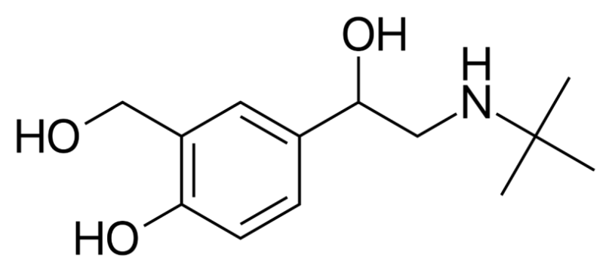
Figure 1. The chemical structure of salbutamol

Salbutamol was invented in 1966 AD in Britain and became commercially available in the United Kingdom in 1969 AD [10,11]. Salbutamol is used in the treatment of acute and chronic asthma, as it works to reverse the obstruction in airflow through an anti-retraction action of the trachea muscle contract, which results in Expansion of the trachea, and it was found that salbutamol remains effective in the body for 6 hours, so it is widely used in the treatment of cases [12] . Ther are many salbutamol assay methods including spectral method, where in assessing active chemicals in pharmaceutical formulations, uv-vis spectrophotometric approaches are inexpensive, simple to use, and rapid to detect, involving only a few minutes in some instances [13-15] ,Chromatographic methods [16-18] and other methods for determination of salbutamol [19-21].

EXPERIMENTAL

Apparatus
Subsequent measurements have been mesured using The following instruments :
UV-visible Spectrophotometric T92 AND Spectrophotometer rangc C (200-800) nm quartize cell 1cm , pH meter Jenway 3310.
Material & solutions used
standard salbutamol solution 250 µg/mL was prepared with a weight of 0.025 g of pure salbutamol using 100 ml of distilled water .
Procain reagent solution of 5x10⁻³M was prepared by dissolving 0.1722 gm in 100 ml distilled water .
Ferric chloride solution of 2x10⁻²M was prepared by dissolving 0.460 gm of it in 100 ml of distilled water
Sodium hydroxide solution (1M) was prepared by dissolving 4 grams of sodium hydroxide IN 100 ml of distilled water
Pharmaceutical solution (250 µg/mL)
butalen tablets (SDI, Samarra, Iraq) was used , each tablet contains 2 mg of salbutamol . Therty tablet of butalen were powdered and weighed precisely an amount of powder equal to 0.025 gm of salbutamol was dissolved with 20 ml of distilled water , then filtered into 100 mL calibrated flask . Next, the solution was made to the volume using distilled water.
RESULT AND DISCUSSION
1ml of ferric chloride 2 x 10⁻² M was added to 2 ml of salbutamol solution (250 µg/ml), then 2 ml of procain solution (5 x 10⁻³ M) and 0.5 ml of Sodium hydroxide solution (1 M) were added , where a green product was observed. the solution was diluted with 25 ml distilled water, mixed well, and left to stand1for 5 min at room temperature . Maximum absorbance of colored product was seen at 442 nm , while no absorbance of blank solution was shown at this wave length .
Optimal Situation
A study was conducted to obtain the optimal conditions that give the highest absorption of the colored product .
Choosing The Best Coupling Reagent
2 ml of different reagents (5×10⁻³ M) were used to coupling with salbutamol. As listed in Table 1, procain had the highest absorption value when coupled with salbutamol . so, in subsequent experiments work it was chosen as the best oxidizing reagent.

TABLE 1. Choosing the Best Coupling Reagent
Absorpance | λ max (nm) | Reagent
0.712 | 442 | Procain
0.443 | 423 | O-Toludine
0.311 | 339 | Sulfathiazole
0.375 | 361 | Sulfapyridine
0.131 | 412 | Sulfadizine
0.244 | 398 | Clopamide
Effect of Reagent Amount
This effect was conducted by taking different volumes of (0.5-3) ml of procain solution (5x10⁻³M) , and the absorption spectrum of each sample was measured against its blank solution at 442 nm, Table 2 shown that (2) ml of the reagent gave the maximum absorption value , so it was adopted in subsequent experiments.

TABLE 2. Effect of Reagent Amount
SAL Con. / Abs. |  |  | Vol. of procain  5x10⁻³ M
20 µg/ml | 15 µg/ml | 10 µg/ml | Vol. of procain  5x10⁻³ M
0.469 | 0.284 | 0.225 | 0.5
0.548 | 0.373 | 0.297 | 1
0.601 | 0.442 | 0.367 | 1.5
0.692 | 0.481 | 0.411 | 2
0.513 | 0.467 | 0.391 | 2.5
0.509 | 0.431 | 0.372 | 3
Choosing the Best Oxidizing Agent
To obtain the best oxidizing agent, a number of oxidizing agents were used with concentration of 2 x 10⁻² M, after measured the absorption spectrum of the products . It was clear that the best oxidizing agent that gives the highest absorption at the highest wavelength is Ferric chloride, and 1.5 ml of FeCl₃ gives the highest color intensity , which was adopted in the subsequent experiments (Table 3 and 4).

TABLE 3. Choosing the Best Oxidizing Agent
Abs. | Λmax (nm) | Chemical formula | 1.5 ml of oxidizing  agent 2x10⁻² M
00.72 | 442 | FeCl₃ | Ferric chloride
------ | ------ | C₆H₆NBr | N-Bromo succinimide
0.523 | 411 | KIO₄ | Potassium pariodate
0.488 | 389 | KIO₃ | Potassium iodate

.

TABLE 4. Effect of Oxidizing Agent Amuont
ml of FeCl₃ (2x10⁻² M) | Abs.
0.5 | 0.446
1 | 0.556
1.5 | 0.708
2 | 0.493
2.5 | 0.487
Effect of Base Type and Ph Function
Experiments were conducted to select the best base, using three bases (Na₂CO₃, KOH and NaOH) with three defirent concentrations (0.1,0.5,1) M to obtain high sensitivity, It was decovered that NaOH recorded the best absorption at a concentration of 1 M with 1 ml of it (pH 10.51 )which is adopted in this method (Table 5 & 6) .

TABLE 5. Selection the Best Base

Concentration / Abs. |  |  | 1 ml of Base
1 M | 0.5 M | 0.1 M | 1 ml of Base
0.719 | 0.626 | 0.504 | NaOH
0.423 | 0.343 | 0.321 | KOH
0.433 | 0.358 | 0.278 | Na₂CO₃

TABLE 6. Best Volume of Base
PH | Abs. | ml of NaOH(1M)
9.67 | 0.421 | 0.3
10.29 | 0.445 | 0.5
10.51 | 0.714 | 1
10.72 | 0.571 | 1.5
10.89 | 0.532 | 2
Sequence of Additions
Different addition sequences were used to determined the best sequence with the highest absorption of product by conducting a number of experiments, and through the results of the absorption of the colored product, it was found that the sequence (D + O + R + B) is the best (Table 7).
TABLE 7. Sequence of Additions
Abs. | Order of Addition | Number Of Order
0.552 | Drug+R+FeCl₃+Base | 1
0.722 | Drug+FeCl₃+R+Base | 2
0.356 | R+FeCl₃+Drug+Base | 3
0.562 | FeCl₃+Drug+R+Base | 4
Coupling Reaction Time Effect
This effect was studied by analyzing the effect of the reagent's coupling time with SAL (20.00 µg/ml) at different time periods (0-20 minutes) before dilution. The results in table 8 show that 5 min. is enough to complete the coupling process and obtain the colored output.

Table 8: Effect of Coupling Reaction Time
Abs. | Time Min.
0.648 | 2
0.719 | 5
0.592 | 10
0.322 | 15
0.289 | 20
Temperature Effect
The temperature effect was studied on the absorption of the colored product using different temperatures (5-50) °C at 442 nm (Table 8) . the results showd that the best temperature for conducting experiments is (15-30) C°, and absorption decreases with an increase in temperature above 35 C°, so the laboratory temperature was adopted for conducting subsequent experiments.

TABLE 9. Effect of Temperature Change
Abs. | Temperature C°
0.421 | 5
0.589 | 10
0.709 | 15
0.713 | 20
0.710 | 25
0.711 | 30
0.701 | 35
0.687 | 40
0.653 | 45
0.588 | 50

Stability of Reaction Product
To complete this study, deferent volumes of salbutamol 250 µg/ml were taken with completing the rest of additions. Then measuring the absorption of the product for a period of 60 minutes, where it was found that the output is stable for a period of not less than 45 minutes (Table 10) , and this period is suitable for making measurements.
Table 10. Stability of Reaction Product
SAL con. / Abs. |  |  | T ( min )
20 μg /ml | 15 μg/ml | 10 μg/ml
0.689 | 0.482 | 0.391 |  | 0
0.709 | 0.491 | 0.411 |  | 5
0.711 | 0.490 | 0.409 |  | 10
0.706 | 0.494 | 0.410 |  | 15
0.712 | 0.490 | 0.414 |  | 20
0.711 | 0.497 | 0.411 |  | 25
0.715 | 0.499 | 0.408 |  | 30
0.709 | 0.493 | 0.412 |  | 35
0.714 | 0.491 | 0.412 |  | 40
0.710 | 0.493 | 0.406 |  | 45
0.708 | 0.481 | 0.399 |  | 50
0.701 | 0.477 | 0.390 |  | 55
0.699 | 0.472 | 0.391 |  | 60

Final Absorption Spectrum
Under the optimal conditions of the suggested procedure the absorption spectrum of green-colored product was measured relative to blank solution , the highest absorption was seen at 442 nm (Figure 2).
Absorbance | 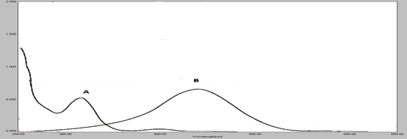
 | Wavelength (nm)
Figure 2: (A) : Spectrum of Absorption of 20 µg/ml of pure salibtumol
(B) : Spectrum of Absorption of 20 µg/ml of (salibtumol - FeCl₃ - Procain system) and its reagent blank
Scanning Electron Microscope Analysis
Comparing the images labeled (a) and (b), a clear difference in the morphology and surface properties of each sample is evident, reflecting the different nature of the reaction and components in each sample.
In image (a), which represents the blank sample containing only procaine and ferric chloride, the surface appears heterogeneous, with the particles appearing lumpy and randomly distributed, with rough edges and an irregular structure.

(a) | 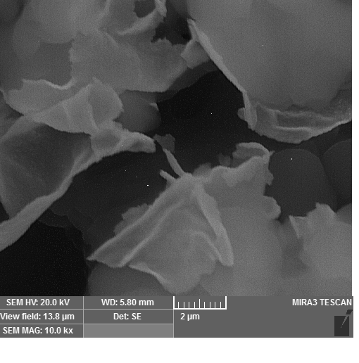 | 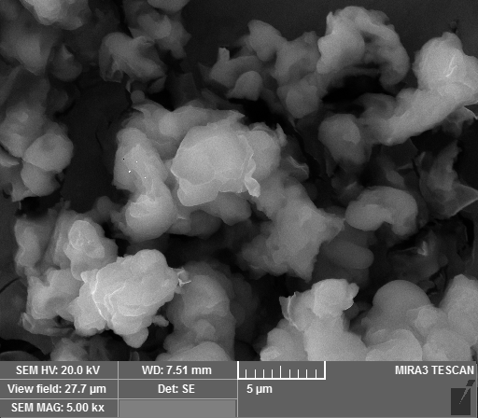
(b) | 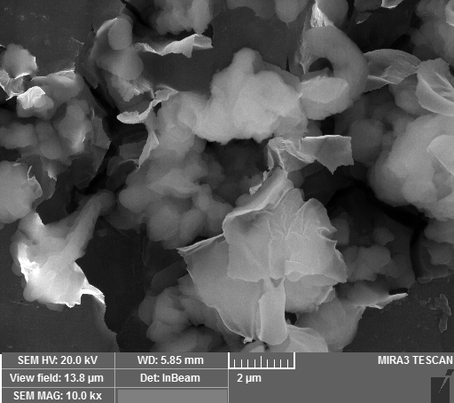 | 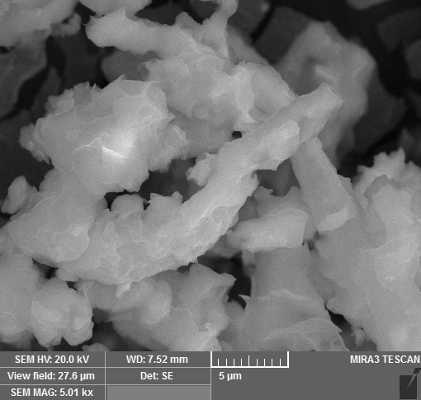
Figure 3: (a) : SEM Analysis of FeCl₃ - Procain (blak) (b) : SEM Analysis of salibtumol - FeCl₃ - Procain system
This pattern indicates the absence of any effective chemical reaction, as the relationship between the components is limited to weak physical attractions that lead to the formation of unstable aggregates, typical of chemically inactive or inert samples that do not contain a drug capable of reacting. Image (b), which represents the sample containing salbutamol with procaine and ferric chloride, shows a clear shift in surface appearance, with the particles becoming more regular, elongated or rod-shaped, and with a smoother, more homogeneous appearance. This change indicates a true chemical reaction that led to a rearrangement of the molecular structure and the formation of a new compound or stable nanoparticles. The homogeneity in shape and size also reflects that the reaction products are similar in composition and properties, which is typical of samples that underwent orderly and specific reactions. Thus, image (a) represents the initial state before the reaction, where random clusters predominate, while image (b) reflects the final state after the reaction, where an orderly nanostructure appears to have formed as a result of the reaction between salbutamol and procaine in the presence of ferric ions.
Calibration Curve
Under the optimum experimental condition ,the absorbance VS. concentration was plotted over the range of concentrations (2-40) µg/ml of salbutamol (Figure 3).

FIGURE 4. Calibration curve of salibtumol - FeCl₃ - Procain system

The linear regression equation is with correlation coefficient of 0.9975 and the molar absorptivity of the colored product was 6.7246 x 10³ L.mol⁻¹.cm⁻¹ and Sandell’s index of 0.0355 µgcm⁻², which indicates that the method is highly sensitive.
Accuracy and Precision
The suggested method was repeated at three different concentrations (5,20,30) µg/ ml of salbutamol solution, and the results showed that an accuracy (average recovery %) the relative standard deviation [22] for analyzing indicated that the method has high accuracy and precision (Table 11).

TABLE 11. Accuracy and Precision
RSD% | Average of Recovery% | Recovery% | Concentration of Salbutamol (found) μg /ml | Concentration of .salbutamol (taken) μg /ml
0.512 | 98.00 | 93.40 | 4.67 | 5
0.207 | 98.00 | 101.35 | 20.27 | 20
0.350 | 98.00 | 99.26 | 29.78 | 30
Detection Limit and Quantification Limit
The detection limit (LOD) and the quantitative limit (LOQ) (Table 12) were calculated based on the following equations [20] :
LOD = 3 x δ/Slope
LOQ=10 x δ / Slope
Where , δ: standard deviation of six Planck readings
Slope: The slope of the calibration curve

TABLE 12. Limit of Detection and Limit of Quantification
LOQ | LOD | Slope | Δ
0.430 | 0.129 | 0.0281 | 0.00121
APLICATIONS
Direct Aplication
The optimized method was applied to determine salbutamol in pharmaceutical preparation (butalen 2mg) using three different concentrations of drug were used with a concentration of 250 µg/mL . In Table 13 the results revealed accuracy in determination of Salbtamol .

TABLE 13. Determination of salbutamol in a pharmaceutical preparation by the direct method
RSD% | Average of recovery% | Recovery% | Con. of Measured SAL μg/ml | Con. of Present SAL μg/ml | Type of pharmaceutical
0.522 | 99.57 | 97.00 | 4.85 | 5 | Tablet
0.462 | 99.57 | 101.10 | 20.22 | 20 | Tablet
0.389 | 99.57 | 100.63 | 30.19 | 30 | Tablet
Standard Addition Aplication
To ensure that the proposed method is free of interference, the standard addition method was applied. the prepared solutions were treated with the same suggested procidure , and the absorptions of product were measured at 442 nm. In Figure 5 and Table 14 the results is shown .

FIGURE 5. Standard addition curve of salbutamol in butalene tablets

TABLE 14. Standard additions method
Recoverg% | Salbutaml (founu) μg/ml | Salbutamol (taken) μg/ml | Type of Drug
99.29 | 9.92 | 10 | Tablest Butalen  2mg S.D.T.Iaq
102.12 | 25.53 | 25 | Tablest Butalen  2mg S.D.T.Iaq

CONCLUSION
Con. of 25 µg/ml
Con. of 25 µg/ml
A new spetrophotometric method was applied to estimate salbutamol by oxidative coupling reactions in the current investigation , depending on reaction of salbutamol with procain , in the presence of FeCl₃ as an oxidizing agent in an alkaline medium, giving a yellwish orang color product, The results demonstrated the ability of this reaction to form a complex that can be measured and analyzed with high accuracy. The study demonstrated outstanding sensitivity in the determination of salbutamol, as the method was able to detect very low concentrations with high reproducibility, reflecting the reliability and accuracy of the method.
The results were supported by scanning electron microscopy (SEM), as the images showed the formation of homogeneous complex structures with regular sizes, reflecting the nature of the interaction and complex formation at the nanoscale. This study reflects the potential of this method as an effective and accurate analytical tool for the determination of salbutamol in various samples, while ensuring high sensitivity and reliable reproducibility.

REFERENCES
- Ardoiz F. and Maseras F., Oxidative coupling mechanisms:current state Understanding, America Chemical Society, 8(2), 1161-1172 , 2018, https://doi.org/10.1021/acscatal.7b02974
- Mohammed S. Al-Enizzia, Omar A. Sh. And Mohamed Y. D. , Oxidative Coupling Reaction For The Spectrophotometric Determination Of Furosemide Using Chlorpromazine Hydrochloride As A Reagent , Chemical Problems , 2 (23) , 256-265, 2025 , 10.32737/2221-8688-2025-2-256-177
- Shakkor Sh. J. , Mohammed N. and Shakor S. R. , Spectrophotometric Method for Determination of Methyldopa in Bure and Pharmaceutical Formulation Based on Oxidative Coupling Reaction , Chemical Methodologies , 6(11) , 851-860 , 2022 ,https://doi.org/10.22034/chemm.2022.342221.1559
- Mohammed, S. E., Abdoon, F. M., and Omar, F. K., New method for estimation of metronidazol by oxidative coupling reaction using phenothiazine reagent, International Journal of Health Sciences, 6(S3), 11189–11200, 2022, 10.53730/ijhs.v6nS3.8818
- Shakkor Sh. J., Aead N.J. , Baker M. H. , Spectrophotometric Determination of Trimethoprim in Pharmaceutical Formulation via Schiff base Reaction using Prepared Organic Reagents , International Journal of Drug Delivery Technology , 11(2) , 2021 , 10.25258/ijddt.11.2.16
- Shakkor Sh. J , Spectrophotometric Determination of Reduced Nimesulide using 8- Hydroxyquinolinol Reagent in Pharmaceutical Preparations , Kirkuk University Journal-Scientific Studies , 10(1):143-157, 2015 , 10.32894/kujss.2015.101964
- Qing L. , Si C. , Yiming N. , Qian L. and Fang C. , Determination of 4-n-butylresorcinol by fluorescence derivatization based on dopamine, Talanta , 281, 126909,2025, https://doi.org/10.1016/j.talanta.2024.126909
- Hassan M. J. M. , Khayoon W. Sh. and Hasssan Sh. Ab-F. , Batch and flow injection spectrophotometric methods for the determination of barbituric acid in aqueous samples via oxidative coupling with 4-aminoantipyrine , Karbala International Journal of Modern Science ,1(3) , 135-141, 2015 ,10.1016/J.KIJOMS.2015.10.003
- Hanckney AC. , Doping, Performance Enhancing Drugs, and Hormones in Sport, Chapter 6- Beta -2 Agonists -2017;65-76. https://csumb.primo.exlibrisgroup.com/permalink/01CALS_UMB/61o2t1/alma993665703502923
- Rajesh G., Arindam C., Swarupashis P. and Ananya B. , A Comparative Study of Montelukast and Salbutamol in Bronchial Asthma, International Journal of Scientific Research in Science and Technology , 5(9) , 21-29 , https://doi.org/10.32628/IJSRST2294112 ‏
- Nemati-k. , Ebrahim A. , and Zolfa M. ,Phase diagrams of PEG1000, 1500, 2000, 4000, 6000+ lithium citrate+ water ATPSs, and the partitioning of salbutamol at T= 298.15 K. , Scientific Reports, 13(1) , 2023, 10.1038/s41598-023-28046-9
- Maltais F., et al. , Salbutamol use in relation to maintenance bronchodilator efficacy in COPD: a prospective subgroup analysis of the EMAX trial , Respiratory Research, 21(1):280 , 2020, 10.1186/s12931-020-01451-8
- Zeena Z. Al Abdali, Nagham N. H. and Elham S. S., Spectrophotometric Determination of Salbutamol Sulphate and Isoxsuprine Hydrochloride in Pharmaceutical Formulations . Baghdad Science Journal, 20(2): 426-433. , 2023, http://dx.doi.org/10.21123/bsj.2022.6902
- Marwa A. Al-Safar and Mohammed S. Al-Enizzi , Spectrophotometric determination of salbutamol via oxidative coupling reaction using reagent benzidine, AIP Conf. Proc. , 2394 (1), 040001, 2022, https://doi.org/10.1063/5.0121660
- vichapng J., Santaladcharyakit Y. , Burakham R. and Srij S. ,Mixed Mielle-mediated Cloud point Extraction Coupled to Spectrophotometric for Fast Screening of Salbutamot in Wastewater, pig Feed and pork samples , Chiang Mai J. Sci. , 47(3), 542 -553 , 2020 , http://epg.science.cmu.ac.th/ejournal/
- Anastasia Y. , Latif H. , Sutardi L. N. and Widiastuti R. , "Salbutamol Residue in plasma and Urinc of Balines Calves after Single- Dose Administrations", Acta vet.Indones, 9(1 ), 30-35. 2021, https://doi.org/10.29244/avi.9.1.30-35
- Kanchan C. and Asna B. , Analytical Method Development and Validation of Salbutamol Sulfate, Bromhexine HCl and Guaifenesin by HPLC Method , International Journal of Current Science , 13(3) , PP. 48-55. ,2023, ijcsp23c1006.pdf
- Thuan N.T.M. and Linh N.T.K. , Simultaneous determinationof salbutamoland clenbuterol in human plasma using liquid chromatography coupled to tandem mass spectrometry ,Pharm. Sci.Asia, 46(2), 120-128. 2019,10.29090/psa.2019.02.017.0025
- Wasan A. Al-Uzri, Mariam J. and Hind H. ,Colorimetric Determination of Salbutamol Sulfate using Spectrophotometry-Continuous Flow Injection Technique in Bulk Powderand Pharmaceutical Forms, Iraqi J Pharm Sci, 32(1) , 45-52 , 2023 , https://doi.org/10.31351/vol32iss1pp45-52
- Han X. ,Development of electrochemical Immunosensor for detecting Salbutamol by Competitive Immune strategy , Int. J. Electrochem. Sci., 15, 7337-7346., 2020 ;https://doi.org/10.20964/2020.08.93
- Decha D., Bunyarithi S., Pongthep P., Chakrit S. , Arsooth S. , Adisorn T. and Supa H. , An electrochemical MIP sensor for selective detection of salbutamol based on a graphene/PEDOT:PSS modified screen printed carbon electrode , The Royal Society of Chemistry’s , 8, 206-212, 2018, https://doi.org/10.1039/C7RA09601A
- Miguel V., Cases A. Lopez-L. , and M.Angeles L., foundations of Analytical chemistry , ATeaching –learning Approach 2017 Edition ;spriger ,92-104, https://doi.org/10.1007/978-3-319-62872-1

