Bibliometric Analysis of Research Panorama on Construction Materials and Sustainability
Elias Artica-Hinostroza^{1, a)}, Bryan Zuñiga-Huaycho^{1, b)} and Renny Nazario-Naveda^{1, c)}
¹Facultad de Ingeniería y Arquitectura, Universidad Autónoma del Perú, Lima 15842, Perú.
^{a)}earticah@autonoma.edu.pe
^{b)}bzunigah@autonoma.edu.pe
^{c)} Corresponding author: renny.nazario@autonoma.pe
Abstract. This research analyzed the literature indexed in the Scopus database between 1998 and 2024 to show the current state of research on construction materials and sustainability. The bibliometric analysis shows notable growth in the last decade, where established research coexists with emerging trends. Journals such as Construction and Building Materials maintain a high impact. Authors such as Huseien and Adesina, despite their recent careers, have achieved great influence, and works such as that of Behera (2014) continue to set a benchmark. India has become a leader in scientific production and networking, although countries such as the United States, the United Kingdom, and China are key players in international coordination. Keyword networks and thematic maps reveal two parallel approaches that requires both materials innovation and process development: one focused on efficient resource, emissions, and life-cycle management, and a more technical approach focused on improving mechanical properties and developing innovative composites.

Introduction
The construction industry significantly drives global economic growth; however, it also represents a major environmental challenge. Traditional materials used in construction, such as cement, bricks, and steel, have a considerable environmental impact, especially due to river quarrying, the exploitation of limestone deposits, the release of greenhouse gases in industrial manufacturing processes, the high consumption of natural resources such as water, and the accumulation of waste [1]. Sustainable alternatives seek to mitigate negative impacts by proposing materials that foster a circular economy by reusing waste and minimizing its generation; in addition, they promote balance with the environment and incentivize responsible practices in the construction industry [2]. These include bamboo, known for being renewable and fast-growing [3]; adobe, which uses local soil and materials [4]; eco-bricks, which use recycled materials [5]; and other innovative materials such as bioplastics, derived from organic materials [6]. Advanced technologies are also playing a key role in the development of sustainable building practices. 3D printing enables more precise construction with material savings; while research into materials such as self-healing concrete is paving the way for more durable and low-maintenance buildings [7]. Adopting these alternatives not only offers environmental benefits but also contributes to more resilient and healthier communities by encouraging sustainable building practices that balance environmental preservation with community well-being [8].

Faced with the need to adapt to changing trends in the use of sustainable materials, scientific research has explored innovative alternatives, seeking to develop materials that help reduce the environmental impact without compromising functionality. In this context, Kim et al. developed an advanced life cycle analysis method that includes recycling and demolition, along with an eco-friendly decision-making procedure that integrates costs and environmental effects, applied to civil structures [9]. Likewise, Schneider et al. analyzed technological advances in the cement industry, highlighting improvements in thermal efficiency, kilns, grinding and the use of alternative fuels, in addition to research in CO₂ capture and reuse and NOx reduction for more sustainable production [10]. In addition, Tocto et al. demonstrated, through a Life Cycle Analysis (LCA) under the ISO 14040 and ISO 14044 standards, that conventional paving stones generate between 46% and 56% more pollution than those made with construction waste [11]. In their research, Balmaceda et al. has shown, using the LCA methodology, that recycled concrete made from construction waste reduces emissions between 2.05 and 3.24 kg CO₂ eq/m³ and decreases other environmental impacts by between 5% and 24% [12].

The reviewed studies demonstrate that alternative materials not only reduce environmental impact, but in many cases also improve functionality. However, a comprehensive synthesis is required that analyzes publication patterns, academic collaboration, and thematic evolution. This paper seeks to map the research landscape on building materials and sustainability through a bibliometric analysis, identifying gaps and opportunities for implementation in future research. Considering that the use of building materials encompasses their incorporation into the design stages, the paper seeks to illustrate how the use of alternative materials can contribute to the construction of more resilient cities with a lower environmental impact.

methodology
This study employed bibliometric techniques to examine scientific publications on construction materials and sustainability, using the Scopus platform as the primary source. Scopus is a widely used database of scientific publications due to its broad coverage of recognized relevant journals [13,14]. Documents in English, Portuguese, and Spanish were searched from 1998 to 2024, using keywords such as "alternative" AND "construction materials" AND "sustainability" AND "environment." Only documents in the format of articles, conference proceedings, reviews, and conference reviews were considered, yielding 517 documents. General search information is found in Table 1. For data processing and visualization, specialized tools such as Biblioshiny by RStudio (version 4.3.3), Microsoft Excel (version 16), and VOSviewer (version 1.6.15) were used. This software, specifically designed for the visualization of connection maps of authors, countries and co-occurrence of keywords [15,16].

TABLE 1. General information about Scopus search.
Description | Results
Timespan | 1998-2024
Sources | 279
Documents | 517
Annual Growth Rate % | 19.33
Keywords plus | 3444
Author's Keywords | 1593
Authors | 1766
Co-Authors per Doc | 3.7
International co-authorships % | 28.63
Articles | 283
Conference papers | 159
Reviews | 70
Conference reviews | 5

Results and Analysis
Figure 1 shows the scientific production on construction materials and sustainability from 1998 to 2024. The graph reveals a clear and forceful evolution in the scientific production on construction materials and sustainability, with an annual growth rate of 19.33% (Table 1). According to Table 1, most of the documents published in these years correspond to scientific articles (283), followed by conference presentations (159), indicating a solid production of formal knowledge in refereed scientific journals and specialized academic events [17,18]. Furthermore, review articles (70) and conference reviews (5) represent a significant proportion, demonstrating an interest in systematizing and synthesizing the knowledge already produced. During the first years, the pace of publications was modest, possibly because sustainability in construction was not yet a priority on academic and governmental agendas [19]. But in mid-2010, the number of articles began to grow rapidly, and with it, the cumulative curve skyrocketed. This change does not seem coincidental; it suggests that the topic has gained prominence on the global research agenda, coinciding with the strengthening of the Sustainable Development Goals (SDGs) and international climate commitments, probably driven by the urgency of finding sustainable solutions in the construction sector [20,21]. The surge in production in recent years reflects a consolidation of the field as a strategic area for researchers, universities, and international organizations, which translates into greater funding and interdisciplinary collaborations [22].

Figure 1. Literature production on construction materials and sustainability by years.

TABLE 2. Most relevant documents in the literature on construction materials and sustainability.
Documents | DOI | Year | Local Citations | Global Citations | Normalized Local Citations | Normalized Global Citations
Behera M, 2014, Constr Build Mater | 10.1016/j.conbuildmat.2014.07.003 | 2014 | 7 | 1048 | 18.00 | 15.19
Kylili A, 2017, Sustainable Cities Soc | 10.1016/j.scs.2017.08.013 | 2017 | 5 | 173 | 17.14 | 5.67
Ding GKC, 2008, J Environ Manage | 10.1016/j.jenvman.2006.12.025 | 2008 | 4 | 883 | 4.00 | 3.77
Alencar Mh, 2017, J Clean Prod | 10.1016/j.jclepro.2017.03.221 | 2017 | 2 | 46 | 6.86 | 1.51
Bin Marsono AK, 2015, Constr Build Mater | 10.1016/j.conbuildmat.2015.03.083 | 2015 | 2 | 82 | 5.50 | 1.89
Achal V, 2015, Earth Sci Rev | 10.1016/j.earscirev.2015.05.008 | 2015 | 2 | 183 | 5.50 | 4.22
Qaidi Sma, 2022, Ceram Int | 10.1016/j.ceramint.2022.06.123 | 2022 | 1 | 199 | 61.00 | 7.09
Mathiyazhagan K, 2019, J Adv Manag Res | 10.1108/JAMR-09-2018-0085 | 2019 | 1 | 64 | 31.00 | 2.07
Nayaka RR, 2018, J Clean Prod | 10.1016/j.jclepro.2018.03.291 | 2018 | 1 | 66 | 14.50 | 3.90
Oluwasola EA, 2016, J Clean Prod | 10.1016/j.jclepro.2016.02.051 | 2016 | 1 | 63 | 4.67 | 2.03

Table 2 shows the most relevant documents in the literature on construction materials and sustainability. Behera's (2014) work leads in global citations with 1048, his research presents a review and analysis of the use of recycled aggregates in concrete [23]. Closely followed by Ding (2008) and Achal (2015), both studies address sustainability in construction, the first one explores biomineralization as an ecological alternative to cement, and the second one proposes an early assessment model to select environmentally responsible designs [24,25]. However, Qaidi's (2022) review study on rubberized geo-polymer composites draws attention due to its recent publication and a high number of normalized citations (61.00 locally and 7.09 globally), suggesting a rapid and significant impact [26]. On the other hand, research such as that of Kylili (2017) and Alencar (2017), although with fewer total citations, shows a notable local relevance, especially in specific contexts of sustainability in the field of construction [27,28]. This diversity in the data reveals both the evolution of the field and the variety of approaches that are setting the tone in current research.

Table 3 reveals the most influential sources in the study of construction materials and sustainability, where Construction and Building Materials stands out with an h-index of 19 and more than 2500 total citations, confirming its central role in the field. However, journals such as Sustainability (Switzerland), with a high m-index (2) and a relatively recent production (since 2018), show a growing impact, reflecting the current demand for research in urban sustainability. It is striking that Journal of Environmental Management, despite its age (2008), maintains a considerable number of citations (1112), while newer publications such as Materials Today: Proceedings and Case Studies in Construction Materials demonstrate rapid adoption, with high productivity rates in a short time.

TABLE 3. Most relevant sources in the literature on construction materials and sustainability.
Sources | h-index | g-index | m-index | TC | NP | YP_start
Construction and Building Materials | 19 | 24 | 1.357 | 2543 | 24 | 2012
Sustainability (Switzerland) | 16 | 28 | 2 | 857 | 36 | 2018
Journal of Cleaner Production | 13 | 17 | 1 | 681 | 17 | 2013
Materials Today: Proceedings | 8 | 11 | 1.6 | 130 | 12 | 2021
Journal of Environmental Management | 7 | 7 | 0.389 | 1112 | 7 | 2008
Case Studies in Construction Materials | 6 | 7 | 1.2 | 631 | 7 | 2021
Environmental Science and Pollution Research | 6 | 9 | 1.2 | 133 | 9 | 2021
Journal of Building Engineering | 6 | 7 | 1.2 | 311 | 7 | 2021
Building and Environment | 5 | 5 | 0.333 | 165 | 5 | 2011
Science of the Total Environment | 5 | 5 | 1 | 504 | 5 | 2021

TABLE 4. Most relevant authors in the literature on construction materials and sustainability.
Author | h-index | g-index | m-index | TC | NP | YP_start
Huseien GF | 4 | 4 | 0.8 | 105 | 4 | 2021
Švajlenka J | 4 | 4 | 0.444 | 125 | 4 | 2017
Adesina A | 3 | 4 | 0.5 | 694 | 4 | 2020
Alengaram UJ | 3 | 3 | 0.375 | 102 | 3 | 2018
Alomayri T | 3 | 3 | 0.75 | 69 | 3 | 2022
Asaad MA | 3 | 3 | 0.6 | 79 | 3 | 2021
Balasbaneh AT | 3 | 4 | 0.273 | 142 | 4 | 2015
Coffetti D | 3 | 3 | 0.375 | 105 | 3 | 2018
Coppola L | 3 | 3 | 0.375 | 105 | 3 | 2018
Ghoshal SK | 3 | 3 | 0.6 | 79 | 3 | 2021

Table 4 presents the most relevant authors in the field of construction materials and sustainability. Due to the multidisciplinary nature of this study, authors from diverse areas of knowledge are observed who address topics of sustainability, construction, and the environment. It is striking that Huseien GF and Švalenka J top the list with an h-index of 4, although with different temporal trajectories: the former with a more recent productivity (since 2021) and the latter with a longer presence since 2017. Adesina A, despite only having an h-index of 3, stands out for accumulating 694 total citations, which suggests that her works, although few, have had a significant impact. Authors such as Alomayri T and Asaad MA, with high productivity indices (m-index of 0.75 and 0.6 respectively), reflect a rapid influence despite their short presence in the field. Interestingly, Balasbaneh AT, with publications since 2015, maintains a considerable number of citations (142), showing that his work on the sustainable use of wood-concrete in construction remains relevant [29]. The table reveals a diverse panorama, with researchers new to the area and others with a consolidated track record and relevance.

Figure 2a provides a comprehensive view of global scientific productivity in construction materials and sustainability, highlighting geographic and collaborative patterns. India leads the way with a high proportion of national publications (SCPs), indicating a strong domestic research capacity. Countries such as the United States and Italy follow India in productivity, although their share of national research is considerable, possibly due to their technical capabilities and domestic funding. Among the most cited researchers in these countries are Shoji D. and Coppola L., trendsetters in materials recycling, life cycle analysis, and mechanical property optimization [30,31]. In the case of China and Malaysia, a large part of their production comes from international collaborations (MCPs), driven by joint projects in areas such as the use of industrial waste in cement or materials such as bamboo [32,33]. In contrast, countries such as Australia, Brazil, and Germany, although with a lower total volume, exhibit a high proportion of SCPs, suggesting a great capacity to sustain internal research with sporadic international collaborations. This diversity in publication patterns reveals that scientific productivity depends not only on the number of articles, but also on the capacity to establish collaborative networks that amplify the reach and relevance of the knowledge generated.

 | 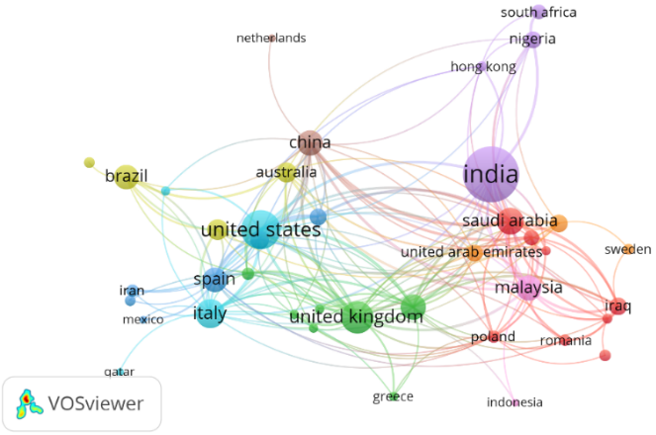
(a) | (b)
Figure 2. a) Scientific production by country by authorship and b) Scientific collaboration network between countries (performed in VOS-viewer).

The co-authorship network by country in Figure 2b confirms this panorama. India emerges as a central node, not only due to its volume of publications, but also due to its high connectivity with the Middle East, Africa, and parts of Asia, which reinforces its role as a global articulator in this area. The United States maintains strong networks with Europe and Oceania, which favors interdisciplinary projects that combine sustainability with advanced technological innovation [34,35]. The United Kingdom also occupies a key position with studies on the development of alternative materials [36,37]. On the other hand, the axis formed by China, Saudi Arabia, and Malaysia points to shared strategic interests in innovation and sustainability [33,38]. This network not only enhances the visibility of research but also accelerates the practical application of its results, favoring the translation of academic advances into regulations, new construction standards, and global strategies to address climate change.

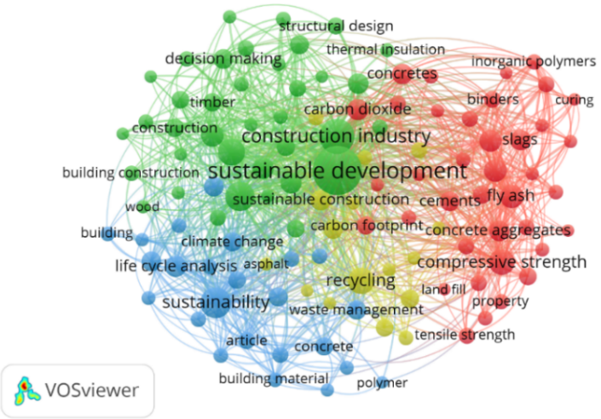
Figure 3. Index keyword co-occurrence network (performed in VOS-viewer).

The co-occurrence network, presented in Figure 3, reflects a diverse but highly interconnected field of research, where "sustainable development" and "construction industry" act as central axes articulating the different thematic lines. Around them, well-defined clusters emerge: green, linked to construction and structural design with an emphasis on decision-making and the use of materials such as wood and concrete. Blue, more oriented toward sustainability in the broadest sense, life-cycle analysis, and waste management, explores the industrial production of traditional materials and its relationship with environmental management systems, closely linking them to sustainability through studies on process efficiency. The red color concentrates technical terms on materials and mechanical properties, such as compressive strength, cements, inorganic polymers, or industrial byproducts like fly ash, where the direct connection with sustainable development highlights its role as a conceptual framework for evaluating ecological alternatives and the functionality of materials. Between them, the yellow color acts as a bridge, integrating concepts such as recycling, carbon footprint, and waste management. Overall, the map suggests a constant dialogue between technical and sustainability approaches, where environmental and material efficiency concerns intertwine with the practical challenges of the construction industry. The centrality of "sustainable development" reflects its predominance as a paradigm in the field, integrating technical, environmental, and construction dimensions. However, opportunities are identified to strengthen research that explicitly links environmental management systems (EMS) with life cycle assessments (LCA), as well as quantitative studies on the mechanical performance of sustainable materials in built environments.

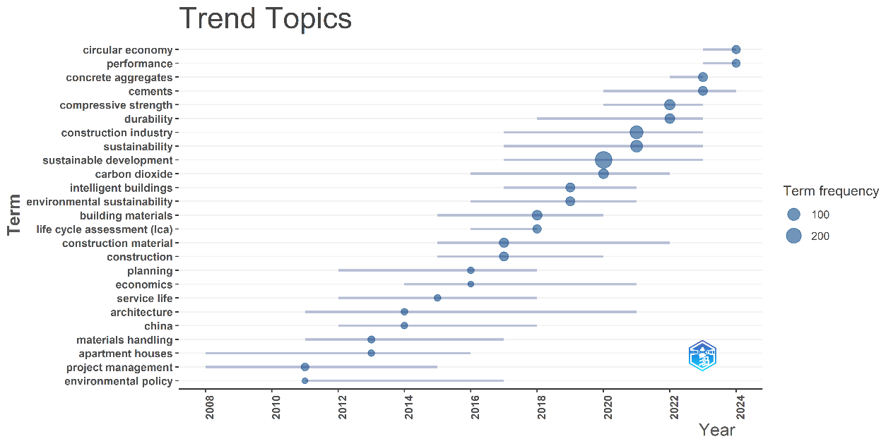
Figure 4. Trending Topics (performed in Biblioshiny with R-Studio).

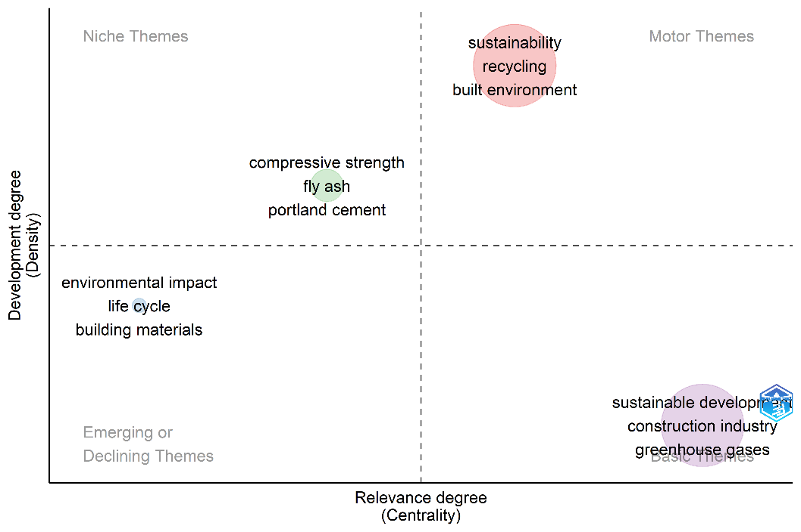
Figure 5. Thematic map (performed in Biblioshiny with R-Studio).

Figure 4 presents a trending topic graph that traces a timeline revealing how academic interest in building materials and sustainability has evolved. Terms such as “sustainability” and “sustainable development” have shown a constant and robust presence for over a decade, consolidating themselves as central axes of research discourse. However, what is most revealing is the recent rise of concepts such as “circular economy” and “life cycle assessment” (LCA), which have emerged strongly since 2020, reflecting a shift towards more systemic and regenerative approaches with, for example, the incorporation of waste materials in improving the properties of some building materials [39]. A thematic diversification is also observed: while technical terms such as “compressive strength” and “durability” remain valid, others such as “intelligent buildings” and “environmental policy” are emerging, suggesting a growing integration between technology, urban planning, and sustainability. The thematic map, presented in Figure 5, offers an accurate snapshot of the current state of research in construction and sustainability. In the upper right corner, in the motor themes quadrant, such as "sustainability," "recycling," and "built environment," are not only well developed but also occupy a central place in academic discourse, making them pillars of the field. In contrast, basic themes such as "sustainable development" and "greenhouse gases" are fundamental but still present opportunities for further exploration. The niche themes quadrant, meanwhile, shows a high degree of specialization, with "fly ash" and "portland cement" standing out, although their cross-cutting impact is limited. Finally, in the emerging or declining themes quadrant, concepts such as "life cycle" and "environmental impact" appear, which are in transition and point to becoming promising lines of research from new perspectives, as analyzed in Figure 3.

CONCLUSION
A bibliometric analysis of research conducted between 1998 and 2024 on building materials and sustainability reveals rapid growth in scientific production over the past decade. Journals such as Construction and Building Materials lead in impact, but more recent publications in new sources show accelerated growth on demand for sustainable urban solutions. Authors such as Huseien GF and Adesina A, although short-lived, stand out for their influence, while works such as those by Behera (2014) remain key references. India is positioned as a leader in both publication volume and author participation and collaborative networks, while countries such as the United States, the United Kingdom, and China act as strategic nodes for international articulation. The keyword network analysis, and thematic map show how sustainability and innovation in building materials are intertwined but follow distinct paths. A systemic approach that prioritizes efficient resource efficiency and life cycle analysis, while technical core is focused on optimizing mechanical properties and exploring new compounds. Progress toward more sustainable construction depends not only on discovering more resistant or environmentally friendly materials, but also on rethinking processes, decisions, and the way we conceive the entire lifecycle of a building.

References
- Sonter, L. J., Ali, S. H., & Watson, J. E., Mining and biodiversity: key issues and research needs in conservation science. Proc. R. Soc. B Biol. Sci., 285(1892), 20181926 (2018).
- Andrew, R. M., Global CO2 emissions from cement production. Earth Syst. Sci. Data, 10(1), 195-217 (2018).
- Xu, P., Tam, V. W., Li, H., Zhu, J., & Xu, X., A critical review of bamboo construction materials for sustainability. Renew. Sustain. Energy Rev., 210, 115230 (2025).
- Salih, M. M., Osofero, A. I., & Imbabi, M. S., Critical review of recent development in fiber reinforced adobe bricks for sustainable construction. Front. Struct. Civ. Eng., 14, 839-854 (2020).
- Zhang, X., & Biswas, W. K., Development of eco-efficient bricks–A life cycle assessment approach. J. Build. Eng., 42, 102429 (2021).
- Philip, E., & Reshmy, R., Applications of Biopolymers in Construction and Civil Engineering. Appl. Biopolym. Sci. Biotechnol. Eng., 265-289 (2024).
- Wu, P., Wang, J., & Wang, X., A critical review of the use of 3-D printing in the construction industry. Autom. Constr., 68, 21-31 (2016).
- Kibert, C. J., Sustainable construction: green building design and delivery. John Wiley & Sons, (2016).
- Kim, S. H., Choi, M. S., Mha, H. S., & Joung, J. Y., Environmental impact assessment and eco-friendly decision-making in civil structures. J. Environ. Manage., 126, 105-112 (2013).
- Schneider, M., Process technology for efficient and sustainable cement production. Cem. Concr. Res., 78, 14-23 (2015).
- Tocto Guerra N., Análisis de ciclo de vida comparativo del adoquín para pavimento peatonal reciclado versus el convencional. Pontificia Universidad Católica del Perú, Lima, Perú, (2020).
- Balmaceda Castillo, H. A., Análisis de ciclo de vida comparativo entre el uso de concreto convencional y alternativas de concreto reciclado. Pontificia Universidad Católica del Perú, Lima, Perú, (2021).
- Saldaña-Escorcia, R., & Gámez, J. K. C., Alternativas para la estabilización de lodos generados en estaciones depuradoras de aguas residuales desde un enfoque sistémico: una revisión. Rev. Investig. Agrar. Ambient., 13(1), 175-194 (2022).
- Minga Vallejo, R. E., Construcción social de aprendizajes a través de MOOCS para la sustentabilidad energética como espacios para la innovación abierta y colaborativa. Universidad de Salamanca, España, (2024).
- Li, H., Xiang, Y., Yang, W., Lin, T., Xiao, Q., & Zhang, G., Green roof development knowledge map: A review of visual analysis using CiteSpace and VOSviewer. Heliyon, 10(3) (2024).
- Linglin, Z., A bibliometric review of zero waste in the built environment using VOSviewer: evolution, hotspots, and prospects. Front. Environ. Sci., 11, 1326458 (2024).
- Nariani, R., & Fernandez, L., Open access publishing: What authors want. Coll. Res. Libr., 73(2), 182–195 (2012).
- Montesi, M., & Owen, J. M., From conference to journal publication: How conference papers in software engineering are extended for publication. J. Assoc. Inf. Sci. Technol., 59(5), 816–829 (2008).
- Akgul, G., & Giritli, F. H., Research trend of sustainability in construction journals. In CIB International Conference Proceedings, London, 23-25 (2015).
- Lu, W., Lou, J., Ababio, B. K., Zhong, R. Y., Bao, Z., Li, X., & Xue, F., Digital technologies for construction sustainability: Status quo, challenges, and future prospects. npj Mater. Sustain., 2(1), 10 (2024).
- Alam Bhuiyan, M. M., & Hammad, A., Engineering and Design for Sustainable Construction: A Bibliometric Analysis of Current Status and Future Trends. Sustainability, 16(7), 2959 (2024).
- Wang, K., & Guo, F., Towards Sustainable Development through the Perspective of Construction 4.0: Systematic Literature Review and Bibliometric Analysis. Buildings, 12(10), 1708 (2022).
- Behera, M., Bhattacharyya, S. K., Minocha, A. K., Deoliya, R., & Maiti, S., Recycled aggregate from C&D waste & its use in concrete–A breakthrough towards sustainability in construction sector: A review. Constr. Build. Mater., 68, 501-516 (2014).
- Ding, G. K., Sustainable construction—The role of environmental assessment tools. J. Environ. Manage., 86(3), 451-464 (2008).
- Achal, V., Mukherjee, A., Kumari, D., & Zhang, Q., Biomineralization for sustainable construction–A review of processes and applications. Earth-Sci. Rev., 148, 1-17 (2015).
- Qaidi, S. M., Mohammed, A. S., Ahmed, H. U., Faraj, R. H., Emad, W., Tayeh, B. A., ... & Sor, N. H., Rubberized geopolymer composites: A comprehensive review. Ceram. Int., 48(17), 24234-24259 (2022).
- Kylili, A., & Fokaides, P. A., Policy trends for the sustainability assessment of construction materials: A review. Sustain. Cities Soc., 35, 280-288 (2017).
- Alencar, M. H., Priori Jr, L., & Alencar, L. H., Structuring objectives based on value-focused thinking methodology: Creating alternatives for sustainability in the built environment. J. Clean. Prod., 156, 62-73 (2017).
- Marsono, A. K. B., & Balasbaneh, A. T., Combinations of building construction material for residential building for the global warming mitigation for Malaysia. Constr. Build. Mater., 85, 100-108 (2015).
- Shoji, D., He, Z., Zhang, D., & Li, V. C., The greening of engineered cementitious composites (ECC): A review. Constr. Build. Mater., 327, 126701 (2022).
- Coppola, L., Coffetti, D., Crotti, E., Gazzaniga, G., & Pastore, T., An Empathetic Added Sustainability Index (EASI) for cementitious based construction materials. J. Clean. Prod., 220, 475-482 (2019).
- He, Z., Shen, A., Wu, H., Wang, W., Wang, L., Yao, C., & Wu, J., Research progress on recycled clay brick waste as an alternative to cement for sustainable construction materials. Constr. Build. Mater., 274, 122113 (2021).
- Ma, X., Cai, L., Chen, L., Fei, B., Lu, J., Xia, C., & Lam, S. S., Bamboo grid versus polyvinyl chloride as packing material in cooling tower: energy efficiency and environmental impact assessment. J. Environ. Manage., 286, 112190 (2021).).
- Noori, M., Zhang, J., Elghandour, E., Cardone, D., & Narjabadifam, P., Versatile aseismic isolation based on practical applications of advanced materials for sustainable resilience against earthquakes. In World Conference on Seismic Isolation (pp. 611-622). Cham: Springer International Publishing (2022).
- Rashid, A. S. A., Latifi, N., Meehan, C. L., & Manahiloh, K. N., Sustainable improvement of tropical residual soil using an environmentally friendly additive. Geotech. Geol. Eng., 35(6), 2613-2623 (2017).
- Sotayo, A., Bradley, D., Bather, M., Sareh, P., Oudjene, M., El-Houjeyri, I., ... & Guan, Z., Review of state of the art of dowel laminated timber members and densified wood materials as sustainable engineered wood products for construction and building applications. Dev. Built Environ., 1, 100004 (2020).
- Peng, Y., & Unluer, C., Development of alternative cementitious binders for 3D printing applications: A critical review of progress, advantages and challenges. Compos. B Eng., 252, 110492 (2023).
- Althoey, F., Ansari, W. S., Sufian, M., & Deifalla, A. F., Advancements in low-carbon concrete as a construction material for the sustainable built environment. Dev. Built Environ., 16, 100284 (2023).
- Nazario-Naveda, R., Angelats-Silva, L., Murga-Torres, E., Villanueva-Corales, Y., Florián-Mejía, J., & Alfaro-Asmat, C., Incorporation of Sugarcane Bagasse Fiber on Concrete and Its Effect on Physical and Mechanical Properties (2025).

