Bibliometric Analysis of Silver Nanoparticles in Sustainable Medical and Bioscience Applications
Moises Gallozzo-Cardenas ^{1, a)}, Renny Nazario-Naveda ^{2, b)}, Luis Angelats-Silva^{3, c)}, Nicole Terrones^{4, d)}, Juan Miguel Alva-Sevilla ^{1, e)} and María Dolores Mondejar-Barrios^{1, f)}
¹ Facultad de Ciencias de la Salud, Universidad César Vallejo, Trujillo 13001, Perú.
² Facultad de Arquitectura, Universidad Autónoma del Perú, Lima 15842, Perú.
³ Laboratorio de Investigación Multidisciplinario, Universidad Privada Antenor Orrego, Trujillo 13008, Perú.
⁴ Instituto de Investigación de la Universidad César Vallejo, Trujillo 13001, Perú.

^{a)} Corresponding author: mmgallozzo@ucvvirtual.edu.pe
^{b)}renny.nazario@autonoma.pe
^{c)}langelatss@upao.edu.pe
^{d)}nterronesr@ucv.edu.pe
^{e)}jmalvas@ucvvirtual.edu.pe
^{f)}mmondejarba@ucvvirtual.edu.pe
Abstract. This bibliometric analysis of silver nanoparticles (AgNPs) research from 2019 to 2024 explores publication trends, authorship patterns, geographic distribution, and keyword usage. A marked increase in publications is observed, particularly in the fields of chemistry and materials science, with comparatively less emphasis on biomedical applications. India and China lead in both publication volume and citation impact, followed by notable contributions from Saudi Arabia. Muhammad Ikram emerges as the most cited author in this domain. The analysis highlights a prevailing interest in green synthesis and antimicrobial properties, with recurring keywords such as “green synthesis” and “antibacterial,” reflecting a strong focus on environmentally friendly methodologies. The most influential journals include Nanomaterials, Polymers, and ACS Omega, which play a key role in disseminating findings. The study highlights the growing importance of international collaboration and increased funding, particularly in addressing challenges related to toxicity and stability. Data analysis was conducted using Scopus, VOSviewer, and Excel, aiming to enhance research cooperation and advance biomedical applications of AgNPs.

Keywords: Silver nanoparticles, Green synthesis, Antibacterial activity, Bibliometric analysis, Sustainable nanomedicine.

Introduction
Nanoparticles (Nps) are materials that are smaller than 100 nm in size and have different chemical and physical properties. These properties focus on having a larger contact area, certain optical, electrical and mechanical characteristics different from larger particles [1,2]. Nanoparticles can be found in nature or can be produced by different methods, such as chemical, physical or biological techniques [3-5]. According to their structure they are classified into: Organic NPs, inorganic, carbon-based nps and composite nanoparticles. Inorganic NPs include gold, silver, copper, titanium dioxide, zinc oxide and ceramics.
In recent years, silver nanoparticles have received increasing attention as they exhibit unique optical, electrical, magnetic and physicochemical properties, which make them potential materials for a wide range of applications. Some of these in the area of agriculture for their effective performance as nano fertilizers and detection of Phytopathogens [6], in environmental applications for water treatment [7,8], standing out among its different applications as outstanding candidates for applications in the biomedical area, due to its antimicrobial properties such as: antibacterial, antifungal and antiviral; as an accelerating agent of the healing process; presenting anticancer activity and facilitating the process of diagnostic imaging [9-13].
Silver nanoparticles can be obtained by two chemical methods - physical or green synthesis. The first is a traditional method involving chemical reduction, micro emulsion and photo reduction techniques, however, these can be toxic and expensive processes [13, 14, 15]. Unlike chemical-physical methods, green synthesis methods are less toxic and lower cost, natural extracts of plants, microorganisms, fungi and algae are usually used in these methods [16, 17]. The synthesis method used and the reductants used to obtain Nps reflect certain size, shape and stability of Nps, which leads to a modification in their properties [8, 9]. These nanoparticles can be functionalized in order to improve the properties of certain materials for specific applications such as adhesion to specific materials. Despite the benefits presented, there are still some challenges presents in this area of research since they present a certain degree of toxicity, depending on the dose, size, shape, and concentration of the nanoparticles, and the stability of these in different biological environments is essential for the effectiveness of the application. So far, green synthesis processes are what present a more stable, environmentally friendly and low-cost alternative to conventional methods (chemical and physical) [13, 14, 18, 19].
This bibliometric analysis seeks to systematically review and analyze the current literature on silver nanoparticles with medical applications. In this work, key points were identified such as: countries and authors with the largest number of articles, identification of key words and journals in which results in the area are published. The objective of the analysis is to provide information to researchers, which will facilitate the analysis of the current status, propose improvements and promote collaborative research in the field of biomedicine.

Materials and method
In this work, a bibliometric analysis was carried out to identify the most outstanding applications of silver nanoparticles, the status of this research topic and possible deficiencies. The Scopus database was used to obtain data, which is considered a reliable source, due to its extensive coverage of abstracts, conference papers, books, scientific articles, and also has a strict system for the selection of content, thus ensuring the indexing of high quality data [20,21]. The search focused on articles published between 2019 - 2024 that are in the English language and that are related to silver nanoparticles with medical applications, due to their antimicrobial, antifungal activity, or that are used as therapy or treatment. These restrictions in the inclusion and exclusion of articles to perform the bibliometric analysis are summarized in Table 1 and the flowchart in Fig. 1.
TABLE 1. Detail of search criteria for articles in Scopus database.
Criteria
TS | ALL ( "silver nanoparticles" OR "silver nano*" OR "Ag nanoparticles" OR "nanosilver" ) AND ( "medicine" OR "health" OR "pharmaceutical" OR "biomedical" ) AND ( "antimicrobial" OR "antibacterial" OR "antiviral" OR "therapeutic" ) AND ( "toxicity" OR "safety" OR "biocompatibility" OR "side effects" ) AND ( "drug delivery" OR "diagnostics" OR "imaging" OR "treatment" ) AND PUBYEAR > 2019 AND PUBYEAR < 2026 AND ( LIMIT-TO ( DOCTYPE , "ar" ) ) AND ( EXCLUDE ( EXACTKEYWORD , "Human" ) OR EXCLUDE ( EXACTKEYWORD , "Nonhuman" ) OR EXCLUDE ( EXACTKEYWORD , "Animals" ) ) AND ( LIMIT-TO ( LANGUAGE , "English" ) ) AND ( LIMIT-TO ( OA , "all" ) ) AND ( LIMIT-TO ( PUBSTAGE , "final" ) ) AND ( LIMIT-TO ( SRCTYPE , "j" ) )
Languages | English
Documents Type | Articles
Period | 2019-2024
Database | Scopus

FIGURE 1. Bibliometric analysis flowchart.
With the proposed restrictions, 14,807 scientific articles were obtained and to facilitate the representation of complex images, link graphs and density plots, VOSviewer 1.6.20, as a data analysis tool, and Excel 16, for data management, were used. These two tools. The data obtained when expressed in graphs facilitate their analysis allowing us to make an evaluation of the current situation of silver nanoparticles focused on applications in medicine.

Results And Discussion

Trend in Articles
Figure 2 shows the number of publications obtained on silver nanoparticles as a function of the year applied to the biomedical field. In this figure we can observe a constant increase from a value of 519 in 2019 to 1751 articles in 2023, which indicates that there has been more attention in the area by researchers, which leads to improving the work carried out, proposing new ideas, prototypes, patents and the increase in financing for the development of the area. In 2023, a maximum peak is observed that suggests an increase in research on silver nanoparticles with biomedical applications. In 2024, there is a slight decrease compared to the previous year, perhaps due to the reduction in project financing, new areas of interest that are emerging or some technological difficulties in the production of nanoparticles. Taking a general approach, there is a positive trend despite the slight decrease in 2024.

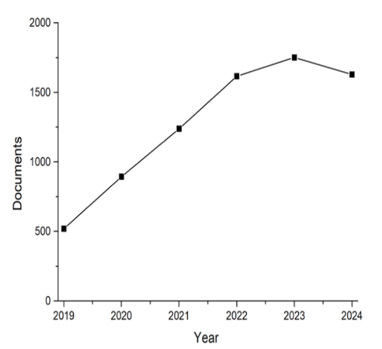
FIGURE 2. Articles published by year obtained from the Scopus database.

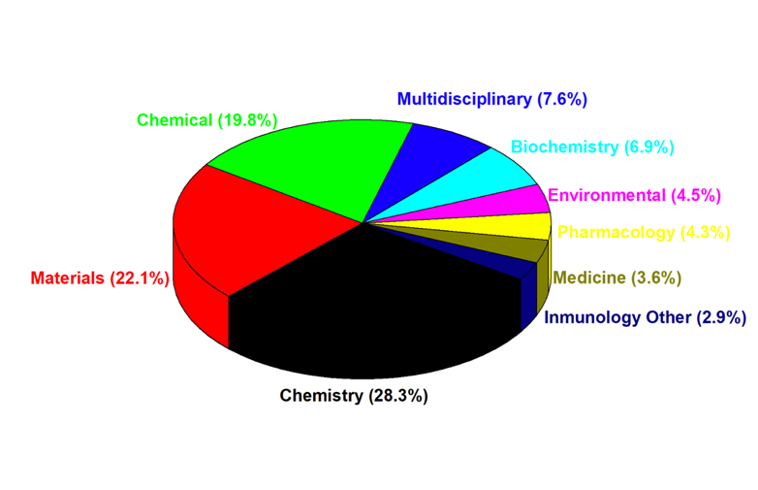
FIGURE 3. Percentages of articles in relation to the Subareas with articles focused on medicine.
Figure 3 shows the production percentages based on the research area, from which it can be observed that the area with the greatest number of scientific articles is Chemistry with 28.3%, which is consistent with the manufacturing process since the synthesis and characterization involves chemical phenomena. With 22.1% of published articles, materials are considered the second area with the greatest number of articles and in third place is Chemical with 19.8%, which shows a high interest in structural, functional and technological applications. In medical applications, there is a 3.6% despite having a low percentage, indicating research on silver nanoparticles for applications in medical therapies, drug administration and diagnostics. In addition, there is 2.9% in the area of ​​​​immunology, which is related to emerging research in immunotherapy and advanced biomedicine.
Table 2 details the 20 journals with the highest number of publications on silver nanoparticles. First, Nanomaterials is ranked with 673 articles and a total of 14,987 citations, indicating that it is considered a reliable source for the scientific community [22]. In second place is Polymers with a total of 589 articles and 10,097 citations. ACS Omega has 450 articles, and its number of citations is 8,908. In sixth place is Scientific Reports, which despite having 342 articles has a high number of citations of 9,336. This shows the trust of researchers towards this journal that will facilitate the dissemination of findings on the subject of silver nanoparticles.
TABLE 2. Journals with number of articles and citations.
Source | Documents | Citations
Nanomaterials | 673 | 14987
Polymers | 589 | 10097
Acs Omega | 450 | 8908
Rsc Advances | 440 | 7794
Heliyon | 361 | 4822
Scientific Reports | 342 | 9336
Molecules | 294 | 6576
Arabian Journal of Chemistry | 211 | 6113
Gels | 116 | 1277
Journal of Materials Research and Technology | 106 | 3412
Journal of Nanomaterials | 98 | 2118
Biointerface Research in Applied Chemistry | 97 | 1337
Materials Research Express | 95 | 1111
Frontiers in Chemistry | 86 | 1391
Journal of King Saud University - Science | 86 | 1382
Catalysts | 81 | 1539
Microorganisms | 76 | 777
Results in Chemistry | 75 | 734
Egyptian Journal of Chemistry | 73 | 683
Processes | 68 | 759

Figure 4 shows the number of articles published by the top five journals and their respective evolution between 2019 and 2024. Regarding the journal Nanomaterials (black), we can observe continuous growth from 2019 to 2022, with a maximum peak in 2022. In 2023, a noticeable drop is seen; this drop continues to trend in 2024, highlighting that the decline tends to be slight. In the journal Polymers (red), we can observe a behavior similar to Nanomaterials, showing much greater growth until 2022. After this year, a decrease is shown. In the case of ACS Omega (blue), a growth in the number of articles published can be observed, which does not show sudden but continuous increases until 2023. In 2024, it has shown a slight drop. In RSC Advances (pink) we can observe a trend with slight increases and decreases in the number of articles but which remain within a certain range, which leads us to conclude that this journal presents stability in the number of publications. Finally, in the Heliyon journal (green) there is stability in the first 3 years, from the year 2021 there is a slight increase in the first years and a greater increase in the year 2023. Leading to its highest peak in the year 2024. These behaviors indicate that the topic of silver nanoparticles has had an attractive period in different journals, but has suffered a certain fall in nanomaterials and polymers, perhaps due to publication prices, the difficulty in uploading scientific articles, the difficulty of the platform or the H index of the journal. Unlike the Heliyon journal, which by showing an increase in the number of articles, indicates greater confidence on the part of the scientific population with the journal in the last three years.

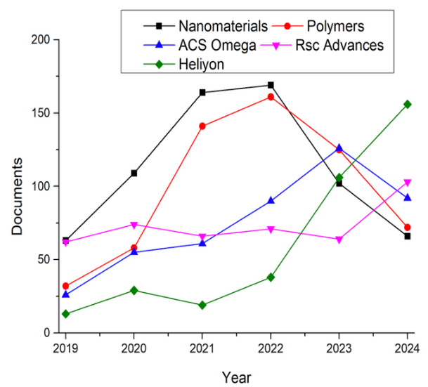
FIGURE 4. Detail of the number of articles per year of the journals with the highest number of articles.
FIGURE 5. Report of journals with a minimum of 65 publications with their respective citation correlation.

Figure 5 shows the journals with the largest number of articles. The journal with the largest number of articles is Nanomaterials, corroborating the analysis performed in Figure 4. In addition to visualizing the journal with the largest number of articles by means of the diameter of the circles, it is possible to observe the network that links the journals, indicating the co-citation, co-occurrence or collaborations that are carried out. Groups of different colors are observed that indicate the topics worked on by the scientific journals. Regarding the links, ACS and Nanomaterials present a high connectivity with other journals, showing relevance in the area and that they have common themes.

Geographic Trend
The Table 3 shows an analysis of 10 countries with the largest number of published scientific documents and details the number of articles and the number of citations made in the different countries. Among these countries, India stands out with 1,208 articles and a large number of citations of 23,149. Followed by China with 1,196 published articles and 19,593 citations. It can also be observed that Saudi Arabia has fewer articles than China but surpasses it in the number of citations. These values ​​indicate that in the countries shown there is greater funding in the area of ​​silver nanoparticles. In addition, Figure 6 shows a network map, in which we can see that countries have more than 170 articles and are divided by three colors, indicating the different areas of application of silver nanoparticles. In research, it is extremely important to make these connections, either through citations or collaborative work, since they allow the development of the topic and its applications. Having previous work helps scientists avoid common mistakes and improve the processes carried out.

FIGURE 6. List of countries with more than 170 articles published in Scopus on Nps.

TABLE 3. Data from countries with the highest number of articles and citations.
Country | Documents | Citations
India | 1208 | 23149
China | 1196 | 19593
Saudi Arabia | 1106 | 20716
Egypt | 772 | 15517
United States | 578 | 12259
Pakistan | 490 | 12089
Iran | 457 | 8783
South Korea | 320 | 6846
Italy | 303 | 5722
Spain | 277 | 4981
Malaysia | 275 | 6718
United Kingdom | 266 | 4786
Brazil | 248 | 2632
Turkey | 234 | 2655
Poland | 222 | 3871
Iraq | 218 | 3161
Germany | 217 | 3882
Romania | 190 | 2856
Russian Federation | 181 | 2776
France | 177 | 3312

Trend In Authorship and Collaborations
Table 4 shows the 20 authors with more than 12 articles and a high H index, which were obtained from the Scopus database. Muhammad Ikram is in first place with 18 articles and 309 citations, which indicates that the articles published by this author are used as a basis for other works, improving the research carried out in the area of ​​silver nanoparticles. Munawar Iqbal, despite having sixteen articles, has one thousand one hundred and four citations, which makes us consider that this author is considered a reliable source for the basis of new research. In addition, it can be observed that the twenty authors have a large number of citations between authors, demonstrating continuous work in the field of silver nanoparticles. These works carried out are very useful in the development of research because they help to learn, improve successful works or correct unsuccessful works.
TABLE 4. List of authors with more than 12 articles and citations.
Author | Documents | Citations
Ikram, Muhammad | 18 | 309
Imran, Muhammad | 18 | 321
Sulaiman, Ghassan M. | 18 | 890
Iqbal, Munawar | 16 | 1104
Ul-Hamid, Anwar | 16 | 243
Haider, Ali | 15 | 239
El-Naggar, Mehrez E. | 14 | 334
Fouda, Amr | 14 | 904
Hasan, Murtaza | 13 | 383
Shahid, Muhammad | 13 | 396
Ullah, Riaz | 13 | 104
Ahmed, M.K. | 12 | 505
Al-Askar, Abdulaziz A. | 12 | 353
Ficai, Anton | 12 | 320
Hamouda, Ragaa A. | 12 | 201
Hashem, Amr H. | 12 | 439
Jabir, Majid S. | 12 | 492
Khafagy, El-Sayed | 12 | 315
Menaa, Farid | 12 | 242
Nabgan, Walid | 12 | 231

Keyword Trends
Table 5 details the keywords most used by the scientific community. The trend is silver nanoparticles with 568 occurrences, being the word most frequently used. Green synthesis is also shown with 421 occurrences and nanoparticles with 387, which shows us that there is an important approach regarding the eco-friendly synthesis method. These silver nanoparticles have antimicrobial properties, and it is common to have antibacterial activity, antimicrobial as keywords used, since these properties are a very important factor in the applications of silver nanoparticles. For organic applications in living systems, toxicity and biocompatibility are considered important factors, due to this it is common to see the keywords cytotoxicity with 261 occurrences and biocompatibility with 119 occurrences. Silver nanoparticles can adhere to other materials, due to which it can be observed that in the analysis carried out there are keywords such as Chitosan with 237 occurrences. These materials are aimed at medical patches or bone regeneration.

FIGURE 7. Keyword report with a minimum of 100 repetitions with their respective citation correlations.
TABLE 5. Report of Keywords with 95 occurrences

Keyword | Occurrences

Silver nanoparticles | 568
Green synthesis | 421
Nanoparticles | 387
Antibacterial | 336
Antibacterial activity | 293
Cytotoxicity | 261
Chitosan | 237
Antimicrobial | 224
Antioxidant | 203
Antimicrobial activity | 199
Gold nanoparticles | 163
Electrospinning | 150
Adsorption | 139
Biocompatibility | 119
Wound healing | 114
Drug delivery | 113
Photocatalysis | 109
Nanotechnology | 105
Silver | 102

In the mapping shown in figure 7, the keywords and their occurrences can be observed, highlighting silver nanoparticles. In this mapping, several groups of keywords can be identified, showing the different applications that exist within the field of silver nanoparticles. The red link suggests a work focused on the biomedical part, whose applications will have antimicrobial activity, wound healing and drug activation or delivery. The yellow link shows a great interest in making applications of silver nanoparticles with chitosan or gold nanoparticles, which would indicate the need to enhance the biological and structural properties present in silver nanoparticles.

Conclusion
The present bibliometric analysis on silver nanoparticles was generated from articles published between 2019 and 2024. It is observed that there was a notable increase in articles on silver nanoparticles, emphasizing the area of ​​chemistry, materials and medical applications. This shows that there has been an increase in funding for research in the area. In the geographical analysis, India and China are the countries with the highest number of published and cited articles. Regarding the authors, Muhammad Ikran stands out as the most cited author in this field. In the keyword analysis, it was seen that silver nanoparticles, green synthesis and antibacterial are the most used words by the research community, thus showing that there is a growing focus on green synthesis methods and antimicrobial properties of silver particles. The most important journals in this area of ​​research are Nanomaterials, Polymers and ACS Omega, which have gained the trust of researchers and facilitate the dissemination of findings on the topic of silver nanoparticles. In the study carried out, it can be observed that keywords such as toxicity and biocompatibility are being used, which indicates that explorations of silver nanoparticles are being carried out that will help optimize their medical applications. From the bibliometric analysis carried out, we can highlight the importance of collaboration between researchers since it facilitates the development of multiple applications of silver nanoparticles, which is presented as a promising field.

Acknowledgment
The research was funded by César Vallejo University, with resolution code P-2025-020.

References
- S. D. Sarker and L. Nahar, “Characterization of nanoparticles”, in Advances in Nanotechnology-Based Drug Delivery Systems (Elsevier, 2022), pp. 45–82.
- J. M. P. Galúcio et al., Curr. Pharm. Biotechnol. 23(3), 420–443 (2022).
- D. Gupta, A. Boora, A. Thakur, and T. K. Gupta, Environ. Res. 231(Pt 3), 116316 (2023).
- J. C. Taylor, “Advances in chemistry research. Volume 83 – Nova science publishers”, Novapublishers.com (21 february 2024), available at: https://novapublishers.com/shop/advances-in-chemistry-research-volume-83/. . Accessed 19 february 2025.’
- E. Z. Gomaa, J. Inorg. Organomet. Polym. Mater. 32(11), 4114–4132 (2022).
- K. Seku, S. S. Hussaini, G. Bhagavanth Reddy, and M. Radha Krishna Reddy, “Silver-based biofungicides for the suppression of pathogenic fungi in agriculture fields”, in Nanofungicides (Elsevier, 2024), pp. 169–194.
- M. B. Uddin Rabbi, S. Haque, and S. Bedoura, Heliyon 10(24), e40931 (2024).
- C. Chikkanayakanahalli Paramesh, A. Giridasappa, A. K. Channapillekoppalu Siddegowda, D. Rangappa, and P. Doddakunche Shivaramu, “History, introduction, and physicochemical properties of silver nanoparticles”, in Silver Nanoparticles for Drug Delivery (Elsevier, 2024), pp. 1–38.
- Y. A. Morozova, D. S. Dergachev, and M. A. Subotyalov, Rev. Clin. Pharmacol. Drug Ther. 19(3), 247–257 (2021).
- M. A. Barkat et al., Recent Pat. Antiinfect. Drug Discov. 13(1), 53–69 (2018).
- F. Bibi, A. Khan, I. Iqrar, M. Iqbal, and Z. K. Shinwari, Pak. J. Bot. 56(2) (2024).
- A. Natarajan, K. R. B. Singh, P. Singh, J. Singh, S. S. Pandey, and R. P. Singh, “Silver nanoparticles based functional materials for anti-bacterial and antiviral applications”, in ACS Symposium Series (American Chemical Society, Washington, DC, 2024), pp. 185–219.
- N. Gupta, C. P. Upadhyaya, A. Singh, K. A. Abd-Elsalam, and R. Prasad, “Applications of Silver Nanoparticles in Plant Protection”, in Nanotechnology in the Life Sciences (Springer International Publishing, Cham, 2018), pp. 247–265.
- P. Mathur, S. Jha, S. Ramteke, and N. K. Jain, Artif. Cells Nanomed. Biotechnol. 46(sup1), 115–126, (2018).
- E. Abbasi et al., Crit. Rev. Microbiol. 42(2), 173–180 (2016).
- K. Jyoti, P. Pattnaik, and T. Singh, Current Materials Science 14 (1), 40–52 (2021).
- P. B. Khodke, R. R. Popat, P. V. Burakale, P. P. Chinchole, and V. N. Shrikhande, Res. J. Pharm. Technol. 10(6), 1820 (2017).
- G. Sivan, R. Pamanji, S. Koigoora, N. Joseph, and J. Selvin, Toxicol. Res. (Camb.) 13(1), tfae019 (2024).
- R. Sakthi Devi, A. Girigoswami, M. Siddharth, and K. Girigoswami, Appl. Biochem. Biotechnol. 194(9), 4187–4219 (2022).
- J. Baas, M. Schotten, A. Plume, G. Côté, y R. Karimi, Quant. Sci. Stud. 1(1), 377–386 (2020).
- O. V. Kirillova, DiPP 7, 69–78 (2017).
- T. Nann, Nanomaterials (Basel) 1(1), 1–2 (2010).

