Molecular Detection and Genotyping of Giardia lamblia in Diarrheic Patients Using Nested PCR and RFLP-PCR by gdh Gene
Fatima Akram Abd Ali ^{1,a)} and Intisar Ghanim Abdulwahhab ^{1,b)}
¹ Tikrit University, College of Education for women, Biology, Tikrit, Iraq.
^{a)} corresponding author : fatima.abd131@st.tu.edu.iq
^{b)} dr.en79@tu.edu.iq
Abstract. This study was conducted to detect Giardia lamblia parasite and identify its genotypes based on the gdh gene using nested PCR and RFLP techniques. 100 stool samples were collected from patients with diarrhea, aged between 1 month and 41 years, during the period from October 2024 to July 2025. Microscopic examination revealed that (36%) of the samples were infected with the parasite. At the molecular level, DNA extraction was successful in 83 samples, of which 61 showed a primary amplification of (605 bp), and 51 samples showed a secondary amplification of (520 bp). RFLP analysis using RsaI enzyme revealed the presence of genotypes A and B, in addition to mixed infections. The prevalence of type B was 50.98%, followed by type A (39.21%), while mixed infections constituted (9.8%).
Keywords: Giardia lamblia, nested PCR, PCR genotyping, gdh gene, RFLP-PCR
INTRODUCTION
Diarrhea is a significant health issue in the world, as the second cause of infectious diseases-related mortality [1]. An illness caused by the parasite Giardia lamblia, or G. intestinalis or G. duodenalis, with an annual estimated number of cases at 280 million [2][3]. Children under five age, adults aged 30 to 40 are the most affected groups, and thousands of children have died of the disease in recent years [4][5]. The most common way of infection is the ingestion of cysts that are resistant to chlorine, which is the primary source of infection through the ingestion of contaminated water and food [6]. The infection can be asymptomatic or it can present diarrhea, bloating and abdominal pains. Sometimes it can lead to chronic complications (irritable bowel syndrome) or constant tiredness [7]. Molecular methods like nested PCR have been found effective in diagnosis, not only with a high level of accuracy, but also by their capability to identify the parasite into eight genotypes (Assemblages A-H) by tpi, gdh and 8 giardin genes [8]. It has a high likelihood of being the simplest and effective laboratory marker because of the gdh gene, which can detect the parasite, and its associated genetic clusters [9].
Though the high burden of giardiasis is known worldwide, there is still a high issue with its exact molecular epidemiology especially in the local Iraqi population. Traditional diagnostics can hardly determine the specific genetic assemblies of the parasite, but it is this data that the focus of molecular studies is crucial because it is essential to figure out the dynamics of complex transmission. A solution of this approach is to focus on a specific solution by using the most sensitive molecular methods- Nested PCR with RFLP analysis to study the reliable gdh gene. The overall objective is thus two-fold to identify G. lamblia correctly and to identify the prevalence of both the zoonotic (Assemblage A) and anthroponotic (Assemblage B) genotypes of the organism including mixed infections in diarrheic patients in Tikrit region. The study is crucial to the environmental health, because the identification of the particular genotypes spread among human population will give the necessary information on tracking the contamination to the source, evaluate the extent of contamination of local water and food resources and present more effective and evidence-based interventions in the community health.
EXPERIMENTAL PART
Samples Collection
One hundred stool samples were collected from patients with diarrhea from Tikrit Teaching Hospital and several health laboratories in Samarra and Al-Dhuluiya cities. Their ages ranged from (1 month to 41 years), during the period from October 1, 2024 to July 1, 2025. Microscopic examination of the samples was performed within the first half hour of collection using the direct wet swab technique with physiological saline, focusing on the mucus- and lipid-rich parts to increase the likelihood of detecting the parasite Giardia lamblia. Samples that showed positive or suspicious results were preserved (100–200) mg in (500) μl of DNA Shield (Zymo Research) solution, then frozen at -20°C until molecular analysis was performed in the Tikrit University Central Laboratory.
Molecular Detection
Molecular analysis was performed to detect G. lamblia using the gdh gene. DNA was extracted from stool samples using the Presto Mini gDNA Kit from Geneaid. The purity and concentration of the samples were then measured using a Nanodrop device at two wavelengths (260/280 nm). Electrophoresis was also performed on a 1% agarose gel to ensure the integrity and quality of DNA before use in subsequent molecular steps. It was found that (83) out of (100) samples contained DNA suitable for analysis.
Preparation of the Primers
Glutamate dehydrogenase (gdh) gene-specific primers were obtained from Macrogen. The primers were prepared as working solutions at a final concentration of 10 pmol/µl after dissolving them in nuclease-free water for use in gene amplification.
The Primer
Nested PCR was used to amplify the gdh gene using two sets of primers. In the first reaction, the forward primer gdh1 (5′-TTCCGTRTYCAGTACAACTC-3′) and the reverse primer gdh2 (5′-ACCTCGTTCTGRGTGGCGCA-3′) were used to produce a 605 bp fragment at 55 °C. In the second reaction, the forward primer gdh3 (5′-ATGACYGAGCTYCAGAGGCACGT-3′) and the reverse primer gdh4 (5′-GTGGCGCARGGCATGATGCA-3′) were used to produce a 520 bp fragment at the same 50 bp binding [10].
Diagnosis of G. Lamblia for the Gdh Gene using Nested PCR
The glutamate dehydrogenase (gdh) gene was used for molecular detection of G. lamblia using a two-stage Nested PCR technique. In the first-round PCR, primers gdh1 and gdh2 were used for initial detection of the parasite and to produce a DNA template for the second reaction, which yielded a 605-base-pair (bp) fragment. The reaction components were prepared by adding 12 µL of master mix, 2 µL of forward primer, 2 µL of reverse primer, and 3 µL of template DNA. The final volume was increased to 25 µL by adding 6 µL of nuclease-free water. After completion of the reaction, the PCR product was electrophoresed on a 2% agarose gel to verify the presence of the resulting bands.
In the second-stage Nested PCR, the product of the first reaction served as the DNA template, along with the primers gdh3 and gdh4, yielding a 520-bp fragment. The reaction was prepared by adding 3 µL of the first reaction product, 2 µL of the forward internal primer, 2 µL of the reverse internal primer, and 12.5 µL of master mix. The final volume was made up to 25 µL using 5.5 µL of nuclease-free water. After completion of the reaction, the Nested PCR product was electrophoresed on a 2% agarose gel to verify the presence of the resulting bands. The thermal program used in both reactions included an initial denaturation at 94°C for 5 minutes, followed by 35 cycles of (denaturation at 94°C for 45 seconds, annealing at 55°C for 45 seconds, and elongation at 72°C for 60 seconds). The reaction was then concluded with a final elongation at 72°C for 10 minutes.
Analysis Of Nested PCR Products Using RFLP
After completing the second stage of nested PCR and obtaining the 520-bp amplified fragment, the products were enzymatically digested with RsaI according to the manufacturer's instructions. The reaction mixture was prepared for each sample by adding 10 µL of the reaction product, 1 µL of RsaI, and 2 µL of 10x In-Cut Buffer. The total volume was then made up to 20 µL using 7 µL of nuclease-free water. The reaction components were mixed, and the mixture was incubated at 37°C for 3 hours. Following digestion, the products were electrophoresed on a 2% agarose gel. Genotype A showed bands of 250 bp, 180 bp, 160 bp, and 100 bp, while genotype B showed bands of 300 bp, 400 bp, and 500 bp.
RESULT AND DISCUSSION
Direct microscopic examination of 100 stool samples using the direct wet smear technique with 0.85% physiological saline revealed that 36 samples (36%) were positive for one of the parasite stages (encysted or trophic), and 64 samples (64%) were negative.
TABLE 1. Infection rates of G. lamblia parasite
percentage | Negative result | percentage | Positive result | Examined sample
64% | 64 | 36% | 36 | 100

The 36% prevalence rate identified in this study is notably higher than the 15.55% rate reported by (Hasan, et al., 2023)[11] in the Kurdistan Region. Personal hygiene habits are explained as behavioral and health determinants with the difference between the diagnosed infection rates and environmental features in the studied areas. In 100 fecal samples DNA has been selectively extracted and the findings indicated that 83 of them were successfully extracted and 17 samples failed to obtain adequate quality and purity of DNA. The samples were extracted and the results were electrophoresed and the results were presented in Figure (1).
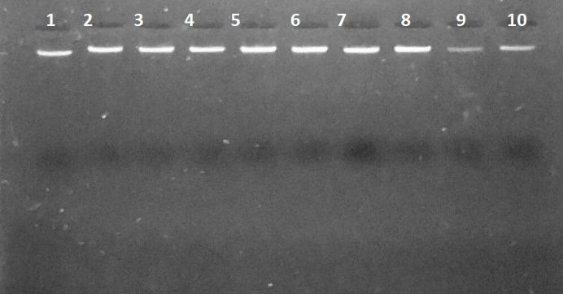
FIGURE 1. DNA bands extracted from stool samples after electrophoresis on 1% agarose gel.
The outcomes of the present research are in line with (Mozer et al.,2022)[12], with the efficiency of DNA extraction in samples amounting to 44.3. On the contrary, in the other study, extraction efficiency significantly decreased, reaching 18% (Faria et al., 2023) [13]. This inconsistency emphasizes how much variability in quality of the extracted DNA influences the quality and efficiency of molecular diagnosis of Giardia lamblia. Gdh gene gdh gene was subjected to nested PCR. During the initial reaction on gdh gene, 83 samples were analyzed, and the outcome revealed the occurrence of clear bands possessing a size of about 605 base pairs when compared with the standard size marker (DNA ladder), in 61 of the samples as depicted in Figure (2).
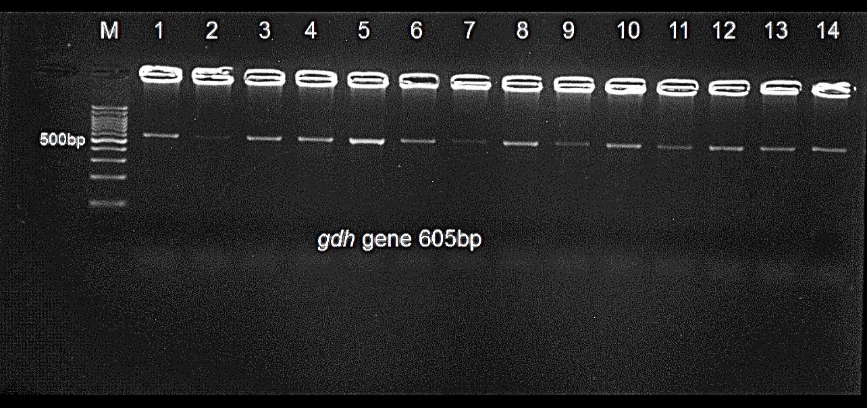
FIGURE 2. The result of the first nested PCR reaction for the gdh gene for samples (1-3-4-5-6-8-9-10-11-12-13-14) represents the positive samples with a size of approximately 605 base pairs. Electrophoresis was carried out in a 2% agarose gel with a standard size indicator of 100 base pairs. Samples (2-7) represent the negative samples.
Nested PCR for the second reaction was performed using gdh gene primers on the positive samples from the first reaction. The results showed clear bands of approximately 520 base pairs when compared with the standard size indicator (DNA ladder) in 51 samples.
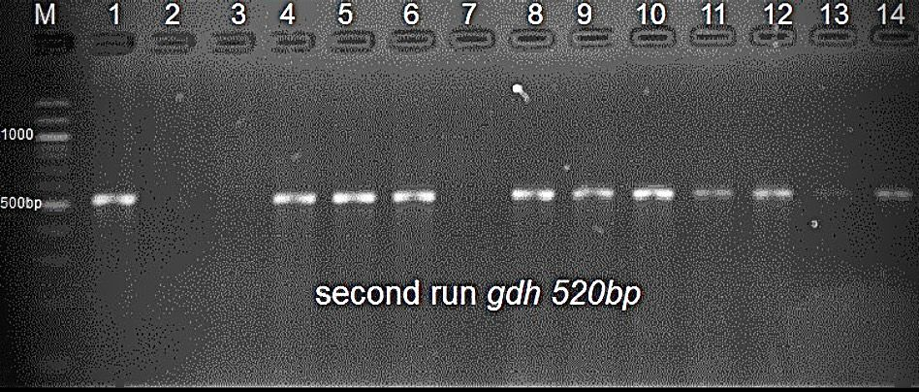
FIGURE 3. The result of the second Nested PCR reaction for the gdh gene for samples (1-3-4-5-6-8-9-10-11-12-14) represents the positive samples with a size of approximately 520 base pairs. Electrophoresis was carried out in a 2% agarose gel with a standard size indicator of 100 base pairs. As for samples (2-3-7-13), they represent the negative samples.
These results are consistent with previous studies such as (Ahmad et al., 2017) [14] which recorded detection at 57.8%. In contrast, the results contradicted those reported by (Al-Asad & Kadhum, 2018) [15] and (Mohammed, 2024) [16] which recorded higher rates using Nested PCR ranging between 70-85%. The products of the second Nested PCR reaction were subjected to enzyme digestion using RsaI to determine the genotypes of G. lamblia assemblages. The results showed that type A was represented by a main band of 250 bp, 180 bp, 160 bp, and 100 bp, and type B by a main band of 300 bp, 400 bp, and 500 bp. Some samples exhibited both bands, indicating mixed A + B infections, as shown in Figure (4).
.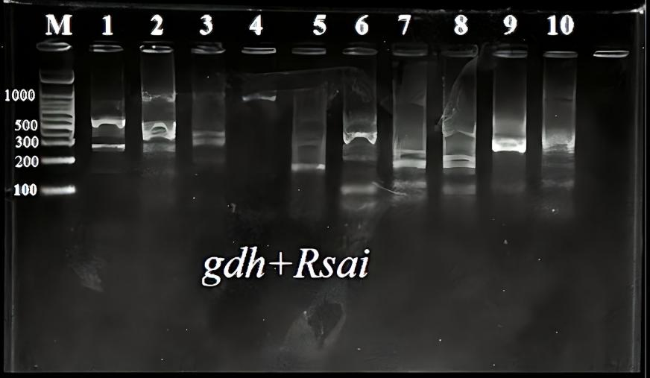
FIGURE 4. Shows from these results that (3-5) samples belong to type A, (1-2-3-10-9) samples belong to type B, while (8-7-6) samples were found to be carrying a mixed infection.
The results of the current study showed that pattern B was superior by 50.98% compared to 39.21% for pattern A, while the mixed samples were 9.8%. These results are consistent with local studies in Iraq, such as Wasit Governorate, which recorded a prevalence of type B at 78% and type A at 22% (Al-Asad & Kadhum, 2018) [15]. On the other hand, some local and international studies showed a prevalence of type A, such as Babylon Governorate, where the prevalence of type A was recorded between 61.9–71.4% compared to 28.6–38.1% for type B(Alseady et al., 2023; Idan & Al-Hasnawy, 2023) [17][18]. Mixed infection (A + B) had 9.8 percent, high levels of mixed infection were found in some of the Iraqi governorates (Dhi Qar, 62.3 and Wasit, 33.3), which means that this type of infection is common among children, and is also similar with international findings in Egypt and Brazil (Rahi and Kadhim, 2021; Hassen, 2009; Dyab et al., 2022; Faria et al., 2016) [19][20][21][22].

CONCLUSIONS
The use of a nested PCR-RFLP assay of gdh gene was successful in the study to detect and genotype the Giardia lamblia in diarrheic patients. The results confirm that nested PCR is a very potent method, which detected 51 positive cases of 100 samples, which indicates the sensitivity of the technique is higher than the method of conventional microscopy that had a 36 percent detection rate. Genotyping of the isolates found that the most common genotype was Assemblage B (50.98%), then Assemblage A (39.21%) followed by a significant proportion of mixed A+B infections (9.8%). The prevalence of Assemblage B indicates that anthroponotic (human to human) transmission is probably the main infection pathway in this population, which is not surprising by comparison with some past studies done locally. The coincidental identification of the zoonotic Assemblage A along with mixed cases emphasizes the convoluted epidemiology of giardiasis in the area, which is why molecular tools are needed to trace the sources of contamination and support effective community health measures. These findings support the increased use of molecular tools for tracking contamination sources and guiding more effective public health interventions
REFERENCES
- N. Roshidi, N. H. Mohd Hassan, A. Abdul Hadi, & N. Arifin, "Current state of infection and prevalence of giardiasis in Malaysia: a review of 20 years of research," PeerJ, 9, p. e12483, 2021.
- A. F. E. Aziz, N. Roshidi, N. Othman, K. M. Hanafiah, & N. Arifin, "Application of Proteomics to the Study of the Therapeutics and Pathogenicity of Giardia duodenalis," Diagnostics, 12(2744), pp. 1-14, 2022.
- M. K. Lynn, J. A. Morrissey, & D. F. Conserve, "Soil-transmitted helminths in the USA: a review of five common parasites and future directions for avenues of enhanced epidemiologic inquiry," Current Tropical Medicine Reports, 8, pp. 32-42, 2021.
- I. Khattak, W. L. Yen, T. Usman, N. Nasreen, A. Khan, S. Ahmad, et al., "Individual and community-level risk factors for giardiasis in children under five years of age in Pakistan: A prospective multi-regional study," Children, 10(6), p. 1087, 2023.
- Ö. O. Kilinç, A. Ayan, B. A. Çelik, Ö. Y. Çelik, N. Yüksek, G. Akyildiz, & F. E. O˘guz, "The Investigation of Giardiasis (Foodborne and Waterborne Diseases) in Buffaloes in Van Region, Türkiye: First Molecular Report of Giardia duodenalis Assemblage B from Buffaloes," Pathogens, 12(106), pp. 1-9, 2023.
- F. E. Adeyemo, "Occurrence and variations of cryptosporidium and giardia in wastewater treatment and receiving river basins," Doctoral dissertation, Durban University of Technology, 2020.
- L. C. Ferguson, A. Smith-Palmer, & C. L. Alexander, "An update on the incidence of human giardiasis in Scotland, 2011- 2018," Parasites & Vectors, 13(1), p. 291, 2020.
- X. Mu, J. Guo, H. Wang, Y. Li, K. Yuan, H. Xu, et al., "Establishment and preliminary application of PCR-RFLP genotyping method for Giardia duodenalis in goats," BMC Veterinary Research, 20(1), p. 527, 2024.
- S. Belkessa, D. Thomas-Lopez, K. Houali, F. Ghalmi, & C. R. Stensvold, "Molecular Characterization of Giardia duodenalis in Children and Adults Sampled in Algeria," Microorganisms, 9(1), p. 54, 2020.
- S. M. Caccio, M. de Giacomo, & E. Pozio, "Sequence analysis of the b-giardin gene and development of a PCR-RFLP assay to genotype Giardia duodenalis cysts from human faecal samples," International Journal for Parasitology, 32, pp. 1023–1030, 2002.
- H. K. Hasan, S. H. Eassa, & H. M. Khalid, "Prevalence of Entamoeba Histolytica and Giardia Lamblia in Children Visiting to Heevi Pediatric Hospital in Dohuk City, Kurdistan Region, Iraq," Journal of Medicinal and Chemical Sciences, 6(10), pp. 2292-2299, 2023.
- S. Mozer, I. G. Abdulwahhab, & A. F. AL-Azaawie, "Extraction of the DNA of Giardia lamblia isolated from vegetables and fruits in a simplified way and its diagnosis using Nested-PCR," Journal of Parasitic Diseases: Official Organ of the Indian Society for Parasitology, 46(3), p. 771, 2022.
- C. P. Faria, A. Pereira, D. Almeida, M. Pinto, Á. Lourenço, & M. do Céu Sousa, "Molecular investigation of ready-to-eat salads for Giardia duodenalis and Cryptosporidium spp. in Portugal," Food and Waterborne Parasitology, 30, p. e00190, 2023.
- A. A. Ahmad, A. M. El-Kady, & T. M. Hassan, "Genotyping of Giardia duodenalis in children in upper Egypt using assemblage-specific PCR technique," PloS one, 15(10), pp. 1-14, 2020.
- N. J. H. Al-Asadi, & R. W. Kadhum, "Molecular detection and genotyping of Giardia lamblia from human samples in Wasit province, Iraq," Journal of Pure and aPPlied Microbiology, 12(2), pp. 827-832, 2018.
- A. B. Mohammed, "Incidence and Molecular Detection of Genotypes for Giardia lamblia Isolated From Children in Zakho District, Duhok Province, Kurdistan Region, Iraq," Cureus, 16(8), 2024.
- H. H. Alseady, S. M. Al-Dabbagh, & A. D. Marhash, "Prevalence and molecular characterization of Giardia intestinalis isolated from children and calves in Babylon province, Iraq," Veterinary World, 16(9), p. 1781, 2023.
- S. R. Idan, & M. H. Al-Hasnawy, "Microscopic and molecular diagnoses of Giardia duodenalis in pet animals in Babylon Province, Iraq," Veterinary World, 16(11), p. 2263, 2023.
- A. Rahi, & H. Kadhim, "Prevalence of mixed infections between Giardia lamblia and Helicobacter pylori in Wasit Province, Iraq," Journal of Medical Research, 15(2), pp. 45–50, 2021.
- T. F. Hassen, "Spread of giardiasis among children in Al-Nassiria City, southern Iraq," University of Thi-Qar Journal of Science, 1(3), pp. 12–19, 2009.
- A. K. Dyab, A. A. Hassan, A. A. Abdelrahim, & A. A. Elmawgood, "Prevalence and associated risk factors for Giardia lamblia among children in Aswan University Hospitals," Journal of the Egyptian Society of Parasitology, 52(2), pp. 323–330, 2022.
- C. P. Faria, "Molecular characterization of Giardia lamblia from patients of a referral hospital of Rio de Janeiro/Brazil: application of multilocus genotyping to study the inter and intra-assemblage variations," Doctoral dissertation, Universidade de Coimbra (Portugal), 2016.

