Removal of Chlorpyrifos by Indigenous Bacteria Isolated from Pesticide-Exposed Agricultural Soils

Magaly De La Cruz-Noriega^{1, a)}, Santiago M. Benites^{1, b)} and Luis Cabanillas-Chirinos^{2, c)}

¹Vicerrectorado de Investigación, Universidad Autónoma del Perú, Lima, Perú.
²Institutos y Centros de Investigación, Universidad Cesar Vallejo, Trujillo, Perú.

^{a)} corresponding author: mdelacruzn@autonoma.edu.pe
^{b)}santiago.benites@autonoma.pe
^{c)}lcabanillas@ucv.edu.pe
Abstract. Although pesticides play a crucial role in agriculture, many of them resist biodegradation. The growing demand for food has driven the intensive use of pesticides such as chlorpyrifos, whose persistence in agricultural soils generates toxic residues that disrupt the native microbiota, threaten human health, and exacerbate environmental pollution. To address this issue, the objective of this study was to isolate, identify, and demonstrate the biotechnological potential of indigenous bacteria from pesticide-exposed agricultural soils for the removal of chlorpyrifos. Standardized microbiological methods were used for sample collection and bacterial isolation, and strain identification was performed with the VITEK 2 microbiological identification system. The results showed that Pseudomonas putida and Klebsiella oxytoca can tolerate chlorpyrifos concentrations up to 500 ppm. Moreover, P. putida exhibited a higher removal efficiency (58 %) compared to K. oxytoca (49 %). This research concludes that the indigenous strains P. putida and K. oxytoca are capable of removing chlorpyrifos, and it recommends further studies to optimize their biodegradation capacity for other pesticides.

Keywords: Agricultural soils; Pesticides; Bioremediation; Pseudomonas sp.; Klebsiella sp.

INTRODUCTION
It is estimated that global food production will need to increase by 70 to 100 % by 2050 to feed the rapidly growing population [1]. Agricultural production continually suffers from a vast array of insect pests, diseases, and weeds, causing losses that rose from approximately US $2 billion per year in the early 1960s to over US $26 billion per year in the 2010s [2]. To curb these losses and boost productivity, the use of pesticides became essential to modern agriculture, yielding an average annual crop‐yield increase of around 30 % [3–5]. However, the excessive and indiscriminate application of conventional pesticides disrupts biodiversity and soil‐microbiota function, including microorganisms beneficial to plants, leading to imbalances in biogeochemical cycles and soil fertility [6–8]. It also results in elevated pesticide residues and the development of resistance [9,10]. Although the soil microbial community degrades various contaminants to meet its energy and carbon needs, it cannot efficiently eliminate them when introduced on a large scale. Biotechnological approaches such as bioremediation can be employed to enhance these microbial activities [11]. Microorganisms can degrade complex, recalcitrant compounds through successive enzymatic reactions into simpler, harmless inorganic molecules—CO₂, oxides, mineral salts, and water. This complete elimination of pesticides is known as biomineralization [12]. The indigenous and diverse microbial community at a contaminated site can metabolize pesticides, having been under continuous stress and adapted to the intrinsic environmental conditions. A variety of these microbes—including species of Bacillus, Klebsiella, Mycobacterium, Pandoraea, Pseudomonas, Sphingomonas, Sphingopyxis, Rhodococcus, Sphingobium, and Phanerochaete chrysosporium—demonstrates their potential in the bioremediation of a wide range of pesticides to restore soil quality, and they have been widely used for pesticide bioremediation [12,13]. Chlorpyrifos is a widely used pesticide worldwide, and its extensive application has been linked to the contamination of water sources, soils, air, and non-target organisms [14]. This compound has raised both public and scientific concerns regarding food safety and environmental health because it inhibits key enzymes such as acetylcholinesterase (AChE) and butyrylcholinesterase (BChE), which play crucial roles in nervous system function. Moreover, chlorpyrifos has been shown to be potentially toxic to organisms, including humans, causing neuronal disorders, oxidative stress, DNA damage, and endocrine disruption [15–17]. As a background, Pailan et al. (2015) demonstrated that Bacillus aryabhattai tolerated organophosphorus pesticide concentrations up to 500 mg/mL of chlorpyrifos and parathion and reported a 56 % degradation of parathion within 24 h. [18]. Conversely, Zhan et al. (2018) showed that Acinetobacter baumannii strain ZH-14, isolated from sludge, could degrade 50 ppm of permethrin in 72 h. [19]. Elzakey et al. (2023) isolated three bacterial and six fungal species from northern Egyptian wastewater capable of removing chlorpyrifos residues at concentrations up to 2000 µg/L; notably, Bacillus cereus strain PC2 and Streptomyces praecox strain SP1 efficiently degraded significant amounts of chlorpyrifos [20]. Bhende et al. (2024) reported that indigenous Pseudomonas aeruginosa RNC3 and Stenotrophomonas maltophilia RNC7 strains, isolated from cotton and chili fields in India, degraded 82.5 mg L⁻¹ and 77.1 mg L⁻¹ of chlorpyrifos in five days without forming harmful byproducts [21]. More recently, Karthika &Velvizhi (2025) isolated eight bacterial strains from cultivated soils with the capacity to degrade chlorpyrifos, identifying P. aeruginosa and Pseudomonas monteilii as the most effective strains [22]. Building on these findings, the present study aimed to isolate, identify, and evaluate the biotechnological potential of indigenous bacteria from pesticide-exposed agricultural soils for the removal of chlorpyrifos, thereby offering a sustainable and environmentally friendly alternative.
MATERIAL AND METHODS
Sample Collection
A 1 kg soil sample was obtained from crop fields with a documented history of frequent pesticide use. Prior to sampling, surface vegetation was cleared, and soil was collected from a depth of 5–20 cm below the surface using spatulas, in accordance with the 2017 Technical Guide for Soil Sampling prepared by Universidad Nacional Agraria La Molina and Catholic Relief Services (CRS) [23]. All samples were labeled before being transported to the research laboratories at Universidad César Vallejo (Fig. 1).

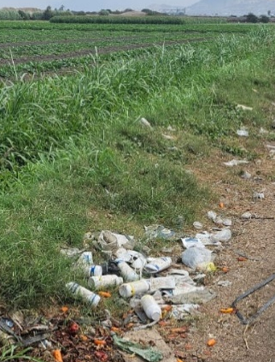 | 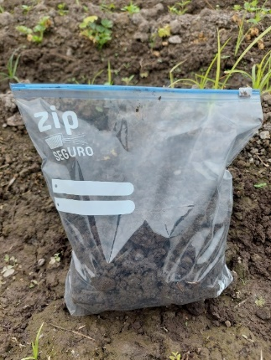
(a) | (b)
Figure 1. Sample collection. (a) Crop fields with excessive insecticide use; (b) Soil sample collected for transport to the laboratory.

Sample Pretreatment
Soil samples were sieved using a N°. 10 mesh sieve (Ø 2 mm opening). Twenty-five grams of sieved soil were inoculated into flasks containing 225 mL of sterile nutrient broth (NB) pre-amended with the pesticide TIFON 4E (480 g/L chlorpyrifos; FARMAGRO) [24] to reach a final concentration of 50 ppm. The inoculated flasks were incubated at 32 °C with shaking (100 rpm) for 24 hours.
Isolation and Identification of Chlorpyrifos-Resistant Bacteria
For bacterial isolation, the surface‐plating method was used. One hundred µL of each soil extract was spread across the surface of nutrient agar (NA) plates supplemented with TIFON 4E (480 g/L chlorpyrifos) at final concentrations of 50, 100, 250, 500, and 750 ppm. The plates were incubated at 36°C for 24 h, and colony formation was then recorded [25]. Colonies demonstrating growth on pesticide‐amended media were aseptically transferred to slants of NA to establish axenic cultures for further analysis. Bacterial identification was carried out using the VITEK2 Compact microbiological identification system, which can discriminate bacterial species with up to 99 % specificity [26]. Only those isolates capable of growing at the highest chlorpyrifos concentration were selected for identification in this study.
Experimental Setup for Chlorpyrifos Removal
Experiments were performed in triplicate using 750 mL bioreactors. Each reactor contained 450 mL of minimal salts medium (MSM) supplemented with 1 % glucose and pre-amended with TIFON 4E (480 g/L chlorpyrifos) to a final concentration of 500 ppm.
A bacterial suspension adjusted to 0.5 turbidity units (equivalent to 1.5 × 10⁸ CFU/mL), as measured with a DESICHEK Plus, was inoculated (50 mL) into each reactor. Reactors were maintained at 23–25 °C with agitation at 100 rpm for 96 hours.
Chlorpyrifos Quantification by UV-Vis Spectroscopy
A 10 mL aliquot was withdrawn from each bioreactor and centrifuged at 600 rpm for 5 minutes at 4 °C using an MPW 352R refrigerated centrifuge. One milliliter of the supernatant was mixed with 1 mL acetonitrile, vortexed, and immediately measured for absorbance at 290 nm on a Jenway™ 6305 UV/Vis spectrophotometer [27,28].
The percentage removal of chlorpyrifos was calculated using the following formula:

$$\begin{aligned}\left[ \frac{A_{T0}-A_{TX}}{A_{T0}}\right]x 100\#\left(1\right)\end{aligned}$$
Where:
AT₀ = absorbance at time zero (0 h)
ATₓ = absorbance at specified times (6, 24, and 96 h)
RESULTS AND DISCUSSION
Although pesticides play a crucial role in agriculture, many are resistant to biodegradation, and their extensive use—along with the toxic residues they produce—has exacerbated environmental pollution. Biodegradation studies aim to characterize the microbial diversity in areas contaminated by various xenobiotics, with the goal of identifying versatile indigenous bacteria capable of degrading a wide range of pollutants. Microorganisms require macroelements to synthesize the biomolecules necessary for growth and development through catabolic and cometabolic processes. Numerous studies have documented that organochlorine and organophosphate pesticides can be degraded via both catabolism and cometabolism [29–31]. The bacterial isolates obtained in this research (see Figure 2) demonstrated the capacity to degrade chlorpyrifos, as evidenced by our isolation procedures and experimental assays. Chlorpyrifos degradation involves multiple enzymatic steps, including the hydrolytic activities of esterases, phosphatases, and organophosphate hydrolases. These enzymes catalyze the conversion of chlorpyrifos into non-toxic end products such as carbon dioxide and water, thereby mitigating its adverse effects [32,33]. In other studies, Bacillus cereus and other Bacillus species isolated from agricultural soils were optimized via response surface methodology, achieving up to 89 % degradation under ideal conditions (neutral pH, 32 °C, and controlled agitation) [34,35].
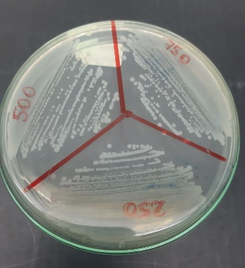 A 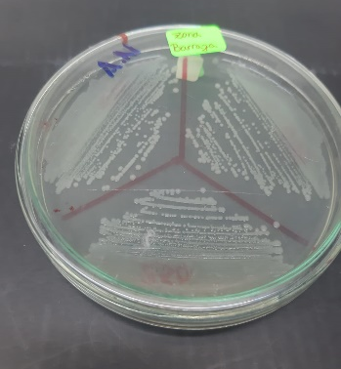B
Figure 2. Bacterial growth on nutrient agar plates containing TIFON 4E at 250, 500, and 750 ppm. (A) Front view of the NA plate; (B) Back view of the NA plate.

Table 1 presents the bacterial species identified from insecticide-contaminated agricultural soils that were able to grow in the presence of 500 ppm of the pesticide.

Table 1. Bacteria capable of growth at different concentrations of TIFON 4E.
TIFON 4E [ppm] | N° of Isolated Colonies | Identified Bacteria
300 | 03 | Escherichia coli,  Pseudomonas putida,  Klebsiella oxytoca
500 | 02 | Pseudomonas putida,  Klebsiella oxytoca
750 | 00 | Ausencia de colonias

Most studies on the degradation of organochlorine and organophosphate pesticides have reported the presence of bacteria, notably species of the genera Bacillus, Pseudomonas, and Serratia [36,37]. In addition, Asamba et al. (2022) demonstrated chlorpyrifos degradation by species of Pseudomonas, Bacillus, Alicaligenes, Stenotrophomonas, and Acromobacter [25], while Kumar et al. (2018) identified species of Flavobacterium, Arthrobacter, Enterobacter, Klebsiella, and Sphingomonas [37]. Other research highlights the potential of fungi to degrade chlorpyrifos, particularly species of the genera Acremonium, Aspergillus, Fusarium, Mucor, Penicillium, and Trichoderma [30]. The bacterial species presented in Table 1 align with previous findings reporting the isolation of Pseudomonas and Klebsiella species capable of degrading chlorpyrifos.

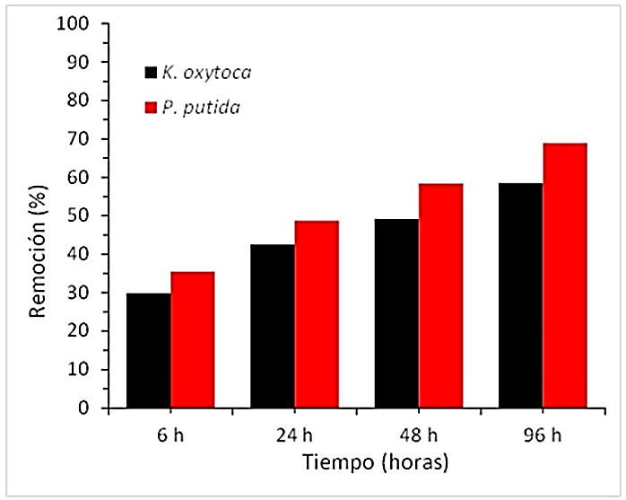
Figure 3. Removal capacity of chlorpyrifos using K. oxytoca and P. putida isolated from pesticide-exposed agricultural soils.

Chlorpyrifos is a widely used pesticide and has a reported half-life in agricultural soils of 60 to 120 days, although it can persist for up to four years depending on climatic conditions and soil type [38]. Conventional methods for removing most organochlorine and organophosphate pesticides rely on chemical processes such as pyrolysis, incineration, and landfill disposal; however, these approaches can produce harmful by-products and are both costly and inefficient [35]. Soil bioremediation using microorganisms offers an alternative to expensive conventional methods, as various microbes can degrade a wide range of xenobiotic contaminants, restoring soil quality more efficiently and sustainably.
The results shown in Figure 3 indicate that after 48 hours of incubation, chlorpyrifos concentrations in the bioreactors were reduced by approximately 50 %. Pseudomonas putida exhibited a higher removal efficiency (58 %) compared with Klebsiella oxytoca (49 %). These findings align with Briceño et al. (2020), who reported 28–42 % removal of chlorpyrifos by Pseudomonas sp. after 120 hours of incubation [39]. Similarly, Akbar et al. (2016) achieved 76–84 % removal using Achromobacter xylosoxidans over 8–20 days [40] and Huang et al. (2021) observed 65 % degradation in 20 days with a bacterial consortium (P. putida, Klebsiella sp., P. stutzeri, and P. aeruginosa) in medium containing 500 mg/L of chlorpyrifos [41].
Compared with other bioremediation studies employing indigenous isolates, our system could likely have exceeded 90 % removal if monitored over 10–20 days. For instance, Shabbir et al. (2018) demonstrated that P. aeruginosa, Enterobacter ludwigii, and Enterobacter cloacae removed 90 % of chlorpyrifos within three days at neutral pH and 37 °C [27]. Asamba et al. (2022) reported removal rates of 87 %, 82 %, 89 %, and 91 % for Lysinibacillus sp., Stenotrophomonas maltophilia, P. putida, and Archromobacter insuavis, respectively, using isolates from dairy farm soils [25]. Farhan et al. (2021) found that Bacillus cereus from cotton‐field soils degraded 88 % of chlorpyrifos in eight days under alkaline conditions (pH 8) at 30–40 °C [42] and Elshikh et al. (2022) showed that B. cereus and Klebsiella pneumoniae from municipal soils achieved 94.5 % removal after 16 days [46].
CONCLUSIONS AND RECOMMANDATIONS
This study confirms that, despite its agronomic benefits, chlorpyrifos poses a significant environmental and public‐health risk due to its high persistence in soil and chronic toxicity. Furthermore, research on indigenous bacteria has emerged as a promising tool for chlorpyrifos removal in pesticide‐exposed agricultural settings: these microorganisms naturally inhabit specific ecosystems and, by adapting to local conditions, can drive in situ bioremediation and environmental restoration.
The adaptability of native bacterial strains to pesticide‐induced stress in contaminated soils makes them ideal candidates for field applications, reducing reliance on expensive and often damaging chemical treatments. Collectively, these findings highlight the potential of indigenous bacteria not only to eliminate chlorpyrifos but also to degrade other recalcitrant pesticides, offering a more sustainable and ecofriendly solution.
In this work, we isolated indigenous bacterial strains capable of tolerating chlorpyrifos concentrations up to 500 ppm and of utilizing the pesticide as a carbon or phosphorus source. Among the isolates, Pseudomonas putida stood out, achieving 58 % removal in just 48 hours surpassing the 49 % removal by Klebsiella oxytoca under identical laboratory conditions. This biodegradation capacity is attributed to the hydrolytic action of enzymes such as esterases, phosphatases, and organophosphate hydrolases, which convert chlorpyrifos into carbon dioxide, mineral salts, and water.
To advance the effective implementation of these biotechnological solutions, it is first essential to scale up and validate the findings under real field conditions. This requires designing pilot trials in representative agricultural plots where not only the efficacy of Pseudomonas putida and Klebsiella oxytoca can be assessed across varying climatic conditions and heterogeneous soil types, but also the behavior of key soil‐quality indicators pH, organic‐matter content, and microbial‐population dynamics—during and after treatment. Concurrently, microbial consortia should be optimized to enhance degradation rates and broaden the spectrum of target pesticides. This entails investigating mixtures of complementary strains and leveraging synthetic‐biology tools or laboratory adaptive‐evolution strategies to strengthen bacterial tolerance and maximize the activity of their hydrolytic enzymes.
In parallel, it is critical to characterize in detail the enzymes involved esterases, phosphatases, and organophosphate hydrolases by purifying them, determining their kinetic parameters, and defining their optimal temperature and pH ranges. Omics approaches such as metagenomics and transcriptomics will also enable the identification of additional metabolic pathways and genetic regulators that could further enhance biodegradation. Rigorous monitoring of intermediate by-products will ensure that no toxic or persistent compounds are formed, while ecotoxicological tests on local fauna and flora before and after application will guarantee the safety of the bioremediation process.
Finally, integrating microbial bioremediation into regulatory frameworks alongside a thorough cost–benefit and social-impact analysis will encourage its widespread adoption, support more responsible pesticide management, protect human health, and foster the sustainable restoration of soil fertility.
REFERENCES
- W. P. Falcon, R. L. Naylor, and N. D. Shankar, Population Dev. Rev. 48, 921–957 (2022).
- R. Crystal‑Ornelas, E. J. Hudgins, R. N. Cuthbert, P. J. Haubrock, J. Fantle‑Lepczyk, E. Angulo, A. M. Kramer, L. Ballesteros‑Mejía, B. Leroy, B. Leung, E. López‑López, C. Diagne, and F. Courchamp, NeoBiota 67, 485–510 (2021).
- M. Zhao, H. Zhou, L. Hao, H. Chen, and X. Zhou, Carbohydr. Polym. 259, 117749 (2021).
- E. Fortunati, A. Mazzaglia, and G. M. Balestra, J. Sci. Food Agric. 99, 986–1000 (2019).
- T. C. Sparks and R. J. Bryant, Pest Manag. Sci. 77, 3608–3616 (2021).
- H. K. Patel, R. K. Kalaria, D. K. Vasava, and H. N. Bhalani, in Biotechnological Innovations for Environmental Bioremediation, 53–82 (Springer Nature Singapore, 2022).
- P. Chávez‑Ortiz, Y. Tapia‑Torres, J. Larsen, and F. García‑Oliva, Appl. Soil Ecol. 169, 104256 (2022).
- A. Mandal, B. Sarkar, S. Mandal, M. Vithanage, A. K. Patra, and M. C. Manna, in Agrochemicals Detection, Treatment and Remediation, 161–187 (Elsevier, 2020).
- N. Wang, M. Huang, X. Guo, and P. Lin, Environ. Sci. Technol. 50, 9627–9635 (2016).
- P. Bakshi, A. D. Singh, J. Kour, S. Jan, M. Ibrahim, B. A. Mir, and R. Bhardwaj, in Handbook of Assisted and Amendment: Enhanced Sustainable Remediation Technology, 331–353 (Wiley, 2021).
- Y. Yang, R. P. Singh, D. Song, Q. Chen, X. Zheng, C. Zhang, M. Zhang, and Y. Li, Ecotoxicol. Environ. Saf. 188, 109826 (2020).
- G. Odukkathil and N. Vasudevan, Rev. Environ. Sci. Bio/Technol. 12, 421–444 (2013).
- M. A. Kaminski, A. Sobczak, A. Dziembowski, and L. Lipinski, Genes 10, 688 (2019).
- M. A. Torres Gutierrez, K. A. Pozo Gallardo, and V. M. Díaz García, Entre Ciencia e Ingenieria 15, 9–21 (2021).
- P. Chawla, R. Kaushik, V. J. Shiva Swaraj, and N. Kumar, Environ. Nanotechnol. Monit. Manage. 10, 292–307 (2018).
- A. L. Rathod and R. K. Garg, J. Forensic Legal Med. 47, 29–34 (2017).
- M. A. Dar, G. Kaushik, and J. F. Villarreal‑Chiu, J. Environ. Manage. 239, 124–136 (2019).
- S. Pailan, D. Gupta, S. Apte, S. Krishnamurthi, and P. Saha, Int. Biodeterior. Biodegrad. 103, 191–195 (2015).
- H. Zhan, H. Wang, L. Liao, Y. Feng, X. Fan, L. Zhang, and S. Chen, Front. Microbiol. 9, 98 (2018).
- E. M. Elzakey, S. M. El‑Sabbagh, E. E.‑S. N. Eldeen, I. A.‑A. Adss, and A. M. K. Nassar, Environ. Monit. Assess. 195, 779 (2023).
- R. S. Bhende, S. Bombaywala, and N. A. Dafale, J. Hazard. Mater. 461, 132668 (2024).
- G. Karthika and S. Velvizhi, Bioremediation J., 1–14 (2025).
- R. B. Mendoza and A. Espinoza, Guía Técnica para Muestreo de Suelos, https://repositorio.una.edu.ni/3613/1/P33M539.pdf (2017).
- FARMAGRO S.A., Ficha técnica TIFON MAX, https://farmagro.nyc3.digitaloceanspaces.com (2024).
- M. N. Asamba, E. N. Mugendi, P. S. Oshule, S. Essuman, L. M. Chimbevo, and N. A. Atego, Heliyon 8, e09176 (2022).
- S. Duggal, R. Gaind, N. Tandon, M. Deb, and T. D. Chugh, ISRN Microbiol. 2012, 107203 (2012).
- M. Shabbir, M. Singh, S. Maiti, S. Kumar, and S. K. Saha, Bioresour. Technol. 263, 280–288 (2018).
- B. K. Singh, A. Walker, J. A. W. Morgan, and D. J. Wright, Appl. Environ. Microbiol. 70, 4855–4863 (2004).
- B. K. Singh and A. Walker, FEMS Microbiol. Rev. 30, 428–471 (2006).
- J. L. Hernández Castellanos, R. Cuervo González, J. L. Montañez Soto, N. D. Hernández Castellanos, M. A. Pérez Vargas, A. Cruz Hernández, and L. Chaires Martínez, Rev. Int. Contam. Ambient. (2021).
- Z. Chishti, S. Hussain, K. R. Arshad, A. Khalid, and M. Arshad, J. Environ. Manage. 114, 372–380 (2013).
- A. R. Nandhini, M. Harshiny, and S. N. Gummadi, Environ. Sci.: Processes Impacts 23, 1255–1277 (2021).
- R. S. Bhende, U. Jhariya, S. Srivastava, S. Bombaywala, S. Das, and N. A. Dafale, Appl. Biochem. Biotechnol. 194, 2301–2335 (2022).
- K. Duraisamy, S. Muthusamy, and S. Balakrishnan, Biocatal. Agric. Biotechnol. 13, 283–290 (2018).

- T. Saengsanga and N. Phakratok, Plant Soil Environ. 69, 210–220 (2023).
- M. Cycoń and Z. Piotrowska‑Seget, Front. Microbiol. 7, 1463 (2016).
- S. Kumar, G. Kaushik, M. A. Dar, S. Nimesh, U. J. López‑Chuken, and J. F. Villarreal‑Chiu, Pedosphere 28, 190–208 (2018).
- S. Y. Gebremariam, M. W. Beutel, D. R. Yonge, M. Flury, and J. B. Harsh, Rev. Environ. Contam. Toxicol. 215, 123–175 (2012).
- G. Briceño, C. Lamilla, B. Leiva, M. Levio, P. Donoso‑Piñol, H. Schalchli, F. Gallardo, and M. C. Diez, PLoS One 15, e0234865 (2020).
- S. Akbar and S. Sultan, Braz. J. Microbiol. 47, 563–570 (2016).
- Y. Huang, W. Zhang, S. Pang, J. Chen, P. Bhatt, S. Mishra, and S. Chen, Environ. Res. 194, 110660 (2021).
- M. Farhan, M. Ahmad, A. Kanwal, Z. A. Butt, Q. F. Khan, S. A. Raza, H. Qayyum, and A. Wahid, Sci. Rep. 11, 10320 (2021).
- M. S. Elshikh, K. M. Alarjani, D. S. Huessien, H. A. M. Elnahas, and A. R. Esther, Environ. Res. 205, 112438 (2022).

