Evaluation of Uranium Levels in Dental Amalgam Fillings Using Neutron Activation Analysis Technology
Omar Abdul^{1, a)} and Sameera A. E.^{1, b)}
¹Department of Physics, College of Ibn Al-Haytham, University of Baghdad, Baghdad, Iraq
^{a)} Corresponding author: omar.Abd1204a@ihcoedu.uobaghdad.edu.iq
^{b)} sameera.a.i@ihcoedu.uobaghdad.edu.iq

Abstract. In this pilot study, we calculated uranium concentrations, equivalent and absorbed doses, and radiological hazard coefficients for ten samples of metal amalgam fillings. These contained mercury at levels ranging from 50 to 60%, while the remaining contents included zinc, tin, silver, and copper, in varying proportions from one manufacturer to another. These samples were collected from various locations in Iraq, from government hospitals or authorized dealers, specifically from Baghdad, using neutron activation technology and a CR-39 solid-state path detector. The samples were ground, pressed into 1.5 cm diameter disc molds, placed on top of the detector pieces, and secured with adhesive tape. They were then exposed to a neutron flux inside an americium beryllium accelerator for seven days at a neutron flux rate of 10⁵ nm cm² s⁻¹ and a neutron flux of 6.048 × 10¹⁰ nm cm. Next, the chemical etching phase was carried out, and the effects were calculated manually using an optical microscope and also using computer images. The results showed uranium concentrations ranging between 3.10 ± 0.74 and 5.41 ± 0.84 ppm for the fifth and seventh samples, respectively, and effective doses ranging between 0.32 and 0.56 mSv/y for the same samples. In other words, the uranium concentration and effective doses were lowest for sample five and highest for sample seven, as shown in the research input table. Our results demonstrate that uranium is still used today, albeit in very small quantities, in the composition of these fillings, despite its ban in the 1980s. However, its radiation doses are still within the limits permitted by the International Atomic Energy Agency and the World Health Organization. Therefore, people with amalgam fillings are exposed to higher radiation doses than others, meaning they have received almost half of the permitted doses. In addition, the study was on one gram per sample, so the increase in weight means an increase in the effective dose received.
Keywords. amalgam, neutron activation, CR-39 detector, etching, uranium concentration.

INTRODUCTION
Radiation resulting from the decay of heavy elements is one of the most important radioactive pollutants affecting the living cells of all organisms. In the field of restorative dentistry, an American patent was issued in 1942[1] to add uranium to these materials to give them a cosmetic appearance and durability. This situation continued until the early eighties, when studies showed risks and warnings regarding their use. Consequently, the American Dental Association issued Standard 52 in 1979[2], [3], [4], which includes reducing the percentage of uranium in dental restorative materials, including fillings and manufacturing materials. These materials still contain, albeit small, percentages of uranium impurities, which is natural. For this reason, we conducted this study to determine the percentage of natural uranium present in amalgam fillings in ten companies from different origins, using neutron activation technology and the CR-39 solid detector, due to its advantages such as sensitivity and high efficiency in detecting the effects of alpha particles. We conducted mathematical calculations using approved equations to calculate the risk factor and procedures. Absorbent and equivalent, and finally discuss the construction risks of these materials and whether they are within the permissible limits or not [5][6]. The Dental Filling Materials are the compounds and elements used in the field of restorative dentistry to repair caries, erosion, and minor fractures in the teeth. either fillings that penetrate the teeth and take the place of caries after their removal or replace a missing part of a tooth, i.e., cosmetic. The need for dental restoration appeared thousands of years ago, as a group of molars dating back to one hundred thousand years ago were discovered. Fillings made of beeswax were found in Italy 650 years ago. Recently, in the nineteenth century, pure metals were used in the process of filling dental cavities, such as gold, silver, and tin. With the advancement of science, a mixture of metals with mercury called amalgam was developed, which remains the most common filling to date, despite surrounding risks and warnings. However, it became popular due to its effectiveness, durability, and cheapness. However, its metallic colour encouraged scientists to search for compounds with properties close to amalgam and with a more aesthetic appearance. They have come up with a group of fillings, including ceramic, resin composites, and glass ionomers. Research is still ongoing to find materials with higher properties and a natural Aesthetic [7], [8]. And the material we studied is Amalgam, the word amalgam in Greek means soft mass, it most important and most common type of filling is a metal alloy, the main element of which is mercury at a rate of about 50 per cent, and the rest of the components are metals whose percentages may vary and are not fixed (lead - zinc - silver – tin). The oldest type is the silver alloy, and it is still commonly used to this day. The old types were made of tin and silver in China from 618 A.D. during the reign of the ruling Tang Dynasty. The composition of the amalgam was published by Liu Wentai, where the recipe indicated that he used 45 parts of silver, 100 parts of mercury, and 900 parts of tin. Because mercury is the most toxic substance, its circulation was banned, and a great uproar was raised around it. In 1844[4], the American Association of Dental Surgeons issued a document banning its use and circulation, and the Regional Dental Association and the St. Louis Association joined it. Amalgam fillings were called plastic fillings at the time. The battle against amalgam intensified when it caused the death of a middle-aged man in Nebraska. The death certificate stated that the filling had caused swelling and oedema of the mouth and windpipe and blocked the airway. The tooth being restored was a second molar in the lower jaw. Another patient died after having eight fillings[8], [9]. The technology used is Neutron activation analysis technique it is one of the most important nuclear techniques used for the quantitative and qualitative determination of inorganic elements present in a specific sample. One of its most important features is that it is a non-destructive technique that takes a very small part of the sample and exposes it to neutrons, and thus it will be excited. Hence, the name activation, i.e., the excitement of the nucleus as a result of absorbing neutrons, does not take into account the chemical structure. Thus, it has found solutions to existing problems, such as valuable and rare samples, such as ancient artefacts and works of art that are feared to be damaged after irradiating the elements. The nuclei are excited and emit radiation. By studying the paths of radioactive decay, as the elements are transformed into their artificial isotopes, and each isotope has a distinctive gamma radiation that has its own characteristics, such as the fingerprint in humans, the concentrations of the elements within these samples can be determined. It has types that have developed according to increasing needs, such as INAA, which is done directly on the samples, and RNAA, which is preceded by a chemical purification process. This technique only requires 50 milligrams of any sample to perform neutron activation[10] [7] . CR-39 detector is one of the types of transparent solid polymers. One of its unique features is that it leaves a cone-like trace when nuclear particles penetrate, as it converts their energy into a tangible trace. It is considered one of the most efficient methods for detecting radiation and knowing the concentrations of heavy elements, as it is inexpensive compared to other methods and sensitive to the lowest energy of particles. As for its mechanism of operation, the sample containing the radioactive element is placed in close proximity, or when studying places or gases and people[8], [11], it is placed in the open air, but for long periods. After that, it is chemically etched using an alkaline solution, usually sodium hydroxide. After this process, we can observe the traces through a traditional light microscope, and using a simple equation, we can reach the density of these traces and thus know the concentration of heavy elements. The chemical structure of this polymer CH2=CH-CH2-O-CO-O-CH2CH2-O-CH2CH2-O-CO-O-CH2-CH=CH2 [9] [12], [13], [14].

METHOD AND MATERIAL

Samples

We collected ten samples of amalgam fillings from different locations, as shown in the attached samples were from a different company as in table 1, in order to identify the differences in the uranium ratios included in the composition of these materials. Each sample included ten capsules to ensure their sufficiency when working on them in the laboratory.
Table 1. Research samples by origin, company, and location.

Sample no. | Manufacturer | Origin | Sample collection location
 | Zhengzhou Linker Medical Equipment Co. | China | Anbar Governorate / Fallujah / Specialized Dental Center
 | Foshan SCS Medical Instrument Co. | China | Baghdad Governorate / Bab Al-Muadham / Al-Qimmah Al-Samiah Company for Dental Supplies
 | Kerr Dental | Australian | Baghdad Governorate / Bab Al-Muadham / Al-Qimmah Al-Samiah Company for Dental Supplies
 | VOCO | Germany | Iraq/Baghdad/Bab Al-Muadham/High Summit Office for Dental Supplies
 | Cavex Avalloy | Netherlands | Baghdad Governorate / Bab Al-Muadham / Al-Qimmah Al-Samiah Company for Dental Supplies
 | Cavex Avalloy II | Netherlands | Baghdad Governorate / Bab Al-Muadham / Al-Qimmah Al-Samiah Company for Dental Supplies
 | Wykalloy | U.S.A | Baghdad Governorate / Bab Al-Muadham / Al-Qimmah Al-Samiah Company for Dental Supplies
 | IVOCLAR VIVADENT | U.S.A | Anbar Governorate / Fallujah / Specialized Dental Center
 | Nu alloy | Colombia | Baghdad Governorate / Bab Al-Muadham / Al-Qimmah Al-Samiah Company for Dental Supplies
 | Vivid Alloy | Italy | Baghdad Governorate / Bab Al-Muadham / Al-Qimmah Al-Samiah Company for Dental Supplies

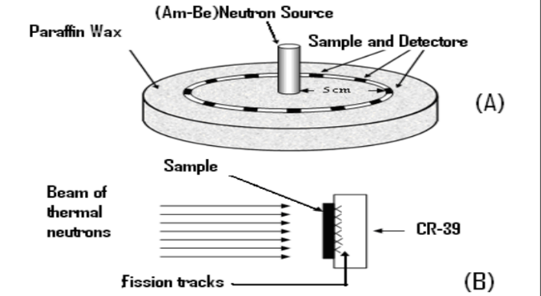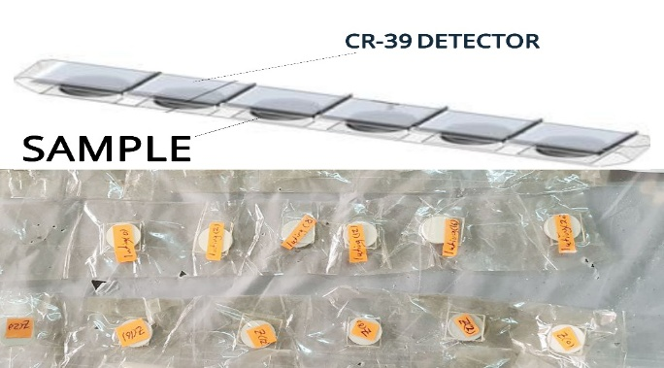
a. | b.
Figure 1. a. The irradiation of the detectors and samples by the neutron source, b. pellets are covered with (CR-39)
detector

The first step was to mix each filling using a specialized amalgamator to ensure the homogeneity of the filling materials and their hardening. After that, we crushed and ground them using a German-made electric grinder and a hand grinder to ensure the smoothness and small size of the particles, which we then sieved using a laboratory sieve with an opening diameter of 250 micrometers. Then, the samples, which were transformed into a fine powder, were pressed using a hydraulic press in a special mould with a diameter of one and a half centimeters and a weight of one gram, which included the addition of 0.2 grams of starch to ensure the consistency of the sample after that and not to disintegrate. Then, the samples were placed on C-39 solid trace detector pieces, as for the CR-39 detector, it was calibrated by subtracting the external contamination present in the laboratory, i.e., the workplace, where eight detectors were placed in various locations for ten days. Then, chemical etching was carried out, and the average readings of the traces representing the emitted alpha particles were taken. The average readings were 19, so this number was subtracted from all the readings. which were cut with dimensions of 1.5 x 1.5 centimeters in the form of a strip as in figure 1 a. We put it in the radioactive material for seven days in our college lab as in b. figure1, and the next step was to take out the samples and wash them with distilled water and then carry out the etching process on the detector pieces using a sodium hydroxide solution at a temperature of 60 C⁰ in a special device for three hours. The samples were taken and washed well and dried and they were read on the light microscope at a rate of ten readings for each sample for the traces that resulted due to the presence of the uranium element in the samples. Then we calculated the number of these traces and their average for each sample and we subtracted the number of traces that were formed on the zero-trace detector in the lab and thus we obtained the concentration of these traces and through equations we calculated the concentration of uranium in these samples and the specific effectiveness and the hazard index and the specific dose and the equivalent dose and the effective dose as follows

CALCULATIONS

First, we need the slope. The slope used in the equation represents the axis of the practical part. The way we get it is as follows: preparing six samples of amalgam from one sample randomly. Five samples are added to the uranium acetate solution with a known concentration, which is mentioned in the table. As for the last sample, it is zero, meaning no uranium is added to it, only raw amalgam. Then we put it in an oven to dry it. After we dried it, we took it out and ground it again. Then we pressed it into moulds and stuck the resulting discs on the face of the detector and entered them into the irradiator in the laboratory like the rest of the samples. This step is considered the first step in the practical part, which is included in equation 3 for calculating the concentration of uranium. We obtain it from the standard samples in Figure 2, by using data in Table 2, which we prepared by mixing the uranium acetate solution, according to the concentrations mentioned in the table. Using the graph, we extracted the slope, which is included in the equation for calculating the concentration and density [15] [16] [17].
$\frac{C_{x}}{C_{s}}= \frac{ρ_{x}}{ρ_{s}} \frac{I_{s}}{I_{x}} \frac{R_{s}}{R_{x}}$ (1)
$C_{x}= \frac{c_{s}}{ρ_{s}} ρ_{x} \frac{I_{s}}{I_{x}} \frac{R_{s}}{R_{x}}$ (2)
$C_{x}= \frac{ρ_{x}}{slope} \frac{I_{s}}{I_{x}} \frac{R_{s}}{R_{x}}$ (3)
C_{x} = Uranium concentration for unknown samples, C_{s} = Uranium concentration for standard samples, $ρ$_{x} = The density of the effects of the unknown models is represented, $ρ$_{s} = The density of the effects of the standard models is represented, R_{x,} R_{s} = The range of the fragments is approximately equal to one. For this value, it is equal to one because it represents the average range of fission fragments in the known standard and unknown samples, and they are almost equal, so the quotient is one

I_{x} = Isotopic abundances of uranium-235 and uranium-238 Content on depleted uranium for unknown samples

I_{s} = Isotopic abundances of uranium-235 and uranium-238 containing natural uranium for standard samples
$I_{x}= \frac{{238}_{U }}{{235}_{U}}= \frac{99.27}{0.201}=495.25$ (4)
$I_{s}= \frac{{238}_{U }}{{235}_{U}}= \frac{99.27}{0.72}=137.87$ (5)
C_{x}(ppm) =$\frac{ρ_{x}}{ slope} ×0.278$ (6)
$ρ_{x}=\frac{N_{ave}}{A}$ (7)

N_{ave}= The rate of quantitative effects within the area., A = area =0.0676 mm²
D_{Ti} = 1.6 x 10⁻¹⁰ ×S. A × E_{r} (8)
H_{Ti} = D_{Ti} × W_{R} (9)
E_{Ti} = $Σ$ W_{Ti} × H_{Ti} (10)
H_{ex} = $\frac{{(S.A )238}_{U}}{185}≤1$ (11)

(S.A) = specific activity Bq/kg, (Hex) = Hazard index, D_{Ti}=Absorbed dose (mGy/y), H_{Ti} =The Equivalent Dose,

E_{Ti} = effective doses (mSv/y)
Table .2 Symbols used in equations and their values
The symbol | Meaning | value
E [18] | Alpha Energy | 4.2 MeV
W_{R} [19] | Alpha Radiation Weighting Factor | 20
W_{Ti} [19] | skin, bone surface Weighting Factor | 0.01

Table .3 Standard amalgam sample data
Uranium concentration (C_{x})ppm | traces density ($ρ$) | Traces average | Net traces
0 | 488 | 52 | 33
2 | 1065 | 91 | 72
8 | 1080 | 92 | 73
12 | 1168 | 98 | 79
16 | 1701 | 134 | 115
20 | 1980 | 153 | 134

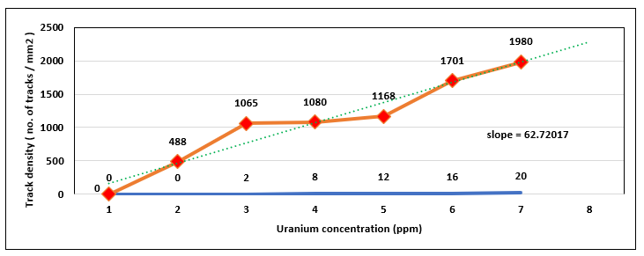
Figure .2 Relationship of trace density with uranium concentration for the standard models amalgam filling

Using equation 6 we were able to calculate the concentration of uranium in the samples and equation 7 was used to calculate the density, as shown in table 4
Table .4 Rate and density of traces and uranium concentrations
Amalgam sample | Traces average | Net traces | traces density ($ρ$) | Uranium concentration (C_{x})  ppm
 | 70 | 51 | 758.66±277.89 | 3.36±1.23
 | 77 | 58 | 857.98±200.47 | 3.80±0.88
 | 84 | 65 | 959.42±191.43 | 4.25±0.84
 | 85 | 66 | 974.21±153.12 | 4.31±0.67
 | 66 | 47 | 701.60±168.63 | 3.10±0.74
 | 70 | 51 | 760.77±301.09 | 3.37±1.33
 | 102 | 83 | 1221.47±191.52 | 5.41±0.84
 | 87 | 68 | 1008.03±332.03 | 4.46±1.47
 | 97 | 78 | 1151.73±327.39 | 5.10±1.45
 | 71 | 52 | 767.11±164.60 | 3.40±0.72

And using equation 11 we were able to calculate the Hazard index and equation 8 to calculate Absorbed dose, equation 9 to calculate The Equivalent Dose and equation 10 to calculate effective doses as shown in table 4

Table .5 Specific activity, sustained dose, equivalent dose, absorbed dose, reward, effective dose, and Hazard index

Amalgam sample | specific activity (S.A) Bq/kg | Hazard index (H_{ex}) | Absorbed dose (mGy/y)  D_{Ti} |  | The Equivalent Dose  (H_{Ti}) | effective doses (mSv/y) For bone and skin surfaces  (E_{Ti})
 | 41.52±15.21 | 0.22 | 0.87 |  | 17.34 | 0.35
 | 46.96±10.97 | 0.25 | 0.98 |  | 19.61 | 0.39
 | 52.51±10.47 | 0.28 | 1.10 |  | 21.93 | 0.44
 | 53.32±8.38 | 0.29 | 1.11 |  | 22.26 | 0.45
 | 38.40±9.23 | 0.21 | 0.80 |  | 16.03 | 0.32
 | 41.64±16.48 | 0.23 | 0.87 |  | 17.39 | 0.35
 | 66.86±10.48 | 0.36 | 1.40 |  | 27.91 | 0.56
 | 55.17±18.17 | 0.30 | 1.15 |  | 23.04 | 0.46
 | 63.04±17.92 | 0.34 | 1.32 |  | 26.32 | 0.53
 | 41.99±9.01 | 0.23 | 0.88 |  | 17.53 | 0.35
a. |  |  |  | b.
Figure .3 a. The Equivalent Dose (H_{Ti}) chart in amalgam filling sample, b. chart in amalgam filling sample Hazard index (H_{ex})

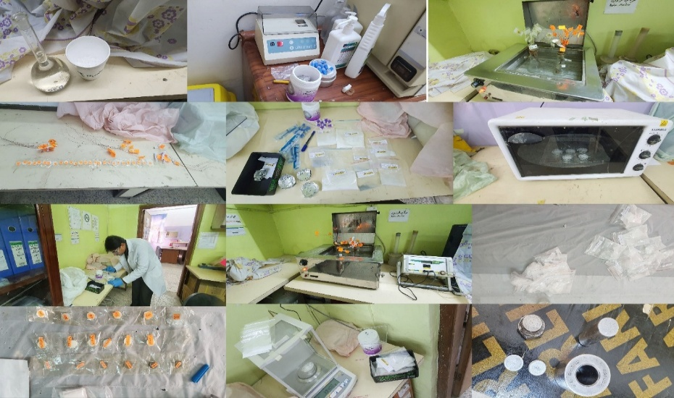
Figure .4 Some of the tools and samples used in the laboratory in this research

CONCLUSION

From Table 4. We note that the uranium concentration ranges from the lowest value (3.10±0.74 ppm) in sample No. 5 to the highest value (5.41±0.84 ppm) in sample No. 7, with the origin and company mentioned in Table 1. The hazard factor will be the highest for this sample, as in Figure 3. b. In general, this percentage is very small, but it proves the presence of uranium inside amalgam fillings. It is also less than the internationally agreed-upon permissible dose as in figure 3.a where highest value of equivalent dose is (0.56 mSv/y), and therefore it is within the safety limits of 1 millisievert per year[20]. There are studies that have been conducted, including the study entitled “Determination of radioactivity levels in feldspathic dental ceramics “[21], which included 42 different samples of ceramics used in the dental industry, and the purpose is to calculate the radioactivity of heavy elements(²³⁸U-²³²Th-²²⁶Ra) using the detector HpGe technique. They found that uranium has a radioactive value of up to 126±8 Bq/kg. The study conducted on zirconium, titled “Zirconia and radioactivity: An in vitro study to establish the presence of radionuclides in dental zirconia”[22], was based on three samples from different sources using gamma ray spectroscopy. The result was that the radioactivity of these samples was (11.082, 11.63, 34.91) Bq/kg. An Italian study was also conducted titled “Determination of dose rates from natural radionuclides in dental materials[23]” Using HPGe (High Purity Germanium Radiation Detectors) technology to determine the presence of uranium and thorium, it confirmed their presence within permissible limits. Our work complements these studies, all of which confirm the presence of uranium in their composition. Therefore, its repercussions, even if within safe limits, are greater for patients with amalgam fillings than for others. Patients with amalgam fillings are more exposed than others to the absorption of radiation resulting from the dissolution of uranium, which negatively impacts the cells surrounding the teeth. Our recommendations are to conduct the same study, but using a different technique. We also want to study the concentration of uranium in glass ionomer fillings and zirconia dental fillings, and try to find alternatives from the manufacturing companies or find ways to separate the heavy elements from the raw materials.

ACKNOWLEDGMENTS

In my research and my practical work in specialized laboratories, I would like to thank those in charge of the Advanced Nuclear Physics Laboratory at the College of Education ibn Al-Haitham, University of Baghdad, Department of Physics.

REFERENCES
[1] C. A. M. Volpato, M. R. C. Pereira, and F. S. Silva, “Fluorescence of natural teeth and restorative materials, methods for analysis and quantification: A literature review,” Journal of Esthetic and Restorative Dentistry, vol. 30, no. 5, pp. 397–407, 2018.
[2] E. Sairenji, K. Moriwaki, M. Shimizu, K. Noguchi, I. Anzai, and N. Ikeda, “Determination of uranium content in dental porcelains by means of the fission track method and estimation of radiation dose to oral mucosa by radioactive elements,” Health Phys, vol. 38, no. 4, pp. 483–492, 1980.
[3] C. Papastefanou, S. Vitsentzos, and P. Garefis, “Uranium in dental porcelain powders and dose induced in oral mucosa,” Radiat Prot Dosimetry, vol. 19, no. 1, pp. 49–53, 1987.
[4] J. E. Moore and W. T. MacCulloch, “The inclusion of radioactive compounds in dental porcelains,” Br Dent J, vol. 136, no. 3, pp. 101–106, 1974.
[5] A. T. Subhi, “calculation of the concentrations of depleted uranium in the diyala river sediment samples using the nuclear track detector CR-39,” Ibn Al-Haitham Journal For Pure and Applied Sciences, vol. 26, no. 3, pp. 122–131, 2013.
[6] K. H. Mahdi, A. T. Subhi, and N. F. Tawfiq, “Calculation of depleted uranium concentration in dental fillings samples using the nuclear track detector CR-39,” 2012.
[7] Z. Elekes et al., “Progress Report on Nuclear Data Research in Institute for Nuclear Research, Hungarian Academy of Sciences (Atomki) Hungary,” process studies, vol. 940, p. 194, 2015.
[8] N. A. Mohammed and S. A. Ebrahiem, “Assessment of radiation risk parameters for natural radon in three Iraqi institutions for February,” AIP Conf Proc, vol. 2307, no. 1, Dec. 2020, doi: 10.1063/5.0035396/698483.
[9] D. Zhou, “CR-39 plastic nuclear track detectors in physics research,” (No Title), 2012.
[10] H. M. T. Hamadani, T. A. Younis, and S. A. Ebrahiem, “Evaluation of The Nuclear Data on (α, n) Reaction for Natural Molybdenum”.
[11] D. Abed, S. Sameera, and A. Ebrahiem, “Measurement of Radon Concentration in College of Education for Pure Science / Ibn Al- Haitham Buildings Using CR-39 Detector,” Ibn AL-Haitham Journal For Pure and Applied Sciences, vol. 31, no. 2, pp. 52–59, Sep. 2018, doi: 10.30526/31.2.1943.
[12] A. Tariq Al-Bayati, “Measurement of uranium concentration in the water samples collected from the areas surrounding in Al-Tuwaitha nuclear site using the CR-39 detector,” J Phys Conf Ser, vol. 1234, no. 1, Jul. 2019, doi: 10.1088/1742-6596/1234/1/012007.
[13] A. T. Al-Bayati, A. M. Alwan, and H. A. Miran, “Determination Of Uranium Concentrations In Rice Samples Available In The Iraqi Market Using The Cr-39 Detector,” Malaysian Journal of Science, vol. 42, no. 2, pp. 1–6, Jun. 2023, doi: 10.22452/MJS.VOL42NO2.1.
[14] A. T. Al-Bayati, A. M. Alwan, and H. A. Miran, “Determination Of Uranium Concentrations In Rice Samples Available In The Iraqi Market Using The Cr-39 Detector,” Malaysian Journal of Science, vol. 42, no. 2, pp. 1–6, Jun. 2023, doi: 10.22452/MJS.VOL42NO2.1.
[15] H. Naseef, N. Kadhim, and B. Rejah‏, “Comparing the Concentration of Uranium in Leukemic and Normal Blood Samples in the City of Baghdad using Fission Fragments Technique‏,” researchgate.net‏, Accessed: Mar. 10, 2025.
[16] E. J. Hall and A. J. Giaccia, “Radiobiology for the radiologist 5th ed,” Philad.: Lippincott Williams&Wilkins, 2000.
[17] J. E. Martin, Physics for radiation protection: a handbook. John Wiley & Sons, 2006.
[18] Merril. Eisenbud and T. F. Gesell, “Environmental radioactivity: from natural, industrial, and military sources,” p. 656, 1997.
[19] J. Magill and J. Galy, Radioactivity, radionuclides, radiation, vol. 259. Springer, 2005.
[20] R. Protection, “ICRP publication 103,” Ann ICRP, vol. 37, no. 2.4, p. 2, 2007.
[21] M. E. Kürkçüoğlu, F. Tozun, I. Kürkçüoğlu, S. H. Tuna, G. B. Cengiz, and E. E. Belgin, “Determination of radioactivity levels in feldspathic dental ceramics,” Applied Radiation and Isotopes, vol. 179, p. 109989, 2022.
[22] A. Brizuela-Velasco, Y. Chento-Valiente, D. Chávarri-Prado, E. Pérez-Pevida, and M. Diéguez-Pereira, “Zirconia and radioactivity: An in vitro study to establish the presence of radionuclides in dental zirconia,” J Prosthet Dent, vol. 126, no. 1, pp. 115–118, 2021.
[23] I. Veronese, G. Guzzi, A. Giussani, M. C. Cantone, and D. Ripamonti, “Determination of dose rates from natural radionuclides in dental materials,” J Environ Radioact, vol. 91, no. 1–2, pp. 15–26, 2006.

