A Comprehensive Remote Sensing Analysis of the Land Cover Dynamics Surrounding Lake Hamrin
Shamam B Abdul-Razak ^{1, a)}, Hameed M Abduljabbar ^{1,} ^{b)}
¹Department of Physics, College of Education for Pure Science Ibn-Al-Haitham, University of Baghdad, Baghdad, Iraq
^{a)}shamam.abd2204p@ihcoedu.uobaghdad.edu.iq
^{b)}corsponding authur : hameed.m.aj@ihcoedu.uobaghdad.edu.iq
Abstract: The land cover study conducted in the Lake Hamrin area of Diyala Governorate, Iraq, significantly contributes to our understanding of environmental changes and their implications for the region's ecological equilibrium. This research utilized three satellite images from 2019, 2022, and 2024, with approximately two-year intervals between each assessment. The images were acquired via the Landsat 8 and 9 OLI satellite data provided by the United States Geological Survey (USGS). The study focused on the area within the path 168 and row 36, and the data analysis was performed using ENVI version 5.3. In this study, training samples were systematically collected to identify various land cover components, with field visits conducted to enhance the reliability of our findings. We assessed the ability to distinguish between subclasses using the Jeffreys-Matusita scale. Notably, the lowest value recorded across all studied years was 1.93, highlighting the presence of spectral overlaps that may have influenced the accuracy of the spatial analysis. The maximum likelihood algorithm was employed to conduct a comprehensive land cover analysis, specifically focusing on changes in water mass attributed to environmental and political factors. The overall classification accuracy was calculated using the maximum likelihood method to assess whether lake water mass area alterations significantly impacted other land cover classes. Certain classes exhibited limited stability due to various environmental and human influences, while others were affected by spectral interference and diminished spatial accuracy. The study thoroughly analyzed changes in land cover components and their effects on the ecological balance of the region, specifically regarding alterations in the lake's water mass. The findings revealed significant variations in the area of water bodies over the selected time frame, along with fluctuations in water levels. These changes have notably impacted various taxonomic classes within the region, emphasizing the interconnectedness of these environmental factors.
Keywords: Land Cover, Land Use, Hamrin Dam, Geospatial Data.
INTRODUCTION
Human activities have caused the Earth to undergo profound environmental changes over the past few centuries. These transformations have significantly affected land cover and use, resulting in wide-ranging impacts on the planet's landscape [1]. The advancements in technology, coupled with the introduction of machinery during the Industrial Revolution, significantly accelerated changes that profoundly impacted global ecosystems [2] [3]. The discourse surrounding the relationship between population growth and the availability of natural resources has a rich history that spans over two centuries. This discussion was notably advanced by Thomas Malthus in 1798 when he introduced a theory predicting that population growth would outpace the land's capacity to produce essential resources [4].
In the latter half of the twentieth century, the concerns associated with the Malthusian projection gained prominence as climate change, epidemics, and political conflicts began to disrupt ecosystems across various regions. It became increasingly clear that humanity's demands on natural resources had reached critical levels [5] [6] [7].
Lake Hamrin, situated in northeastern Iraq, is recognized as one of the region's most significant artificial bodies of water. It was established in 1981 following the construction of the Hamrin Dam [8].
The dam was designed primarily to manage flood risks, provide essential irrigation water, and generate hydroelectric power. As a result, the lake plays a crucial role in supporting both the ecological balance and the region's economic stability [9].
Over the decades, the lake has emerged as a critical indicator of the health of the surrounding environment. The fluctuations in its water levels provide insight into the broader impacts on agricultural land, vegetation, and biodiversity. However, significant water level variations, influenced by environmental and human factors, have substantially altered the adjacent land and land cover [10].
Remote sensing is essential for providing an in-depth analysis of spatial changes in land use and land cover over defined time intervals. This technology enhances our understanding of environmental dynamics and supports informed decision-making [11], Land use encompasses the various ways humans utilize land resources for multiple purposes, including food production, shelter, recreation, and the extraction of raw materials. This utilization is significantly influenced by the land's inherent biophysical properties. Unfortunately, ecosystems face increasing threats from organic and chemical pollution from agricultural and industrial activities. This situation has led to concerning levels of degradation of our natural resources [12].
In developing countries, the growing population and the drive to optimize production from limited resources significantly contribute to environmental degradation, adversely impacting land cover [13] [14] [15] [16] [17] [18] [19].
Changes in land use and land cover (LULC) represent one of the most critical environmental challenges facing the global community in the 21st century. Addressing these changes is essential for sustainable development and the protection of our ecosystems [20] [21], Land use assessment and monitoring changes are integral to the development, planning, and management of urban areas and associated projects. To this end, many countries implement distinct strategies to regulate environmental resource use by analyzing land use and land cover (LULC) patterns. A comprehensive study and evaluation of the changes linked to urbanization are essential for understanding the role of cities as catalysts for regional development. [22] [23] [24].
Assessing current land use and analyzing its temporal changes is a fundamental and strategic approach for urban planners, decision-makers, and natural resource managers. Remote sensing technologies are crucial in facilitating the detection and analysis of these changes, considering their dynamic characteristics. These technologies are essential for effective planning in sustainable urban development [25] [21] [26]
Accurate data derived from remote sensing techniques holds significant value in urban environments. It enhances effective planning and management while providing a robust tool for analyzing urban area land use patterns and changes. Recent advancements in remote sensing methods and technologies present increasing opportunities for precisely detecting and monitoring these changes [27] [28].
The following is a review of significant prior studies conducted in this field:
-Zainab Hussein (2020). This study examined the city of Baghdad from 1986 to 2019, revealing profound changes in land cover driven by a combination of environmental and human factors. The research indicated a significant decline in natural areas, which have been mainly supplanted by agricultural land use. Additionally, numerous public parks have been lost due to an escalating housing crisis, further intensified by exceptional climatic conditions. These alterations have notably impacted the landscape, particularly as substantial areas have been modified due to increased rainfall and natural vegetation changes observed in 2019. This highlights the direct effects of climate factors on Baghdad's urban environment [29] [30].
Ahmed Bahjat (2022). This study focused on Lake Hamrin in Iraq, employing remote sensing techniques to assess surface area and water temperature from October 2019 through September 2020. The analysis found that the maximum surface area was recorded in October (264,617 km²), while the minimum occurred in September (140,202 km²). Furthermore, the highest water temperature was observed in June (45.49°C), and the lowest in February (3.09°C). These results provide essential insights for decision-makers in the sustainable management of water resources [31].
Abdul Jassim (2024). This study utilized Landsat satellite imagery from 2014 to 2022 to assess changes in land cover within the Kirkuk region. Two classification techniques were employed to conduct this analysis: Maximum Likelihood Classification (MLC) and Neural Network Classification (NN). The findings revealed that the accuracy of the MLC classification surpassed that of the NN classification. Notably, there was a significant increase in both agricultural and urban land areas in Kirkuk, while the extent of bare land and soil experienced a decline. These changes are primarily attributed to economic and population growth factors. The insights gained from this research can support urban planners in promoting sustainable development and safeguarding rural areas from uncontrolled expansion [32].
Mohammad Amin et al. (2025). Lake Hamrin in Iraq is facing severe drought due to climate change and human activities. The study indicated a substantial decrease in the lake's area, from 220.42 km² in 2004 to 35.28 km² in 2009, and a recovery to 306.11 km² by 2019. These variations are mainly due to diminished rainfall and modifications within river systems, highlighting the urgent need for measures to prevent the complete desiccation of the lake [33].
This study aims to identify and monitor changes in land cover within the Lake Hamrin region and its surrounding areas and analyze the effects of fluctuations in water levels on land cover. A comprehensive understanding of these changes is vital for evaluating environmental and economic impacts. This information will be instrumental in helping urban planners promote sustainable development and safeguard rural areas from uncontrolled expansion.

STUDY AREA
Lake Hamrin is an engineering marvel that bridges humanity and nature. Lake Hamrin is an artificial reservoir formed by the construction of the Hamrin Dam, located in the Diyala Governorate, approximately 50 kilometers northeast of Baqubah. The accompanying geographical maps (Figure 1) delineate the precise location of the lake and its surrounding areas, situated between longitudes 44° 53′ 26.16" - 45° 07′ 28.03" north and latitudes 34° 04′ 24.75" - 34° 19′ 12.74" east. This remarkable site exemplifies the harmonious coexistence of natural beauty and human ingenuity in engineering [33].

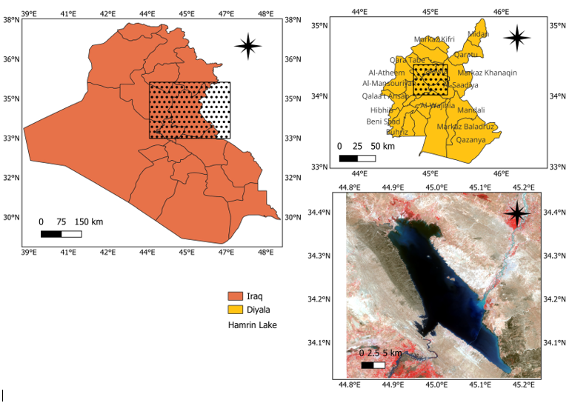
a b

c
Figure 1a,b,c: The Geographic Location of Hamrin Lake within the Diyala Governorate, Iraq. "EPSG:4326-WGS84"

The Hamrin Dam, located at the confluence of the Hamrin Hills and the Diyala River, represents a significant engineering achievement in Iraq. It is the first earthen dam characterized by a solid clay core. Spanning 3,336 meters in length and rising to 40 meters, the dam features a 70-meter-wide spillway with five gates capable of managing a water discharge of up to 4,000 cubic meters per second. In addition to its primary water storage function, the dam integrates a power generation station, serving as a vital resource for sustainable development in the region [34].
The Hamrin Dam was constructed from 1976 to 1981 and officially commenced operations in 1981. This impressive infrastructure spans the Diyala River, which is recognized as one of the most significant tributaries of the Tigris River. The dam represents a pivotal advancement in Iraq's water resource management field.
Lake Hamrin is a noteworthy example of the harmonious interaction between nature and human innovation. It exemplifies a model for balancing developmental needs and environmental stewardship [35].
The area surrounding Lake Hamrin is distinguished by its remarkable plant diversity, supported by favorable climatic conditions and fertile soils. This rich environment fosters the growth of various plant species, broadly categorized into three groups: aquatic, wild, and agricultural plants. Below is a detailed overview of the flora found in the Lake Hamrin region:
Aquatic plants are integral to the lake's ecosystem, as they stabilize the soil and provide vital habitats for aquatic organisms. Among the most significant of these plants are:
Reeds, which grow abundantly along the lake's edges and play a vital role in water purification.
Water lilies, which contribute to the area's aesthetic appeal.
Additionally, a diverse range of wild plant species thrives in this region, further enhancing its ecological richness [36].
The region features a diverse array of herbs and shrubs well-suited to the semi-arid climate, including species such as wormwood and sage [37], along with crops like wheat, barley, vegetables, and fruits, and pastoral plants that contribute significantly to livestock farming must also be acknowledged [38] [39].
The Hamrin Lake area is distinguished by its urban diversity, which reflects the economic and social development occurring within the region [40]. This urbanization encompasses residential neighborhoods, essential infrastructure, and various industrial facilities, including gravel quarries and brick manufacturing plants [41] [42].
Lake Hamrin is recognized as a significant water body in Iraq. The lake's water is sourced from various natural inputs, including the Diyala River, seasonal rainfall, groundwater, and natural springs. Human interventions such as artesian wells and irrigation projects also contribute to its water supply. These diverse sources are essential for maintaining the lake's water level and are instrumental in supporting agricultural and economic activities in the surrounding region [43].
The Hamrin Lake area is distinguished by a series of hills in the northeastern Iraq. These elevations range from 200 to 500 meters above sea level, serving as notable geographical landmarks [44]. These hills are primarily sedimentary and limestone rocks [45] significantly influencing the local climate. They function as a natural barrier that intercepts moisture-laden winds, resulting in increased precipitation on the slopes facing the wind [46]. Furthermore, they contribute to temperature regulation by diminishing the effect of hot and dry winds in the area [47] .
The region's geographical and climatic characteristics play a crucial role in shaping its landscape and functionality. These hills are prominent natural landmarks and significantly influence various human activities, including agriculture [48], grazing, tourism, and the regional economy [49] [50].
The hills surrounding Lake Hamrin are integral to the region's water resources. The lake receives water primarily from small streams on these slopes, especially during the rainy season [51].
These hills serve as natural barriers, effectively protecting the lake from pollution and drought while reducing the impact of winds that may carry dust and other contaminants. Lake Hamrin encompasses a complex ecosystem, with the surrounding hills providing essential protective boundaries and the Diyala River supplying a vital water source. Urbanization presents significant challenges in striking a balance between development and sustainability. To manage this area effectively, it is imperative to foster cooperation at both local and regional levels to ensure the conservation of its valuable resources [52].
METHODOLOGY
The following research procedures were employed in this study:
- Selection of Spatial Data: This study utilized Landsat 8 and 9 satellite images from April 2019, 2022, and 2024 (second level) to perform a comparative analysis. The objective was to assess the impact of changes in the area of Hamrin Lake on the land cover within the region.
- Spectral Data Conversion and Reflectivity Correction: The visual values were methodically converted to reflectivity values. This conversion process accounted for prior spectral correction, effectively removing atmospheric distortions. Such measures were critical for ensuring the precision of the reflectivity values utilized in the analysis, as outlined in the following equation [53]:
$ρ_{λ}=0.0000275×Q_{cal}-0.2$ … (1)
Where $ρ_{λ}$ TOA planetary reflectance and $Q_{cal}$ is the pixel value of the band.
- Layer Stacking and Region Definition: The spectral layers were systematically stacked and cropped to conform to the study area's established boundaries.
- Separability Assessment: To ensure the distinctiveness of our training samples, we calculated the separability of sub-class pairs utilizing the Jeffries-Matusita measure.
- Data Classification Using the Maximum Likelihood Algorithm: A supervised maximum likelihood classifier was applied to categorize the satellite scenes into the designated classes accurately.
- Classification Accuracy Assessment: We computed the kappa coefficient and overall accuracy alongside assessing separability and identifying unclassified areas within each satellite scene.
- An analysis of changes in land cover resulting from variations in the size and water volume of Lake Hamrin during the specified study period.
RESULTS and DISCUSSION
This study employed Landsat 8 and 9 satellite imagery to analyze three significant years: 2019, 2022, and 2024, as presented in Figure 2.
Each pair of consecutive images is separated by a two-year interval, as outlined in Table 1. These years were strategically chosen to capture seasonal variations, focusing on the spring season, which signifies both the peak and conclusion of the rainy period in Iraq. During this season, Lake Hamrin typically reaches its maximum capacity, making it an optimal timeframe for monitoring hydrological and environmental changes within the region.

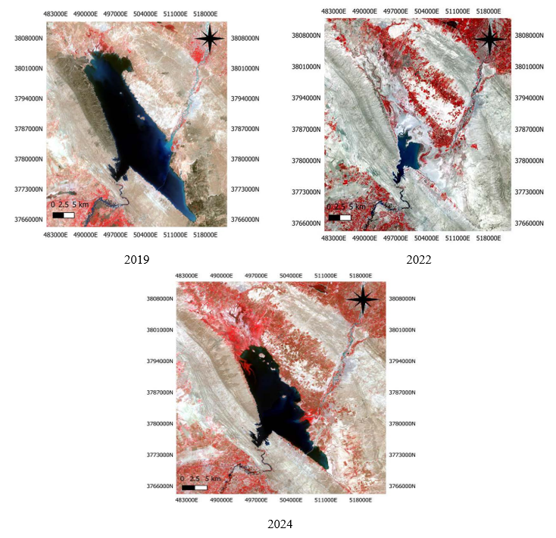
a b

c
Figure2 a,b,c presents satellite images of Hamrin Lake, captured in various years, EPSG:32638-WGS84/UTM Zone 38

Table 1, presents a comprehensive overview of the scenes utilized in the project
No. | Data | Time | Landsat | Path, Row | Cloud Cover | Resolution Of Band (m)
1 | 5/24/2019 | 7:32:53 | OLI-8 | 168,36 | 0.13 | 30
2 | 4/22/2022 | 7:32:58 | OLI-9 | 168,36 | 0.01 | 30
3 | 4/27/2024 | 7:32:51 | OLI-9 | 168,36 | 0.5 | 30

In response to the notable climatic and environmental changes observed in the Hamrin Lake area in recent years, we utilized a supervised maximum likelihood classifier (SML) methodology to classify the land cover components in satellite images systematically. As illustrated in Figure 3, the results of this classification provided essential insights into the current status of the lake and its surrounding environment. This comprehensive analysis contributes to a better understanding of the environmental changes occurring in the study area.
The training samples for each land cover component class were meticulously selected using the Jeffries-Matusita metric. This approach enabled the calculation of the separation factor and the assessment of differentiation between sub-pairs. The minimum separation factor recorded was 1.93 across all satellite images collected over the three years, this value confirms the absence of spectral overlap between the training samples representing different land cover classes, thus reflecting the accuracy and distinctiveness of the samples utilized in the analysis.
To ensure the classification process's accuracy and reliability, we comprehensively evaluated the model's performance utilizing two key indicators: the overall accuracy rate and the kappa coefficient. The results demonstrated an exceptional overall accuracy of 99% and a kappa coefficient 0.99. These findings affirm the effectiveness and reliability of our classification methodology.
The components have been classified into subclasses to conduct a comprehensive analysis of the changes in key land cover patterns. This classification facilitates a detailed examination of the transformations that have transpired over time, offering a clearer perspective on the evolution of the environmental landscape and urban structure in the area of interest. The regions associated with each subclass are presented in Figure 4.
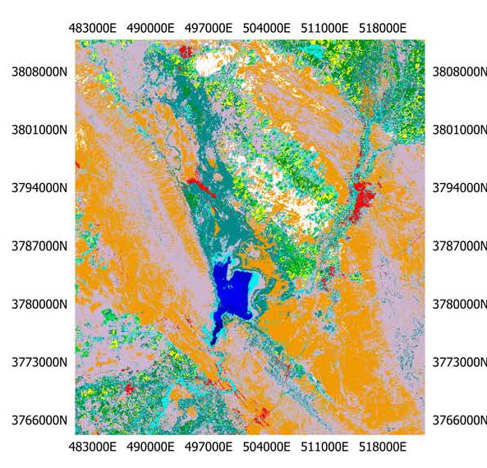  a b  c | 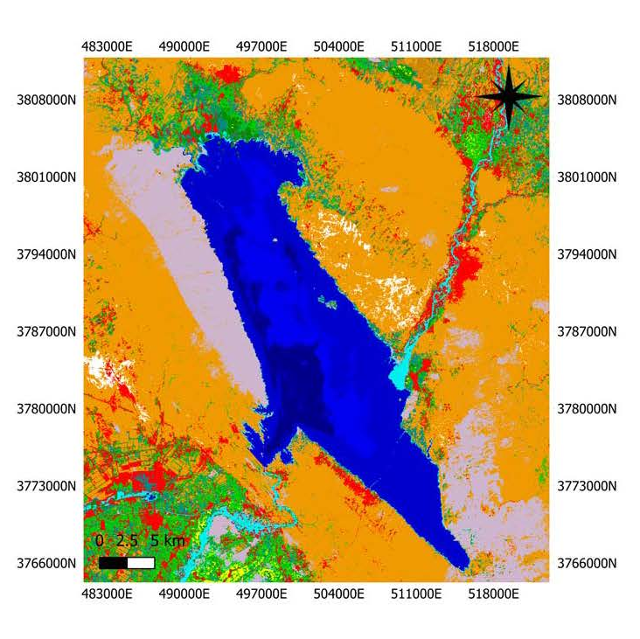
2022 | 2019
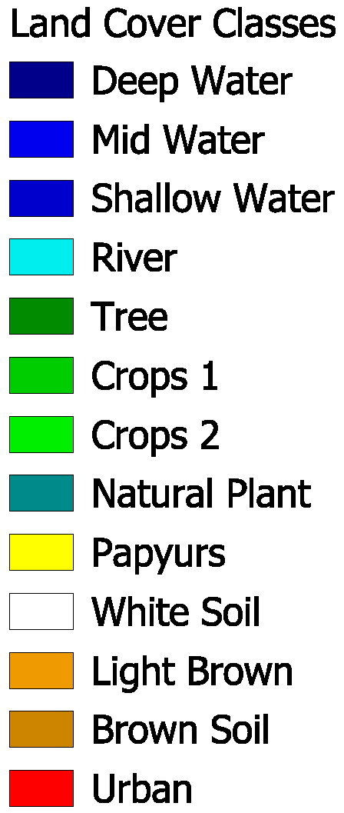 | 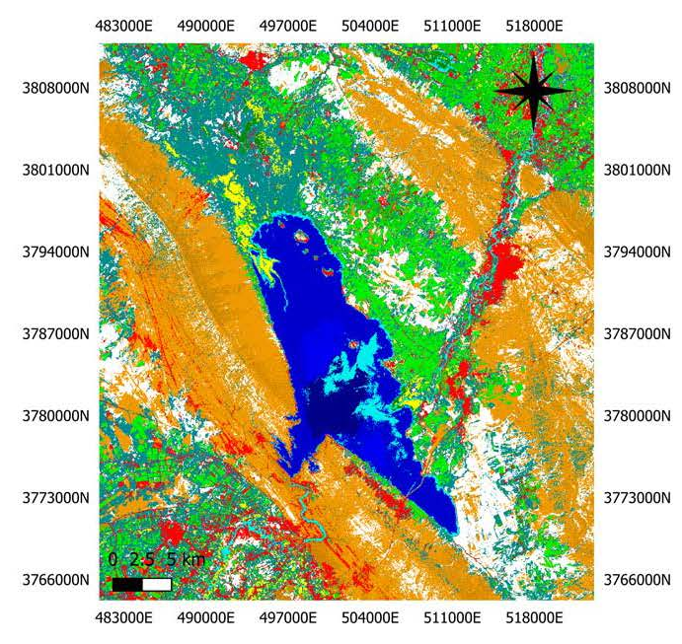
2024
Figure 3a,b,c. Land Cover Classification Results Derived from Training Samples "EPSG:32638-WGS84/UTM Zone 38"

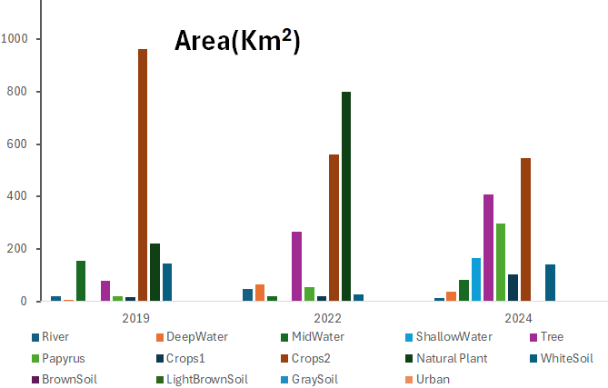
Figure 4, The area of each subclass

We have designated 2019 as the reference year to systematically assess the changes in land cover surrounding Lake Hamrin over the past six years. This approach facilitates a thorough comparison of the consistency of various land cover classes and the environmental and human dynamics observed in the region, as illustrated in Figure 5.
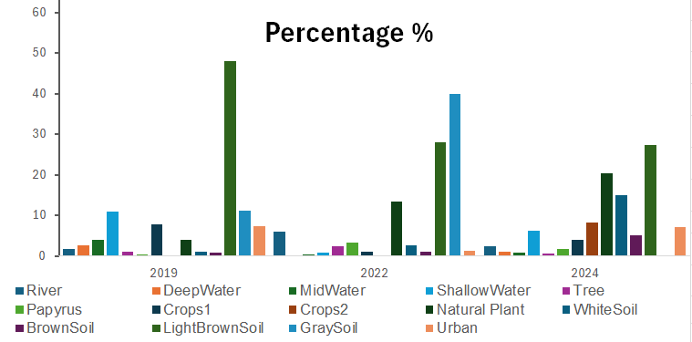
Figure 5, The consistency of various land cover classes.

Lake Hamrin experienced its highest recorded water levels across all deep, medium, and coastal depths during 2019. This significant increase was primarily due to the substantial rainfall and flooding that the region encountered. In 2022, natural vegetation, including wild plants such as reeds, peaked despite the limited rainfall during the rainy season and a notable rise in temperatures throughout the country. This growth occurred alongside the water management policies implemented by neighbouring countries, which adversely affected the lake's surrounding area. Remarkably, the natural and wild plants showed a strong recovery, attributed to elevated temperatures that led to increased evaporation rates and enhanced humidity levels in the region. Furthermore, these plants rely significantly on the groundwater resources available for irrigation. Crops fluctuated between 2019 and 2024 but achieved their highest value in 2024. This increase coincided with the region's recovery from extended drought conditions and improved security situations, following years of instability caused by terrorist groups in the lake's vicinity. The lowest recorded value for urban development occurred in 2022, attributed to significant security unrest that affected the region. However, this sector recovered significantly by 2024.
Additionally, the dark soil at the lake's bottom reached its peak value in 2022, attributable to drought and heightened evaporation levels that led to a receding waterline, revealing substantial portions of the lakebed. In contrast, the medium brown soil recorded its highest value in 2019, resulting from the floods associated with that year's hefty rainy season. In 2024, the white soil, indicative of the region's prevalent gravel, and the dark brown soil, representing the hills of the Hamrin area, recorded their highest values to date. This significant increase can be attributed to the proliferation of gravel quarries and the notable rise in urbanization and construction activities throughout the region during that year. Variations in classification accuracy have led to the reassignment of specific classes from the correct classification (omission) to the commission class, see figures 6 and 7. This has resulted in discrepancies in the calculated representation percentages for some classes within the study area's land cover. The two figures below demonstrate the percentage of omissions and commissions for each class across all approved years.

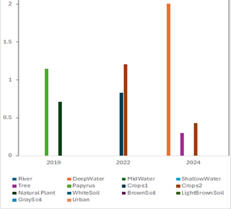 |  | 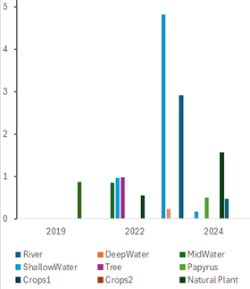
Figure 7, The omission percentage |  | Figure 6, The commission percentage

Errors during the classification process resulting from omissions and overlaps between classes are evaluated based on established omission and overlap values. We have set critical thresholds of 2% for omissions and 5% for commissions. The classification errors and their corresponding causes are presented for review in Table 2. The difficulty in differentiating subclasses arises from the high similarity in their spectral responses, compounded by the limited spatial resolution of the Landsat (8,9) satellites, which is 30 meters. Consequently, it has been observed that some classes exhibit distinct oscillatory behavior, whereas others demonstrate relative stability.

Table 2, The omission and commission between the classes
Year | Omission | Commission | Notes
2019 | White Soil | Light Brown Soil | Belong to the same main class
 | Gray Soil | Urban | The two classes are interference
2022 | River | Shallow Water | Belong to the same main class
 | Shallow Water | River | Belong to the same main class
 | Brown Soil | Gray Soil | Belong to the same main class
 | Light Brown Soil | Urban | The two classes are interference
2024 | River | Shallow Water | Belong to the same main class
 | Shallow Water | River | Belong to the same main class
 | Natural Plant | Papyrus | Belong to the same main class
 | Light Brown Soil |  | Commission to different classes

CONCLUSION
Global climate change, encompassing global warming, profoundly impacts weather patterns in Iraq. This phenomenon has resulted in fluctuations in rainfall during the rainy season, significantly affecting vegetation cover, water bodies, and soil quality in the region.
Notably, vegetation attained its highest recorded value in 2024 due to increased cultivated land and enhancements in agricultural land management practices. This improvement was facilitated by an extended rainy season, a moderate climate, and the stability the region has experienced following significant security challenges.
There was also a notable increase in vegetation in 2022 compared to 2019, despite witnessing a less favorable rainy season, severe drought conditions, and a sharp rise in temperatures. This increase in vegetation cover can be attributed to the increased reliance on groundwater resources. Although elevated temperatures contributed to higher evaporation rates, they simultaneously provided suitable moisture levels conducive to crop growth.
Water levels across all classes peaked in 2019, primarily due to the region's abundant rainy season and the resulting floods. The year 2024 ranked second, as a significant recovery in water levels was observed, attributable to ample rainfall and flooding, indicating a positive long-term trend for the area's hydrology.
In contrast, the lowest water levels were recorded in 2022, marked by severe drought and desertification. This decline was further compounded by reduced rainfall during the rainy season and the closure of critical tributaries, including the Tigris River and Lake Hamrin, by neighbouring countries.
Soil conditions across all classes also exhibited considerable changes. The highest soil quality values were noted in 2022, reflecting the impacts of desertification and drought on the region. In 2019, soil conditions were favourable, influenced by erosion resulting from rainfall and flooding. By 2024, alterations in soil quality were increasingly linked to agricultural activities, urban development, and the expansion of gravel quarries, reflecting the enhanced security and stability that followed the successful containment of ISIS activity in the area.
In summary, there has been a marked increase in both agricultural and urban land use in recent years, accompanied by a decrease in the extent of bare land. These developments are primarily attributed to the region's population growth and economic advancement. Additionally, the analysis revealed significant changes in land cover throughout the study period, including modifications in soil quality, vegetation cover, and water bodies. The area of lakes was closely associated with variations in rainfall rates.
REFERENCES
- N.S. Ahmed and H. M. Abduljabbar, “A Study of the Land Cover of Razzaza Lake during the Past 25 Years Using Remote Sensing Methods,” Ibn Al-Haitham Journal for pure and Applied Sciences, vol. 36, no. 1, pp. 158-169, 2023.
- C. E. Ellis, N. Gauthier, K. G. Klein, R. B. Bliege, N. Boivin, S. Daiz, Q. D. Fuller, L. J. Gill, Q. J. Kaplan, N. Kingston and H. Lovke, “People have shaped most of terrestrial nature for at least 12,000 years,” Proceedings of the National Academy of Sciences, vol. 118, no. 17, 2021.
- Ahmed, Noor S; Abduljabbar, Hameed M;, “A Study of the Land Cover of Razzaza Lake during the Past 25 Years Using Remote Sensing Methods,” Ibn Al-Haitham Journal for Pure and Applied Sciences, vol. 36, no. 1, pp. 158-169, 2023.
- [Ehrlich, R P; Holdren, P J;, “Impact of population growth,” Science, vol. 17, no. 3977, pp. 1212-1217, 1971.
- J. Rockstrom, W. Steffen, K. Noon, A. Persson, S. f. Chapin, F. E. Lambin, M. T. Lenton, J. H. Schellnhuber and B. Nykvist, “A safe operating space for humanity,” Nature, vol. 46, no. 7263, pp. 472-475, 2009.
- F. E. Lambin, L. B. Turner, J. H. Giest, B. S. Agbola, A. Angelsen, W. J. Brace, T. O. Coomes, R. Dirzo, G. Fischer, C. Folke and S. P. George, “The causes of land-use and land-cover change: moving beyond the myths,” Global Environmental Change, vol. 11, no. 4 , pp. 261-269, 2021.
- C. E. Ellis and N. Ramankutty, “Putting people in the map: anthropogenic biomes of the world,” Frontiers in Ecology and the Environment, vol. 6, no. 8, pp. 439-447, 2008.
- D. A. Abdullah, I. Masih and P. Z. Van Der , “The Impact of Upstream Dam Construction on Downstream Water Availability: A Case Study of the Tigris-Euphrates River Basin,” International Journal of Water Resources Development, vol. 35, no. 4, pp. 611-630, 2019.
- H. W. Hassan and K. B. Nile, “Impact of Climate Change and Upstream Dam Construction on the Hydrology of the Tigris River Basin,” Water Resources Management, vol. 34, no. 5 , pp. 1835-1850, 2020.
- R. M. Mahmood and N. Al-Ansari, “Environmental Impacts of Dams on Water Resources in Iraq: A Review,” Environmental Earth Sciences, vol. 80, no. 12, pp. 1-15, 2021.
- S. P. Roy and A. Roy, “ Land Use and Land Cover Change in India: A Remote Sensing & GIS Perspective,” Journal of the Indian Institute of Science, vol. 90, no. Journal of the Indian Institute of Science, 90, 489-502, pp. 489-502, 2010.
- F. E. Putz, B. M. Geoffey, K. Redford and R. Fimbel, “Conservation Biology,” Tropical Forest Management and Conservation of Biodiversity: an Overview, vol. 15, no. 1, pp. 7-20, 2001.
- S. P. Roy and A. Roy, “ Land Use and Land Cover Change in India: A Remote Sensing & GIS Perspective,” Journal of the Indian Institute of Science, vol. 90, pp. 489-502, 2010.
- Al-Fartusi, A J; Malik, M I; Abduljabbar, H M;, “Spatial-temporal of Iraqi coastline changes utilizing remote sensing,” AIP Conf. Proc, vol. 3018, no. 020062, pp. 1-9, 2023.
- S. Parveen, J. Bashir and B. Parveen, “A LITERATURE REVIEW ON LAND USE LAND COVER CHANGES.,” International Journal of Advanced Research, vol. 6, no. 7, pp. 1-6, 2018.
- [M. A. Majed and H. M. Abduljabbar, “The Change in the Land Cover of Mahmudiyah City in Iraq for the Last Three Decades,” Ibn Haitham Journal for Pure and Applied Sciences, vol. 35, no. 3, pp. 44-55, 2022.
- Jia, Xin; Lee, Harry F; Zhang, Wenchao; Wang, Lin; Sun, Yonggang;, “Human-environment interactions within the West Liao River Basin in Northeastern China during the Holocene Optimum,” Quaternary International, vol. 426, pp. 10-17, 2016.
- H. Shen, R. N. Spengler, X. Zhou, A. Betts, P. W. Jia, K. Zhao and X. Li, “Seeing the wood for the trees: active human–environmental interactions in arid northwestern China,” Earth System Science Data, vol. 16, no. 5, p. 2483–2499, 2024.
- Trabelsi, Nadia; Triki, Ibtissem; Hentati, Imen; Rachdi, Nizar;, “Classification and Spatio-Temporal Change Detection of Land Use/Land Cover Using Remote Sensing and Geographic Information System in the Manouba Region, NE Tunisia,” Journal of Geographic Information System, vol. 15, no. 6, 2023.
- Alawamy, Jamal Suliman; Balasundram, Siva K; Mohd Hanif, Ahmad Husni; Sung, Christopher Teh Boon;, “Detecting and Analyzing Land Use and Land Cover Changes in the Region of Al-Jabal Al-Akhdar, Libya Using Time-Series Landsat Data from 1985 to 2017,” MDPI, vol. 12, no. 11, 2020.
- A. H. Shaban, “Flood Scenario of Tigris River in Baghdad City,” Journal of science, vol. 64, no. 7, pp. 3717-3724, 2023.
- Onur, Isin; Maktav, Derya; Sari, Mustafa; Sonmez, N K;, “Change detection of land cover and land use using remote sensing and GIS: A case study in Kemer, Turkey,” International Journal of Remote Sensing, vol. 30, no. 7, pp. 1749-1757, 2009.
- A. J. Hatam, A. A. N. Al-Jasim and H. M. Abduljabbar, “A study of the climate and human impact on the future survival of the Al-Sannya marsh in Iraq,” Journal Of Water And Land Development, vol. 37, no. 1, pp. 55-70, 2024.
- R. Y. Hassain, “Submerged Surface Area and Water Storage Volume of Hamrin Dam Lake,” Iraq Journal of Sciences, vol. 65, no. 6, pp. 3524-3535, 2024.
- Mhana, Khalid Hardan ; Norhisham, Shuhairy Bin; Katman, Herda Yati Binti; Yaseen, Zaher Mundher;, “Road urban planning sustainability based on remote sensing and satellite dataset: A review,” Heliyon, vol. 10, no. 21, 2024.
- N. S. Ahmed and H. M. Abduljabbar, “Degradation of Razzaza Lake During the past 25 Years Using Remote Sensing,” AIP Conference Proceedings , vol. 2769, no. 020008, pp. 1-11, 2023.
- D. J. Abed and H. M. Abduljabbar, “The Effect of different flooding raio on Al- Shuwaija marsh,” AIP Conference Proceedings, vol. 2437, no. 020015, pp. 1-8, 2022.
- Al.Fartusi, Adel Jassim; Malik, Mutasim Ibrahim; Abduljabba, Hameed Majeed;, “Spatial-temporal of Iraqi coastline changes utilizing remote sensing,” AIP Conf. Proc, vol. 3018, no. 020062, pp. 1-9, 2023.
- Z. H. Qassim and H. M. Abduljabbar, “Land Cover Change For Baghdad City In The Period 1986 to 2019,” in AIP Conference Proceedings, 2020.
- H. M. Abduljabbar and T. A. Naji, “Separting The Terrain Cover of Iraq Marshes Region Using New Satallite Band Combiation,” Iraq Journal of Agricultural Sciences, vol. 51, no. 6, pp. 1504-1516, 2020.
- A. Bahjat, “Using Remote Sensing and Geographic Information Systems to Study the Change Detection in Temperature and Surface Area of Hamrin Lake,” Baghdad Science Journal, vol. 19, no. 5, 2022.
- A. T. T. Jasim , “In Kirkuk City, Iraq using Landsat imagery and maximum likelihood classification,” Dysona-Applied -Science, vol. 6, no. 1, pp. 113-119, 2024.
- M. H. Ameen, . H. J. Jumaah and N. K. Khursheed, “An analysis of hydrologic dynamics in Hamrin Lake, Iraq using remote sensing and GIS techniques,” DYSONA – Applied Science, vol. 6, no. 1, pp. 96-103, 2025.
- A. J. Hadi and T. A. Mohammed, “Compliance of Haditha Dam in Iraq to the International Standards forSurveillance and Monitoring,” Journal of Engineering, vol. 30, no. 7, pp. 35-58, 2024.
- R. . Y. Hussain, “Submerged Surface Area and Water Storage Volume of Hamrin Dam Lake Using Contour Lines,” Iraqi Journal of Science, 2024, Vol. 65, No. 6, pp: 3524-3535, vol. 65, pp. 3524-3535, 2024.
- S. Al-Hussaini, “Aquatic Plants in Iraqi Wetlands,” Journal of Environmental Studies, vol. 15, no. 3, pp. 45-60, 2020.
- S. Al-Saadi , “Medicinal Plants in Semi-Arid Regions,” Journal of Arid Environments, vol. 45, no. 2, pp. 123-135, 2021.
- M. Al-Doori, “Forage Plants in Iraq,” Agricultural Studies Journal, vol. 12, no. 4, pp. 89-102, 2020.
- H. Al-Samarrai, “Traditional Uses of Plants in Iraq,” Ethnobotany Research Journal, vol. 9, no. 2, pp. 156-170, 2021.
- K. Al-Zubaidi, “Infrastructure Development in Hemrin Region,” Journal of Urban Studies, vol. 15, no. 2, pp. 89-102., 2022.
- M. Al-Jumaily, “Environmental Impacts of Quarrying in Iraq,” Environmental Science Journal, vol. 12, no. 3, pp. 45-60, 2019.
- A. Al-Tamimi, “Brick Industry in Iraq: Challenges and Opportunities,” Industrial Engineering Journal, vol. 8, no. 4, pp. 123-135, 2020.
- A. Al-Hasani, “Groundwater Resources in Iraq,” Hydrogeology Journal, vol. 28, no. 5, pp. 210-225, 2020.
- M. Al-Jubouri, “Geological Study of Hemrin Area,” Journal of Earth Sciences,, vol. 45, no. 3, pp. 123-135, 2018.
- A. Al-Dulaimi, “Geomorphology of Iraqi Highlands,” Geomorphology Journal, vol. 34, no. 5, pp. 210-225, 2020.
- R. Al-Maliki, “Climate Regulation by Topographic Features,” Journal of Climatology, vol. 12, no. 4, pp. 89-102, 2019.
- H. Al-Samarrai, “Impact of Topography on Local Climate,” Climate Dynamics, vol. 23, no. 2, pp. 156-170, 2021.
- FAO, “Agricultural Development in Semi-Arid Regions,” in United Nations, Rome, 2018.
- M. Al-Doori, “Grazing Systems in Iraq.,” Journal of Range Management,, vol. 34, no. 5, pp. 210-220, 2020.
- K. Al-Zubaidi, “Ecotourism in Hemrin Region,” Tourism Management Journal, vol. 15, no. 2, pp. 89-102, 2022.
- R. Al-Maliki, “Topographic Influence on Water Resources,” Hydrology Journal, vol. 12, no. 4, pp. 123-135, 2019.
- B. B. Ahmood, Z. H. Hamza and M. Al-Hadithi, “An Overview of the Remote Sensing and GIS Techniques Application toDetect Changes in the Surface Area of Water Bodies in Iraq,” Iraqi Geological Journal , vol. 57, no. 1D, pp. 263-274, 2024.
- K. Sayler, Landsat 8-9 Collectin2 (C2) lever2 Science Product (L2SP) Guide, colle, 2024.

