Antibacterial, Antivirulant and Antioxidant Activities of Photosynthesized Selenium Nanoparticles Against Escherichia coli Isolates

Dhuha H. Al Jubouri^{1, a)} and Esam J. Alkalifawi^{1, b)}

¹Department of Biology, College of Education for Pure Science Ibn Al-Haitham, University of Baghdad, Baghdad, Iraq
^{a)} corresponding author. wrdta3965@gmail.com
^{b)} aesam365@yahoo.com.
Abstract. In this study, the antibacterial, antivirulence, and antioxidant properties of photosynthesized selenium nanoparticles (MC-SeNPs) were evaluated against 50 Escherichia coli isolates (33.3%) obtained from 150 clinical samples. Among the isolates, 60% were recovered from urinary tract infections, 30% from wounds, and 10% from burns. Antimicrobial susceptibility testing revealed variable resistance patterns among the isolates. The antimicrobial activity of MC-SeNPs, assessed using a resazurin-based microdilution method, showed minimum inhibitory concentrations (MICs) ranging from 1250 to 312.5 µg/ml. At sub-MIC levels, MC-SeNPs significantly reduced biofilm formation, with inhibition rates ranging from 7.8% to 85% in strong biofilm producers, 44% to 57% in moderate producers, and 39% to 71% in weak producers. Antioxidant activity assays demonstrated a dose-dependent increase in free radical scavenging capacity with Myrtus communis L. leaf extract, MC-SeNPs, and ascorbic acid. Hemolytic activity testing indicated minimal toxicity, as MC-SeNPs exhibited the lowest hemolytic effect even at higher concentrations. Overall, the findings highlight the potential of MC-SeNPs as effective antimicrobial and antivirulence agents with strong antioxidant capacity and low cytotoxicity, suggesting their suitability for diverse medical, industrial, and environmental applications.
Keywords: MC-SeNPs, Escherichia coli, UTIs, Wounds, Burns.

Introduction
Escherichia coli is a gram-negative bacillus, non-spore-forming, and motile through peritrichous flagella. Its colonies are smooth, convex, and may appear slimy when encapsulated. On MacConkey agar, E. coli ferments lactose producing bright pink colonies, while on eosin methylene blue (EMB) agar, it shows a characteristic green metallic sheen. It does not hydrolyze gelatin, does not produce H₂S in triple sugar iron agar, and grows optimally at 36–37 °C (1-3). E. coli is part of the normal intestinal microbiota of humans and animals but can become pathogenic, causing urinary tract infections (UTIs), wound infections, genital tract infections, and respiratory diseases (4). Among these, UTIs are the most common (5, 6). Pathogenic strains of E. coli possess virulence genes located within pathogenicity islands ranging from 10 to 200 kb. These factors include capsules, lipopolysaccharides, adhesins, and enzymes, which facilitate immune evasion and tissue colonization (7). A major clinical challenge is the rising prevalence of antibiotic-resistant strains, largely due to antibiotic misuse. E. coli is among the most resistant bacteria, employing multiple drug resistance mechanisms (8). Selenium nanoparticles (SeNPs) have recently gained significant attention because of their high bioavailability, strong biological activity, low toxicity, and superior efficiency in preventing oxidative damage compared to other selenium forms (9). In biomedical applications, SeNPs are reported to possess antioxidant (10, 11), anticancer (12), antimicrobial (13), and immunoregulatory properties (14). They exhibit broad-spectrum antimicrobial effects against bacteria and fungi (15), likely mediated through excessive reactive oxygen species (ROS) generation, disruption of cell membranes, inhibition of protein synthesis, and interference with DNA replication (16). Given these unique properties, SeNPs have been proposed as promising candidates to combat multidrug-resistant pathogens, including E. coli. However, published studies reveal variations in outcomes due to differences in synthesis methods, nanoparticle size, concentrations used, bacterial lifestyle (planktonic or biofilm), and microbial strains investigated (17). This highlights the importance of further exploring the biomedical potential of SeNPs against E. coli-associated infections.

Materials and Methods

Clinical Samples Collection
Clinical samples were collected between 20 July and 20 December 2024 from hospitals affiliated with Baghdad Karkh and Al-Rusafa Health Departments. A total of 150 samples were obtained from patients suspected of E. coli infection, including urine samples from urinary tract infections, and swabs from burn and wound patients.

Isolation and identification of E. coli
All one hundred and fifty samples examined, including morphological characteristics on different culture media, Gram staining, motility, biochemical tests and finally confirmation with the ID-GNB cards of the VITEK® 2 compact system (18, 19), showed that the isolates were E. coli.

Antibiotic sensitivity test
The antibiotic susceptibility tests were carried out using two methods. The first Kirby Bauer disk diffusion method: The method of (20) was used. The diameter of the inhibition around the antibiotic disc was measured to determine the efficacy of the antibiotic for 50 isolates. The second VITEK® 2 Compact system method: The method of (19) was used. The VITEK® 2 Compact System automatically processes the antimicrobial susceptibility cards of Gram-negative bacteria VITEK® 2AST-GN419 cards until MICs for 50 isolates are obtained.

Photosynthesis of selenium nanoparticles
The selenium nanoparticles synthesised with an extract from the leaves of Aas (M.communis L.) and their properties were described in a previous study (20).

Resazurin Microplate Assay (REMA)
REMA was used to determine the MIC of MC-SeNPs, where the MIC was determined by recording the observed colour change (21).

Detection of biofilm formation
Biofilm formation was measured using the 96-well tissue culture plate (TCP) method as previously described with minor modifications (22).

Inhibition of biofilm formation
Fifty E. coli isolates were incubated in 96-well microtiter plates with two subinhibitory concentrations of MC-SeNPs (1000–1.95 µg/ml). After 24 hours at 37°C, planktonic cells were removed, and the remaining biofilms were stained with crystal violet. Biofilm formation was then quantified using an Absorbance Microplate Smart Reader™ at 590 nm, where colour intensity reflected bacterial adhesion and biofilm development (23).

DPPH radical scavenging assay
The ability of MC-SeNPs to scavenge free radicals was tested using the DPPH radical scavenging assay (24).

In vitro Hemolysis Assay
The haemolytic activity of MC-SeNPs was evaluated in vitro using erythrocytes from fifty human blood samples collected with donor consent (n=5) (25). Red blood cells were isolated by centrifugation, washed with DPBS, and diluted to prepare a stock solution. Various concentrations of MC-SeNPs were incubated with 1 mL of the red cell suspension at 37°C for 24 hours. 1% SDS and DPBS served as positive and negative controls, respectively. After incubation, absorbance was measured at 540 nm to calculate the percentage of haemolysis:

Hemolytic activity%= $\frac{Absorbance of sample- Absorbance of blank}{Absorbance of control - Absorbance of blank}$ × 100 (1)

Statistical analysis
The data were tabulated in an IBM SPSS version 26.0 data sheet, which was used for the statistical analysis. Significant differences were tested using the chi-square test for person analysis. Statistical significance was defined for the tables as a probability value (p≤0.05) (26). For the figures, the data were also analysed using analysis of variance (ANOVA) between groups with four replicates and a probability value p≤0.05. The results were expressed as mean±standard deviation (SD) (27).

Results

Clinical samples collection
A total of 150 clinical samples were collected between 20 July and 20 October 2024 from several hospitals in Baghdad, including Imam Ali, Martyr Ghazi Al-Hariri, the Specialised Burns Hospital, Baghdad Teaching Hospital, Ibn Al-Balady, and Al-Mada’in General Hospital. The samples comprised 80 urine samples from UTI patients, 40 wound swabs, and 30 burn swabs. Of these, 70 were from males (46.66%) and 80 from females (53.33%). The largest proportion came from the 20–29 age group, with 17 male (24.28%) and 20 female (25%) samples, while the smallest proportion was two male (2.85%) and two female (2.5%) samples. Chi-square analysis showed no significant difference between genders across age groups (p>0.05), indicating a homogeneous distribution.

 | 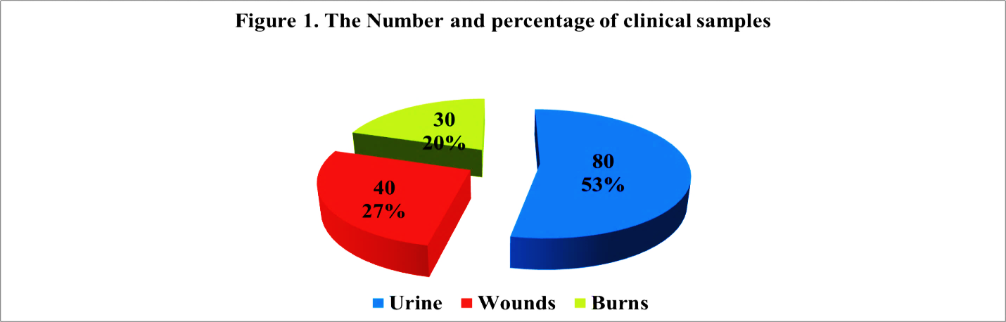 |  | 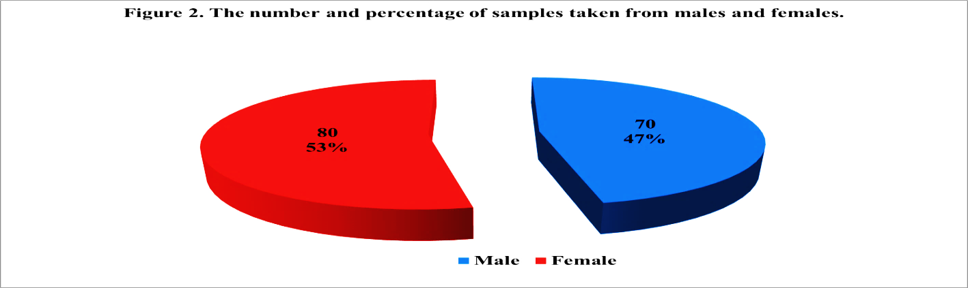
Figure 1. Distribution of clinical samples by source. |  |  | Figure 2. Gender distribution of clinical samples

Isolation of bacteria
Out of 150 clinical samples, 50 E. coli isolates (33.3%) were identified using morphological, microscopic, biochemical tests, and the VITEK® 2 system. These included 30 isolates (60%) from urinary tract infections, 15 (30%) from wounds, and 5 (10%) from burns (Fig. 3).

Figure 3. The number and percentage of E.coli isolates from clinical samples.

Antimicrobial susceptibility test
Seventeen antimicrobial discs were tested against fifty E. coli isolates from clinical samples. Most isolates were resistant to seven antibiotics—Ampicillin, Amoxicillin, Cloxacillin, Gentamicin, Amikacin, Tobramycin, and Tetracycline—classifying them as multidrug-resistant (MDR). Conversely, the isolates were largely sensitive to ten antibiotics, including Imipenem, Meropenem, Nitrofurantoin, Chloramphenicol, Nalidixic acid, Ciprofloxacin, Streptomycin, Kanamycin, Trimethoprim-Sulfamethoxazole, and Clindamycin. Chi-square analysis confirmed significant differences in antibiotic responses (p≤0.05).

TABLE 1. Antimicrobial resistance profiles of E. coli clinical isolates against various antibiotics with associated p-values.
Antibiotics discs | Number and Percentage |  |  | p-value
Antibiotics discs | Sensitive | Intermediate | Resistance | p-value
Ampicillin (10µg) | 1 (2%) | 2 (4%) | 47 (94%) | 0.01*
Amoxicillin (10μg) | 1 (2%) | 1 (2%) | 48 (96%) | 0.05*
Imipenem (10µg) | 47 (94%) | 2 (4%) | 1 (2%) | 0.01*
Meropenem (10µg) | 47 (94%) | 2 (4%) | 1 (2%) | 0.001*
Nitrofurantoin (10 μg) | 45 (90 %) | 4 (8%) | 1 (2%) | 0.001*
Cloxacillin (5 μg) | 3 (6%) | 7 (14%) | 40 (80%) | 0.001*
Chloramphenicol (30 μg) | 46 (92%) | 3 (6%) | 1 (2%) | 0.001*
Nalidxic acid (30 μg) | 45 (90 %) | 3 (6%) | 2 (4%) | 0.01*
Ciprofloxacin (5 μg) | 47 (94%) | 2 (4%) | 1 (2%) | 0.01*
Streptomycin (10 μg) | 30 (60%) | 12 (24%) | 8 (16%) | 0.001*
Kanamycin (30 μg) | 32 (64%) | 11 (22%) | 7 (14%) | 0.001*
Gentamicin (30 μg) | 3 (6%) | 7 (14%) | 40 (80%) | 0.001*
Amikacin (30 μg) | 3 (6%) | 10 (20%) | 37 (74%) | 0.001*
Tobramycin (10µg) | 2 (4%) | 10 (20%) | 38 (76%) | 0.001*
Trimethoprim/ Sulfamethoxazole (1.25/23.75 μg) | 48 (96%) | 1 (2%) | 1 (2%) | 0.05*
Tetracycline (30 μg) | 2 (4%) | 8 (16%) | 40 (80%) | 0.001*
Clindamycin (2µg) | 46 (92%) | 3 (6%) | 1 (2%) | 0.001*
p-value | 0.001* | 0.001* | 0.001*
# Person chi-square test of independence, *significant differences (p≤0.05).

Antimicrobial susceptibility testing using the VITEK® 2 compact system with an AST-N419 card revealed that most E. coli isolates were resistant to eleven antibiotics, including Amikacin, Aztreonam, Minocycline, Rifampicin, Cefepime, Ceftazidime, Cefazolin, Colistin, Gentamicin, Ticarcillin, and Ticarcillin+Clavulanic acid. Conversely, the isolates were largely sensitive to seven antibiotics: Ciprofloxacin, Pefloxacin, Imipenem, Meropenem, Piperacillin, Piperacillin+Tazobactam, and Trimethoprim/Sulfamethoxazole. Chi-square analysis confirmed significant differences in susceptibility patterns (p≤0.05).

TABLE 2. Antibiotic susceptibility patterns of clinical E. coli isolates using VITEK® 2 compact system (AST-N419 card.
Antibiotics agents | Number and Percentage |  |  | p-value#
Antibiotics agents | Sensitive | Intermediate | Resistance | p-value#
Amikacin | 6 (12%) | 5 (10%) | 39 ( 78% ) | 0.01*
Aztreonam | 4 (8%) | 6 (12%) | 40 (80%) | 0.01*
Minocycline | 4 (8%) | 4 (8%) | 42 (84%) | 0.05*
Rifampicin | 4 (8%) | 5 (10%) | 41 (82%) | 0.01*
Cefepime | 3 (6%) | 7 (14%) | 40 (80%) | 0.001*
Ceftazidime | 4 (8%) | 8 (16%) | 38 (76%) | 0.001*
Cefazolin | 9 (18%) | 2 (4%) | 39 (78%) | 0.001*
Ciprofloxacin | 36 (72%) | 9 (18%) | 5 (10%) | 0.001*
Pefloxacin | 38 (76%) | 10 (20%) | 2 (4%) | 0.001*
Colistin | 1 (2%) | 2 (4%) | 47 (94%) | 0.01*
Gentamicin | 3 (6%) | 7 (14%) | 40 (80%) | 0.001*
Imipenem | 50 (100%) | 0 (0%) | 0 (0%) | 0.05*
Meropenem | 50 (100%) | 0 (0%) | 0 (0%) | 0.05*
Piperacillin | 47 (94%) | 2 (4%) | 1 (2%) | 0.01*
Piperacillin +  tazobactam | 48 (96%) | 1 (2%) | 1 (2%) | 0.05*
Ticarcilline | 4 (8%) | 10 (20%) | 36 (72%) | 0.001*
Ticarcilline + clavulanic acid | 4 (8%) | 8 (16%) | 38 (76%) | 0.001*
Trimethoprim /sulfamethoxazole | 35 (70%) | 9 (18%) | 6 (12%) | 0.001*
p-value | 0.001* | 0.001* | 0.001*
# Person chi-square test of independence, *significant differences (p≤0.05).

Antimicrobial Activity of MC-SeNPs by Resazurin (REMA)
The antimicrobial activity of MC-SeNPs against E. coli isolates was evaluated using a resazurin-based 96-well plate microdilution method. The MIC of MC-SeNPs varied among the isolates: 1250 µg/ml for isolates 1, 3, 5, 7, 11, 12, 15, 18, 19, 23, 24, 25, 27, 30, 33, 34, 35, 36, 43, 44, 46, and 47; 625 µg/ml for isolates 4, 6, 9, 13, 17, 21, 22, 26, 29, 31, 42, and 49; and 312.5 µg/ml for isolates 2, 8, 10, 14, 16, 20, 28, 32, 37, 38, 39, 40, 41, 45, 48, and 50 (Fig. 4).

Biofilm formation detection
The results of this study showed that the biofilm-forming isolates were divided into 31 isolates with strong biofilm formation with a percentage of 62%, thirteen isolates with moderate biofilm formation with a percentage of 26% and six isolates with weak biofilm formation with a percentage of 12%, Fig. (5-7).

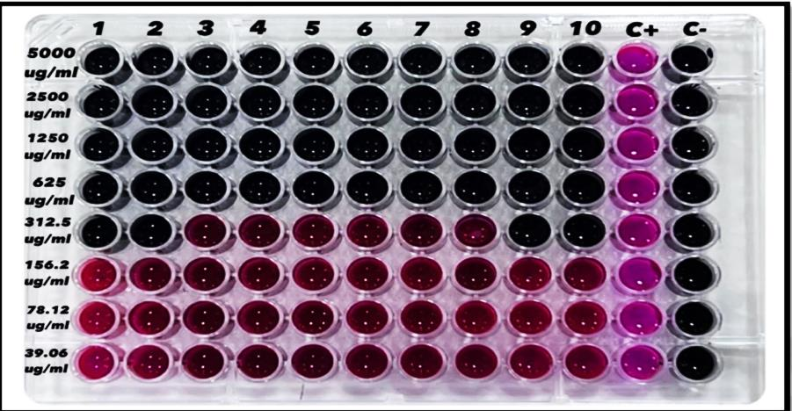
Figure 4. Minimum Inhibitory Concentration (MIC) of MC-SeNPs against E. coli isolates determined by the Resazurin Microtiter Assay (REMA).

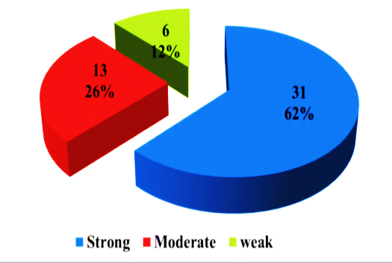
Figure 5. Percentage distribution of E. coli isolates based on biofilm formation strength.

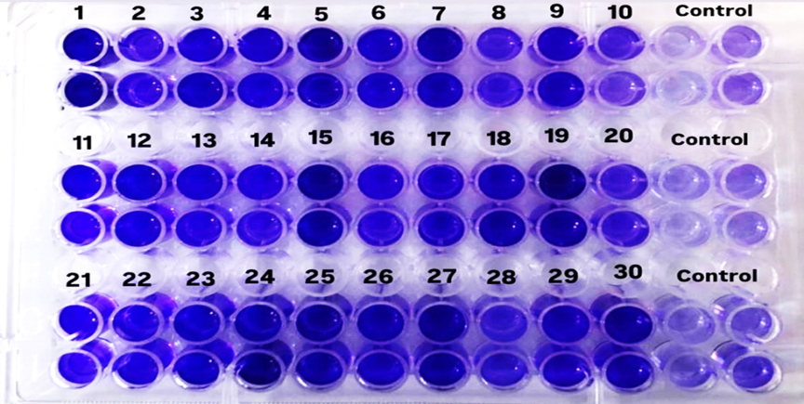
Figure 6. Color development indicating biofilm formation by E. coli isolates using microtiter plates.

The effect of MC-SeNPs on the biofilm formation
In this study, the effect of selenium nanoparticles synthesized from M. communis L. leaf extract on biofilm formation by fifty E. coli isolates was evaluated, including strong, moderate, and weak biofilm producers. Using the sub-minimal inhibitory concentration (SUB-MIC), the results showed that inhibition rates ranged from 7.8% to 85% in strong biofilm isolates, 44% to 57% in moderate biofilm isolates, and 39% to 71% in weak biofilm isolates. These findings indicate a significant potential of selenium nanoparticles in reducing biofilm formation across different E. coli phenotypes.

The antioxidant activity of M.communis L. leaf extract, MC-SeNPs and ascorbic acid
The antioxidant activity of M. communis L. leaf extract, MC-SeNPs, and ascorbic acid was evaluated using DPPH radical scavenging assays. The results showed a concentration-dependent increase in radical scavenging activity. For M. communis L. extract, activity ranged from 10.32% at 1.95 µg/ml to 75.12% at 1000 µg/ml. MC-SeNPs exhibited higher activity, from 14.81% at 1.95 µg/ml to 98.84% at 1000 µg/ml. Ascorbic acid showed similar high activity, from 16.21% at 1.95 µg/ml to 98.94% at 1000 µg/ml (Fig. 10).
To assess the efficacy of photosynthesised MC-SeNPs in erythrocyte haemolysis, haemolytic activity was measured in vitro in a dose-dependent manner. Even at higher doses, the photosynthesised MC-SeNPs were observed to have the lowest haemolytic effect, indicating low toxicity (Fig. 11).

Figure 7. Biofilm formation by E. coli isolates measured by optical density (OD) using the microtiter plate method.

Figure 8. Effect of MC-SeNPs on biofilm formation by E. coli isolates measured by optical density (OD).

Figure 9. Percentage inhibition of biofilm formation in E. coli isolates treated with MC-SeNPs.
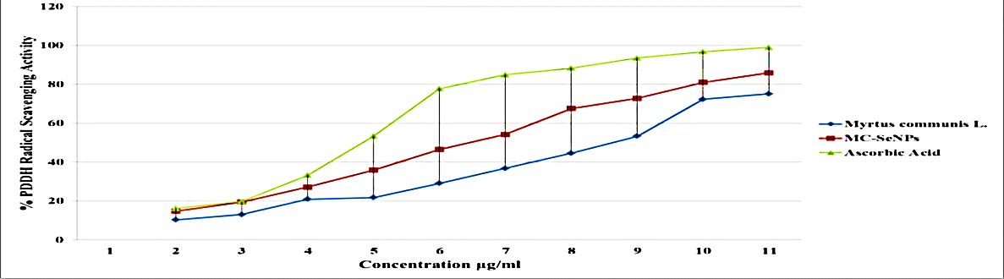
Figure 10. Comparative percentage of radical scavenging activity of Aas leaf extract, MC-SeNPs, and ascorbic acid.

Figure 11. The haemolysis activity of Aas leaf extract and MC-SeNPs.

Discussion
The isolation of E. coli was carried out using standard bacteriological methods (17). Clinical samples were cultured on MacConkey agar and incubated at 37°C for 24 h, producing pink colonies. Pure isolates were subcultured on nutrient agar and eosin methylene blue (EMB), where metallic green colonies confirmed E. coli (28). Gram staining and biochemical tests, including TSI and IMViC, further characterised the isolates, while final confirmation was done using the VITEK® 2 compact system (18). A total of 50 E. coli isolates (33.3%) were obtained from 150 samples: 30 (60%) from urinary tract infections, 15 (30%) from wounds, and 5 (10%) from burns, consistent with previous studies in Baghdad (29–31). Antimicrobial susceptibility was tested using both the Kirby-Bauer disc diffusion and VITEK® 2 AST systems. The VITEK® 2 method was more accurate and reliable, whereas Kirby-Bauer presented limitations such as uneven bacterial distribution (32). Results showed most isolates resistant to seven antimicrobials by Kirby-Bauer and eleven by VITEK® 2, aligning with previous findings (33). Biofilm analysis revealed 31 strong (62%), 13 moderate (26%), and 6 weak (12%) biofilm formers, consistent with other reports linking biofilms to resistance in clinical isolates (34, 35). Treatment with Myrtus communis-derived selenium nanoparticles (MC-SeNPs) significantly inhibited biofilm formation: 7.8–85% in strong, 44–57% in moderate, and 39–71% in weak biofilm formers, in agreement with previous studies (36, 37). Antioxidant assays showed increased radical scavenging with higher concentrations of plant extract, MC-SeNPs, and ascorbic acid, due to direct neutralisation of ROS and activation of antioxidant enzymes such as GPx and SOD (38, 39). MC-SeNPs demonstrated superior activity compared to plant extract alone, supporting earlier studies (40, 41). Finally, haemolysis assays indicated low toxicity of MC-SeNPs, with reduced haemolytic activity at lower concentrations, consistent with previous findings (42).

CONCLUSION
The results of this study indicate that selenium nanoparticles from mycelium (MC-SeNPs) have antimicrobial, antiviral and antioxidant properties as well as low cytotoxicity. This makes them promising for clinical applications as alternative antibiotics and in industry and the environment as an anti-pollution agent. However, the use of these particles in practise requires further studies to assess their toxicity and efficacy in vivo to ensure their safety and effectiveness.

Acknowledgments
We thank the staff of the Science University/Biotechnology Department for their support in conducting the experiments and interpreting the results, especially Dr Laith and his group.

References
- R. Najm and J. M. Hussein, J Popul. Ther. Clin. Pharmacol. 30, e459–e464 (2023).
- V. Hemraj, S. Diksha and G. Avneet, IJLS 1, 1–7 (2013).
- A. Wanger, V. Chavez, R. S. P. Huang, A. Wahed, J. K. Actor and A. Dasgupta, Microbiology and Molecular Diagnosis in Pathology (Elsevier Inc., 2017), 300pp.
- N. Jonathan, V. Martinson and S. T. Walk, EcoSal Plus 9, ESP-0003-2020 (2020). https://doi.org/10.1128/ecosalplus.esp-0003-2020.
- C. Zagaglia, M. G. Ammendolia, L. Maurizi, M. Nicoletti and C. Longhi, Microorganisms 10, 1425 (2022). https://doi.org/10.3390/microorganisms10071425
- P. Pokharel, S. Dhakal and C. M. Dozois, Microorganisms 11, 344 (2023). https://doi.org/10.3390/microorganisms11020344
- B. Pakbin, W. M. Brück and J. W. A. Rossen, Int. J. Mol. Sci. 22, 9922 (2021). https://doi.org/10.3390/ijms22189922
- S. Biswas, M. Bal, S. Pati, R. Rana, S. Dixit and M. Ranjit, Disc. Med. 1, 1–17 (2024). https://doi.org/10.1007/s44337-024-00102-x
- T. Cherian, T. Merlin, K. Rajendran and J. Thomas, Results Surf. Interf. 19, 100562 (2025). https://doi.org/10.1016/j.rsurfi.2025.100562
- P. Chilala, M. Jurickova, Z. Pokorna, T. Motlova, P. Horky and S. Skalickova, PLoS One 20, e0325460 (2025). https://doi.org/10.1371/journal.pone.0325460.
- R. M. Yasir and N. H. Zaki, Asian Pac. J. Cancer Prev. 26, 1303–1311 (2025). https://doi.org/10.31557/APJCP.2025.26.4.1303
- E. Sans-Serramitjana, M. Obreque, F. Muñoz, C. Zaror, M. d. L. L. Mora, M. Viñas and P. Betancourt, Pharmaceutics 15, 2253 (2023). https://doi.org/10.3390/pharmaceutics15092253
- I. F. Xia, H.-K. Kong, M. M. H. Wu, Y. Lu, K.-H. Wong and K. W. H. Kwok, Antioxidants 11, 964 (2022). https://doi.org/10.3390/antiox11050964
- A. M. Asaad, S. A. Saied, M. M. Torayah, N. I. Abu-Elsaad and S. M. Awad, BMC Microbiology 25, 33 (2025). https://doi.org/10.1186/s12866-025-03743-9
- M. A. J. Raoof and M. A. Fayidh, J. Phys Conf. Ser. 1879, 022051 (2021). https://doi.org/10.1088/1742-6596/1879/2/022051.
- M. Rasha and N. H. Zaki, Iraqi J. Biotechnol. 24, 146–158 (2025).
- R. I. Abdulwahhab and S. M. Hussein, Iraqi J. Biotechnol 23, 221–232 (2024).
- A. H. F. Duraye, Z. H. Hadi, Z. H. Jarad, Z. S. Naji, Z. H. Hussein, Z. H. Abd Hamada and F. H. Naema, Int. Aca J. App. Biomed Sci 5, 1–6 (2024). https://www.iarconsortium.org/journal/iajabms/home/
- A. W. Bauer, W. M. Kirby, J. C. Sherris and M. Turck, Am J Clin Pathol 45, 493–496 (1966).
- M. Banerjee and V. D. Rajeswari, Biocatal. Agric. Biotechnol. 55, 102978 (2024). https://doi.org/10.1016/j.bcab.2023.102978
- M. S. Elshikh, S. Ahmed, P. Funston, M. Dunlop, R. McGaw, R. Marchant and I. M. Banat, Biotechnol. Lett. 38, 1015–1019 (2016). https://doi.org/10.1007/s10529-016-2079-2
- B. M. Coffey and G. G. Anderson, Methods Mol. Biol. 1149, 631–641 (2014). https://doi.org/10.1007/978-1-4939-0473-0_48
- K. K. Annamalai, B. Selvaraj, K. Subramanian, R. Binsuwaidan and M. Saeed, Microb. Pathogen. 193, 106740 (2024). https://doi.org/10.1016/j.micpath.2024.106740
- I. Gulcin and S. H. Alwasel, Processes 11, 2248 (2023). https://doi.org/10.3390/pr11082248
- M. A. Dobrovolskaia, J. D. Clogston, B. W. Neun, J. B. Hall, A. K. Patri and S. E. McNeil, Nano Lett. 8, 2180–2187 (2008). https://doi.org/10.1021/nl0805615
- SAS Institute Inc., Statistical Analysis System, User’s Guide, Version 9.1, Cary, NC, USA (2012).
- J. H. Zar, Biostatistical Analysis, 5th ed., ISBN: 0131008463 (2010).
- M. A. Zinnah, M. R. Bari, M. T. Islam, M. T. Hossain, M. T. Rahman, M. H. Haque, S. A. M. Babu, R. P. Ruma and M. A. Islam, Bangl. J. Vet. Med. 5, 25–32 (2007). https://www.researchgate.net/publication/232962996
- B. O. Abdulsattar, N. A. Al-Saryi, M. H. Abbas and A.-R. A. Abdulhussein, Gene Rep. 19, 100591 (2020). https://doi.org/10.1016/j.genrep.2020.100591
- D. R. Hamady and S. K. Ibrahim, Biochem. Cell. Arch. 20, 5553–5557 (2020). https://connectjournals.com/03896.2020.20.5553
- S. M. Mahmood and S. K. Ibrahim, Ibn AL-Haitham J. Pure App. Sci. 38, 63–73 (2025). https://doi.org/10.30526/38.2.3744
- D. L. C. Pradana, A. F. Muti, E. P. Rahmi, N. Elzuhria, A. Fajwatunnisa, U. Hanidah, F. Buulolo, T. A. Hidayat, F. A. Nabilla, , and N. A. Rizqi, J. of Res. Pharm. Pharmac. Sci. 2, 38–47 (2023). https://doi.org/10.33533/jrpps.v2i1.7027
- A. Salam, Y. Al-Amin, J. S. Pawar, N. Akhter and I. B. Lucy, Saudi J. Biol. Sci. 30, 1–15 (2023). https://doi.org/10.1016/j.sjbs.2023.103582
- S. A. Abdul Hamid and R. M. Khoshaba, Iraqi J. Sci. 65, 5546–5554 (2024). https://doi.org/10.24996/ijs.2024.65.10.19
- M. A. Raoof and M. A. Fayidh, Int. J. Drug Deliv. Technol. 12, 695–700 (2022).
- Z. M. Romi and M. E. Ahmed, Iraqi J. Sci. 65, 1948–1968 (2024). https://doi.org/10.24996/ijs.2024.65.4.15
- M. H. Al-Azzawi and E. J. Al-Kalifawi, Egyptian J. Hosp. Med. 90, 2275–2282 (2023). https://ejhm.journals.ekb.eg/.
- S. Boussahel, A. Djeridane and D. Ait-Yahia, J. Appl. Bot. Food Qual. 95, 1–8 (2022). https://doi.org/10.5073/JABFQ.2022.095.001.
- T. Rahman, M. R. Hasan and M. M. Hossain, Oxid. Med. Cell. Longev. 2024, 8823094 (2024). https://doi.org/10.1155/2024/8823094.
- I. H. Al-Abdeli and E. J. Alkalifawi, Ibn AL-Haitham J. Pure Appl. Sci. 36, 110–126 (2023). https://doi.org/10.30526/36.4.3141
- K. H. AL-Ramlawee and E. J. Al-Khalifawi, Iraqi J. Sci. 66, 2290–2310 (2025). https://doi.org/10.24996/ijs.2025.66.6.9
- A. Mesdaghiniaa, Z. Pourpakc, K. Naddafi, R. N. Nodehia, Z. Alizadehc, S. Rezaeid, A. Mohammadie and M. Faraji, MethodsX 6, 156–161 (2019). https://doi.org/10.1016/j.mex.2019.01.001.

