Evaluation of Parasitic Contamination Loaded by American Cockroach Collected from Hospitals in Dhuluiya, Salah Al-Din Province, Iraq; Implication Health Risk
Mather Ahmed Hussein ^{1, a)} and Alaa Emad Tawfiq ^{1, b)}
¹ Tikrit University, College of Education for Girls, Department of Biology, Iraq
^{a)} Corresponding author: Mather.ahmed.hussein@gmail.com
^{b)} alaa.altikrity@tu.edu.iq

Abstract. The abundance of cockroaches in hospital environments, particularly in sewage systems, makes them potential human health risk factors through the transmission of various pathogens. This study evaluates the parasitic contamination carried by American cockroaches collected from the sewage systems in hospitals in Dhuluiya, Salah Al-Din Province, Iraq. A total of 37 American cockroaches were collected from sewage systems, and both internal and external parasites were isolated between October 2024 and March 2025. The parasites were identified microscopically using Lugol's iodine dye. The results revealed the presence of 14 different parasite species, with Nyctothyrous ovalis being the most prevalent gut flora. Other dangerous types, such as Strongyloides stercoralis and Enterobius vermicularis, were also identified. Additional pathogenic parasites included Ancylostoma duodenale, Trichomonas hominis, Entamoeba histolytica, Dipylidium spp., and Fasciola hepatica. This study suggests that the sewage systems in local hospitals in Salah Al-Din Province, Iraq, act as a source of medically important parasites.
Keywords: Public Risk, Periplaneta Americana , Parasites, Cockroaches, Iraq.
INTRODUCTION
Many types of cockroaches have adapted to various environmental niches, enabling them to survive under diverse conditions Although from 4600 species identified, ninety nine percent belong to non-human [1-3], such as in in the tropics and subtropics of the world [4]. Although 4600 species have been identified, ninety-nine percent of them are non-human [5]. However, some species, such as the German cockroach (Blatella germanica) and the American cockroach (Periplaneta americana), are closely associated with humans and are characterized by their widespread global presence [6,7]. Depending on the World Health Organization (WHO), American cockroach became a major public health risk doe to their capability to carry mechanically many types of human pathogens like bacteria, fungi, viruses, and parasites on their body surfaces [9,10]. Parasites, among the most diverse and prevalent human pathogens, are particularly common in developing countries and can cause a variety of diseases in both animals and humans [11], and the health risk increased due to their ability to transmission by vectors though many ways like during food consumption [12] also on the external surfaces of arthropods [13]. Many previous studies have highlighted the significant risk posed by cockroaches in transmitting human pathogens, as one study in Nigeria states the importance of the role of the American cockroach from the home environment in the transfer of pathological medical parasites on the outer and inner surface, and showed that 79 out of 150 American cockroaches were contaminated with medical parasites, including Entamoeba histolytica and various types of nematodes [14], confirmed by other previous works using different environments like university environment [15] and in shops [16] as well as in hospital settings (17), and this indicates that these environments can pose a medical hazard by sheltering cockroaches contaminated with medical parasites, but the assessment of the parasitic contamination in local environments in Iraq is still unclear and require further local studies.
Recently in capital, Baghdad, Iraq, a study of [19] shows great role of these insects in transmitting dangerous pathogens, as the American cockroaches in hospital environment, other local studies show the role of this insect in transmission bacterial pathogens [18] and these findings assume the importance to carry epidemiological studies in other local area, especially in hospitals environment. As many local studies prove that American cockroaches carry many types of pathogenic parasites, like Ancylostoma duodenale, Nyctotherus ovalis, Ancylostoma duodenale [20], and other types including Enterobius vermicularis and Giardia species [21]. Although there have been many studies on them worldwide, the researchers believed that more thorough research should be done locally because there aren't many studies on American cockroaches, and as far as we know, no prior studies have been done on their potential role as human intestinal parasite vectors in hospitals environment in Salah al-Din Governorate. In order to ascertain the proportion of American cockroaches infected with medical parasites, the current study set out to isolate American cockroaches from hospitals environment within the Salah al-Din Governorate.
This research is important for public health, especially in hospital settings, where American cockroaches can pose a serious health risk by carrying harmful parasites. By studying the cockroaches found in hospitals in Salah Al-Din Province, Iraq, the research sheds light on how these insects can spread diseases like Strongyloides stercoralis, Enterobius vermicularis, and Fasciola hepatica. These findings are crucial for improving hygiene and infection control in hospitals, as they show how cockroaches, particularly in sewage systems, can be a hidden source of infections. This research helps raise awareness and provides valuable information for better sanitation practices, ultimately protecting the health of hospital patients, staff, and the wider community.
EXPERIMENTAL PART
A total of thirty-seven American cockroach specimens were collected from sewage systems of local hospitals in the Dhuluiya area. The collection period spanned from the beginning of October 2024 to the end of March 2025. All specimens were identified and verified by the Iraqi Natural History Center Research and Museum on December 17, 2024. The collected cockroaches were euthanized after being placed in sterilized containers and subjected to refrigeration at -4°C, following the method outlined by [22]. To facilitate the displacement of external parasite stages, 10 mL of sterile normal saline was added to each sample, which was then vigorously shaken. The samples were subsequently centrifuged at 3000 rpm for 5 minutes, and the resulting pellets were examined under a microscope. Lugol's iodine dye was applied to the pellet samples to assist in the identification of external parasites, as per the procedure described by [23].
The protocol established by [20] was used to isolate internal parasites from the American cockroaches. Each specimen was anatomized, and the digestive tract (Figure 2) was carefully isolated and washed with distilled water. Following this, 10 mL of normal saline was added, and the sample was centrifuged at 2000 rpm for 5 minutes. The resultant pellet was then microscopically examined for the presence of internal parasites. To aid in the identification process, the pellets were stained with Lugol's iodine dye, as indicated by [6]. The identification of both external and internal parasites isolated from the American cockroaches was carried out using the most recent identification keys provided by [24]. Various diagnostic characteristics, such as size, shape, and the number of cysts, were used in conjunction with these keys to accurately identify the parasites present in the samples.
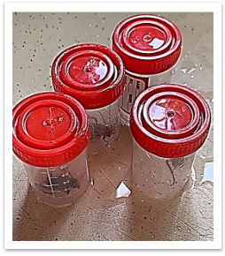
FIGURE 1. Sterilized Plastic Containers Containing Cockroach Samples Collected for Laboratory Examination.
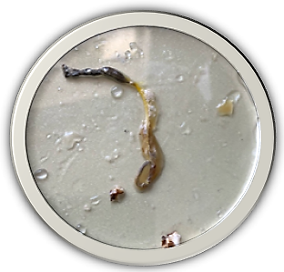
FIGURE 2. The Digestive Tract of the American Cockroach.
RESULTS AND DISCUSSION
Results of present study as shown in table (1) show that November is preferable duration of prevalence of American cockroaches in hospitals, as the table show that 67.57% (25 samples) of total collected cockroaches were in November month, while in October and December, the study was unable to collect American cockroaches. During first period of year, present study collects 12 samples of American cockroaches distributed equally (6 sample) to January and February, while no sample collected during March. This study reveals presence of 14 different parasites species with different diagnostic stages, and table (2) shows that the most prevalent parasites in local hospitals were Nectothyrous ovalis (7 samples) followed by both Strongyloides stercoralis and Enterobius vermicularis (4 samples for each one), 3 samples were positive for Ancylostoma duodenalis and Trichomonas hominis, other parasites species like Entamoeba histolytica (cyst) and Dipylidium (eggs) and Fasciola hepatica (eggs) were appeared in twice, while Entamoeba coli (cyst), Giardia lamblia (trophozoite), Hymenolepis nana, Toxocara canis, Diphyllobothrium latum, and Ascaris lumbricoides were appeared once.
TABLE 1. Distribution of Collected Cockroaches and Percentage of Parasite Infections by Month
Month | Number of Collected Cockroaches | Percentage (%)  Part/Whole $×$ 100% | Number of Affected Cockroaches | Percentage(%)  Part/Whole $×$ 100%
October 2024 | - | - | - |  | -
November 2024 | 25 | 67.5% | 11 |  | 44%
December 2024 | - | - | - |  | -
January 2025 | 6 | 16.2% | 3 |  | 50%
February 2025 | 6 | 16.2% | 6 |  | 100%
March 2025 | - | - | - |  | -
Total | 37 | 100% | 21 |  | -

TABLE 2. Parasite Species Isolated from American Cockroaches Collected from Hospital Environments
No. | Parasites (Stage) | Number
1 | Entamoeba coli (cyst) | 1
2 | Entamoeba histolytica (cyst) | 2
3 | Giardia lamblia (trophozoite) | 1
4 | Strongyloides stercoralis | 4
5 | Ancylostoma duodenalis | 3
6 | Trichomonas hominis | 3
7 | Dipylidium (eggs) | 2
8 | Nyctothyrous ovalis | 7
9 | Hymenolepis nana | 1
10 | Enterobius vermicularis | 4
11 | Fasciola hepatica (eggs) | 2
12 | Toxocara canis | 1
13 | Diphyllobothrium latum | 1
14 | Ascaris lumbricoides | 1
Total |  | 33

Nosocomial infections, also known as hospital-acquired infections, are a significant health concern, particularly in hospital settings where individuals may contract these infections from the hospital environment itself. A recent study indicated that these infections in hospitals in Iraq pose a critical health risk [21]. Controlling the sources of these infections is crucial for effectively managing and mitigating the associated health risks. Therefore, the present study aims to assess the parasitic contamination carried by American cockroaches in hospital environments, as these cockroaches may serve as a potential source of parasitic infections acquired within hospitals.The findings of the present study reveal that Nyctotherus ovalis is the most prevalent parasite species carried by American cockroaches. This particular parasite is known to be a common part of the gut flora of cockroaches [19]. This result aligns with the findings of previous studies [17,18]. However, other research suggests that Nyctotherus ovalis may be considered a pseudo-parasite for both humans and animals [18], with its exact impact on human health not fully understood. Nevertheless, the present study posits that this parasite may represent a potential health risk to humans, warranting further investigation.In addition to Nyctotherus ovalis, the study identified two well-established human pathogenic parasites: Strongyloides stercoralis and Enterobius vermicularis. This observation is consistent with a recent study by [16], which successfully isolated both parasites and highlighted the potential public health implications of their presence. Other studies have also reached similar conclusions [14,15]. Enterobius vermicularis is one of the most significant human pathogens, particularly in cooler and temperate climates, as observed in developed countries [12,13]. This parasite can lead to various diseases and is transmitted through close contact between infected and non-infected individuals or via inhalation of its eggs [11]. It is associated with several health issues, including urinary tract infections, pelvic abscesses, and salpingitis [9,10]. Additionally, recent reports suggest that Enterobius vermicularis may also contribute to appendicitis [8].Strongyloides stercoralis is another critical human pathogen responsible for strongyloidiasis [7]. The presence of these parasites in hospital environments, carried by cockroaches, raises serious health concerns. It is believed that the transmission of these parasites could occur through sewage systems, particularly from municipal sewage workers in the hospital. This hypothesis is supported by the fact that all samples in this study were collected from hospital sewage. Previous studies have corroborated this idea [1], showing that sewage workers may acquire infections from exposure to contaminated sewage.Additionally, Ancylostoma duodenale, a parasite known to cause upper gastrointestinal bleeding, was also reported in recent studies [6]. Entamoeba histolytica, responsible for amebiasis, is another dangerous parasite that contributes to high global mortality rates [3]. Dipylidium caninum, the causative agent of dipylidiosis, is a tapeworm transmitted by fleas and, less commonly, lice [2].
The presence of these harmful parasites, carried by American cockroaches in hospital sewage systems, highlights the critical role these insects may play in transmitting parasitic infections. This underscores the importance of maintaining strict hygiene and controlling potential sources of infection within hospital environments to reduce the risk of nosocomial infections.
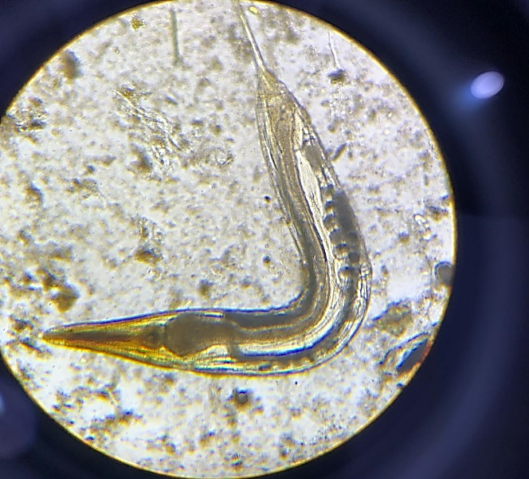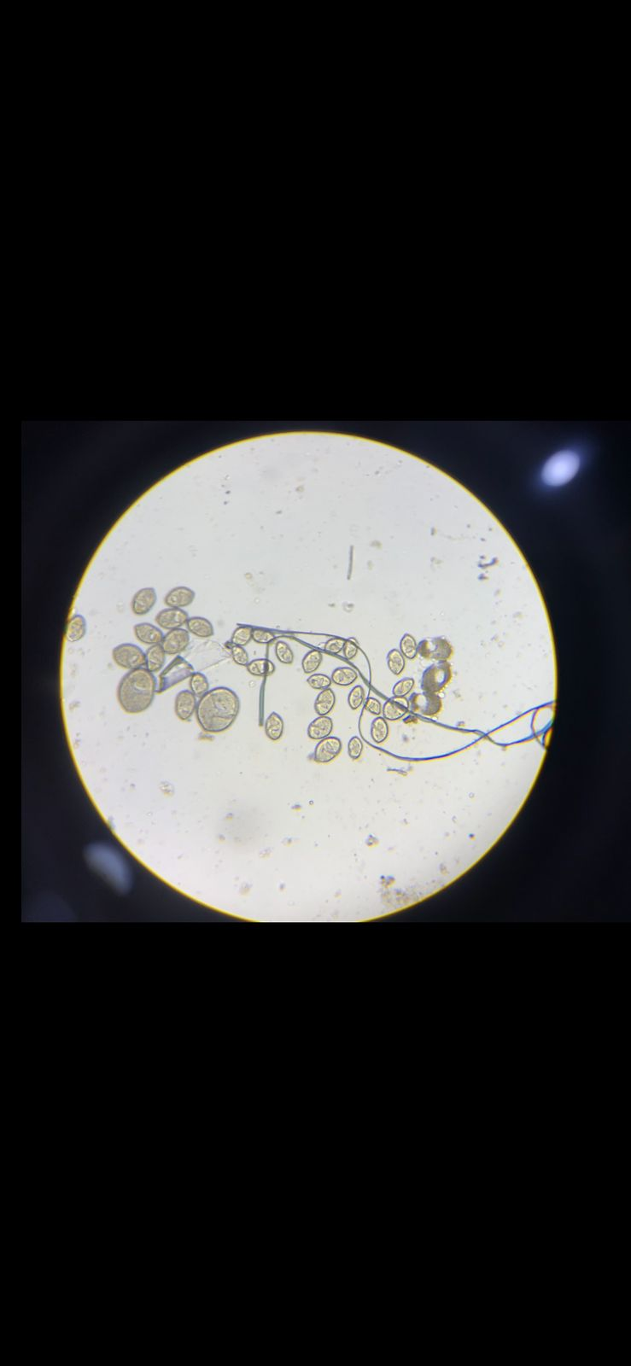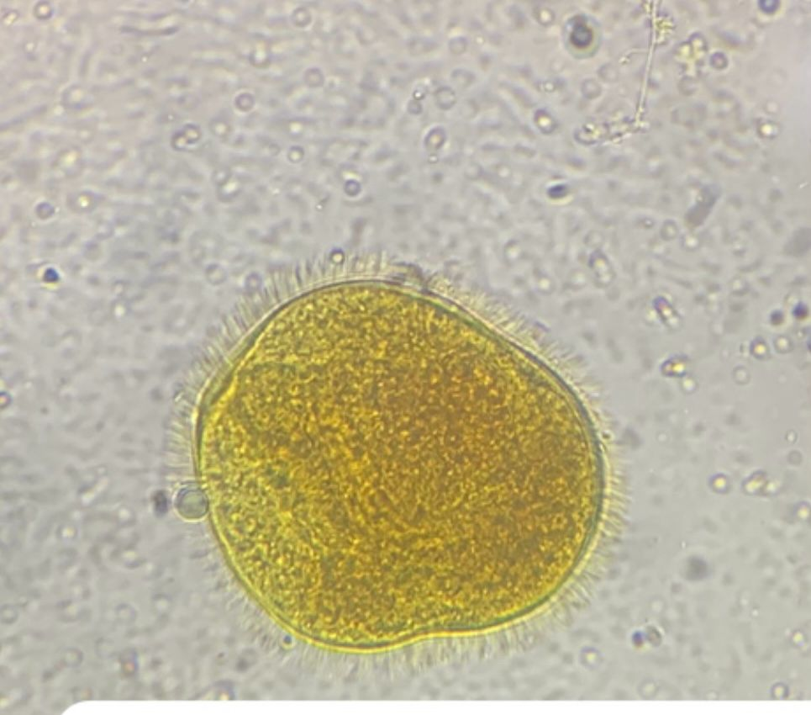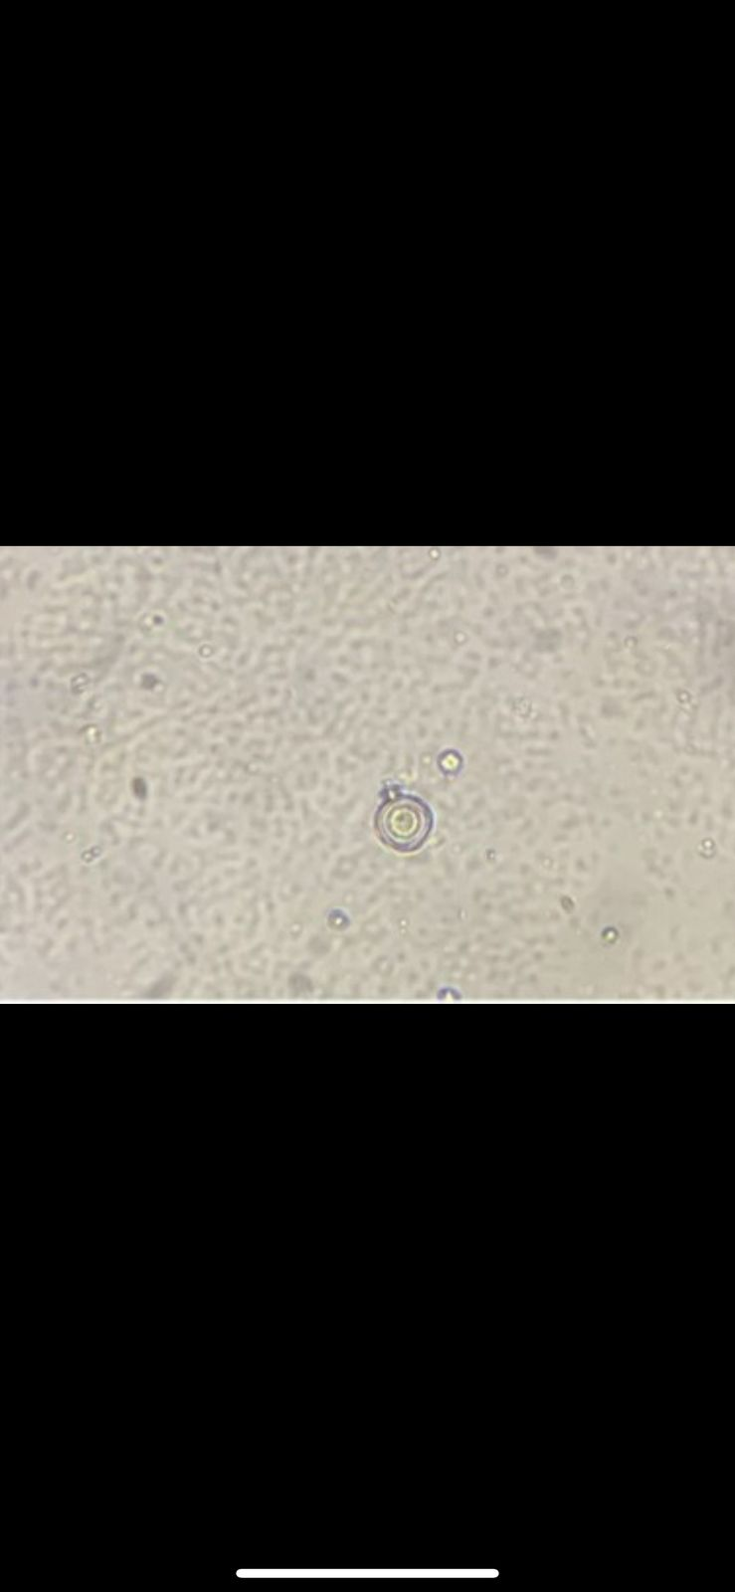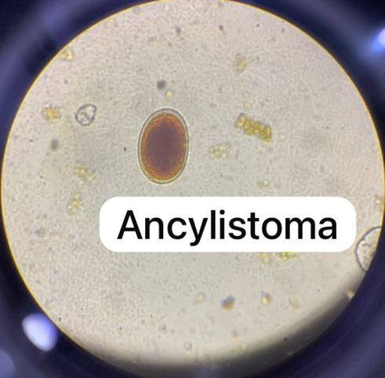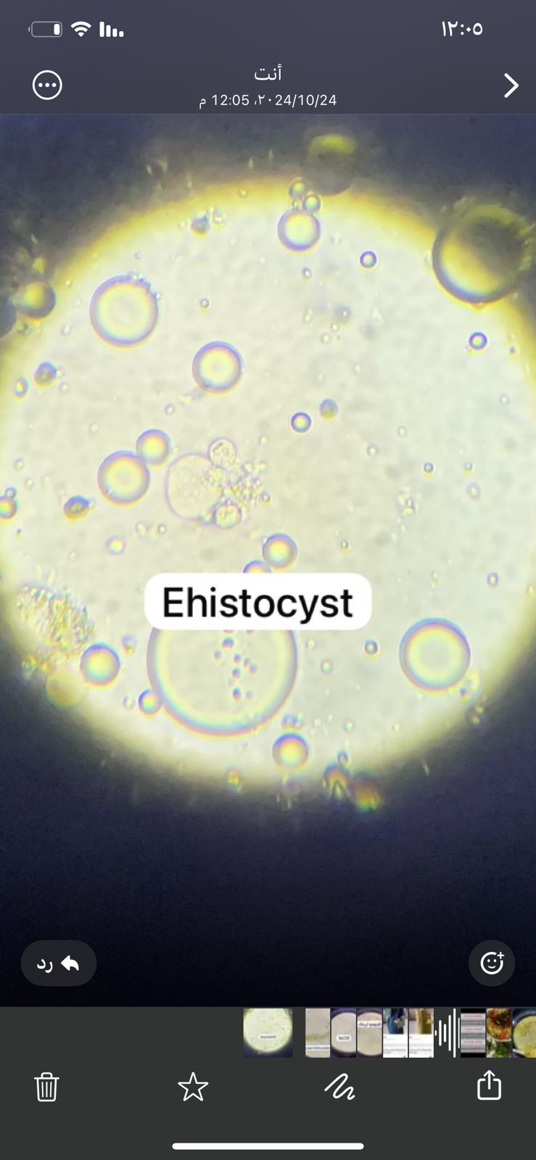
(f)
(e)
(d)
(c)
(b)
(a)
FIGURE 1. Microscopic examination of parasites isolated from American cockroaches: Strongyloides stercoralis (a), Nectothyrous ovalis (b), Balantidium coli (c), Hymenolepis eggs (d), Ancylostoma duodenale (e), Entamoeba coli (cyst) (F).
Figure 1 displays several species, each with distinctive characteristics. Strongyloides stercoralis (a), a parasitic nematode, is shown in its larval form. Nectothyrous ovalis (b), a ciliate organism, appears with its characteristic oval shape. Balantidium coli (c), another ciliate protozoan, is depicted with its typical appearance. The eggs of Hymenolepis (d), a tapeworm, are identified by their rounded shape and internal structures. The Ancylostoma duodenale (e) hookworm eggs are presented, showcasing their typical morphology. A closer examination of Strongyloides stercoralis (f) reveals more details of its larval stage. Lastly, Entamoeba coli (g) is shown in its cyst form, highlighting the defining structural features of this protozoan parasite. These images serve as important visual representations, aiding in the identification and understanding of these parasites' biology and pathogenic mechanisms.
Nyctotherus ovalis is a predominant intestinal parasite of the American cockroach and is generally considered part of its normal flora. However, some researchers suggest that this parasite may play a role in disease transmission if present in unsanitary environments, such as hospitals or polluted areas, especially when the host is in poor health. Although it is generally considered a harmless parasite, there is evidence that it may be associated with some pathological symptoms when transmitted to humans under certain conditions, such as immunocompromised individuals or coinfection with other parasites [17][19][21]. Thus, further studies are needed to evaluate its potential health impact in hospital environments, where cockroaches are present in contaminated sewage systems.
CONCLUSIONS
A study conducted in the hospital sewage systems of Dhuluiya, Salah Al-Din Province, Iraq, has raised significant concerns about the public health risks posed by American cockroaches. These cockroaches were found to carry 14 different types of parasites, including some that can be harmful to humans, such as Strongyloides stercoralis, Enterobius vermicularis, and Fasciola hepatica. The most common parasite found was Nyctothyrous ovalis, a ciliate commonly found in cockroach gut flora. While its exact role in causing harm to humans isn’t fully understood, it suggests the need for further research. These findings stress the importance of maintaining strict hygiene standards and infection control measures in hospitals, particularly in sewage systems, to minimize the risk of infections. It also highlights the need for continued research into how cockroaches may act as carriers of diseases, helping us understand their role as potential vectors for human pathogens, especially in healthcare settings.
ACKNOWLEDGMENTS
I would like to express my deepest gratitude to the University of Tikrit, College of Education for Girls, Department of Biology, and to my supervisor, Alaa Emad Tawfiq, for their continuous support and guidance throughout my academic journey. Their encouragement has been invaluable to my success.
REFERENCES
- F. Hassanein, I. Masoud, & A. Shehata, "Infection hazard of exposure to intestinal parasites, H. pylori, and hepatitis viruses among municipal sewage workers: a neglected high-risk population," Parasitol. United J., vol. 12, no. 2, pp. 130-138, 2019. DOI : 10.23749/mdl.v114i2.14300
- J. Rousseau, A. Castro, T. Novo, & C. Maia, "Dipylidium caninum in the twenty-first century: epidemiological studies and reported cases in companion animals and humans," Parasites Vectors, vol. 15, no. 1, p. 131, 2022. DOI : 10.1186/s13071-022-05243-5
- M. Kantor, A. Abrantes, A. Estevez, A. Schiller, J. Torrent, J. Gascon, ... & C. Ochner, "Entamoeba histolytica: updates in clinical manifestation, pathogenesis, and vaccine development," Can. J. Gastroenterol. Hepatol., vol. 2018, p. 4601420, 2018. DOI : 10.1155/2018/4601420
- T. Edwards, P. Burke, H. Smalley, & G. Hobbs, "Trichomonas vaginalis: Clinical relevance, pathogenicity and diagnosis," Crit. Rev. Microbiol., vol. 42, no. 3, pp. 406-417, 2016. DOI : 10.1016/B978-0-443-22204-7.00003-4
- P. Karadbhajne, A. Tambekar, A. Gaidhane, Z. Q. Syed, & S. Gaidhane, "A Case Report on Ancylostoma Duodenale Infection in Pregnant Woman," Biosci. Biotech. Res. Commun., vol. 14, pp. 100-103, 2021. DOI : 10.21786/bbrc/14.6.23
- A. C. Ronquillo, L. B. Puelles, L. P. Espinoza, V. A. Sánchez, & J. Luis Pinto Valdivia, "Ancylostoma duodenale as a cause of upper gastrointestinal bleeding: a case report," Braz. J. Infect. Dis., vol. 23, no. 6, pp. 471-473, 2019. DOI: 10.1016/j.bjid.2019.09.002
- D. Buonfrate, F. Formenti, F. Perandin, & Z. Bisoffi, "Novel approaches to the diagnosis of Strongyloides stercoralis infection," Clin. Microbiol. Infect., vol. 21, no. 6, pp. 543-552, 2015. DOI: 10.1016/j.cmi.2015.04.001
- A. Taghipour, M. Olfatifar, E. Javanmard, M. Norouzi, H. Mirjalali, & M. R. Zali, "The neglected role of Enterobius vermicularis in appendicitis: A systematic review and meta-analysis," PLoS One, vol. 15, no. 4, p. e0232143, 2020. DOI: 10.1371/journal.pone.0232143
- S. Choudhury, B. Kumar, & D. K. Pal, "Enterobius vermicularis infestation of urinary tract leading to recurrent urinary tract infection," Trop. Parasitol., vol. 7, no. 2, pp. 119-121, 2017. DOI: 10.4103/tp.TP_76_17
- A. Peixoto, R. Gonçalves, M. Silva, R. Gaspar, R. Silva, R. Portugal, & G. Macedo, "Eosinophilic ileocolitis due to Enterobius vermicularis infection: a rare cause of anemia," Int. J. Colorectal Dis., vol. 31, no. 3, p. 743, 2016. DOI: 10.1007/s00384-015-2239-1
- I. Cranston, N. Potgieter, S. Mathebula, & J. H. Ensink, "Transmission of Enterobius vermicularis eggs through hands of school children in rural South Africa," Acta Trop., vol. 150, pp. 94-96, 2015. DOI: 10.1016/j.actatropica.2015.07.001
- S. Wang, Z. Yao, Y. Hou, D. Wang, H. Zhang, J. Ma, ... & S. Liu, "Prevalence of Enterobius vermicularis among preschool children in 2003 and 2013 in Xinxiang city, Henan province, Central China," Parasite, vol. 23, p. 30, 2016. DOI: 10.1051/parasite/2016030
- M. Moosazadeh, G. Abedi, M. Afshari, S. A. Mahdavi, F. Farshidi, & E. Kheradmand, "Prevalence of Enterobius vermicularis among children in Iran: A systematic review and meta-analysis," Osong Public Health Res. Perspect., vol. 8, no. 2, pp. 108, 2017. DOI: 10.24171/j.phrp.2017.8.2.03
- A. V. Akeju, T. A. Olusi, & R. T. E. Obi, "Intestinal parasites associated with American cockroach (Periplaneta americana) in Akure, Ondo state, Nigeria," J. Parasit. Dis., vol. 48, no. 1, pp. 67-73, 2024. DOI: 10.1007/s12639-023-01561-4
- M. A. Irawan, Y. C. Panggabean, D. A. Dalimunthe, & L. Siahaan, "Prevalence of Cockroach Density, Gastrointestinal Disorders, and Identification of Parasites in Cockroaches in Helvetia Deli Serdang Village," J. Endocrinol., vol. 2686, p. 0856, 2025.
- J. S. Ngwamah, A. Mathias, & Y. B. Dakum, "Evaluation of the role of cockroaches as a vector of medically important parasites carried in Lokoja, Kogi State, Nigeria," J. Appl. Entomol., vol. 1, no. 1, pp. 01-05, 2021.
- L. P. Van der Geest, S. L. Elliot, J. A. J. Breeuwer, & E. A. M. Beerling, "Diseases of mites," Exp. Appl. Acarol., vol. 24, no. 7, pp. 497-560, 2000. DOI: 10.1023/A:1026510621315
- S. Johny, A. Merisko, & D. W. Whitman, "Efficacy of eleven antimicrobials against a gregarine parasite (Apicomplexa: Protozoa)," Ann. Clin. Microbiol. Antimicrobials, vol. 6, no. 1, p. 15, 2007. DOI: 10.1186/1476-0711-6-15
- R. B. Lopes, & S. B. Alves, "Effect of Gregarina sp. parasitism on the susceptibility of Blattella germanica to some control agents," J. Invertebr. Pathol., vol. 88, no. 3, pp. 261-264, 2005. DOI: 10.1016/j.jip.2005.06.002
- A. F. Monegro, V. Muppidi, & H. Regunath, "Hospital-Acquired Infections (Archived)," StatPearls [Internet], Treasure Island (FL): StatPearls Publishing, 2023 Feb 12, PMID: 28722887, 2025.
- A. M. Mustafa, R. Q. Salih, H. A. Yaseen, W. A. Hamadameen, S. H. Kakamad, F. Abdullah, ... & S. S. Abdalla, "Evolution of Antimicrobial Resistance in Community vs. Hospital-Acquired Infections," Barw Med. J., 2025.

