Research Trends on the Use of Nanoparticles in Construction Materials: A Bibliometric Analysis
Renny Nazario-Naveda^{1, a)}, Santiago M. Benites^{1, b)}, Moisés Gallozzo-Cárdenas^{2, c)}, Randy Quiroz-Avila^{2, d)}, Dennis Cuevas-Vega^{2, e)} and Anthony García-Vilca^{2, f)}
¹Facultad de Ingeniería y Arquitectura, Universidad Autónoma del Perú, Lima 15842, Perú.
²Departamento de Ciencias, Universidad Tecnológica del Perú, Trujillo 13001, Perú.
^{a)} Corresponding author: renny.nazario@autonoma.pe
^{b)}santiago.benites@autonoma.pe
^{c)}c21228@utp.edu.pe
^{d)}u24237001@utp.edu.pe
^{e)}u24211664@utp.edu.pe
^{f)}u24201009@utp.edu.pe
Abstract. This study presents a bibliometric analysis focused on scientific articles and reviews in English on the use of nanoparticles in construction materials, collected from the Scopus database between 2010 and June 2025. The results reveal a dynamic and expanding field of research, with notable growth in scientific production, led mainly by China and India. The journal Construction and Building Materials is consolidated as the main publication source. Salemi N. and Singh LP. are presented as recognized and important local and global references in the literature. The co-occurrence analysis and the conceptual structure reveal a division between fundamental studies of nanomaterials and practical applications in construction materials and their characterization. Research is grouped in main areas as the study of the physical and chemical properties of nanomaterials, the improvement of material properties through nanoparticles, the development of sustainable materials, and specific applications in the construction industry.

Introduction
For the past few decades, traditional materials such as concrete and steel have been fundamental pillars in the development of modern infrastructures. Their success is largely due to their outstanding physical, mechanical, and thermal properties. However, they also present structural and environmental limitations that, under certain conditions, restrict their performance, reduce their useful life, and increase maintenance costs [1]. Among the main technical challenges are their low corrosion resistance, propensity to cracking, and chemical degradation. In addition, there is a high environmental impact due to the emission of CO₂ during production, especially in the case of Portland cement, which is responsible for around 7% of global emissions [2]. As a result, the construction industry must explore alternatives that allow improving the efficiency, sustainability, and resilience of materials, especially to face extreme climate scenarios or high structural demands [3,4].

Nanotechnology has emerged as a promising solution to address these challenges. Due to their unique scale and properties, nanoparticles can modify the behavior of materials from a molecular level, enabling substantial improvements in their properties [5]. Nanomaterials such as nanosilica, carbon nanotubes, or various metal oxides have been shown to be capable of increasing mechanical strength, reducing porosity, increasing durability, and also conferring new functionalities, such as self-cleaning or self-repair [6]. In this line, the work of Sobolev et al. is fundamental, laying the foundations for understanding and manipulating matter at the atomic and molecular scales, highlighting the “bottom-up” approach that mimics nature to build materials from the nanoscale, demonstrating that it is possible to design materials with superior crack resistance and durability [7]. Similarly, reviews such as that by Pacheco-Torgal and Jalali have documented considerable improvements in the properties of Portland cement by incorporating titanium dioxide (TiO₂), highlighting not only the increase in mechanical strength, but also the development of surfaces with self-cleaning capacity [8]. For their part, Hanus and Harris have explored the incorporation of nanosilica, TiO₂ and aerogels, not only to create advanced concretes and antimicrobial coatings, but also to develop highly efficient thermal insulators that reduce energy consumption [9]. However, despite theoretical and experimental advances, the implementation of nanomaterials in the construction industry remains limited. As Van Broekhuizen warns, the implementation of nanomaterials in the industry is still incipient and is limited to niche products such as coatings and additives [10]. Despite its potential, its large-scale adoption is limited by technical difficulties, such as the homogeneous dispersion of nanoparticles, high production costs, and a lack of clear regulations governing their use. Overcoming these obstacles is crucial to fully harnessing the benefits of nanotechnology and transforming the construction industry toward a more efficient and sustainable future.

In this context, bibliometric studies are necessary to understand the state of existing knowledge, identify the most relevant contributions, and create new knowledge [11,12]. To this end, this work seeks to examine, through a bibliometric review, emerging trends, key players, and the impact of research on the use of nanoparticles in the optimization and development of construction materials. This understanding is essential to propose future lines of research and application opportunities that guide the scientific community and industry toward the development of more efficient and sustainable materials, anticipating advances and paving the way for their practical implementation.

methodology
Scopus is a multidisciplinary scientific platform aimed at the academic, scientific and professional community, managed by the publishing house Elsevier since 2004. It integrates bibliometric indicators that allow evaluating the impact of journals, authors and their publications. The more than 20,000 indexed research journals and conference proceedings make it one of the largest unified sources of information in the fields of science, technology, medicine and social sciences [13]. This bibliometric analysis focused on articles and reviews in English that address the topic of the use of nanoparticles in construction materials, retrieved from the Scopus database between 2010 and June 2025. The following keywords were used for the search: “nanoparticle” AND “construction materials” AND “concrete” OR “brick” OR “steel”. Table 1 contains general information about the search. Information was collected from 380 documents including articles and reviews, 218 sources, and 1,432 authors. The data compendium was downloaded and organized into a Microsoft Excel 365 file, taking into account keywords, authors, affiliations, organizations, countries, area of ​​study, among others. Finally, the processing and visualization of thematic networks was carried out using specialized tools such as Biblioshiny by RStudio (version 4.3.3), Microsoft Excel (version 16), and VOSviewer (version 1.6.15).
TABLE 1. General information about Scopus search.
Description | Results
Timespan | 2010-2025
Sources | 218
Language | English
Documents | 380
Keywords plus | 3731
Author's Keywords | 1250
Authors | 1432
Co-Authors per Doc | 4.57
International co-authorships % | 27.11

Results and Analysis
Figure 1 shows the temporal evolution of research on the use of nanoparticles in construction materials through the number of articles published per year and the cumulative number of articles from 2010 to June 2025. The graph reveals a significant growth in scientific production, especially in recent years, suggesting an increase in interest in this area of ​​study. The cumulative curve highlights how research has progressively increased, possibly driven by the maturity of technologies in the synthesis and characterization of nanoparticles, the emergence of new applications in construction or a greater recognition of their potential to improve the properties of materials [14].

Table 2 presents the most relevant documents in the research on the use of nanoparticles in construction materials. Salemi N. (2013) leads with 10 local citations, indicating the punctual influence of her work in evaluating the effect of nanoparticles on the durability of polypropylene fiber reinforced concrete [15], while Singh Lp. (2013) stands out in global citations (645), with her review that compiles the benefits of nanosilica in cementitious materials, reflecting its wide recognition in the general literature [16]. It is worth highlighting Praveenkumar Tr. (2019) and Kotop Ma. (2021), whose high normalized local citations (12.14 and 30.40, respectively) suggest an exceptional impact in relation to their year of publication, demonstrating the growing relevance of their recent research in this field [17,18]. The recurring presence of the journal Construction and Building Materials underlines its central role as a platform for this topic [19,20], also accompanied by specialized journals in materials, nanomaterials and biotechnology, which suggests the multidisciplinary approach to the subject. This analysis confirms the consolidation of nanoparticles as a dynamic research area in construction materials, with influential contributions that endure (such as Singh LP., 2013) and recent works that are rapidly gaining relevance.

Figure 1. Scientific production in the period 2010-2025.

TABLE 2. Most relevant documents in the literature on the use of nanoparticles in construction materials.
Documents | DOI | Year | Local Citations | Global Citations | Normalized Local Citations | Normalized Global Citations
Salemi N, 2013, Constr Build Mater | 10.1016/j.conbuildmat.2013.07.037 | 2013 | 10 | 127 | 4.58 | 0.80
Singh LP, 2013, Constr Build Mater | 10.1016/j.conbuildmat.2013.05.052 | 2013 | 7 | 645 | 3.21 | 4.04
Raki L, 2010, Mater | 10.3390/ma3020918 | 2010 | 6 | 409 | 2.00 | 1.96
Praveenkumar TR, 2019, Constr Build Mater | 10.1016/j.conbuildmat.2019.05.045 | 2019 | 5 | 119 | 12.14 | 3.63
Van Broekhuizen P, 2011, J Nanopart Res | 10.1007/s11051-010-0195-9 | 2011 | 5 | 116 | 8.00 | 3.33
Kotop MA, 2021, Ain Shams Eng J | 10.1016/j.asej.2021.04.022 | 2021 | 4 | 91 | 30.40 | 1.71
Seifan M, 2018, Appl Microbiol Biotechnol-A | 10.1007/s00253-018-8782-2 | 2018 | 3 | 76 | 8.67 | 2.53
Singh LP, 2012, Mater Technol | 10.1179/1753555712Y.0000000005 | 2012 | 3 | 33 | 3.60 | 0.49
Horszczaruk E, 2015, Constr Build Mater | 10.1016/j.conbuildmat.2014.12.009 | 2015 | 3 | 211 | 7.20 | 4.47
Lucas SS, 2013, Cem Concr Res | 10.1016/j.cemconres.2012.09.007 | 2013 | 3 | 199 | 1.38 | 1.25

Table 3 identifies the most influential academic sources in research on the use of nanoparticles in construction materials. Construction and Building Materials emerges as the dominant source, with an h-index of 20, a g-index of 34, and 2326 total citations since 2012, reflecting its leadership in both productivity (34 articles) and sustained impact. More recent journals, such as Case Studies in Construction Materials (since 2021), show an m-index of 1.4, indicating rapid growth. The presence of interdisciplinary publications such as Chemical Engineering Journal, Environmental Science and Pollution Research, and Applied Microbiology and Biotechnology confirms the convergence of multiple disciplines in this field to develop innovative and sustainable solutions in construction, from the manufacturing and characterization of nanomaterials to their functionality in specific building materials, which can range from the study of their mechanical, thermal, or antimicrobial properties. With this, the results suggest two possible patterns: specialized construction sources (Journal of Building Engineering since 2020) that maintain high impact rates (m > 1), and generalist sources (Materials since 2010) that accumulate higher TC (724) but with lower annual impact (m = 0.313), evidencing differences in focus and temporality. This distribution confirms that research is concentrated on specific thematic nuclei, with Construction and Building Materials as the main axis, but with emerging high-impact contributions in recent publications.

TABLE 3. Most relevant sources in the literature on the use of nanoparticles in construction materials.
Sources | h-index | g-index | m-index | TC | NP | YP_start
Construction and Building Materials | 20 | 34 | 1.429 | 2326 | 34 | 2012
Case Studies in Construction Materials | 7 | 10 | 1.4 | 324 | 10 | 2021
Journal of Building Engineering | 7 | 8 | 1.167 | 262 | 8 | 2020
Chemical Engineering Journal | 5 | 6 | 0.714 | 457 | 6 | 2019
Materials | 5 | 8 | 0.313 | 724 | 8 | 2010
Applied Microbiology and Biotechnology | 4 | 4 | 0.5 | 276 | 4 | 2018
Applied Nanoscience (Switzerland) | 4 | 5 | 0.571 | 90 | 5 | 2019
Environmental Science and Pollution Research | 4 | 6 | 0.5 | 116 | 6 | 2018
Journal of Materials in Civil Engineering | 4 | 5 | 0.267 | 52 | 5 | 2011
Journal of Nanoparticle Research | 4 | 4 | 0.267 | 200 | 4 | 2011

Table 4 presents the most influential authors in research on the use of nanoparticles in construction materials, revealing significant patterns in productivity and scientific impact. Mohammed A.A. and Ahmed H.U. stand out with the highest m-index (1.5 and 1.25 respectively), demonstrating a rapid consolidation as recent references in the field, despite their short career (since 2022) [21,22]. Praveenkumar T.R. and Zhang X. show a longer influence, with a higher total number of citations (CT of 286 and 196) but lower m-index, reflecting a sustained impact, although less intensive over time. The presence of authors such as Berenjian A. and Seifan M. (both since 2018) with identical values ​​in h-index = 5, g-index = 5 and CT = 362, suggests frequent collaborations or similar methodological approaches [20]. It is observed that new researchers (Mohammed A.A., Ahmed H.U., Li Y.) are rapidly reaching leadership positions (m ≥ 1), and that established authors maintain relevance through accumulated citations, although with a lower relative annual impact. The concentration of high CT values ​​in recent authors (Mohammed A.A. with 501 citations) demonstrates the growing dynamism of this research field.

TABLE 4. Most relevant authors in the literature on the use of nanoparticles in construction materials.
Author | h-index | g-index | m-index | TC | NP | YP_start
Mohammed AA | 6 | 7 | 1.5 | 501 | 7 | 2022
Praveenkumar TR | 6 | 7 | 0.545 | 286 | 7 | 2015
Zhang X | 6 | 7 | 0.462 | 196 | 7 | 2013
Ahmed Hu | 5 | 6 | 1.25 | 467 | 6 | 2022
Berenjian A | 5 | 5 | 0.625 | 362 | 5 | 2018
Li J | 5 | 6 | 0.5 | 102 | 6 | 2016
Li Y | 5 | 6 | 1 | 172 | 6 | 2021
Seifan M | 5 | 5 | 0.625 | 362 | 5 | 2018
Ebrahiminezhad A | 4 | 4 | 0.5 | 276 | 4 | 2018
Ghasemi Y | 4 | 4 | 0.5 | 276 | 4 | 2018

Figure 2 shows the scientific production by country, revealing the geographical distribution of research on the use of nanoparticles in construction materials. China clearly leads the scientific production, which coincides with the prominence of Asian authors such as Yang D. and Qiu F. identified in the co-authorship map [23]. India and Iran occupy prominent positions, thus explaining the influence of authors such as Praveenkumar T.R. (India) and Ebrahiminezhad A. (Iran) [24]. The presence of the United States and Australia (although minor) reflects specialized contributions, such as those of authors linked to Western institutions (Berenjian A. and Seifan M.) [20]. Iraq emerges as a relevant player, linked to the high impact of researchers such as Mohammed A.A. and Ahmed H.U., whose recent productivity on the subject (since 2022) suggests accelerated growth in the region [21,25]. This geographic distribution confirms that the field is dominated by countries with significant investments in nanotechnology and infrastructure (China, India), while specific collaborative networks and individual authors drive specific advances. This data also reinforces the role of Construction and Building Materials (Table I) as a leading journal, being a preferred channel for these countries.

Figure 2. Scientific production by country (performed in Biblioshiny with R-Studio).

Figure 3a elaborates on the previous geographic analysis by differentiating between national scientific output (SCP) and international scientific output (MCP) in research on the use of nanoparticles in construction materials. China and India maintain their leadership, but it is now revealed that their output is predominantly SCP, which contrasts with countries such as Australia and the United States, which show a higher proportion of MCP, thus explaining their collaborative networks. Korea and Italy emerge as actors with significant international collaboration (MCP), although with a lower total volume. The network map (Figure 3b) visualizes these connections, where China and India appear as central hubs, but with mainly regional links (China–Pakistan), while the United States and the United Kingdom act as intercontinental bridges (USA–Iran–New Zealand), facilitating the global transfer of knowledge. This SCP/MCP duality clarifies why authors from countries with high MCP achieve high impact; their work is integrated into international networks through strong collaborations. The presence of European countries (Czech Republic, Portugal, Spain) with low production could suggest niches of collaborative specialization.

 | 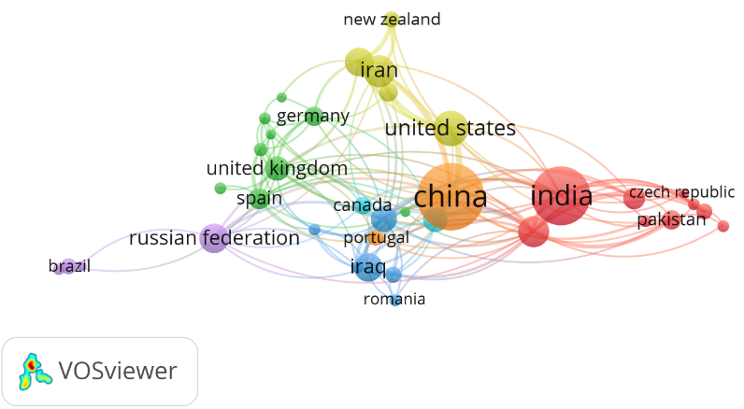
(a) | (b)
Figure 3. a) Scientific production by country by authorship and b) Scientific collaboration network between countries (performed in VOS-viewer).

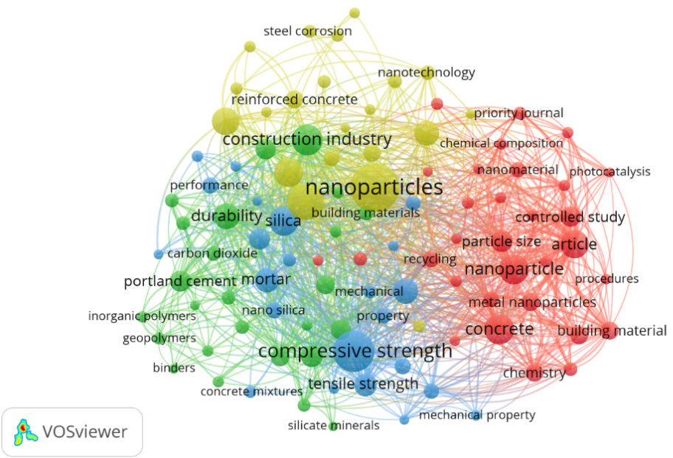
Figure 4. Index keyword co-occurrence network (performed in VOS-viewer).

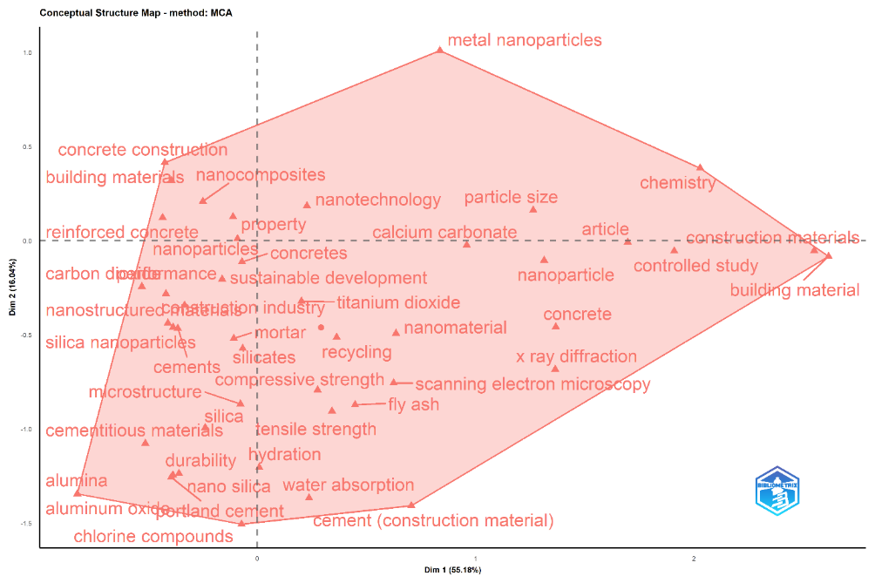
Figure 5. Conceptual structure (performed in Biblioshiny with R-Studio).

Figure 4 (Keyword co-occurrence network) presents the thematic structure of research on the use of nanoparticles in construction materials, organized into four main clusters that reflect the dominant research lines. The red cluster, focusing on fundamental aspects such as “particle size”, “nanomaterial”, “concrete” and “chemistry”, highlights controlled studies on the chemical and physical properties of nanomaterials applied to concrete and other construction materials. This group aligns with the work of authors such as Ebrahiminezhad A. and Berenjian A., who explore the scientific basis of these applications [26,27]. The blue cluster, dominated by terms such as “compressive strength”, “tensile strength”, and “performance”, highlights the focus on nanoparticle-enhanced mechanical properties, which explains the high productivity of journals such as Construction and Building Materials and authors such as Ahmedzade P. and Praveenkumar T.R., who suggest research on the optimization of concrete formulations by incorporating nanomaterials to improve their properties [28-30]. The green cluster, which includes “geopolymers”, “durability”, and “carbon dioxide”, reflects the growing attention to sustainable and low environmental impact materials, a trend also observed in the participation of countries such as Iran and India [31,32]. Finally, the yellow cluster, with terms such as “nanotechnology”, “reinforced concrete”, and “steel corrosion”, highlights the practical applications in the construction industry, linked to international collaborations and the relevance of authors such as Mohammed A.A. [33,34]. This thematic network not only confirms the interdisciplinary nature of the field (from fundamental chemistry to applied engineering) but also highlights how international collaborations and advances in nanotechnology are driving innovative solutions to traditional challenges in construction, such as durability and mechanical strength.

Figure 5 shows a conceptual structure map generated using the Multiple Correspondence Analysis (MCA) method in Biblioshiny, which allows us to visualize how scientific works on the use of nanoparticles in construction materials are organized thematically. This technique identifies distinct groups of terms that coexist in the literature, forming thematic cores and helping to identify the main lines of research. Thus, terms such as "metallic nanoparticles," "chemistry," and "controlled study" are grouped in the upper right corner, suggesting a more basic or experimental approach. In the center and to the left, concepts associated with traditional materials and their improvement using nanotechnology appear, such as "nanoparticles," "nanocomposites," "reinforced concrete," and "compressive strength," indicating a strong connection between nanoparticle research and the mechanical performance of materials. In the lower left area, a set of terms linked to cementitious compounds is concentrated, such as "Portland cement", "hydration", "durability" and "silica nanoparticles", which reflects the particular interest in the modification of cementitious matrices by means of nanomaterials.

CONCLUSION
The study reveals a dynamic and multidisciplinary research field characterized by exponential growth in scientific production, led by China and India, with emerging contributions from countries such as Iraq and Iran, with Construction and Building Materials predominating as the main source. Salemi N. and Singh LP. are presented as recognized and important local and global references in the literature, and the high impact of authors such as Mohammed A.A. and Praveenkumar T.R. underscore the maturity of the field. The analysis of co-occurrence and conceptual structure reveals a duality between fundamental research and practical applications. Scientific production is divided into four main research focuses: 1) manufacturing and characterization of nanomaterials, 2) properties of materials incorporated with nanoparticles, 3) sustainable materials, and 4) applications in the construction industry. Furthermore, the existence of collaborative networks allows for the search for specialized technical solutions, with an emphasis on sustainability and efficiency, uniting the contexts and visions of different parts of the world. This field, although mature, continues to grow vigorously, focused on solving global infrastructure challenges through nanotechnology, with a focus on smart and sustainable materials.

References
- Adam M. Neville, Properties of concrete. Instituto Mexicano del Cemento y del Concreto: Arquine Ediciones, (1995).
- Fantilli, A. P., Mancinelli, O., & Chiaia, B., The carbon footprint of normal and high-strength concrete used in low-rise and high-rise buildings. Case Stud. Constr. Mater., 11, e00296 (2019).
- Ravelo, G., Influencia de los elementos climáticos en el deterioro de las fachadas de edificaciones del barrio Colón. Arquit. Urban., 32(3), 38-47 (2011).
- Sen, S., Li, H., & Khazanovich, L., Effect of climate change and urban heat islands on the deterioration of concrete roads. Results Eng., 16, 100736 (2022).
- Velásquez, C. L., Khatib, S. K., & González, F. L., Nanopartículas: fundamentos y aplicaciones. Universidad de los Andes (2015).
- Tsotsis, G., Aplicaciones de la nanotecnología en los materiales de la construcción (Master's thesis, Universitat Politècnica de Catalunya) (2018).
- Sobolev, K., & Gutiérrez, M. F., How nanotechnology can change the concrete world. Am. Ceram. Soc. Bull., 84(10), 14-17 (2005).
- Pacheco-Torgal, F., & Jalali, S., Nanotechnology: Advantages and drawbacks in the field of construction and building materials. Constr. Build. Mater., 25(2), 582-590 (2011).
- Hanus, M. J., & Harris, A. T., Nanotechnology innovations for the construction industry. Prog. Mater. Sci., 58(7), 1056-1102 (2013).
- Van Broekhuizen, P., van Broekhuizen, F., Cornelissen, R., & Reijnders, L., Use of nanomaterials in the European construction industry and some occupational health aspects thereof. J. Nanopart. Res., 13(2), 447-462 (2011).
- Moral-Muñoz, J. A., Herrera-Viedma, E., Santisteban-Espejo, A., & Cobo, M. J., Software tools for conducting bibliometric analysis in science: An up-to-date review. Prof. Inf., 29(1) (2020).
- Avenali, A., Daraio, C., Di Leo, S., Matteucci, G., & Nepomuceno, T., Systematic reviews as a metaknowledge tool: caveats and a review of available options. Int. Trans. Oper. Res., 30(6), 2761-2806 (2023).
- Giwa, S. O., Adegoke, K. A., Sharifpur, M., & Meyer, J. P., Research trends in nanofluid and its applications: A bibliometric analysis. J. Nanopart. Res., 24(3), 63 (2022).
- Ivanov, L. A., Xu, L. D., Bokova, E., Ishkov, A. D., & Muminova, S., Inventions of scientists, engineers and specialists from different countries in the area of nanotechnologies. Part I. Nanotechnologies Construction: A Scientific Internet-Journal, 13(1) (2021).
- Salemi, N., & Behfarnia, K., Effect of nano-particles on durability of fiber-reinforced concrete pavement. Constr. Build. Mater., 48, 934-941 (2013).
- Singh, L. P., Karade, S. R., Bhattacharyya, S. K., Yousuf, M. M., & Ahalawat, S., Beneficial role of nanosilica in cement based materials–A review. Constr. Build. Mater., 47, 1069-1077 (2013).
- Praveenkumar, T. R., Vijayalakshmi, M. M., & Meddah, M. S., Strengths and durability performances of blended cement concrete with TiO2 nanoparticles and rice husk ash. Constr. Build. Mater., 217, 343-351 (2019).
- Kotop, M. A., El-Feky, M. S., Alharbi, Y. R., Abadel, A. A., & Binyahya, A. S., Engineering properties of geopolymer concrete incorporating hybrid nano-materials. Ain Shams Eng. J., 12(4), 3641-3647 (2021).
- Ahmedzade, P. E. R. V., Tigdemir, M., & Kalyoncuoglu, S. F., Laboratory investigation of the properties of asphalt concrete mixtures modified with TOP–SBS. Constr. Build. Mater., 21(3), 626-633 (2007).
- Seifan, M., Mendoza, S., & Berenjian, A., Mechanical properties and durability performance of fly ash based mortar containing nano-and micro-silica additives. Constr. Build. Mater., 252, 119121 (2020).
- Ahmed, H. U., Mohammed, A. A., & Mohammed, A. S., Effectiveness of silicon dioxide nanoparticles (nano SiO2) on the internal structures, electrical conductivity, and elevated temperature behaviors of geopolymer concrete composites. J. Inorg. Organomet. Polym. Mater., 33(12), 3894-3914 (2023).
- Ahmed, H. U., Faraj, R. H., Hassan, A. Q., Mohammad, Y. O., Omer, K. M., Mohammed, A. S., & Mohammed, A. A., Green synthesis of nano-silica from olivine rock and its impact on the mechanical performance of geopolymer concrete composites. Innov. Infrastruct. Solut., 8(7), 202 (2023).
- He, M., Yue, X., Qiu, F., Yang, D., & Zhang, T., Functionalized brick slag particles with superhydrophobicity for thermal management applications. J. Dispersion Sci. Technol., 44(11), 2210-2218 (2023).
- Rao, M. S. C., Vijayalakshmi, M. M., & Praveenkumar, T. R., Behaviour of green concrete (blended concrete) using agro-industrial waste as partial replacement of cement along with nanoparticles. Appl. Nanosci., 13(3), 2285-2293 (2023).
- Ahmed, H. U., Mohammed, A. S., & Mohammed, A. A., Proposing several model techniques including ANN and M5P-tree to predict the compressive strength of geopolymer concretes incorporated with nano-silica. Environ. Sci. Pollut. Res., 29(47), 71232-71256 (2022).
- Zhu, S., Meng, H., Gu, Z., & Zhao, Y., Research trend of nanoscience and nanotechnology–A bibliometric analysis of Nano Today. Nano Today, 39, 101233 (2021).
- Cely-Bautista, M. M., Castellar-Ortega, G., Jaramillo-Colpas, J., & Mejía, I. R., Trends in the development of metallic and bimetallic nanoparticles: a patents landscape analysis. Ing. Competitividad, 25(3), 3 (2023).
- Abdalla, J. A., Thomas, B. S., Hawileh, R. A., & Kabeer, K. S. A., Influence of nanomaterials on the workability and compressive strength of cement-based concrete. Mater. Today Proc., 65, 2073-2076 (2022).
- Khan, M. A., Ashraf, M. S., Onyelowe, K. C., Tariq, K. A., Ahmed, M., Ali, T., & Qureshi, M. Z., Machine learning predictions of high-strength RCA concrete utilizing chemically activated fly ash and nano-silica. Sci. Rep., 15(1), 10255 (2025).
- Cheraghcheshm, F., & Javanbakht, V., Surface modification of brick by zinc oxide and silver nanoparticles to improve performance properties. J. Build. Eng., 34, 101933 (2021).
- Chen, T., Li, X., Wang, Q., Li, Y., Xu, L., Yang, Y., ... & Gao, Z., A multifunctional Ag NPs/guar gum hydrogel as versatile platform for catalysts, antibacterial agents, and construction of oil-water separation interfaces. Int. J. Biol. Macromol., 270, 132035 (2024).
- Xiang, H., Zhang, W., Huang, X., Hu, C., Yin, H., Ma, B., ... & Ren, K., ZnO Nanoparticle-Enhanced Zn/Ni superhydrophobic Stainless Steel Mesh: Microstructural Control for High-Efficiency Oil-Water Separation. J. Environ. Chem. Eng., 117595 (2025).
- Chen, J., & Poon, C. S., Photocatalytic construction and building materials: from fundamentals to applications. Build. Environ., 44(9), 1899-1906 (2009).
- Kirthika, S. K., Goel, G., Matthews, A., & Goel, S., Review of the untapped potentials of antimicrobial materials in the construction sector. Prog. Mater. Sci., 133, 101065 (2023).

