From Biotechnology to Sustainable Innovation: A Bibliometric Analysis of Microbial Electricity Generation and Its Entrepreneurial Potential
Jonathan R.-F.^{1, a)}, Renny Nazario-Naveda^{1, b)}, Santiago M. Benites^{1, c)}, Daniel Delfin-Narciso^{2, d)} and Moises Gallozzo Cardenas^{3, e)}
¹ Facultad de Ingenieria y Arquitectura, Universidad Autónoma del Perú, Lima 15842, Perú.
²Grupo de Investigación de Ciencias Aplicadas y Nuevas Tecnologías, Universidad Privada del Norte, Trujillo 13007, Perú.
³Departamento de Ciencias, Universidad Tecnologica del Peru, Trujillo 13011, Perú.
^{a)} Corresponding author: srojasfl@autonoma.edu.pe
^{b)}renny.nazario@autonoma.pe
^{c)}santiago.benites@autonoma.pe
^{d)}daniel.delfin@upn.edu.pe
^{e)}c21228@utp.edu.pe
Abstract. This research addresses the need to understand the scientific development and entrepreneurial potential of microbial electricity generation, a technology that converts organic waste into bioelectricity using microbial fuel cells (MFCs) while treating wastewater. Despite its promising dual nature—treatment and electricity production—its degree of maturity and market transfer pathways remained unclear, prompting a bibliometric analysis to map trends, key players, and business opportunities. To this end, a search strategy was designed in the Scopus database (1986–2025) with terms related to microorganisms, energy, conversion, entrepreneurship, and biotechnology, retrieving 215 documents that were filtered, normalized, and exported for analysis. Quantitative methods—annual production, distribution by document type, and citation metrics (citations, h-index)—were combined with mapping tools in VOSviewer: keyword co-occurrence, co-authorship networks, Sankey diagrams, and trend issues. Minimum thresholds were established to focus the maps on the most relevant actors, concepts, and collaborations. The results indicate that 40.2% of the publications are peer-reviewed, 34.1% original articles, 22.4% papers, and 3.3% other formats, with exponential growth in production since 2000. The thematic analysis revealed three main clusters: microbial biotechnology ("bacteria," "metabolism"), applied innovation ("innovation," "bioengineering"), and technical-chemical tools ("chemistry," "biofuel"). The international collaboration network places China, the United States, and India as dominant hubs, and authors such as Singh S. and Zhang W. as leaders. These findings demonstrate the consolidation of the field and open avenues for green ventures, such as the integration of CCMs into water treatment plants and portable power generation devices, providing an empirical basis to guide policies and business models toward a circular bioeconomy.
Keywords: Microbial electricity, microbial fuel cells, bibliometric analysis, sustainable innovation, entrepreneurial potential

Introduction
Microbial electricity generation represents a powerful convergence of biotechnology and sustainable energy innovation, where engineered microbial fuel cells (MFCs) convert organic waste into bioelectricity while simultaneously treating wastewater [1]. At its core, MFC technology harnesses the metabolic activity of exoelectrogenic bacteria such as Shewanella and Geobacter to oxidize organic substrates found in domestic or industrial waste streams, releasing electrons that flow through an external circuit to generate electrical energy [2]. Recent advances in materials engineering and reactor design have significantly improved the performance and efficiency of these systems [3]. Innovations include the optimization of electrode materials—from carbon fiber and activated carbon composites to nanomaterial-enhanced cathodes—and the refinement of membrane technologies that facilitate proton exchange, ultimately streamlining electron transfer dynamics. Beyond their technical appeal, MFCs are deeply embedded in emerging sustainable economic models [4,5]. The concept of “microbial commons” reimagines domestic and urban environments as living public utilities that not only manage waste safely but also produce renewable outputs such as bioelectricity, purified water, and even biofertilizers [6]. This reconceptualization paves the way for decentralized energy infrastructures and local economic autonomy, particularly by empowering underrepresented groups to contribute to and benefit from green economies [7]. Moreover, these systems are being integrated with renewable energy architectures and smart grid operations [8], for example, by charging 12V batteries in local settings, which enhances energy autonomy and reduces reliance on traditional centralized power grids [9]. This integration supports global efforts to transition from carbon-intensive fossil fuel systems to cleaner, renewable alternatives [10]. Despite the modest power output currently achieved at the milliwatt scale, the versatility of MFCs extends their applications far beyond simple energy recovery [11]. Researchers have demonstrated successful integration of MFCs with photobioreactors and microalgae cultivation systems, which not only boost energy density but also yield valuable biomass and biofuels, further reinforcing the circularity of these biotechnological solutions [12]. Parallel innovations are also emerging in microbial electrosynthesis (MES), where anaerobic biofilms at the cathode convert CO₂ into multi-carbon compounds and renewable fuels. This complementary approach highlights the transformative potential of microbial systems to link energy production with chemical synthesis, contributing to a broader portfolio of bio-based technologies essential for sustainable innovation [13]. The combination of MFCs with decentralized wastewater treatment also plays a crucial role in environmental remediation [14]. By reducing chemical oxygen demand (COD) and immobilizing toxins, these systems significantly support local water sanitation initiatives and can even enable biosensing of environmental pollutants, opening new avenues for green technology entrepreneurship [15]. Additionally, the integration of democratized manufacturing technologies such as 3D printing and CNC milling facilitates the construction of site-specific microbial spaces. This decentralization of production not only lowers entry barriers for small-scale innovators but also drives a new era of sustainable entrepreneurship aligned with multiple UN Sustainable Development Goals [16]. Conducting a bibliometric analysis on the intersection of biotechnology and sustainable innovation—focused on microbial electricity generation and its entrepreneurial potential—is highly relevant to both science and society [17]. This type of study enables systematic mapping of knowledge growth, identification of emerging trends, key actors, and institutional collaborations, as well as visualization of the scientific dynamics driving this technological convergence. Given that microbial fuel cells represent an innovative solution with dual benefits (wastewater treatment and electricity generation), their bibliometric analysis provides an empirical basis for assessing scientific maturity, interdisciplinary evolution, and potential for technology transfer [18]. Furthermore, by incorporating an entrepreneurial lens, thematic gaps and opportunities for developing sustainable business models based on environmental biotechnology can be identified [19]. This facilitates decision-making for researchers, investors, and policymakers seeking to advance clean technologies with real impact on the Sustainable Development Goals [20]. In sum, this analysis not only helps to understand the current state of research but also to project science-based innovation strategies that ethically, effectively, and regeneratively connect the lab to the market. The primary objective of this research is to map, quantify, and characterize the scientific development of microbial electricity generation as a convergence of biotechnology, sustainability, and entrepreneurial innovation. This goal aims to provide a structured view of knowledge growth, prevailing thematic areas, collaboration networks, and the most influential authors, institutions, and countries in the field. To achieve this, the study will identify emerging trends and the most promising research lines around the use of microbial fuel cells; detect thematic gaps and interdisciplinary opportunities that could drive sustainable technological innovations and viable business models; evaluate the impact of scientific publications through metrics such as co-citation, co-authorship, and keyword analysis; and analyze the connection between academic development and technology transfer toward green ventures. These objectives will enable the articulation of bibliometric research with strategic decisions in science, technology, and innovation, helping to guide both public policy and private investment toward a regenerative and resilient bioeconomy.

methodology
The study encompasses both the design of the bibliographic search strategy and the analytical techniques used to characterize microbial electricity generation and its connection to entrepreneurial innovation. Initially, a comprehensive query was defined in the Scopus database, selected for its breadth and multidisciplinary coverage. The search strategy (see Table 1) included terms related to microorganisms (“microbial,” “microbe,” “bacteria,” “biofilm”) and energy generation, restricted to English-language articles published between 1986 and 2025. After applying these filters, a total of 215 documents were retrieved, forming the initial analysis corpus (see Table 1).

TABLE 1. Search Strategy
Criteria | Details
Search Terms (TS) | ("microbial" OR "microbe" OR "bacteria" OR "biofilm") AND ("electricity" OR "power" OR "energy" OR "current") AND ("generation" OR "production" OR "harvesting" OR "conversion") AND ("entrepreneurial" OR "business" OR "startup" OR "innovation") AND ("biotechnology" OR "bioengineering" OR "bioprocessing" OR "biomanufacturing")
Language | English
Document Type | Article
Time Period | 1986–2025
Database | Scopus
Published Documents | 215
Once the records were retrieved, data preprocessing was carried out. This step included the removal of duplicates and the normalization of author, institution, and journal names to ensure consistency in subsequent analyses. Additionally, institutional affiliations were manually verified for accuracy, and missing metadata—particularly regarding countries of origin and document types—was completed. During the science mapping phase, VOSviewer was used to perform keyword co-occurrence analysis, co-authorship mapping, and collaboration network analysis between countries. Minimum occurrence thresholds were established (e.g., 10 appearances for keywords and three documents per author) to focus the maps on relevant concepts and actors.
The software enabled the generation of thematic cluster maps, Sankey flow diagrams connecting authors, journals, and countries, and temporal trend graphs. These visual tools facilitated the interpretation of emerging dynamics, revealed thematic gaps, and outlined opportunities for technology transfer toward green ventures. Altogether, the methodology ensures a rigorous and replicable approach to understanding and projecting the development of microbial biotechnology within the context of sustainability.

Results and Analysis
Figure 1 presents two key components that help illustrate the evolution and characteristics of scientific output related to microbial electricity generation and its entrepreneurial potential. In Figure 1(a), 40.2% of the documents are scientific reviews, indicating a high level of reflection and consolidation of knowledge within the field. This proportion suggests that many authors are systematizing existing information, evaluating progress, and proposing new perspectives for future research [21].
Original research articles follow at 34.1%, representing new empirical or experimental contributions that are essential for advancing the discipline. Conference proceedings account for 22.4%, reflecting an active community engaged in the early dissemination of findings. Lastly, the “Other” category comprises a minimal 3.3%, likely including book chapters, editorials, or less common formats. On the other hand, Figure 1(b) reveals a clear upward trend in the number of annual publications, especially from the year 2000 onward. During the first two decades of the analysis, output remained low and stable, but the last decade shows exponential growth. This expansion reflects growing international interest in sustainable solutions linked to bioenergy, environmental biotechnology, and technological entrepreneurship [22].
The rise in the cumulative publication curve (red line) reinforces this trend, confirming the progressive consolidation of the field. Taken together, both figures suggest that this research area is not only gaining scientific relevance but also has a solid foundation of established literature. The balance between empirical publications and theoretical reviews indicates a mature community with capacity for innovation and forward-looking development [23]. Moreover, the notable increase in publications in recent years points to emerging opportunities for scientific entrepreneurship, particularly in microbial fuel cell technologies with both environmental and energy-related impact. This evolution positions the field as a strategic pillar within biotechnology aligned with the United Nations Sustainable Development Goals (SDGs).

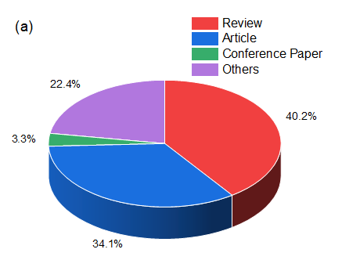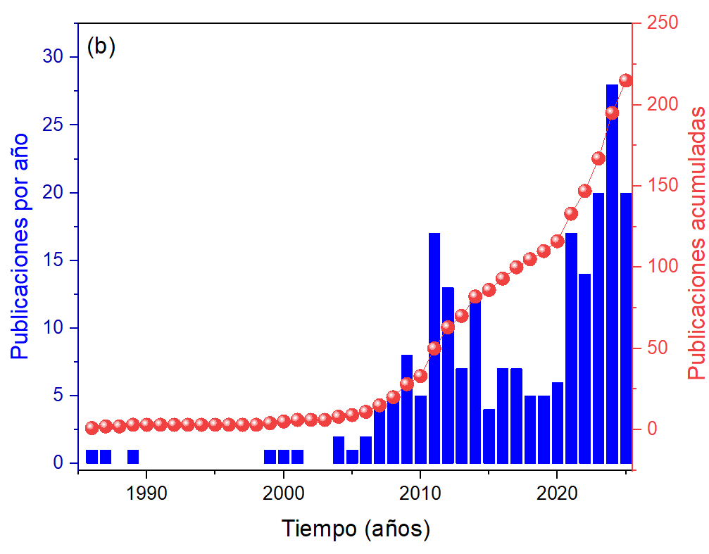
FIGURE 1. (a) Percentage of documents by type of publications and (b) publications by year.

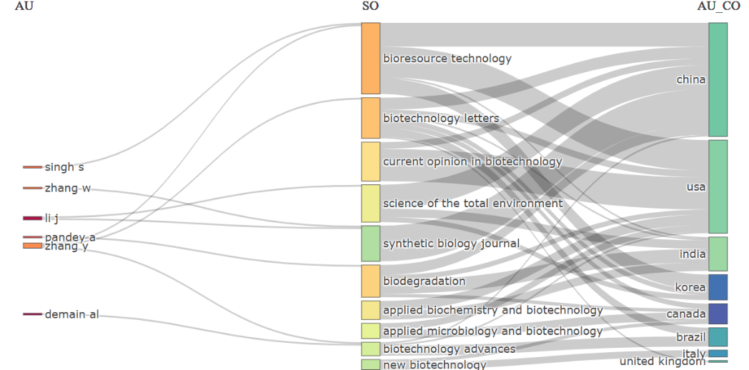
FIGURE 2. Connectivity between Authors, Journals and Countries in scientific production.

Figure 2 presents a Sankey-style visualization that explores the relationships among three key elements in scientific output related to microbial electricity generation and its trajectory toward sustainable innovation: authors (AU), scientific journals (SO), and countries of institutional affiliation (AU_CO). This representation helps illustrate how knowledge flows from individual contributions to global dissemination and recognition through publications and international collaboration. In the first column, representing authors, prominent names include Singh S, Zhang W, Li J, Pandey A, Zhang Y, and Demain AL. All are associated with leading research in biotechnology, bioenergy, and bioelectrochemical systems. Their presence in the network reflects not only their scientific productivity but also their ability to publish in high-impact journals, many of which appear in the second column of the diagram. This includes specialized journals such as Bioresource Technology, Biotechnology Letters, Current Opinion in Biotechnology, Science of the Total Environment, and Synthetic Biology Journal. These publications concentrate much of the most recent and relevant knowledge on sustainable technologies and biotechnological applications, confirming their role as key platforms for academic visibility in the field. The third column consists of the authors’ countries of institutional origin [26]. China, the United States, and India stand out as major scientific hubs, consistent with their sustained investment in research and development in renewable energy and biotechnology [27]. Other countries such as South Korea, Canada, Brazil, Italy, and the United Kingdom also appear, suggesting that interest in microbial electricity and its technical and commercial viability is truly global. This diversity of countries also points to growing international scientific collaboration, contributing to the diversification of knowledge and the adaptation of sustainable technologies to specific regional contexts [28].
Figure 3 presents a Country Collaboration Map that illustrates global research networks in biotechnology and sustainable technologies, with a particular focus on microbial electricity generation. Countries are shaded in varying tones of blue, likely indicating the intensity or number of collaborations, while connecting lines represent the existence and strength of academic and scientific ties between nations. Notable cooperation routes emerge between the United States, India, and several European countries, highlighting these as central nodes in research on microbial fuel cells and their entrepreneurial potential. To contextualize the map within a bibliometric study, this analysis not only charts who collaborates with whom, but also sheds light on how transnational alliances are driving the advancement of an emerging technology that transforms microbial activity into electrical energy. In this way, the figure underscores the role of international cooperation in accelerating clean innovation. The visualization is particularly valuable as it helps identify collaboration patterns and leading regions, as well as potential geographic gaps in research. By showing where partnerships are concentrated and how knowledge flows across borders, researchers and funders can spot opportunities to foster new alliances, balance resource distribution, and strengthen emerging areas [29]. Furthermore, by focusing on microbial electricity, the figure emphasizes the significance of this field in developing sustainable energy solutions and advancing their path to market [30].
Future trends in biotechnology geared toward sustainable innovation—particularly in the field of microbial electricity generation—anticipate a qualitative leap across several fronts, combining technical advancements, interdisciplinary integration, and ecologically conscious business models [31]. First, microbial fuel cell system design is expected to evolve toward modular, high-efficiency architectures. The incorporation of advanced materials—such as graphene-based electrodes, conductive nanomaterials, and membranes with enhanced selectivity—will optimize electron transfer and reduce energy losses. This materials-centered approach will be complemented by improved control of microbial cultivation conditions through smart sensors and the Internet of Things (IoT), enabling real-time monitoring platforms that enhance process reproducibility and scalability [32].
In parallel, the rise of artificial intelligence and big data analytics will have a decisive impact. Through machine learning approaches, researchers will be able to predict which microbial consortia are most efficient at degrading specific contaminants and generating optimal electrical currents [33]. This predictive capability, grounded in bibliometric and genomic analyses, will accelerate the identification of novel electrogenic strains and support the metabolic engineering of microorganisms to maximize bioelectric performance. The use of collaborative bioinformatics platforms and open-access repositories will foster synergy among research groups, shortening development timelines and avoiding duplication of efforts [34].
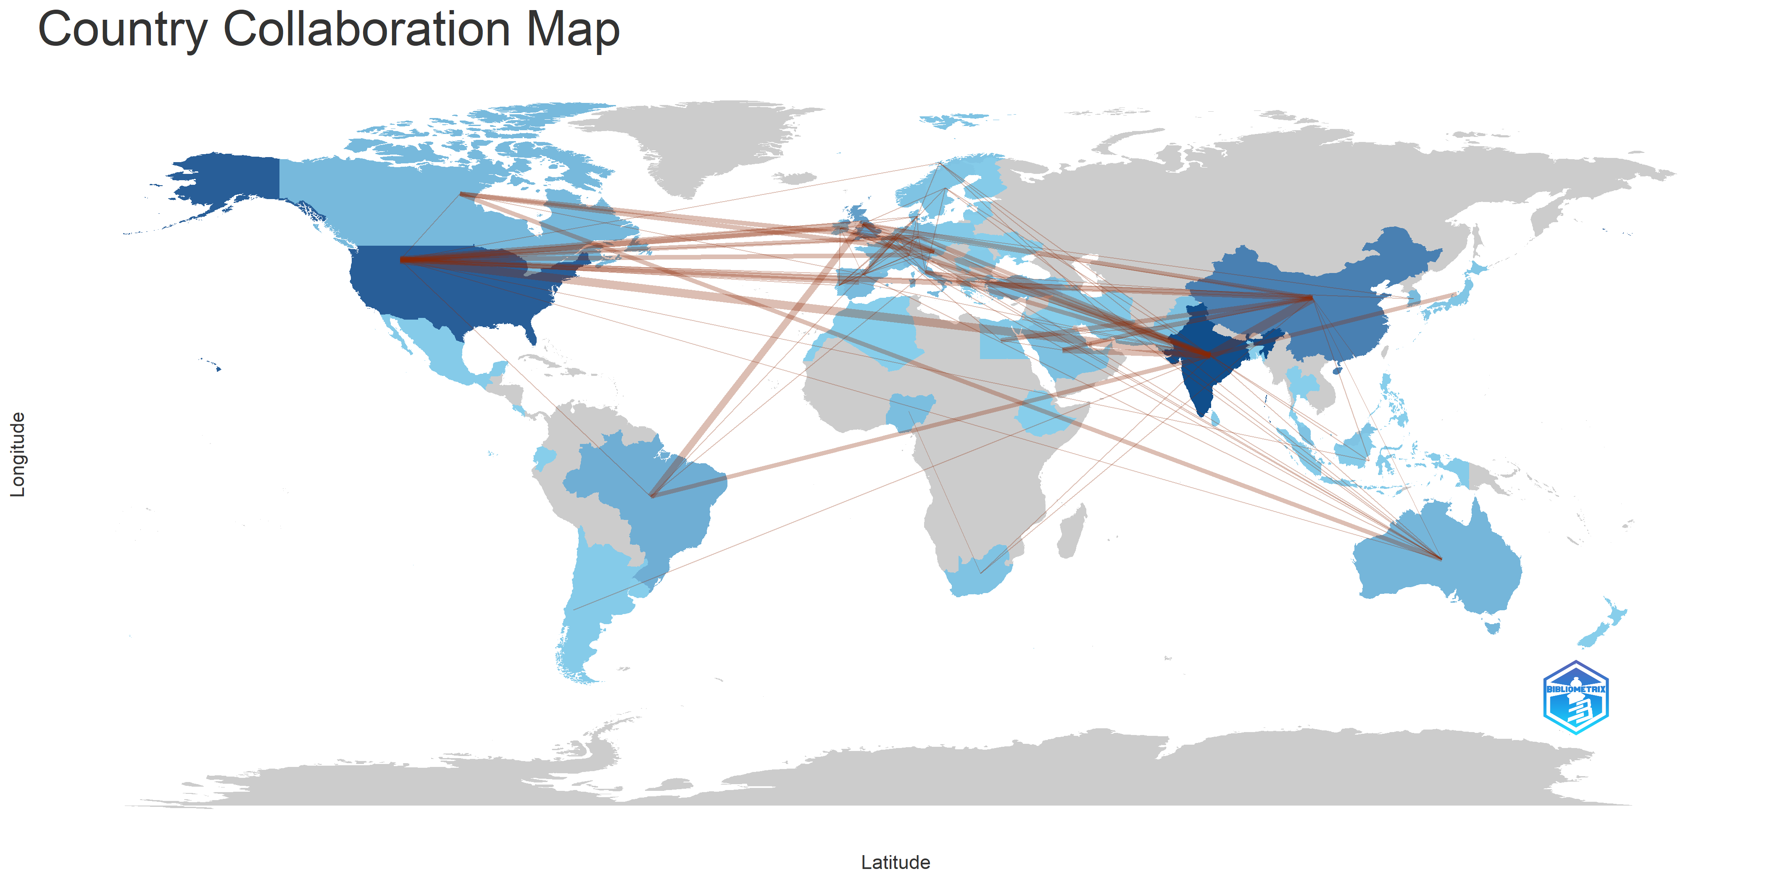
FIGURE 3. Global research networks between countries.
On the entrepreneurial front, a dynamic ecosystem of startups and spin-offs is emerging, focused on practical applications—from wastewater treatment using integrated MFCs in treatment plants to portable electricity-generation devices for remote sensors [35]. The growing demand for decentralized and sustainable solutions will attract impact investment and public support mechanisms aligned with the Sustainable Development Goals (SDGs). Business models such as “green energy-as-a-service” or “pay-per-use MFC platforms” will open new monetization pathways while enabling communities and small industries to adopt clean technologies without large upfront capital investments [36].
Finally, a strengthening of international and multidisciplinary collaboration networks is taking shape. Bibliometric analyses reveal sustained growth in co-authorship among bioengineers, microbiologists, materials scientists, and environmental economists [37]. In the near future, consortia will integrate not only technical expertise but also specialists in public policy, innovation sociology, and green finance, ensuring that the transition from lab to market is both agile and responsible. This convergence of knowledge and human capital will shape a robust ecosystem in which microbial electricity generation moves beyond a niche research area to become a cornerstone of the circular bioeconomy.

CONCLUSION
The bibliometric analysis of microbial electricity generation and its entrepreneurial potential reveals a rapidly expanding field—both in volume and in the diversity of scientific contributions. The results show that, out of the 215 documents analyzed, 40.2% are theoretical reviews, indicating a consolidation of knowledge and a growing interest in systematizing previous findings; original research articles account for 34.1%, reflecting robust experimental contributions; conference proceedings make up 22.4%, highlighting the swift dissemination of preliminary results; and the remaining 3.3% classified as “other” suggests emerging formats of scientific communication. The temporal progression of publications—virtually nonexistent before 2000 and exponentially thereafter—confirms that microbial electricity has evolved from a marginal niche into a strategic research node in sustainable energy.

The keyword co-occurrence mapping identifies thematic clusters centered around microbial biotechnology (“bacteria,” “metabolism”), applied innovation (“innovation,” “bioengineering,” “biofuel,” “fermentation”), and technical tools (“chemistry,” “priority journal”), demonstrating a balance between fundamental research and industrial applications. This thematic structure reveals that the study of microbial electrogenesis converges with process engineering and synthetic biology, pointing to a versatile technological platform capable of integrating waste treatment and energy generation. Meanwhile, the Sankey network analysis highlights key authors such as Singh S., Zhang W., and Pandey A., who are linked to high-impact journals like Bioresource Technology and Biotechnology Letters, and to institutions primarily located in China, the United States, and India. This geography of collaboration underscores the global nature of the technological challenge and the importance of transnational partnerships in accelerating knowledge transfer and scaling prototypes into real-world solutions.

Finally, the findings suggest a growing alignment between academic research and green entrepreneurship. The intensity of publications in specialized forums and the interest in business models based on the integration of microbial fuel cells into wastewater treatment plants and portable devices indicate the emergence of an entrepreneurial ecosystem grounded in solid bibliometric metrics. This scenario opens up opportunities for new public-private partnerships, impact-driven funding, and policies that promote the circular bioeconomy. Altogether, the results confirm the scientific maturity of the field and outline clear pathways for transforming microbial electricity from a laboratory innovation into business ventures with environmental and social impact.

ACKNOWLEDGMENTS
The research was funded by the Universidad Autonoma del Peru.

References
- Unuofin, J. O., Iwarere, S. A., & Daramola, M. O. (2023). Embracing the future of circular bio-enabled economy: unveiling the prospects of microbial fuel cells in achieving true sustainable energy. Environmental Science and Pollution Research, 30(39), 90547-90573.
- Toczyłowska-Mamińska, R., & Mamiński, M. Ł. (2022). Wastewater as a renewable energy source—utilisation of microbial fuel cell technology. Energies, 15(19), 6928.
- Geetha, M., Safamariyam, E., Roshan, S., & Synumol, P. (2025). Biofuel cells: a novel innovation. In Biofuel Cells and Energy Generation (pp. 1-26). Woodhead Publishing.
- Christensen, S. (2024). Innovative Biotech Solutions for Renewable Energy: Market Potential and Commercial Challenges. Journal of Commercial Biotechnology, 29(6), 36-45.
- Akinsemolu, A., Onyeaka, H., Fagunwa, O., & Adenuga, A. H. (2023). Toward a resilient future: the promise of microbial bioeconomy. Sustainability, 15(9), 7251.
- Zahoor, A., & Mukeet, S. (2023). Microbial Entrepreneurship: Harnessing Microbes for Economic Growth and Societal Benefit. Qlantic Journal of Social Sciences and Humanities, 4(2), 36-43.
- Althuri, A., & Mohan, S. V. (2022). Emerging innovations for sustainable production of bioethanol and other mercantile products from circular economy perspective. Bioresource Technology, 363, 128013.
- Imoro, A. Z., Acheampong, N. A., Oware, S., Okrah, H., Coulibaly, V. T., Ali, A. G., ... & Offei, F. (2022). The potential benefits of microbial fuel cells in the context of the sustainable development goals. In Microbial fuel cells for environmental remediation (pp. 167-182). Singapore: Springer Nature Singapore.
- Sharma, M., Sharma, S., Alkhanjaf, A. A. M., Arora, N. K., Saxena, B., Umar, A., ... & Baskoutas, S. (2024). Microbial fuel cells for azo dye degradation: A perspective review. Journal of Industrial and Engineering Chemistry.
- Chakma, R., Hossain, M. K., Paramasivam, P., Bousbih, R., Amami, M., Toki, G. I., ... & Karmaker, A. K. (2025). Recent applications, challenges, and future prospects of microbial fuel cells: a review. Global Challenges, 9(5), 2500004.
- Esfandyari, M., Jafari, D., & Azami, H. (2024). Microbial fuel cells for energy production in wastewater treatment plants-a review. Biofuels, 15(6), 743-753.
- Pan, P., Samanta, A., Roy, K., & Bhattacharyya, N. (2025). A Bibliometric Analysis of Lysinibacillus spp. as Electrogenic Bacteria in Microbial Fuel Cells. Biosciences Biotechnology Research Asia, 22(1), 113-123.
- Antonopoulou, G., Bampos, G., Ntaikou, I., Alexandropoulou, M., Dailianis, S., Bebelis, S., & Lyberatos, G. (2023). The biochemical and electrochemical characteristics of a microbial fuel cell used to produce electricity from olive mill wastewater. Energy, 282, 128804.
- Tan, W. H., Chong, S., Fang, H. W., Pan, K. L., Mohamad, M., Lim, J. W., ... & Yang, T. C. K. (2021). Microbial fuel cell technology—a critical review on scale-up issues. Processes, 9(6), 985.
- Xian, Y., Li, Q., He, Y., Zhou, G., Li, H., Feng, X., ... & Su, C. (2025). Treatment of 2, 4-di-tert-butylphenol-containing wastewater with an anaerobic baffle reactor coupled microbial fuel cell (ABR-MFC) system: performance, microbial communities, and metabolic functions. Separation and Purification Technology, 368, 133048.
- Khan, S. S., Amjad, M., Shareef, H., & Larkin, S. (2024). Review of microbial fuel cell from a techno-economic perspective. Energy Exploration & Exploitation, 42(1), 373-398.
- Ji, B., Zhao, Y., Vymazal, J., Mander, Ü., Lust, R., & Tang, C. (2021). Mapping the field of constructed wetland-microbial fuel cell: A review and bibliometric analysis. Chemosphere, 262, 128366.
- Bose, D., Bhattacharya, R., & Mukherjee, A. (2024). Bibliometric analysis of research trends in microbial fuel cells for wastewater treatment. Biochemical Engineering Journal, 202, 109155.
- Ishaq, A., Said, M. I. M., Azman, S. B., Abdulwahab, M. F., & Jagun, Z. T. (2023). Optimizing total ammonia–nitrogen concentration for enhanced microbial fuel cell performance in landfill leachate treatment: a bibliometric analysis and future directions. Environmental Science and Pollution Research, 30(36), 86498-86519.
- Huang, M., Zhao, L., Chen, D., Liu, J., Hu, S., Li, Y., ... & Yang, Y. (2024). Bibliometric analysis and systematic review of electrogenic bacteria in constructed wetland-microbial fuel cell: Key factors and pollutant removal. Journal of Cleaner Production, 142018.
- Ahmad, A., Al Senaidi, A. S., Vishnu, D. S., Khanam, S. Z., Alrahbi, A. S., Fettah, N., & Sharma, I. (2025). Bio-electrolysis of petroleum wastewater using microbial fuel cell for energy production. Biomass Conversion and Biorefinery, 15(7), 11121-11132.
- Chakma, R., Hossain, M. K., Paramasivam, P., Bousbih, R., Amami, M., Toki, G. I., ... & Karmaker, A. K. (2025). Recent applications, challenges, and future prospects of microbial fuel cells: a review. Global Challenges, 9(5), 2500004.
- Cui, W., Espley, S., Liang, W., Yin, S., & Dong, X. (2025). Microbial fuel cells for power generation by treating mine tailings: recent advances and emerging trends. Sustainability, 17(2), 466.
- Fasihi, M., Jouzi, F., Tervasmäki, P., Vainikka, P., & Breyer, C. (2025). Global potential of sustainable single-cell protein based on variable renewable electricity. Nature Communications, 16(1), 1496.
- Cai, Z., Nong, R., Dong, S., Zhou, G., He, Y., Wang, F., ... & Su, C. (2025). Understanding the potential role of microbial electrolysis cells in promoting electron transfer and microbial metabolism during the drying period in treating metformin-containing wastewater with an adsorption-biological coupling system. Journal of Environmental Management, 380, 125027.
- Intasit, R., & Kim, B. S. (2025). Sustainable biodiesel production from agricultural lignocellulosic waste via oleaginous microbial processes. BMC biotechnology, 25(1), 84.
- Zhai, W., Gao, Q., Liu, L., Jiang, K., Zhu, S., Ni, J., ... & Wang, Z. (2025). Biomass aerogel doped with FeS₂/MoS₂-modified anode for enhanced bioelectricity generation in microbial fuel cell and efficient treatment of high-concentration wastewater. Journal of Environmental Chemical Engineering, 117596.
- Nisa, S. Q. Z., Murti, R. H. A., Ni'am, A. C., Sitogasa, P. S. A., & Wibowo, E. C. (2025). Tofu Wastewater Treatment and Bioelectricity Production Potential by Combining Anaerobic Baffled Reactor and Microbial Fuel Cells. Envirotek: Jurnal Ilmiah Teknik Lingkungan, 17(1), 1-5.
- Kossmann, H., Karslioglu, Ö. Ö., & Breunig, P. (2025). From Moo to Microbes: pathways for precision fermentation in recombinant protein production. Journal of Agriculture and Food Research, 102056.
- Kumar, S., Yadav, S., & Ghangrekar, M. M. (2025). Wastewater treatment employing microbial carbon-capture cells with concomitant bioenergy production and valuable product recovery. In Algal Biorefinery (pp. 263-271). Elsevier.
- Alrashidi, W., Alhazmi, S., Sayegh, F., & Edris, S. (2025). Microalga-Based Electricity Production: A Comprehensive Review. Energies, 18(3), 536.
- Sankar, N. P., & Johnvictor, A. C. (2025). Analysis of the impact of organic manure in techno-efficient production of renewable energy from food waste. Journal of the Taiwan Institute of Chemical Engineers, 175, 106242.
- Luo, Z. Y., Wang, R. X., Yang, X. L., Wang, Z. J., Zhai, S. Q., & Sun, Y. (2025). Long-term operational characteristics of microbial fuel cells based on novel biofilm-separated membrane. Journal of Water Process Engineering, 73, 107724.
- Topkar, R., Patil, A., Magadum, P., Wadmare, S., Gurav, R., Hwang, S., ... & Jadhav, R. (2025). Biohydrogen Production: Harnessing Microbes for Clean Energy Generation. In Microbial Biofuel (pp. 80-113). CRC Press.
- Xian, Y., Li, Q., He, Y., Zhou, G., Li, H., Feng, X., ... & Su, C. (2025). Treatment of 2, 4-di-tert-butylphenol-containing wastewater with an anaerobic baffle reactor coupled microbial fuel cell (ABR-MFC) system: performance, microbial communities, and metabolic functions. Separation and Purification Technology, 368, 133048.
- Zhu, Y., Chen, Y., Zhang, W., Li, Y., Yu, F., & Yan, Y. (2025). Urban river ecosystem instability during initial restoration: Novel perspective on state transitions within key functional group of the microbial food web. Journal of Cleaner Production, 520, 146172.
- Aryanfar, Y., García Alcaraz, J. L., Keçebaş, A., Fernandez, J. B., Arslan, B., Ilbas, M., ... & Irshad, K. (2025). Transforming food industrial sludge into sustainable resources: innovations in waste management and renewable energy recovery. Business Strategy and the Environment, 34(3), 3672-3700.

