Molecular detection of Cryptosporidium Parvum Using TRAPC1 and TRAPC2 Genes in Salah Al-Din Governorate
Maysaa Manea Jassim Al-Ahbabi ^{1,a)} and Intisar Ghanim Abdulwahhab ^{1,b)}
¹ Tikrit University, College of Education for women, Biology, Tikrit, Iraq.
^{a)} corresponding authour: maysaa.manea247@st.tu.edu.iq
^{b)} dr.en79@tu.edu.iq
Abstract. This study aimed to diagnose Cryptosporidium parvum infection in children using the TRAPC1 and TRAPC2 genes. One hundred stool samples were collected from patients attending Tikrit Teaching Hospital between October 1, 2024, and April 30, 2025. Using modified Ziehl-Neelsen stain, Cryptosporidium parvum was detected in 38% of the samples, with higher infection rates in males (42%) than in females (31.5%). The highest prevalence was observed in the 3-5 year age group (44.4%), while the lowest was in the 13-15 year age group (21.4%). Seasonal variation in infection rates was observed, with the peak prevalence in January (56%) and the lowest rate in October (16.6%). DNA was extracted from 100 stool samples and the results showed the presence of a DNA band in 93 samples out of a total of 100 samples. Conventional PCR diagnosis was then performed using primers for both the TRAPC2 and TRAPC1 genes on 93 samples and the results showed that the number of samples positive for the TRAPC2 gene was 18 samples (19.4%), while the TRAPC1 gene gave a positive result in 26 samples (27.9%).
Keywords: Cryptosporidium parvum, PCR Conventional, TRAPC1, TRAPC2
INTRODUCTION
Cryptosporidium parvum is an obligate unicellular parasite of the intestinal microbiota. It has great importance to human and animal health and with economic relevance the parasite represents an important intestinal pathogen. Infection is globally endemic with host species, parasite genotype strain, and infection site determining the degree of severity [1]. In otherwise healthy people, infection usually produces intestinal symptoms immediately for a short period of time - things like severe diarrhea, abdominal cramps, loss of weight and appeal, tiredness, and light fever. There are no established cures [2], and in immunocompromised patients, symptoms can last longer. Some 20-odd species of Cryptosporidium capable of infecting humans are thought to exist, with C. hominis and C. spp., the most widely distributed Parvum [3]. Cryptosporidiosis is commonly diagnosed by the microscopic detection of cysts in feces [4]. Molecular techniques like polymerase chain reaction (PCR) allow the identification of human and animal genotypes, contributing to epidemiologic studies, source attribution, and efficient control [5]. The Throrombospoudin Related Adhesive Protein TRAP gene encodes for a thrombospondin related adhesive protein which is involved in motility and invasion of host cells by this parasite and constitutes both a putative virulence factor and a potential diagnostic marker [6] An important molecular marker for differentiating C. parvum isolates at the species level is the TRAPC1 gene. The presence of its genotypes in human isolates are nearly exclusive, and thus, the transmission of the infection associated with it is generally as an incidence of human-to-human. Polymorphism of the TRAPC2 gene are quite evident and exist in human isolates as well as those from animals. Consequently, there are both zoonotic infection sources and the human-to-human transmitted ones [7].
While the prevalence of cryptosporidiosis is a known public health burden, a significant epidemiological problem remains in distinguishing the primary transmission routes. Relying solely on microscopic detection is insufficient for tracing infection sources , leaving a critical gap in understanding whether infections in a community are primarily anthroponotic (human-to-human) or zoonotic (animal-to-human). This study aims to solve this diagnostic challenge by employing conventional PCR to target two key genes: TRAPC1 and TRAPC2. The importance of this approach lies in the distinct epidemiological data these genes provide; the TRAPC1 gene is almost exclusively associated with human isolates, whereas TRAPC2 is polymorphic and found in both human and animal sources. Therefore, the central goal of this research is not only to provide a precise molecular diagnosis but, more importantly, to use the relative prevalence of these two genes to illuminate the dominant transmission pathways of C. parvum in Salah Al-Din Governorate. This distinction is crucial for environmental health, as it will help authorities determine whether control strategies should prioritize improving sanitation and hygiene (to combat human-to-human spread) or focus on managing contaminated water supplies and livestock contact (to control zoonotic transmission).
EXPERIMENTAL PART
Samples Collection
Samples were collected from patients visiting Tikrit Teaching Hospital in Salah al-Din Governorate, after obtaining approval from the hospital administration to visit the hospital and collect samples from patients. Sample collection continued from October 1, 2024 to April 30, 2025. 100 stool samples were collected from patients (aged 5 months to 15 years). The stool samples were examined microscopically after staining with Ziehl-Neelsen stain to detect the presence of oocysts. Samples that were positive for microscopic examination and suspected were placed in DNA Shield preservative prepared by Zymo Research, where 100-200 mg of the sample was placed in 500 microliters of preservation solution and then frozen at -20°C until study was conducted. They were then transferred to the central laboratory at Tikrit University for the purpose of conducting experiments.
Molecular Study
Molecular studies were conducted to detect Cryptosporidium parvum from fecal samples using a gene-specific DNA extraction kit. DNA was extracted from the collected samples using the Presto Minig DNA Extraction Kit, supplied by Geneaid. Purity and concentration were measured at a wavelength of 260/280 nm. The DNA was then electrophoresed on a 1% agarose gel. This step is essential to ensure that the extracted DNA is sufficiently pure and does not undergo fragmentation that could compromise its efficacy in subsequent molecular applications.
Preparing the Primers
All primers were prepared by Macrogene and were prepared as working solutions at a final concentration of 10 pmol/µl after dissolving them in nuclease-free water for gene amplification.
The Primers
Conventional PCR with 369 bp specific primers for TRAP-C2 gene was used, forward primer F: 5'-CAT ATT CCCTGT CCC TTG AGT TGT-3', reverse primer R: 5'-TGG ACAACC CAA ATG CAG AC-3'. For TRAP-C1 gene with 1200 bp specific primers, forward primer F: 5'GGATGGGTATCAGGTAATAAGAA-3', reverse primer R: 5'- R:5'CAACTAGCCCAGTTCTGACTCTCTGG-3' [8].
Conventional Polymerase Chain Reaction for Both TRAPC1 And TRAPC2 Genes
The TRAPC1 and TRAPC2 genes of Cryptosporidium parvum were amplified using conventional PCR to identify the parasite at the molecular level. A reaction mixture was prepared by adding 3 µL of template DNA, 0.75 µL of forward primer, and 0.75 µL of reverse primer. 12.5 µL of prepared master mix was used, and the reaction volume was made up to 25 µL using 8 µL of nuclease-free water. The thermal amplification conditions for both genes included an initial denaturation at 94°C for 5 min with one cycle. This was followed by 30 cycles of denaturation at 94°C for 50 s, ligation at 55°C for 30 s, and elongation at 72°C for 60 s, followed by a final elongation at 72°C for 10 min with one cycle. Electrophoresis was performed on 2% agarose gel to ensure the success of the reaction and the production of the desired bands.
RESULT AND DISCUSSION
Based on results from the study using modified Ziehl-Neelsen stain, the prevalence of C. parvum parasite was 38(38%) positive samples and 62(62%) negative samples out of 100 stool samples examined. This suggests that the possibilities that the present infection of the parasite in the governorate may pose a threat to the health of the people there. Several possible explanations for the spread of the parasite include drinking contaminated water, keeping livestock around homes, using animal manure for fertilising vegetables, and direct contact with infected livestock (e.g., sheep and cows) since the infected animals are a source of transmission of parasite egg sacs [9]. The current study results demonstrated that there are variations in the infection in terms of the gender, as the total number of positive males was recorded (23) corresponding to a percentage of (37.09%) and in the case of females (15) corresponding to a percentage of (39.5%) (Table 1).
TABLE 1. C. parvum infection rates according to the sex of the infected person
Sex | Examined sample | Positive result | % | Positive result | %
Male | 62 | 26 | 42% | 39 | 62.90%
Female | 38 | 12 | 31.5% | 23 | 60.5%
Total | 100 | 38 | 38% | 62 | 62%

The results indicate a higher incidence among males than females, consistent with [10] in Karbala Governorate, where the infection rate among males was 10%, while it was lower among females, at 6.4%. However, they did not agree with [11], where females had higher rates. The difference in infection rates between males and females may be due to several factors, including males being more active than females because they are in direct contact with external environmental factors that play a role in the transmission of parasite egg sacs, and a lack of attention to personal hygiene and handwashing, which increases the chances of infection with the parasite [12]. The results of the current study showed that the highest infection rate was recorded for the age groups (3-5 years) reaching (44.4%) out of a total of 27 samples examined, while the lowest infection rate was recorded for the age group (13-15 years), as the infection rate reached (21.4%) out of a total of 14 samples examined, as shown in Table 2.
TABLE 2. C. parvum infection rates according to age groups
According to age | Examined sample | Positive result | Percentage
5 month -2 years | 23 | 10 | 43.5%
3-5 years | 27 | 12 | 44.4%
6-9 years | 25 | 9 | 36%
10-12 years | 11 | 4 | 36.5%
13-15 years | 14 | 3 | 21.4%
Total | 100 | 38 | 38%

The results of the current study are consistent with a study conducted in Mosul, which recorded the highest infection rate in the 3-5 year age group, at 49.4% [13]. The results of this study are not consistent with what was recorded by [14] in Ethiopia, which recorded the highest infection rate in the 9-10 year age group, at 31.5. The proportion of rising infection spread in the 1–5-year group could also be potentially associated with an immature immune system of younger age groups [15]. Results of the current study also revealed the highest infection rates recorded according to study months were equal to 56% of the total number of 25 samples examined during the month of January, while the lowest rate was 16.6% of the total number of 6 samples examined during the month of October Table 3.
The results of the current study agreed with [16] who indicated that the cause of the spread of C. parvum in winter is attributed to rainwater that washes away soil contaminated with animal waste containing egg sacs to mix with the water of streams and rivers. This study differed from what was recorded by [17] who indicated that the spread of the parasite in summer is 3.57% and the reason is due to several factors including swimming in streams and rivers contaminated with egg sacs on hot days.

TABLE 3. Infection rates with C. parvum parasite during the study months
According to | Examined sample | Positive result | Percentage
October | 6 | 1 | 16.6%
November | 15 | 6 | 40%
December | 22 | 8 | 36.5%
January | 25 | 14 | 56%
February | 17 | 6 | 35.5%
March | 15 | 3 | 20%
Total | 100 | 38

DNA was extracted from 100 stool samples and the results showed that the extraction process was successful in 93 samples, while 7 samples did not show sufficient quality DNA. The extraction results were electrophoresed and the results were as in Figure (1), which shows the DNA genomic DNA bands extracted from the stool samples.
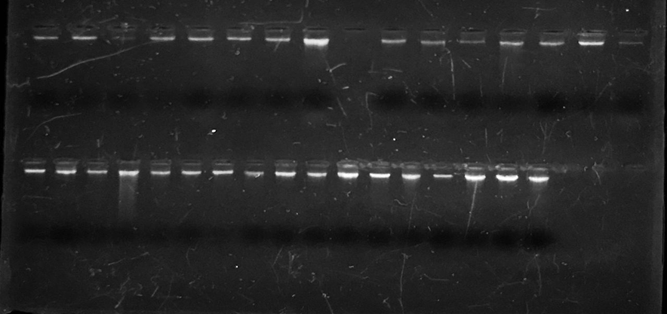
FIGURE 1. Genomic DNA packages of the samples after extraction and migration on a 1% agarose gel using the safe DNA dye Red Safe.
The results of a study conducted by Al-Masoudi and Dahash, 2025, in Iraq to extract the parasite's DNA showed a success rate of 66.6%, which is consistent with the results of the current study. However, it does not match a study conducted in Turkey, where the parasite's DNA was extracted at a rate of 4.6% [19]. The efficiency of molecular detection of Cryptosporidium parvum depends largely on the quality of the DNA extraction, as the presence of inhibitors in the DNA directly affects PCR results. Conventional PCR diagnosis was performed using TRAP-C2 gene primers on 93 samples. The results showed that the number of samples positive for the gene was 18 (19.4%), with the appearance of a band measuring 369 base pairs compared to the standard size indicator, ladder DNA, as shown in Figure (2).
This percentage was lower compared to some previous studies, as the detection rate in immunocompromised patients through similar PCR targeting the TRAP-C2 gene was 27.5% . This observation also contrasts with a previous study in Pakistan [20] where the prevalence of 12.8% was found in stool samples. These discrepancies could be explained by geographic heterogeneity, differences in diagnostic methods, population immune status and sample size . The presence of TRAP-C2 gene in the study sample highlights the epidemiological significance of this gene to be a potential diagnostic target for C. parvum. Moreover, these results are consistent with the role of this gene as a factor in the pathogenicity and life cycle of the parasite, especially in the adherence and invasive processes [21]. Then, based on the TRAPC1 gene primers, the conventional PCR diagnosis was applied on 93 samples, so that the species number positive for the gene was 26 (27.9%) with the appearance of a band with a size of 1200 base pairs against the standard size indicator Ladder DNA as shown in Figure (3).

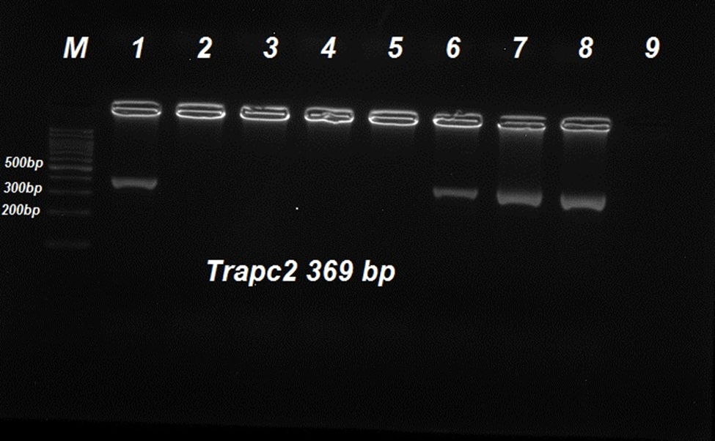
FIGURE 2. The result of the PCR reaction for the TRAP C2 gene. Samples (1, 6, 7, 8) represent the positive samples. The size of the gene was 369 base pairs. Electrophoresis was carried out in a 2% agarose gel and the size of the standard size indicator was 100 base pairs. Samples (2, 3, 4, 5, 9) represent the negative samples.
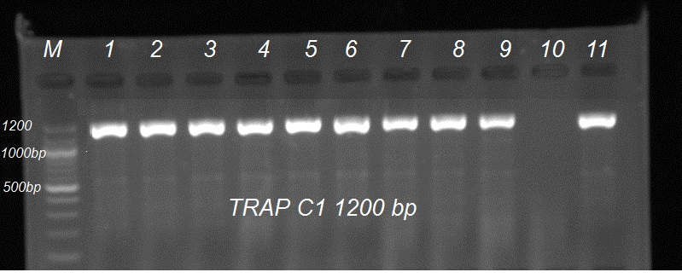
FIGURE 3. The result of the PCR reaction for the TRAPC1 gene. Samples (1, 2, 3, 4, 5, 6, 7, 8, 9, 11) represent the positive samples. The size of the gene was 1200 base pairs. Electrophoresis was performed on an agarose gel at a concentration of 2% and the size of the standard size indicator was 100 base pairs. Sample (10) represents the negative samples.
The results of a study [22] in Bangladesh showed a prevalence of 10%, while a study [23] reported a different prevalence of 87.5% and 92.9%.The results of the current study showed that the diagnosis of C. parvum using the TRAPC1 gene was higher than the TRAPC2 gene. This may be due to the nature of the sample collection site, as they were collected in a central city where direct exposure to animals is less common, suggesting that most transmission was from person to person. The TRAPC2 gene was less prevalent, as transmission may have originated from animal sources or from human to human.
CONCLUSIONS
This study successfully identified Cryptosporidium parvum infection in children in Salah Al-Din Governorate , revealing a significant overall prevalence of 38% based on microscopic examination of 100 stool samples , which suggests the parasite may pose a notable public health threat in the region. Epidemiological analysis identified specific risk factors, including higher infection rates in males (42%) than females (31.5%) and the highest prevalence among the 3-5 year age group (44.4%). A crucial environmental finding was the pronounced seasonal peak in January (56%) , which is likely linked to rainwater washing soil contaminated with animal waste into drinking water sources. The primary significance of this research lies in its successful molecular diagnosis using conventional PCR on 93 DNA samples. The study found that the TRAPC1 gene (detected in 27.9% of samples) was more prevalent than the TRAPC2 gene (19.4%). Given that TRAPC1 is almost exclusively associated with human-to-human transmission while TRAPC2 is linked to both zoonotic and human sources , this central finding strongly implies that anthroponotic (human-to-human) transmission is the dominant infection route in this urban study area. This highlights the utility of the TRAPC1 and TRAPC2 genes as important molecular markers for differentiating transmission cycles, which is critical for developing effective public health control strategies.
REFERENCES
- M. A. Saab, "Effect Cryptosporidium parvum on Lactoferrin level in children with diarrhea," Wasit Journal for Pure Sciences, 3(4), pp. 127-135, 2024.
- A. Khan, S. Shams, S. Khan, M. I. Khan, S. Khan, & A. Ali, "Evaluation of prevalence and risk factors associated with Cryptosporidium infection in rural population of district Buner, Pakistan," PLoS One, 14(1), p. e0209188, 2019. doi: 10.1371/journal.pone.0209188.
- H. K. Askar, Y. J. Salman, & A. A. Mohiemeed, "Some Epidemiological Aspects of Cryptosporidium parvum Among Children Below Five Years in Kirkuk Province," Journal of Population Therapeutics and Clinical Pharmacology, 30(8), pp. 378-389, 2023. doi: 10.47750/jptcp.2023.30.08.041.
- A. Fall, R. C. Thompson, R. P. Hobbs, & U. Morgan-Ryan, "Morphology is not a reliable tool for delineating species within Cryptosporidium," Journal of Parasitology, 89, pp. 399–402, 2003. doi: 10.1645/0022-3395(2003)089[0399:MINART]2.0.CO;2.
- S. Mozer, I. G. Abdulwahhab, & A. F. Al-Azaawie, "Diagnosis Of Contamination Of Vegetables And Fruits With Cryptosporidium Spp Using Nested-PCR Technique," Natural Volatiles & Essential Oils, pp. 223-232, 2021.
- M. S. Paoletta, & S. E. Wilkowsky, "Thrombospondin Related Anonymous Protein Superfamily in Vector-Borne Apicomplexans: The Parasite's Toolkit for Cell Invasion," Frontiers in Cellular and Infection Microbiology, 12, p. 831592, 2022. doi: 10.3389/fcimb.2022.831592.
- F. Spano, L. Putignani, S. Guida, & A. Crisanti, "Cryptosporidium parvum: PCR-RFLP analysis of the TRAP-C1 (thrombospondin-related adhesive protein of Cryptosporidium-1) gene discriminates between two alleles differentially associated with parasite isolates of animal and human origin," Experimental Parasitology, 90, pp. 195-198, 1998.
- M. M. Peng, L. Xiao, A. R. Freeman, M. J. Arrowood, A. A. Escalante, A. C. Weltman, et al., "Genetic polymorphism among Cryptosporidium parvum isolates: evidence of two distinct human transmission cycles," Emerging Infectious Diseases, 3(4), p. 567, 1997.
- L. E. Jerez, F. A. Núňez-Fernández, J. Fraga, I. Atencio, I. Cruz, I. Martínez, L. Ayllón, & L. J. Robertson, "Diagnosis of intestinal protozoan infections in patients in Cuba by microscopy and molecular methods: advantages and disadvantages," Journal of Microbiological Methods, Vol. 179, p. 106102, 2020.
- A. H. J. Al-Marshadi, "Microscopic and molecular diagnosis of the Cryptosporidium parvum parasite in Karbala Governorate," Master's thesis, College of Education, University of Karbala, 2021, pp. 74-83.
- A. I. AL-Hindy, A. A. Elmanama, & K. J. A. Elnabris, "Cryptosporidiosis among Children Attending Al-Nasser Pediatric Hospital Gaza Palestine," Turkish Journal of Medical Sciences, 37(6), pp. 367-372, 2007.
- A. K. AL-Mamouri, "Epidemiology of intestinal parasites and head lice in pupils of some primary schools at AL-Mahaweel district, Babylon province," MSc. Thesis, Science College, Babylon University, 2000, 122 pp.
- S. H. Younis, & F. Al-khashab, "Epidemiological study of Cryptosporidium parvum parasite in some districts of Nineveh province, with referring to histopathological effects in lab mice," College of Basic Education Research Journal, 17(4), pp. 1023-1048, 2021.
- T. Hailegebriel, "Prevalence of intestinal parasitic infections and associated risk factors among students at Dona Berber primary school, Bahir Dar, Ethiopia," BMC Infectious Diseases, 17(1), p. 362, 2017.
- N. K. Oanh, B. K. Na, & W. G. Yoo, "The potential breakthroughs with ChatGPT in parasitology," Iranian Journal of Parasitology, 18(2), pp. 275-278, 2023.
- W. Gatei, C. N. Wamae, C. Mbae, A. Waruru, E. Mulinge, T. Waithera, S. M. Gatika, S. K. Kamwati, G. Revathi, & C. A. Hart, "Cryptosporidiosis: prevalence, Genotype Analysis, and Symptoms Associated With Infection in Children in Kenya," American Journal of Tropical Medicine and Hygiene, 75(1), pp. 78-82, 2006.
- A. N. M. Al-Baldawy, "Microscopic and Molecular Detection of cryptosporidium species in children with persistent Diarrhea in Al-Najaf province," M.SC. thesis, College of Medicine, University of Kufa, 2017, pp. 80-87.
- H. K. Al-Masoudi, & O. A. M. Dahash, "Molecular Detection of Cryptosporidium parvum by Specific Gene (Heat Shock Protein) in Children at Babylon Center," Medical Journal of Babylon, 22(2), pp. 412-417, 2025. doi: 10.4103/MJBL.MJBL 1118 23.
- F. Özkan, & A. İça, "Molecular Diagnosis and Typing of Cryptosporidium spp. Species in Human Stools with Diarrhea," Turkish Journal of Parasitology, 48(3), pp. 184-190, 2024. doi: 10.4274/tpd.galenos.2024.60392.
- J. I. Boulter-Bitzer, H. Lee, & J. T. Trevors, "Molecular targets for detection and immunotherapy in Cryptosporidium parvum," Biotechnology Advances, 25(1), pp. 13-44, 2007.
- R. G. Mahmudunnabi, S. Kasetsirikul, N. Soda, M. Sallam, A. S. Pannu, N. T. Nguyen, et al., "Critical evaluation of current isolation, detection, and genotyping methods of Cryptosporidium species and future direction," Environmental Science: Water Research & Technology, 10(7), pp. 1527-1551, 2024.
- L. Putignani, & D. Menichella, "Global distribution, public health and clinical impact of the protozoan pathogen Cryptosporidium," Interdisciplinary Perspectives on Infectious Diseases, 2010(1), p. 753512, 2010.
- M. Katiyar, S. Padukone, R. Gulati, & R. Singh, "A multiplex PCR assay for the detection of Cryptosporidium species and simultaneous differentiation of Cryptosporidium hominis, Cryptosporidium parvum in clinical stool samples," bioRxiv, 2023-03, 2023.

