Nested-PCR Detection of Entamoeba Histolytica and E.dispar in Diarrheal Patients
Hanan Thabat Khdir ^{1,a)} and Intisar Ghanim Abdulwahhab ^{1,b)}
¹ Tikrit University, College of Education for women, Biology, Iraq.
^{a)} corresponding author: hanan.th.khdir@gmail.com
^{b)} dr.en79@tu.edu.iq
Abstract. The current research aimed to diagnose Entamoeba histolytica and Entamoeba dispar by the use of nested-PCR. As the study, 100 samples of stool of patients with moderate and severe diarrhea with or without blood in the stool were collected at Tikrit Teaching Hospital, Al-Alam Hospital, and other laboratories in the Al-Alam District (between early October and late June 2025). The age of patients ranged between one month to 40 years with all genders. Diagnosis of the samples was based on morphological and molecular analysis through the Nested Polymerase Chain Reaction technique with the emphasis on the 18S rRNA gene with E. histolytica-specific and E. dispar-specific primer pairs. It was found that the general rate of infection of Entamoeba spp. was 65 percent of the total samples examined under the microscope. Molecular study of the Entamoeba genus showed that the 900-base-pair fragment of the 18S rRNA gene was detected in 88% of the sample analysed whereas the Eh1-Eh2 gene of E.histolytica was detected in 42% of the positive samples and ED-1 and ED-2 genes in E.dispar were found in 27%. Keywords: Diarrhea, Nested PCR, 18SrRNA, E. histolytica, E. dispar.
INTRODUCTION
Entamoeba genus is a group of unicellular protozoa, in other words, single-celled organisms that are characterized by the use of pseudopodia (locomotion). Majority of the species of this genus live in the human intestine and cause serious illness and death to humans [1]. The Entamoeba histolytica, Entamoeba dispar, and Entamoeba moshkovskii have phenotypic similarities even though their molecular differences exist. Entamoeba histolytica is a common amoebic causing parasite. It is estimated that infections will go up to 480 million which translates to 40,000 to 110,000 deaths per year around the world. This is the third most common cause of death after malaria and the schistosomiasis. The causative organism of the disease is the active trophozoite form which lives in the wall and lumen of the large intestine especially in cecum and the terminal parts of the small intestine causing intestinal perforation, hemorrhage, stricture, granuloma formation and can result in appendicitis [4,5].
Diagnosis of Entamoeba spp. in human feces is based on microscopic analysis with a sensitivity of only 60 percent. This method cannot morphologically differentiate E. histolytica, E. dispar, and E. moshkovskii [6,7]. Over the last few years, the molecular means, namely Nested PCR, became an important tool of specific diagnosis of intestinal amoebiasis. This is a two-cycle DNA amplification technique to reduce nonspecific signals and improve the detection sensitivity [9,10]. It also provides the qualitative differentiation of E. histolytica and E. dispar in clinical specimens. The biomolecular discrepancy between microscopic and molecular results has, as demonstrated by the field studies, pointed to the importance of nested PCR in providing accurate data on the epidemiological distribution of an individual species, in addition to assessing how likely E. dispar is as a cause of human gastrointestinal diseases [11].
As there is a diagnostic difficulty and clinical significance to amoebiasis, there is an evident necessity to develop methods that are able to differentiate the pathogenic form of Entamoeba histolytica, and morphologically equivalent, non-pathogenic E. dispar. The shortcomings of classical microscopy can be a wrong diagnosis, and the carriers of the non-pathogenic group are treated unnecessarily, and the real prevalence of amoebic dysentery is not accurately determined. Hence, the main objective of this research is to use highly sensitive and specific Nested Polymerase Chain Reaction (Nested-PCR) method to tightly determine and distinguish between E. histolytica and E. dispar in the study region in diarrheal patients. This study is notable because it will not only give a more precise epidemiological image of these two different species but also emphasize the clinical usefulness of molecular instruments to make a reliable diagnosis. The findings should help to improve the management of patients, more precise policies to combat the disease on the population level, and the clear picture of the molecular epidemiology of amoebiasis in Iraq.
EXPERIMENTAL PART
Samples Collection
One hundred stool samples were obtained from patients experiencing severe to moderate diarrhea, including bloody diarrhea, at Tikrit Teaching Hospital, Al-Alam Hospital, and outpatient laboratories in Al-Alam District, between October 1, 2024, and the end of June 2025. The age of the patients ranged between 1 month and 40 years and both sexes were represented. The samples were collected in sterilized yet wide mouthed plastic beakers that had securely sealed lids to help in keeping the samples moist and prevent drying. The microscopic examination was performed during the first three hours of the sample collection and focused on the areas with mucus or blood in order to pinpoint the active stage of the parasitic agent that triggered the disease. The active stage is mainly found in soft materials, but rarely in solid or semi-solid samples, which normally contain the enclosed stage. The presence of encysted stage is a common characteristic of parasitic infection [12]. The Samples were kept in DNA Shield solution.
Molecular Study
Molecular testing was performed to detect Entamoeba spp. from stool samples, based on specific genes. The method was performed according to the following steps:
Genomic DNA Extraction
DNA was isolated from the collected samples utilizing the Presto™ Mini gDNA Kit supplied by Geneaid. Subsequent to extraction, the purity and concentration of the isolated DNA were quantified utilizing a Nanodrop spectrophotometer, by assessing the absorbance at a wavelength ranging from 260 to 280 nm.
Nested PCR
A primary PCR was performed using primers E-1 and E-2 to amplify a 900 bp fragment of the 18S rRNA gene, confirming Entamoeba spp.. Following this, two separate nested-PCRs were conducted using the 900 bp product as a template: one reaction used primers EH-1 and EH-2 to detect E. histolytica (439 bp), and a second reaction used primers ED-1 and ED-2 to detect E. dispar (174 bp).
PCR Components Preparation
The nested PCR mixture was created utilizing the PCR master mix kit provided by the Korean- Bioneer, in accordance with the manufacturer's guidelines. In the initial round, two sets of designed primers were utilized: 0.75 µL of forward primer at 10 pmol and 0.75 µL of reverse primer at 10 pmol. 3 µL of template DNA (5–50 ng/µL) was included, along with 12.5 µL of master mix. The total reaction volume was adjusted to 25 µL by adding 8 µL of nuclease-free water. Upon finalizing the PCR mixture preparation, the tubes were sealed and meticulously vortexed for 10 seconds. The tubes were thereafter placed in a PCR thermocycler to execute the cycles as per the reaction protocol. During the initial round of the PCR, the thermal protocol commenced with a pre-denaturation phase at 95°C for 5 minutes, succeeded by denaturation at 95°C for 30 seconds, followed by an annealing phase at 58°C for 30 seconds, and concluding with 30 cycles of extension at 72°C for 30 seconds. The Final Extension phase was conducted at 72°C for 5 minutes, performed once.
Second Round
The product of the initial reaction was subsequently transferred to an Exispin vortex centrifuge operating at 3000 rpm for a duration of 3 minutes. The constituents of the Nested PCR reaction in the second round were as follows: 3 μL of template DNA (5–50 ng/μL), 0.75 μL of forward primer (10 pmol), 0.75 μL of reverse primer (10 pmol), and 12.5 μL of master mix were included. The total reaction volume was adjusted to 25 μL by adding 8 μL of nuclease-free water. The thermal protocol commenced with an initial denaturation step at 95°C for 5 minutes, succeeded by a denaturation step at 94°C for 30 seconds, an annealing step at 55°C for 30 seconds, and an extension step at 72°C for 30 seconds. The cycles were reiterated 30 times. The last extension phase was conducted at 72°C for a single duration of 5 minutes.

Electrophoresis of Nested-PCR Products
Entamoeba spp. gene amplification products were analyzed using 2% agarose gel electrophoresis. After completion of the process, the bands were detected using a UV transilluminator, and the gel results were photographed for documentation and analysis.
RESULT AND DISCUSSION
Based on the results of the study provided in Table (1), it is observed that the prevalence of the Entamoeba Spp infection among the 100, which were analyzed by microscopic examination was 65% and 35% did not show the presence of the parasite as provided in Table (1). According to the results of the current study, it was found that the rate of infection was about 65 percent of E. histolytica, which is 60 percent as reported by [13] in Salah al-Din and is close to the results of 61.93 percent reported by [14]. Conversely, this was not similar to the result of [15] at 33 percent (8.3) which was the lowest infection rate of Entamoeba species under microscopic examination. This difference might be attributed to differences in sanitation, individual hygiene, population density, style of life, and climatic conditions that favour extended cysts survival therefore increasing the likelihood of infection [16].
TABLE 1. Percentage of samples tested for Entamoeba spp.
Examined samples | Positive result | Percentage | Negative result | Percentage
100 | 65 | 65% | 35 | 35%
The genetic material (deoxyribonucleic acid) of the patients who showed symptoms of infection with the parasite, numbering (100) samples, was extracted, and 88% DNA was obtained, as shown in Figure (1).
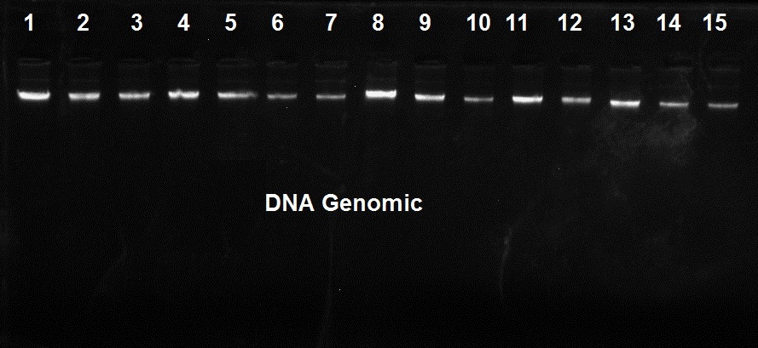
FIGURE 1. Electrophoresis of 1% agarose gel of genomic DNA of samples after extraction.
The results showed that the prevalence of Entamoeba spp. in diarrhea samples was 88%, which is consistent with [17], who reported 83% Entamoeba spp. infection, and with [18], who reported 69.3% using multiplex nested PCR in Malaysia. However, the results differed from those reported by [19] in Tikrit, where they recorded 9.3%. Direct microscopic diagnosis cannot differentiate Entamoeba histolytica from other species such as E. hartmanni, E. dispar, and E. moshkovskii[20]. The changes observed by PCR may be attributed to several reasons, the first of which is differences in the method of extracting DNA from stool samples.
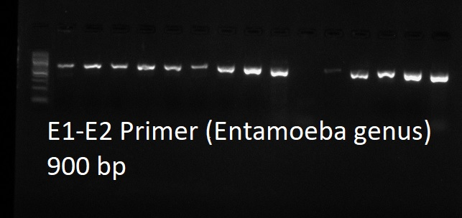
M 1 2 3 4 5 6 7 8 9 10 11 12 13 14 15
FIGURE 2. Shows the results of the nested-PCR reaction for the 18S rRNA gene at 900 bp and 2% agarose gel electrophoresis for the Entamoeba genus for the sample group based on the use of specialized primers. The results showed the presence of a band (1, 2, 3, 4, 5,6,7, 8, 9, 12, 13, 14,15) represent the positive samples, while samples (10, 11) represent the negative samples.
The results of the Nested-PCR technique for the gene (ED1-ED2) for the samples under study. The results showed the presence of a band (174 bp) in 27% of the samples, in addition to a band specific to the sex represented by the band (900 bp) that appeared as a very weak band that could hardly be seen. This may be a result of the small number of DNA copies (copy number).
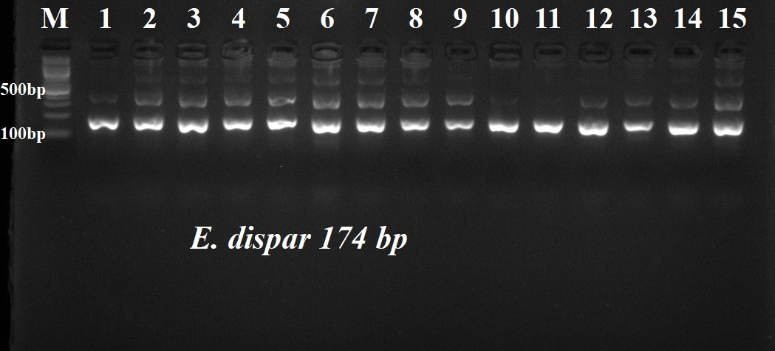
FIGURE 3. The results of nested- PCR for the ED-1 & ED-2 gene in samples (1-15) indicate represents the positive samples. The size of the gene was 174 base pairs. Electrophoresis was conducted using a 2% agarose gel, with the standard size marker measuring 100 base pairs.
The results of the current study are consistent with those of [21], where the infection rate with E. dispar using Nested-PCR was approximately 30.8%. They do not agree with a study conducted in Malaysia by [22], which reported an E. dispar infection rate of 5.6%. They also do not agree with a study conducted in Australia, which recorded an infection rate of approximately 70.8% with E. dispar, compared to 4.5% with E. histolytica [23]. A study in Brazil showed that E. dispar was more prevalent, with a prevalence of 90%, compared to 10% for E. histolytica among infected individuals [24]. In a similar study in India, 49.5% of patients were infected with E. dispar, while only 7.4% were infected with E. histolytica [25]. The discrepancy between studies is likely due to several factors, including differences in DNA extraction methods from stool samples, length of study, sample size, time of study, geographic location, population density, and target age group.The nested PCR specific for E. histolytica showed positive bands at 439 bp in 42% of the samples."

CONCLUSIONS
The current work clearly shows that the Nested-PCR method is far more sensitive and specific than the traditional microscopy at detecting Entamoeba infections and that the DNA of this parasite was successfully detected in 88 percent of the samples, as opposed to 65 percent based on the microscopy. Most importantly, the prevalence of the pathogenic E. histolytica was demonstrated to be high (42 %of the positive cases) by the application of molecular diagnosis, showing a high rate of true amoebic dysentery in the study region. Also, the fact that non-pathogenic E. dispar was identified in 27 % of cases only confirms that microscopy cannot be used to provide accurate clinical diagnosis and results in a gross overestimation of pathogenic infections, which is comparable to findings internationally. The study also helps in the knowledge of the geographical differences in dominance of species and it also highlights the need to adopt localized molecular surveillance. Thus, Nested-PCR can be regarded as a necessary tool ensuring proper diagnosis and the management of a patient as well as the application of the data on the local epidemiology to inform the strategies involving the population health.
REFERENCES
- N. Guillén, "Pathogenicity and virulence of Entamoeba histolytica, the agent of amoebiasis," Virulence, 14(1), p. 2158656, 2023.
- A. Singh, I. T. Banerjee, U. Khan, & S. K. Shukla, "Epidemiology of clinically relevant Entamoeba spp. (E. histolytica/ dispar/ moshkovskii/ bangladeshi): a cross sectional study from North India," PLoS Neglected Tropical Diseases, 15(9), p. e0009762, 2021.
- S. D. Jari, & Z. Fadhil Abbas, "The Exploring of Pro-Inflammatory Cytokine IFN-γ, IL-17 and TNF-α in Patients with Amoebic Dysentry from Kerbala Province," 2025.
- W. E. Mahmood, A. J. Mahmoud Zangana, & H. S. Ahmad, "The Effect of Amoebic Dysentery on Some Physiological Parameters," Pakistan Journal of Life & Social Sciences, 22(1), 2024.
- S. K. Sardar, A. Ghosal, T. Haldar, M. Maruf, K. Das, Y. Saito-Nakano, et al., "Prevalence and molecular characterization of Entamoeba moshkovskii in diarrheal patients from Eastern India," PLoS Neglected Tropical Diseases, 17(5), p. e0011287, 2022.
- S. Das, N. Rajkumari, A. Gunalan, D. Rajavelu, & J. J. Olickal, "A comparative analysis of microscopy, coproantigen serology, and nested multiplex PCR in the laboratory diagnosis of Entamoeba histolytica infection," Journal of Laboratory Physicians, 14(2), pp. 125-131, 2022.
- D. R. Abenoja, M. E. A. Abuan, S. P. G. Aniceto, A. G. N. Bugayong, M. K. R. Fabiculanan, J. D. A. Galleta, et al., "Commensal vs. Pathogenic: challenges in differentiating E. histolytica and other non-pathogenic amoeba," 2024.
- S. Mozer, I. G. Abdulwahhab, & A. F. Al-Azaawie, "Diagnosis Of Contamination Of Vegetables And Fruits With Cryptosporidium Spp Using Nested-PCR Technique," Nat Volatiles Essent Oils, pp. 223-232, 2021.
- S. Mozer, I. G. Abdulwahhab, & A. F. Al-Azaawie, "Extraction of the DNA of Giardia lamblia isolated from vegetables and fruits in a simplified way and its diagnosis using Nested-PCR," Journal of Parasitic Diseases, 46(3), pp. 771-775, 2022.
- I. G. Abdulwahhab, "Effect of Crataegus Azarolus Extracted in Treatment of Giardia Lamblia Infection," Indian Journal of Forensic Medicine & Toxicology, 15(2), 2021.
- H. Rodulfo, B. Ahmar, M. E. Rodríguez, L. Mora, & M. De Donato, "Nested PCR revela elevado sobrediagnóstico de E. histolytica en Barcelona, Venezuela," Investigacion Clinica, 53(4), pp. 365-377, 2012.
- C. G. Clark, & L. S. Diamond, "Methods for cultivation of luminal parasitic protists of clinical importance," Clinical Microbiology Reviews, 15(3), pp. 329-341, 2002.
- K. T. Aziz, R. A. Rostam, A. O. Qasem, & P. M. Azize, "Epidemiological Study for Entamoeba Histolytica Infection and their Risk Factors among Children in Pediatric Hospital in Sulaimani Province-Iraq," Kufa Journal for Nursing Sciences, 12(1), 2022.
- H. F. Alyasari, H. O. AlHashim, A. H. Altaei, & M. B. Al-Shuhaib, "Identification of serious clinical amebic dysentery cases in the middle Euphrates region of Iraq," Journal of Biological Sciences, 19, pp. 148-154, 2019.
- C. M. Lepore, L. Kamau, & E. Kanduma, "Molecular prevalence of Entamoeba species patients in Eastern Kenya," European Journal of Biology and Biotechnology, p. Ejbio 10-24018, 2022.
- J. J. Verweij, F. Oostvogel, E. A. Brienen, A. Nang-Beifubah, J. Ziem, & A. M. Polderman, "Short communication: prevalence of Entamoeba histolytica and Entamoeba dispar in northern Ghana," Tropical Medicine & International Health, 8, pp. 1153-1156, 2003.
- Z. Hamzah, S. Petmitr, M. Mungthin, S. Leelayoova, & P. Chavalitshewinkoon-Petmitr, "Differential detection of Entamoeba histolytica, Entamoeba dispar, and Entamoeba moshkovskii by a singleround PCR assay," Journal of Clinical Microbiology, 44, pp. 3196-3200, 2006.
- R. Ngui, L. Angal, S. A. Fakhrurrazi, Y. L. A. Lian, L. Y. Ling, J. Ibrahim, et al., "Differentiating Entamoeba histolytica, Entamoeba dispar and Entamoeba moshkovskii using nested polymerase chain reaction (PCR) in rural communities in Malaysia," Parasites & Vectors, 5(1), p. 187, 2012.
- M. A. Kadir, S. T. El-Yassin, & A. M. Ali, "Detection of Entamoeba histolytica and Giardia lamblia in children with diarrhea in Tikrit city," Tikrit Journal of Pure Science, 23(6), pp. 57-64, 2020.
- A. El Bakri, A. Samie, S. Ezzedine, & R. Abu Odeh, "Differential detection of Entamoeba histolytica, Entamoeba dispar and Entamoeba moshkovskii in fecal samples by nested PCR in the United Arab Emirates (UAE)," Acta Parasitologica, 58(2), pp. 185-190, 2013.
- R. Ngui, L. Angal, S. A. Fakhrurrazi, Y. L. A. Lian, L. Y. Ling, J. Ibrahim, et al., "Differentiating Entamoeba histolytica, Entamoeba dispar and Entamoeba moshkovskii using nested polymerase chain reaction (PCR) in rural communities in Malaysia," Parasites & Vectors, 5(1), p. 187, 2012.
- M. Y. Noor Azian, Y. M. San, C. C. Gan, M. Y. Yusri, Y. Nurulsyamzawaty, A. H. Zuhaizam, et al., "Prevalence of intestinal protozoa in an aborigine community in Pahang, Malaysia," Tropical Biomedicine, 24, pp. 55-62, 2006.
- R. Fotedar, D. Stark, N. Beebe, D. Marriot, J. Ellis, & J. Harkness, "PCR detection of Entamoeba histolytica, Entamoeba dispar and Entamoeba moshkovskii in stool samples from Sydney, Australia," Journal of Clinical Microbiology, 45, pp. 1035-1037, 2007.
- L. Braga, M. L. Gomes, M. W. Silva, C. Paiva, A. Sales, & B. J. Mann, "Entamoeba histolytica and Entamoeba dispar infections as detected by monoclonal antibody in an urban slum in Fortaleza, Northeastern Brazil," Revista da Sociedade Brasileira de Medicina Tropical, 34, pp. 467-471, 2001.
- K. Khairnar, & S. C. Parija, "A novel nested multiplex polymerase chain reaction (PCR) assay for differential detection of Entamoeba histolytica, E. moshkovskii and E. dispar DNA in stool samples," BMC Microbiology, 7(1), p. 47, 2007.

