Assessment of the Change in the Surface Area of Iraq's Waters Between 2019 and 2024
Fatima I. Ahmad ^{1,a)}, Auday H. Shaban ^{1,b)}
¹ Department of Remote Sensing & GIS, College of Science, University of Baghdad, Baghdad, Iraq.

^{a)} Fatima.Abd2309@sc.uobaghdad.edu.iq
^{b)} auday.h@sc.uobaghdad.edu.iq
Abstract. Remote sensing techniques are advanced systems and tools that are highly effective in measuring huge areas covered by water in a short period of time compared to traditional methods. In this paper, we focus on calculating the area of all water bodies and rivers in Iraq using remote sensing techniques and Geographic Information System (GIS). To detect variations in the water surface area, Landsat 8 satellite images were taken in two time periods. In this research, many classification techniques were used with multiple Band Combinations. The classification technique that gives the best results is maximum likelihood and (564) band composite, that applied to extract the results to find the total water surface areas in Iraq. The results displayed that the surface area of the water in July 2019 was 10081.2447 km2 and that the surface area in July 2024 was 5133.4974 km2.
Keywords: water resources, Iraq water table, supervised classification methods.

Introduction
Iraq is one of the countries with a rich and diverse water system, encompassing numerous rivers and bodies of water [1]. These contain the two main rivers, the Tigris and Euphrates, and their numerous secondary rivers and tributaries. Water bodies contain numerous marshes, lakes, and swamps [2] [3]. This has led researchers to conduct numerous studies using remote sensing tools and geographic information systems, which have a high capacity to monitor variations, measure water bodies, determine water quality, and produce various maps related to the water system [4] [5]. Therefore, in this paper, remote sensing systems and geographic information systems were used to conduct measurements to determine the volume of variation in the surface area of water in all of Iraq [6]. Landsat 8 satellite images were used, and all images were taken covering all of Iraq for both July 2024 and July 2021. The goal was to determine the variance between the two years [7]. In this paper, the measurement methods were based on the methods discussed and proven effective in calculating the surface water area in the two previous studies [8] [9]. Therefore, the Band Combination 564 and the Supervisor classification technique were used [10] [11]. The basic band combination concept is a simple way to select the most useful bands for image analysis. Band selection is based on the premise that each spectral band captures different information about the scene, and the principle of merging these bands in ways that make it easier to highlight terrain features, rather than detecting features using a single spectral band [12] [13]. The use of a type of maximum likelihood classification technique, which is considered a classic classification algorithm based on Bayes' theorem, is based on statistics and is one of the supervised classification methods that rely on the basics of the classification algorithm: taking a number of samples for each land cover class, creating a sampling table, and applying it to the entire image to extract all land features [14, pp. 274-281] [15]. Lakes have suffered from numerous variations in their area and volume since ancient times due to geological changes, climate change, evaporation, erosion, drought, lack of rainfall, and other factors that have altered the shape of the water system in Iraq [16] [17]. However, the most recent challenge facing this water system is geopolitical factors, which have played a major role in changing the water area and exposing it to severe and continuous drought over the past period [18]. This is due to Iran's alteration of tributary flows, disrupting a major water source. Furthermore, Turkey's construction of several dams on the Tigris and Euphrates rivers has significantly reduced water flow to Iraq. There are some studies conducted in Iraq, the research paper was prepared by Youssef Al. et al. The aim paper reveals the changes that occurred in the Hammar Marsh is located south of the Euphrates and the Central Marshes is located between Dallah and the Euphrates. This research uses the (MNDWI), and the result after applying the equation was that the R value for the Euphrates was 0.4, while the value for the Tigris was 0.5 [19]. The paper prepared by Malik R. et al. This research paper aims to study, evaluate and map the variability of water bodies and vegetation cover during the period of 1990, 2000 and also 2007 in the central region of Iraq. The results showed a decrease in the surface area of water during the mentioned years, with values of 10.6%, 2.5% and 7.6% respectively [20]. The paper prepared by Taghred A. et al. This research aims to measure the seasonal impact on the water bodies in the Iraqi marshes during the period from 1987 to 2017 using the Support Vector Machine (SVM) classifier. The result was that the water bodies recovered more in the winter than in the summer, but they faced a continuous decline in general due to the decrease in water levels [21]. The paper prepared by Zainab A. et al. This research aims to examine the changes that occurred in the marshland’s region of southern Iraq during the period from 2017 to 2019 using images from the Landsat 8 satellite, collecting images for time period to determine the amount of variation. The result was that in 2019 there was an increase in the surface area of water by 140% compared to 2018 and 60% compared to 2017 [22]. The goal of this research is to determine the extent of variation in the surface area of Iraq's water supply between July 2019 and July 2024.

Study Area
Iraq is considered one of the countries with the oldest civilizations in the world, and its geographical location contributed to the establishment of these civilizations. Its geographical location lies at 33°N 43°W, giving it a continental character, as it lies south of the Asian continent [1]. Iraq overlooks a vast desert known as the Najd Desert in the Arabian Peninsula and the Syrian Desert. It also overlooks a narrow body of water, the Arabian Gulf. It is also separated from the Black and Caspian Seas by mountain barriers, as it is surrounded to the east and north by the Anatolian Plateau and the Taurus Mountains [3]. This geographic location has given Iraq a rich and diverse water system, including numerous rivers and bodies of water. Fig. 1 displays the area (Iraq).

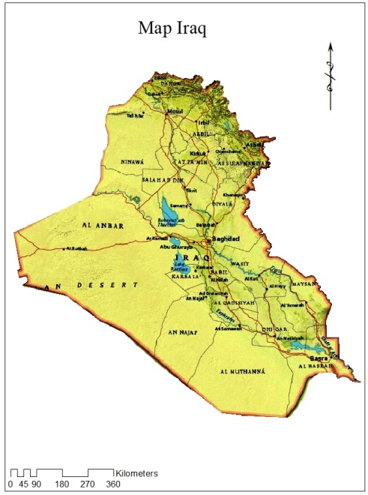
FIGURE 1. Studied area (Iraq)

Methodology
The hydrological system in Iraq is one of the most important factors influencing the region's ecosystem. Remote monitoring technologies are a vital tool for monitoring changes in surface water. This research is based on the methodology of two previous studies, as the first research (Investigation of band groups for hydrological detection) proved that it identified both Hamrin Lake and Dokan Lake as a study area to conduct calculations on them to choose the best color combination to calculate the surface water area using satellite images taken at different and multiple time periods. Many band combinations were used for the scene to determine the best color combination to extract the area of the study areas and compare it with the real data obtained from the Ministry of Water Resources. The band Combination used was:
Cb-1 = (5-4-3)
Cb-2 = (5-6-4)
Cb-3 = (6-5-4)
Cb-4 = (6-5-3)
Cb-5 = (6-5-2)
The maximum classification was applied to all color combinations to extract the results gains, and through it, it was concluded that the Band Combination 564 is the most appropriate for calculating the surface area of water based on real data from the Hamrin and Dokan lakes
As for the second research (verification of classification methods in hydrological discoveries), Hamrin Lake and Dukan Lake were chosen to extract the surface area of the lake, using Landsat 8 satellite images of these two lakes at various time periods. Several types of Supervised classification were used, namely (Mahalanobis) distance classification, maximum classification, parallel surface classification, neural network classification) to extract the surface area of the two lakes, in order to compare them with the actual data taken from the Ministry of Water Resources. All selected Supervised classification types were applied to the Band Combination (564). The results showed that the maximum classification is the most appropriate for identifying water bodies based on the consistency with real data for Dukan Lake and Hamrin Lake. Therefore, the basic work steps consist of collecting Landsat 8 satellite images covering the entire territory of Iraq for each of two years (July 2019 and July 2024). All images are processed and combined to produce a single image of Iraq. Image processing techniques and spectral band Combination identification of the 564 images are used based on the initial research. Several directed classification types (Mahalanobs distance classification, maximum classification, and parallelepiped classification) were used to extract the surface area of Iraq's water bodies. The results presented represent the areas of all water bodies and rivers. Apparent surface area is an indicator of water surface variability.

Results and Discussions
The results obtained in this study relate to the calculation of the surface area of water bodies in Iraq. This study is based on the results of the first and second studies. The results represent the first study that used the classification process of the five Band composite determine the surface areas of water. To make the evaluation by comparing it with real data, the actual volume of Hamrin Lake in July 2022 was 0.196 and in July 2023 it was 0.371, so the volume ratio between the two years was 1.8928571. The results of the ranges used for Hamrin Lake are shown in Table 1. Surface areas were calculated using ArcGIS. The table shows the calculated surface areas in square kilometers for Hamrin Lake in July 2022 and 2023.

TABLE 1. The surface area values for Hamrin at July 2022 and2023 in square kilometers by maximum likelihood supervised classification method
Type Band |  | A1 (area2023) |  | A2 (arae2022) |  | R= A1/A2
Cb-1 | 73.4904 |  | 46.1781 |  | 1.5914557
Cb-2 | 77.0706 |  | 44.1243 |  | 1.7466702
Cb-3 | 72.0387 |  | 43.4835 |  | 1.6566905
Cb-4 | 71.3808 |  | 40.6539 |  | 1.7558168
Cb-5 | 68.0049 |  | 41.814 |  | 1.6263668

Table 2, illustrated the calculated surfaces areas for Dukan Lake in November for both 2017 and 2018. Note that the actual volume of Dukan Lake in November 2017 was 0.9356 and November 2018 was 0.7921, so the volume ratio between the two years was 1.181163994. The area ratios were calculated to show the level of evaluation.

TABLE 2. The surface area values for Dukan at November 2017 and 2018 in square kilometers by maximum likelihood supervised classification method
Type Band |  | A1 (area2017) |  | A2 (arae2018) |  | R= A1/A2
Cb-1 | 169.3971 |  | 136.5885 |  | 1.24020031
Cb-2 | 159.9372 |  | 133.9533 |  | 1.193977304
Cb-3 | 157.0086 |  | 131.9652 |  | 1.189772758
Cb-4 | 166.0005 |  | 158.1183 |  | 1.049850017
Cb-5 | 163.3239 |  | 141.6897 |  | 1.152687175

Table 3, illustrated the calculated surfaces areas for Hamrin Lake in October for both 2021 and 2022. Note that the actual volume of Hamrin Lake in October 2021 was 0.1030, and for October 2022 it was 0.1274. The volume ratio between the two years was 1.236893204. The area ratios were calculated to show the level of evaluation.

TABLE 3. The surface area values for Hamrin at October 2021 and2022 in square kilometers by maximum likelihood supervised classification method
Type Band | A1 (area2022) | A2 (arae2021) | R= A1/A2
Cb-1 | 26.2512 | 22.9995 | 1.14138133
Cb-2 | 28.0593 | 23.0319 | 1.21827986
Cb-3 | 28.0377 | 26.9568 | 1.04009749
Cb-4 | 27.4653 | 26.3871 | 1.04086088
Cb-5 | 28.1295 | 21.8277 | 1.28870655

The results of the second study, which used four types of directed classification on composite Band satellite images, were presented. 564 The evaluation process was based on real data. Water surface areas were determined. The results demonstrated the effectiveness and efficiency of the maximum classification in calculating water surfaces. Surface areas were calculated using ArcGIS software. Fig. 2&3 shows the classification results of Hamrin Lake in July 2022 and 2023. Area ratios were calculated to illustrate the evaluation level shown in Fig. 4.

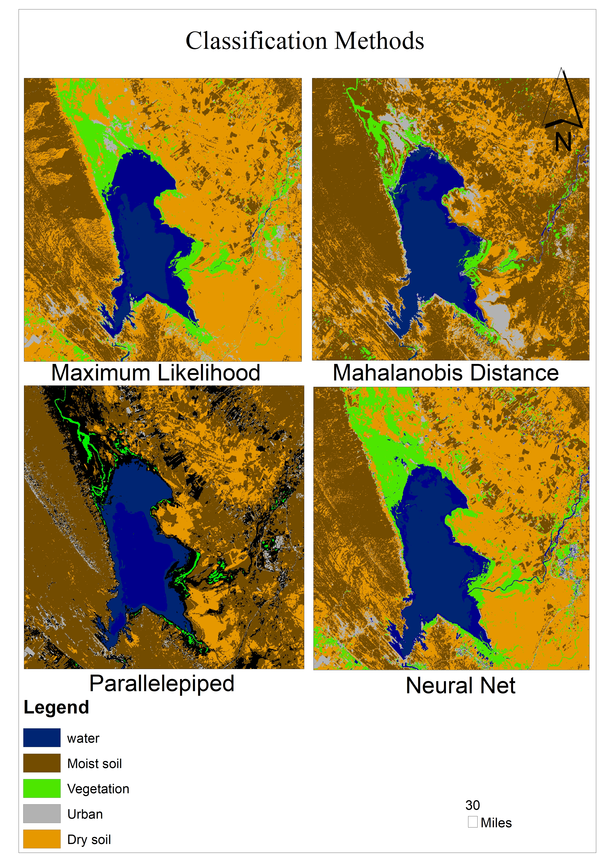
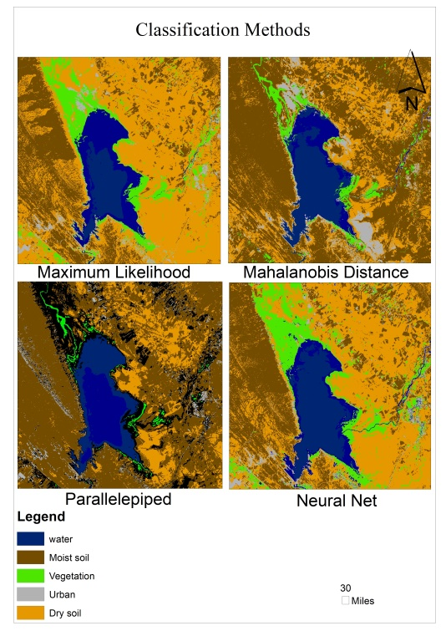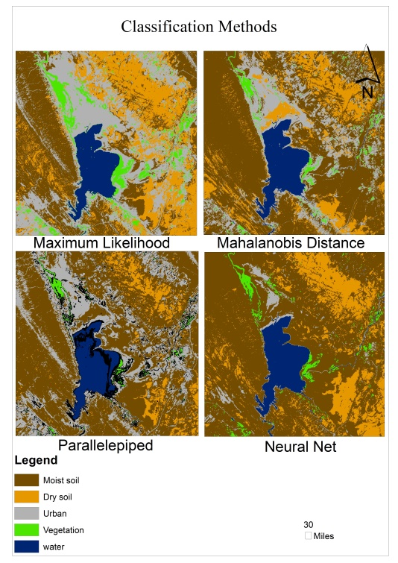
FIGURE 2. Hamrin lake for 2023 FIGURE 3. Hamrin lake for 2022

The use of different types of Supervised classification for Hamrin Lake for the year 2022 and 2023 led to the emergence of multiple results. These results demonstrated the effectiveness and efficiency of the maximum likelihood classification and its extent in calculating water bodies with an accuracy very close to the real data, better than the rest of the mentioned classification types.

FIGURE 4. Comparison results for Hamrin Lake for both 2022 and 2023 using the band combination (564)

Figure 5&6 displays the designed surface areas of Dukan Lake in November for both 2017 and 2018. Area ratios were calculated to show the assessment level shown in Fig. 7.

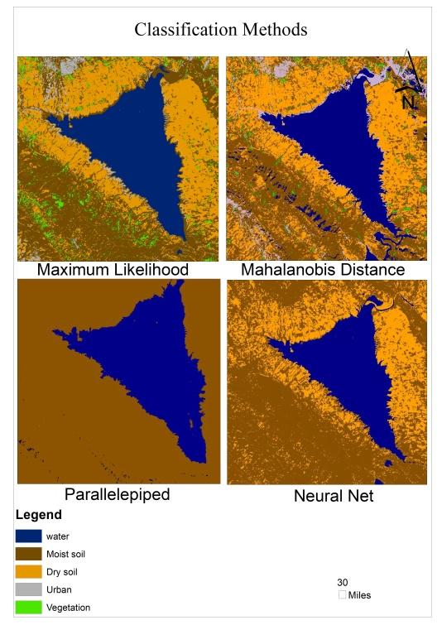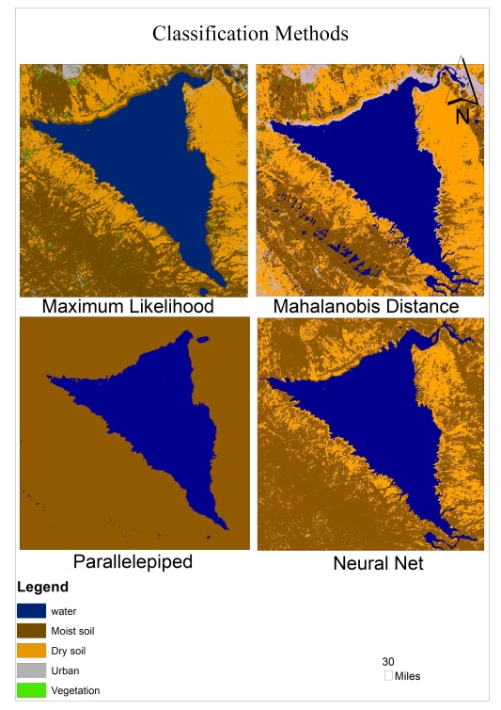
FIGURE 5. Dokan lake for 2018 FIGURE 6. Dokan lake for 2017

The use of different types of Supervised classification for Dokan Lake in 2017 and 2018 has shown multiple results. These results demonstrate the effectiveness and efficiency of the maximum likelihood classification and its ability to calculate water bodies with an accuracy very close to the real data, better than the rest of the mentioned classification types.

FIGURE 7. Comparison results for Dukan Lake for both 2017 and 2018 using the band combination (564)

Figure 8&9 displays the designed surface areas of Lake Hamrin lake at October for each year 2021 and 2022. Area ratios were calculated to show the assessment level shown in Fig. 10.

FIGURE 8. Hamrin lake for 2023 FIGURE 9. Hamrin lake for 2022

The use of different types of Supervised classification for Hamrin Lake in the year 2021 and 2022 has shown multiple results. These results demonstrate the effectiveness and efficiency of the maximum likelihood classification and its ability to calculate water bodies with an accuracy very close to the real data, better than the rest of the mentioned classification types.

FIGURE 10. Comparison results for Hamren lake for both 2021 and 2022 using the band combination (564)

The results are displayed after processing and merging all the scenes to produce a single image of Iraq and using the techniques on the image. When using the 564 bands and applying the( maximum classification , Mahalanobis classification and parallelepiped classification) to display the acquired results, the areas of all water surfaces and the areas of the rivers of Iraq were determined in full. The surface areas were calculated using the GIS program for the entire Iraq and the classification results were displayed in kilometers. Fig. 11 display the results that showed the peak of the total area. Table 4 illustrates the calculated surface areas in square kilometers for Iraq in July 2024

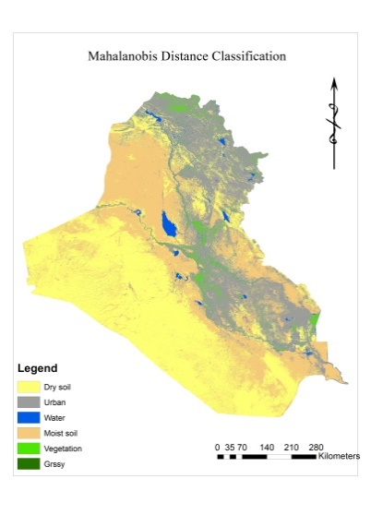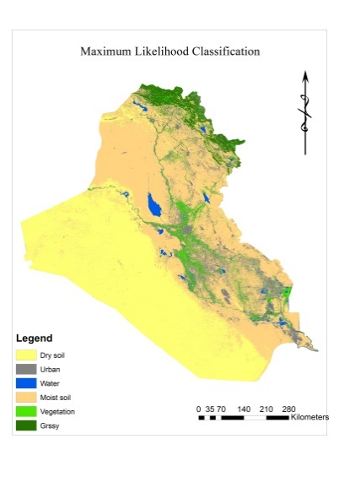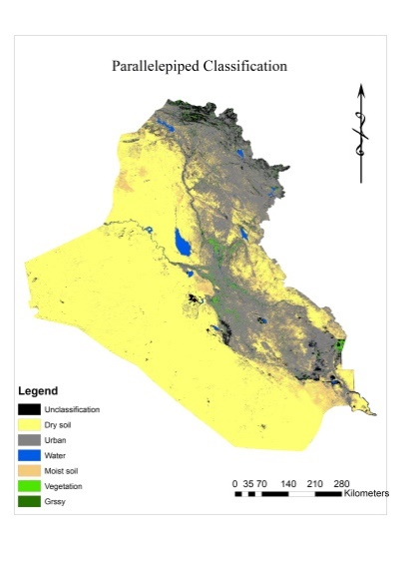
FIGURE 11. Supervised classification of Iraq July 2024

The use of different types of Supervised classification methods for Iraq in the year 2024 has shown multiple results. These results demonstrate the effectiveness and efficiency of the maximum likelihood classification and its ability to calculate water bodies with an accuracy very close to the real data, better than the rest of the mentioned classification types.

TABLE 4. Iraqi water surface area in July 2024 through supervise classification methods
Year 2024 | Area km² | Ratios water
Parallelepiped | 3525.3612000 | 0.0081044
maximum | 5306.1489000 | 0.0121982
Mahalanobis | 4945.8339000 | 0.0113699

Table 5, The calculated surface areas for Iraq in July 2019, Fig.12 display the results that showed the peak of the total area
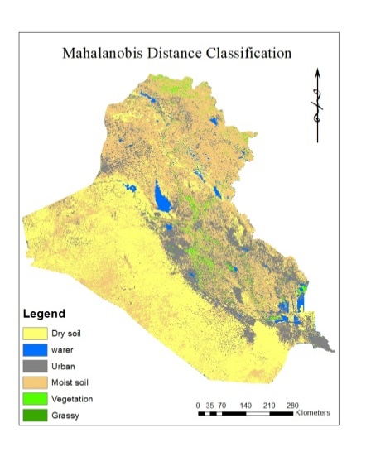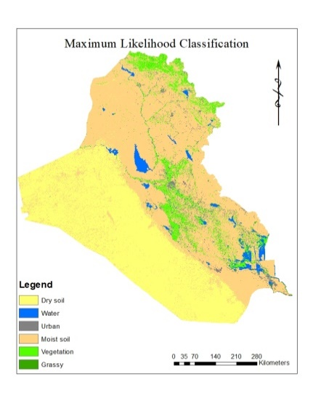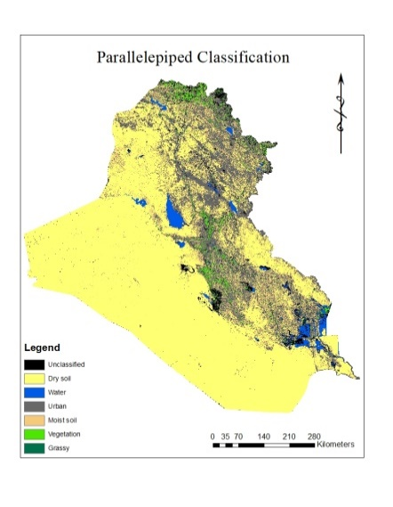
FIGURE 12. co-883. supervised classification of Iraq July 2019

The use of different types of Supervised classification for Iraq in the year 2019 has shown multiple results. These results demonstrate the effectiveness and efficiency of the maximum likelihood classification and its ability to calculate water bodies with an accuracy very close to the real data, better than the rest of the mentioned classification types.
TABLE 5. Iraqi water surface area in July 2019 through supervise classification methods
Year 2019 | Area km² | Ratios water
parallelepiped | 8333.7516000 | 0.0191583
maximum | 9927.3825000 | 0.0228218
mahalanobis | 9263.2410000 | 0.0212951

The apparent results and the clarity of the specific variance over the two years indicate the efficiency and effectiveness of the approach used, which has a high ability to highlight variance in a prominent manner. Each method is based on a working principle and algorithm. The idea behind band merging is that each spectral band captures different information about the scene, which makes it easier to highlight the scene's features. The feature to be revealed is what determines the types of bands to be merged. Understanding and studying the spectral properties of the target feature and their interaction with electromagnetic wavelengths and other factors will all determine the selection of the band group. Based on this, the 564 band group was selected. Maximum likelihood classification was applied to extract the survey results. This is because the maximum likelihood algorithm assumes a Gaussian distribution (the concept of a normal distribution of data is that the spectral values of pixels within a given land cover class should follow a Gaussian distribution, that is, in simpler terms, when the spectral values of a given land cover class are summed on a graph. The curve will appear bell-shaped. The vector diagram represents the mean spectral values for each class. Also, the covariance matrices that describe the modulation and correlation between the spectral bands for each land cover class were calculated. Therefore, they were used to extract the results.

References
- A. R. Hamza Abdullah, "The Water Crisis in Iraq: Challenges and Problematic Solutions," Ph.D. Thesis, Center for Strategic and International Studies - University of Baghdad, 2024.
- A. G. Dekker, T. J. Malthus, M. M. Wijnen and E. Seyhan, Remote Sensing of Environment, 41(2-3) 211-225, (1992).
- B. A. Hussein, " Gulf Economic Journal, 29(23) 204-242, (2012).
- M. Rashed, a. M and F. M. Alattar, IOP Conference Series: Earth and Environmental Science, 58, 8-12, (2024).
- Y. Afaq and A. Manocha, Ecological Informatics,63, 101310, (2021).
- S. M. Ali and A. S. Mahdi, Iraqi Journal of Science, 49(1), 244-255, (2008).
- M. M. Hason, M. R. Abbas, B. B. Ahmad and T. R. Abbas, IOP Conf. Ser.: Mater. Sciences. Engineering, 928(2) 022018, (2020).
- H. S. AL-BAHRANI, Int. J. Sus. Dev. Plann, 389-399, (2014).
- J. Gong, H. Sui, M. Guorui and Z. Qiming, International Society for Photogrammetry and Remote Sensing, 37, 757-762 (2008).
- C. Albertini, A. Gioia, V. Iacobellis and S. Manfreda, Remote Sens, 14(23) 6005, (2022).
- K. Zhai, X. Wu, Y. Qin and p. Du, Geo-spatial Information Science, 18,32–42, (2015),
- H. D. Cheng, X. H. Jiang, Y. Jiang and J. Wang, Pattern Recognition, 34(12) 2259–2281, (2001)
- K. G. Ruddick, V. De Cauwer, Y. J. Park and G. Moore, Limnology and Oceanography, 51(2) 1167–1179, (2006).
- X. Jia and R. A. John, IEEE Transactions on Geoscience and Remote Sensing, 32(2) 274-281, (1994).
- P. V. Bolstad and T. M. Lillesand, Photogrammetric Engineering & Remote Sensing, 57(1), 67-74, (1991).
- Y. K. AL-Timim, L. E. George and M. H. AL-Jiboori, Iraqi Journal of Science, 53(4), 1078-1082, (2012).
- A. N. Abdul-Hameed and A. S. Mahdi, Iraqi Journal of Science, 64(3)1545- 1545, (2023).
- A. N. Abdul-Hameed and A. S. Mahdi, Iraqi Journal of Science, 64(3) 1545- 1545, (2023).
- Y. Al-Mamalachy and Z. J. Al-saedi, Iraqi Bulletin of Geology and Mining, 18(1), 77-87, (2022).
- M. R. Abdas, M. M. Hason, B. B. Ahmad, A. W. Rasib and T. R. Abbas, IOP Conference. Ser.: Mater. Sciences. Engineering, 928, 022064, (2020).
- T. A. Naji and H. M. Abduljabbar, AIP Conference Proceedings, 2307, 4397-4403, (2020).
- Z. A. Abdullah and H. M. Abduljabbar, AIP Conference Proceedings, 2307, 20-32, (2020).
- Sarah T. Yaseen, Auday H. Shaban, Kareem A. Jasim, Journal of Physics: Conference Series, 1879, 032062, (2021).

