RAPD Typing of Multidrug-Resistant Klebsiella pneumonia Possessing OqxA and OqxB Efflux Pump Genes
Douaa Rashed Hamady^{1, b)} and Rana Mujahid Abdullah^{1, a)}
¹ Department of Biology, College of Education for Pure and Applied Science (bn Al-Haitham), University of Baghdad. Baghdad, Iraq.

^{a).}douaarashed@yahoo.com
^{b)} Corresponding author: dr.rana_alshwaikh@yahoo.com
Abstract. One hundred and thirty clinical samples were collected from Baghdad hospital including urine, sputum, blood, wound and burn infections. Isolation, identification, microscopic examination, biochemical and antimicrobial susceptibility testing were performed. DNA extraction and polymerase chain reaction were then performed to analyses three genes (16S rRNA, oqxA and oqxB). Finally, typing of K. pneumoniae with the RAPD method. The results showed that all K. pneumoniae isolates was 50 (38.4%).The minimum inhibitory concentrations (MICs) test showed that resistance of isolates was 50(100%) to ticarcillin, 43(86%) to ticarcillin/clavulanic acid, 50(100%) to piperacillin, 32(64%) to piperacillin/tazobactam, 39(78%) to ceftazidime , 34(68%) to cefepime , 44(88%) to aztreonam . Genotyping revealed that oqxA was present in 50 (100%) of K. pneumoniae, while oqxB was present in 27 (54%) of isolates. The results of the genotyping of K. pneumoniae using the RAPD method showed that 12 different genotypes with a molecular weight of 250-1500 base pairs.
Keywords: Klebsiella pneumoniae, oqxA, oqxB, MICs, Genotype, RABD method.

INTRODUCTION
The genus Klebsiella a member of the family Enterobacteriaceae [1]. It is Gram-negative [2], (0.6-6 , 0.3-1) μm wide, singly, in pairs, or as short chains, ferments lactose, is non-motile [3], non-spore forming, oxidase negative, and contains a protuberant polysaccharide capsule. It also develops quickly on normal media and its colonies seem large, pink, round and mucous on MacConkey agar, demonstrating lactose fermentation and acid production. It also grows rapidly on CHROMO agar, nutrient agar, blood agar, and eosin methylene blue agar (EMB) [4,5]. In 1834, Edwin Klebs discovered the genus Klebsiella and named it after him [6]. In 1883, Friedlander, a German pathologist, isolated an encapsulated bacillus from the lungs of a patient who had died of pneumonia. Klebsiella is called Friedlander’s bacillus [7]. The prevalence of K. pneumoniae may be a nosocomial pathogen in Europe and the United States of America (USA) as a result of the acquisition of antibiotic resistance markers that give it a selective advantage in the hospital environment and is responsible for 6-17% of urinary tract infections (UTIs), 4-15% of septicemia, 7-14% of pneumonia [8], 2-4% of wound infections, 4-17% of nosocomial infections in intensive care units and 3-20% of all neonatal septicemia [9]. Efflux pumps are known to enhance host resistance to antimicrobial peptides in other bacteria and are an important constituent of the host’s innate immune system [10]. Efflux pumps have been recorded as one of the mechanisms responsible of antibiotic resistance [11]. It is likely that this mechanism plays a similar role in the virulence of K. pneumoniae, which has membrane-spanning efflux pumps to discharge toxic combinations extending from heavy metal ions to organic chemicals, containing antibiotics. The overall architecture of these efflux pumps is greatly preserved: an energy-transfer subunit in the inner membrane combined through an adapter protein to an outer membrane channel subunit that allows the toxic combinations to be barred into the environment [12]. K. pneumonia’s most common efflux pump is OqxAB. The OqxAB efflux pump, which involves of OqxA as a peripheral component and OqxB as a Trans membrane protein, is a member of the resistance node division (RND) family [13]. It confers resistance to several antibiotics, including chloramphenicol, trimethoprim, nitrofurantoin, quinoxalines, fluoroquinolones, chloramphenicol, and tigecycline [14]. oqxAB has been progressively identified among K. pneumoniae as one of the mechanisms of plasmid-mediated quinolone resistance (PMQR) in excess of the past periods [13, 14]. RAPD PCR (Random Amplification of Polymorphic DNA PCR) is a simple, fast, inexpensive and widely used typing method that does not require advanced knowledge of the DNA sequences of the target organism. RAPD typing has been successfully used for epidemiological analysis of many bacteria as well as for clinical isolates of K. pneumonia [15]. Molecular typing and virulence analysis of clinical isolates are powerful tools that can shed light on multidrug resistant (MDR) Klebsiella pneumonia infections and allows the identification of different strains of certain bacterial species depending on the analysis of their genetic material. Although all strains tested belong to the same species, subtle differences in the bacterial genome make it possible to distinguish between these unrelated strains and those that may have originated from a common source [16]. typing is commonly used to identify the source and routes of bacterial infection, track the transmission of healthcare- associated pathogens, identify virulent strains, and evaluate the effectiveness of control measures [17]. The study aimed to detect the RAPD PCR typing and examined the prevalence of the oqxA and oqxB genes and their role in the development of the multidrug resistance (MDR) phenotype in clinical isolates of Klebsiella pneumoniae.

MATERIALS AND METHODS

Samples Collection, Isolation, Identification and Microscopic Examination
Fifty clinical samples were taken from patients in Baghdad city hospitals, including (Al-Imamain Al-Kadhimiya Hospital, Al-Karkh General Hospital, Al-Kadhimiya Children's Hospital, Burns Hospital, and Ghazi Al-Hariri Hospital) during the period from 15/10/2023 to 25/12/2023.
All samples were inoculated on MacConkey agar, Eosin blue agar, blood agar (Oxoid, UK) and CHROMagar Orientation (Pioneer, France) and further biochemical tests including catalase, oxidase, indole, methyl red, Voges Proskauer, and Simon citrate (IMViC) [18]. To microscopic examination staining with Gram stain [19].To final diagnosis using 16S rRNA gene [20].

Antimicrobial Susceptibility Test

The susceptibility of bacterial isolates was detected by defining the MICs values of some antibiotics from different classes using Vitek 2 Compact System using AST-GN cards (Antibiotic sensitivity test card) containing 16 antibiotics with different concentrations distributed on 64 wells. Consequences were deduced according to CLSI [21].

DNA Extraction
Total genomic DNA was extracted from K. pneumoniae isolates grown on MacConkey agar utilizing a DNA purification kit (Promega, USA) according to the manufacturer's instructions. DNA concentration was measured by Quantus Fluorometer and the extracted DNA was screened for 16SrRNA (F: GCAAGTCGAGCGGTAGCACAG , R: CAGTGTGGCTGGTCATCCTCTC , 260 bp [22], oqxA (F: CTCGGCGCGATGATGCT, R: CCACTCTTCACGGGAGACGA) 392bp [23] and oqxB(F: TTCTCCCCCGGCGGGAAGTAC , R: CTCGGCCATTTTGGCGCGTA ) 512bp [23]genes , RAPD (AAG ACG CCG T ) 300-1500bp [24] utilizing primers (Macrogen, Korea). The dried product of primers was dissolved in sterile distilled deionized water (Promega, USA) to attain 100 pmol/μl and formerly diluted to 10 pmol/μl rendering to the manufacturer's instructions. Polymerase chain reaction (PCR) was done by utilizing a Thermal Cycler (USA/Thermo Fishe Scientific). The PCR reaction mixture with a final volume of 24μl contained 1μl each of forward and reverse primers, 12.5μl of Go Taq Green Master Mix, 2μl of template DNA, and 7.5μl of sterilized deionized distilled water

Agarose Gel Electrophoresis
The PCR amplification of (16S rRNA, oqxA and oqxB) genes was confirmed by electrophoresis at 100 V for 60 min on 2% agarose gel using a ladder (100-1500 base pairs) as a molecular weight marker. A UV-Transilluminator was utilized to monitor the PCR product in 320 nm UV light [25]. Table 1

TABLE 1. Polymerase chain reaction mixture (PCR Products).
PCR Steps | Temperature (°C)  16S rRNA | Temperature (°C)  oqxA and oqxB | Time  16S rRNA | Time  oqxA and oqxB | Cyclesʼ Number  16S rRNA | Cyclesʼ Number  oqxA and oqxB
Initial Denaturation | 95 | 95 | 3min | 1min | 1 | 1
Denaturation | 95 | 95 | 45sec | 45sec | 28 | 35
Annealing | 58 | 60 | sec 45 | sec 45 | 28
Extension | 72 | 72 | 1 min | 1 min | 28
Final Extension | 72 | 72 | min5 | min5 | 1 | 1

Typing of K. Pneumoniae using the RAPD Method
The PCR mixture was prepared at 24 μl contained 1 μl each of forward and reverse primers, 12.5 μl of Go Taq Green Master Mix, 2 μl of DNA, and 7.5 μl of sterilized deionized distilled water for the genes. Then the contents of the PCR tubes were mixed well with the mixer and then placed in a thermal cycle as shown in Table 2.

TABLE 2. Optimal Conditions for PCR for RAPD gene investigation.
No. | Phase | Temperature | Time | Cycles number
1 | Initial Denaturation | 94 | 5 min | 1
2 | Denaturation | 94 | 1 min | 45
3 | Annealing | 36 | 1 min | 45
4 | Extension | 72 | 1 min | 45
5 | Final Extension | 72 | 9 min | 1
Five μL of the PCR was then transferred to the electrophoresis on the prepared agarose gel at a concentration of 2%.

Ethical Approval
Ethical Approval and consent to participate, according to the Helsinki Declaration, Ethical permission has been obtained from the College of Education for Pure Science (Ibn Al-Haitham) at the University of Baghdad and the Iraqi Ministry of Health and Environment no. (39891) on 19/10/2023, subject to the agreement of the patients directed.

RESULTS

Isolation and Detection of Samples
After performing morphological and microscopic examinations, biochemical tests and genetic diagnosis by detecting the 16S rRNA gene. After the final diagnosis, 50 (38.4%) of K. pneumoniae bacteria were obtained. The results of the study presented that the highest percentage of K. pneumoniae isolation was from urine samples Urine of patients with urinary tract infections (UTI) as it reached 25 (50%) of the total isolates, 14 (28%) from sputum, 6 (12%) from wounds, 3 (6%) from blood, 2 (4%) from burns. Fifty bacterial isolates showed the ability to grow on MacConkey agar and showed bright pink colonies with a mucoid structure, which is a distinctive feature of K. pneumoniae bacteria because it ferments lactose. When grown on blood agar medium, large, shiny, gray-white, round colonies appeared with no non-hemolytic hemolysis of the type (γ-hemolysis). Also, when grown on CHROMagar™ medium, a metallic blue bacterial colony appeared. All 50 was performed after staining with Gram stain. The results of microscopic examination showed that they were Gram-negative rods. For further identification, biochemical tests were performed on 50 isolates, including urease, citrate, catalase, and Fuchs-Proskauer. All isolates gave positive results, and gave negative results for the oxidase, indole, and methyl red test.

Antimicrobial Susceptibility of K. Pneumoniae
In this study, antibiotic sensitivity testing was performed on seven antibiotics. Most of the K. pneumoniae bacteria showed resistance to an extensive range of antibiotics that were examined. The bacterial isolates showed resistance to Ticarcillin and Ticarcillin/Clavulanic Acid by 100% and 86%, respectively, All bacterial isolates showed resistance to Piperacillin, which is one of the beta-lactam antibiotics, at a rate of (100%); The results of this study presented that the resistance of bacterial isolates against Piperacillin/Tazobactam at (64%) The resistance of bacterial isolates to Ceftazidime, one of the antibiotics of the Cephalosporins group, reached (79%). The results of the current study indicated that the resistance to Cefepime, which amounted to (68%), which is one of the antibiotics of the Cephalosporins group. The results of the present study indicated that resistance to the antibiotic Aztreonam, which belongs to the group of Monobactam family antibiotics, was (88%).

Detection of 16SrRNA, oqxA and oqxB Genes
All K. pneumoniae isolates were subjected to molecular diagnosis using PCR technology to confirm the diagnosis using the primer for the 16SrRNA gene because it is a stable gene and has little variation for long periods in the bacterial species. The electrophoresis results showed that all K. pneumoniae isolates (50 isolates) at a rate of 100% possessed the 16SrRNA gene as shown in Fig. 1 (a). Compared with the multiplexed bands and the DNA ladder size indicator, it was found that the resulting bands had a molecular weight of 260 base pairs.
The results of the existing study presented that 50 bacterial isolates (100%) belong to K. pneumoniae bacteria that possess the oqxA gene. After comparing the multiple bands with the ladder size indicator bands, it was found that all of them have a molecular weight of 392 base pairs, as presented in Fig. 1 (b).
The results of the existing study displayed that 27 bacterial isolates (54%) out of a total of 50 bacterial isolates belonging to K. pneumoniae bacteria possess the oqxB gene. After comparing the multiple bands with the ladder size indicator bands, it was found that all of them had a molecular weight of 512 base pairs, as presented in Fig. 1(c).
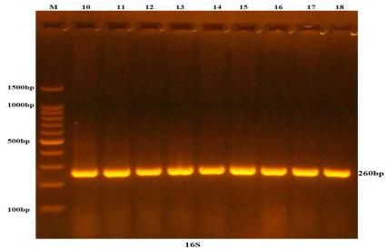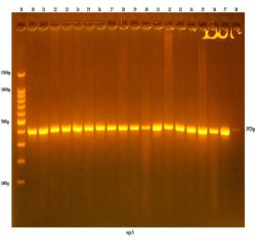
a b
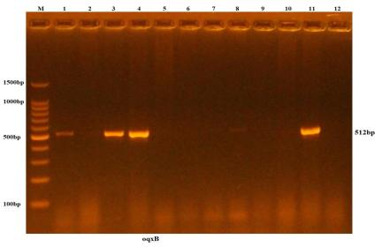
c
Figure 1. (a) Electrophoresis of the PCR product of the 16S rRNA gene (260 base pairs) of K. pneumoniae (b) Electrophoresis of the PCR product of the oqxA gene (392 base pairs) of K. pneumoniae (c) Electrophoresis of the PCR product of the oqxB gene (512 base pairs) of K. pneumoniae on agarose gel at a concentration of (0.2%) and a potential difference of 100 volts for 60 minutes. Line M (volume index) 100 – 1500 base pairs.

Genotyping of K. pneumoniae by RAPD Method
The results of the genotyping of K. pneumoniae bacteria using the RAPD method showed the presence of 12 different genotypes with a molecular weight of 250-1500 base pairs as in Fig. 2, the most frequent being 500, 550 and 1400 base pairs. However, 43 (86%) of the isolates had bands, while 7 (14%) had no bands. The remaining 12 samples of K. pneumoniae showed similarities in the positions of some bands, but their RAPD profiles were not similar. Therefore, it was concluded that these samples belong to different genetic groups.
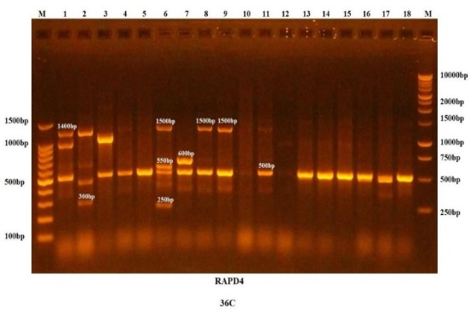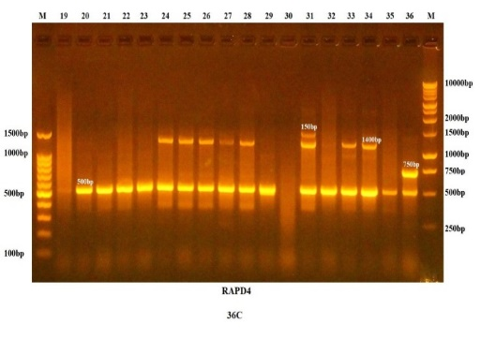
a b

Figure 2. Electrophoresis of PCR Product of RAPD Gene using primer (300-1500 base pairs) of K. pneumoniae Isolates agarose gel at a potential difference of 70 volts for 50 minutes. The PCR reaction product was visualized under UV light at 280 nm. M line 250-10000 base pairs, lines (K1-18) in Fig. (2a), (K19-36) in Fig. (2b).
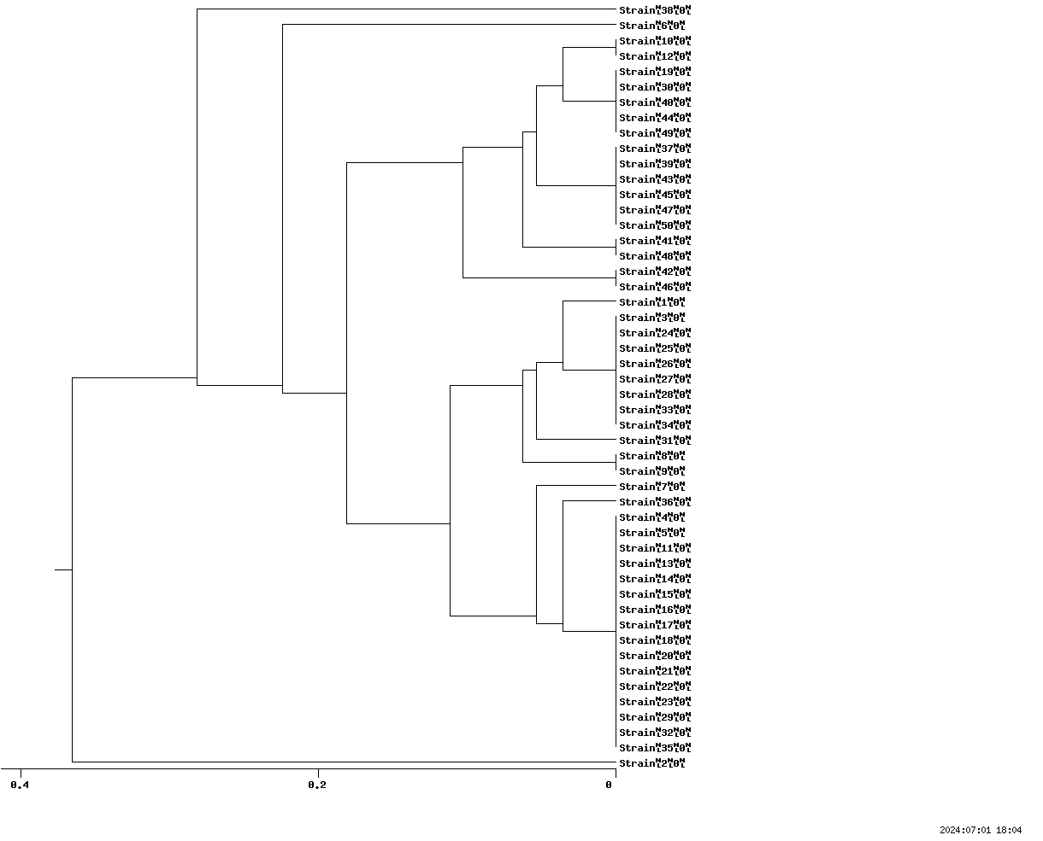
Figure 3. Shows the genetic tree of K.pneumoniae isolates using the RAPD technique.

The random amplification of the polymorphic DNA (RAPD) of the DNA tree of K. pneumoniae revealed the presence of two main groups with a similarity of 0.2 (Fig. 3). The first group contained isolation 2, while the second group was the main group containing 43 isolates arranged in two groups: The first contained five groups (10, 12), (19, 30, 40, 44, 49), (37, 39, 43, 45, 47, 50), (41, 48) and (42, 46). The second contained three groups (3, 24, 25, 26, 27, 28, 33, 34), (8, 9) and (4, 5, 11, 13, 14, 15, 16, 17, 18, 20, 21, 22, 23, 29, 32, 35). Isolates 1, 6, 7, 31, 36 and 38 represent different genotypes. The results of the current study showed a relationship between bacterial isolates isolated from different clinical sources, with the first group containing one (2) isolate characterized by being strong in biofilm formation and isolated from urine and containing a gene acrAB. The second main group is divided into two groups: The first group contains five subgroups (10, 12) collected from the Ghazi Hariri Hospital. The source of isolation was the production and formations of both are strongly biofilm-forming and contain the genes acrAB, oqxA and tolC. (19, 30, 40, 44, 49) The source of isolation is the production and contains the genes acrAB, oqxA, tolC. The isolates (37, 39, 43, 45, 47, 50) have in common that they contain the genes acrAB oqxA tolC. (41, 48) contain the five genes acrAB, oqxA, oqxB, tolC mdtK. (42, 46) have in common that they contain the genes acrAB, oqxA, tolC. The second group of the main group also contains three subgroups (3, 24, 25, 26, 27, 28, 33 and 34), which have in common that they contain the genes acrAB, oqxA and tolC. (8, 9) were isolated from Ghazi Hariri Hospital and contain four genes acrAB, oqxA, tolC and mdtK. (4, 5, 11, 13, 14, 15, 16, 17, 18, 20, 21, 22, 23, 29, 32, 35) this group contains three genes acrAB, oqxA and tolC. The isolates (1, 6, 7, 31, 36, 38) represent different genotypes.

DISCUSSION
Fifty bacterial isolates (38.4%) of the total 130 samples were recognized as K. pneumoniae. The isolated bacterial samples originated with high prevalence in urine 25 (50%), while less prevalence was found in sputum 14 (28%), wounds 6 (12%), blood 3 (6%) and lastly burns 2 (4%). Numerous studies have shown that the most common Found is urinary tract infections [26, 27, 28]. The results of the microscopic examination of bacteria showed that they were Gram-negative rods with single or double chains or short chains [29]. For further identification, some biochemical tests were performed on 50 bacterial isolates, including the urease, citrate, catalase, and Fuchs-Proskauer test. All isolates gave positive results and negative results for the oxidase, indole, and methyl red test [30].
The electrophoresis results showed that all K. pneumoniae isolates at a rate of 100% of 16SrRNA gene, bands had a molecular weight of 260 base pairs. The results of this study are consistent with study of Budiarso et al. [31]. Molecular identification such as PCR for clinical bacterial isolates has occupied a prominent position in clinical identification research due to its accuracy and rapid identification compared to other identification methods such as morphological and biochemical diagnosis [32].Among the several thousand genes within the bacterial genome, the 16SrRNA gene has been the primary key to evolutionary identification compared to well-curated 16SrRNA gene sequence databases [33]. The utility of the 16SrRNA gene has not altered eventually, meaning that random sequence alterations are a more perfect extent of time (evolution), and that the 16SrRNA gene (1500 bp) is large and adequate for informatics determinations [34]. The isolates showed resistance to Ticarcillin and Ticarcillin/Clavulanic Acid , which was consistent with Mustafa [35]. All isolates showed resistance to Piperacillin agreed with Mustafa and Abdullah [36]. The reason for the resistance is that the bacteria can produce chromosomally encoded β-lactamases and can deal with this intrinsic resistance or plasmid-encoded penicillinase enzymes. Furthermost K. pneumoniae isolates product beta-lactamase SHV-1 [37]. The results of this study displayed that the resistance of isolates against Piperacillin/Tazobactam agreed with Khalid and Ghareeb [38]. The resistance of isolates to Ceftazidime, and was consistent with Hasan et al. [39] [40]. Beta-lactam targets (penicillin-binding proteins) to avoid the use of antibiotics. permeability of antibiotics into and out of the cell through several mechanisms, such as efflux pumps, through the outer membrane [41]. The results of the existing study indicated that the resistance to Cefepime. The results were close of Obaid and Hasson [42], as they indicated that the percentage of resistance to the antibiotic was (60%). The results of the current study differed from Yazgan et al. [43]. They found that the resistance to the antibiotic was (100%). Many studies have shown that K. pneumoniae are resistant to antibiotics such as third-generation cephalosporins, carbapenems, fluoroquinolones, and aminoglycosides [44]. The results of the recent study displayed that resistance to the antibiotic Aztreonam, which is close to Ajeel and Mohammed [45]. The researchers mentioned that the unsuitable usage of antibiotics or the transfer of resistance genes between organisms via plasmids accomplished by taking resistant genes, integrins, bacteriophages and transposons are possibilities, as evidence of the high prevalence of multidrug-resistant K. pneumoniae strains [46].
Many studies agreed with the results of the present study for the oqxA gene and did not agree with the results of the study for the oqxB gene. Among these studies is the study of Mustafa and Abdullah [47], where 50 bacterial isolates were isolated from different hospitals in Baghdad from different clinical sources. They found that the percentage of bacterial isolates possessing the oqxA gene was 48 (96%), while the bacterial isolates that possessed the oqxB gene were very low, reaching 6(12%) in isolate. According to the studies, the high prevalence of oqxA in K. pneumoniae isolates is a probable pool for the gene's extent [14].Horizontal transfer of these genes and their exchange from the chromosome to the plasmid enhances the capability to raise the level of MDR phenotypes [48]. Also with the results of the study of Amereh et al. [49] when isolating 100 bacterial isolates from different clinical sources in the city of Hamdan, they found that the percentages of isolates containing the oqxA and oqxB genes reached (95, 98)% correspondingly. According to Li et al. [14] study, the oqxAB efflux pump is one mechanism by which quinolone and fluoroquinolone resistance is achieved. E. coli and K. pneumoniae, two species of quinolone-resistant bacteria, frequently possess the oqxAB gene. According to the same study, the oqxAB efflux pump may also be linked to resistance to other antibiotics in addition to fluoroquinolone resistance. In hospitals, the high prevalence of K. pneumoniae strains containing OqxAB genes in their efflux pump genes poses a significant threat to infection control and antibiotic therapy. K. pneumoniae appears to have oqxAB resistance to ciprofloxacin because of its high oqxAB pump expression. Also, the results of the study by Albarri et al. [50] in Turkey, in which 50 bacterial isolates were isolated, showed that the percentage of bacterial isolates that possessed oqxA genes was 29(63%) and oqxB genes was 24(52%), the last gene being consistent with our study. Several genes associated with antibiotic resistance were found, including the genes acrAB and oqxAB as well as the transcriptional activators ramA and soxS, which are overexpressed in non-susceptible K. pneumoniae isolates [51].
Mahmmudi et al. [52] have shown that RAPD-PCR markers are powerful and effective techniques for isolate identification and initial screening, screening and identification of species differences at strain level as well as the lower time and cost compared to biochemical methods. The RAPD method can be used for the rapid identification of the major variants of Klebsiella spp., including the pathogenic, multidrug-resistant K. pneumoniae group, and is highly versatile. The numerous serotypes in Klebsiella spp. can explain the relevant extent of genetic diversity by RAPD analysis [53].The current result differs from the studies of Hassan et al. [54], who applied the RAPD assay to classify 96 samples of K. pneumoniae into 51 different patterns, and Wasfi et al. [55], who found 18 different RAPD phenotypes in 36 samples of K. pneumoniae. Farivar et al. [56] classified 81 samples of K. pneumoniae using RAPD-PCR. This resulted in five groups, 16 individual species and 14 common species, and linked these genotypes to resistance patterns. Finally the results of the current study were close to the results of Mustafa [35] who revealed the random amplification of polymorphic DNA (RAPD) of K. pneumoniae DNA tree for the presence of two main groups at a similarity of 0.2. The first group contained isolation 8, while the second group was the main group with 19 isolations arranged in four subgroups.

CONCLUSION
According to this study, K. pneumoniae isolates may be less susceptible to multiple antimicrobial agents due to their high oqxA prevalence. In addition, 12 different genotypes were detected using the RAPD method.

ACKNOWLEDGMENTS
The authors would like to University of Baghdad and Ministry of Health to provide the necessary facilities to conduct the research.

REFERENCES
- T.M. Khalid, and K.K. Ghaima, Iraqi J Biotechnol. 21(2), 124-135 (2022).‏ http://jige.uobaghdad.edu.iq/index.php/IJB.
- R.M. Abd Al-Rhman, and M.A. Al-Aubydi, Iraqi J. Sci. 57(2A), 893-900 (2016).‏ https://ijs.uobaghdad.edu.iq/index.php/eijs/article/view/7456.
- M.S. Mustafa, and R.M. Abdullah, Iraqi J Sci. 61(8), 1902-1912 (2020).‏ https://ijs.uobaghdad.edu.iq/index.php/eijs/article/view/7456.
- S.N.A. Al-Timimi "Persistence and Filaments Formation in Klebsiella pneumoniae Clinical Isolates," MSc. Thesis. Mustansiriyah University, 2021.
- S.K. Sharma, N.K. Mudgal, P. Sharma, and B.N. Shrngi, Adv Anim Vet Sci. 3(2), 116-122 (2015). http://dx.doi.org/10.14737/journal.aavs/2015/3.2.116.122.
- L. Righini, "Genomic and Functional Analysis of Members of the Gut Microbiota: Novel Insight on Clostridium ramosum, Escherichia coli, and Enterobacteriaceae," University of Modena and Reggio Emilia Ph.D. School Of Agri-Food Sciences, Technologies and Biotechnologies, 2020. https://hdl.handle.net/11380/1201048. (In Italian).
- M. Pokra, D.K. Sharma, P. Mehta, H.R. Verma, S. Pundir, J. Rana, and D. Kulmi, Int J Curr Microbiol Appl Sci. 5(6), 150-60 (2016). http://dx.doi.org/10.20546/ijcmas.2016.506.019.
- G.A. Abdulhasan, Iraqi J Sci. 56(3C), 2553-2560 (2015).‏ https://www.ijs.uobaghdad.edu.iq/index.php/eijs/article/view/9621.
- R.A. Fodah, J.B. Scott, H.H. Tam, P. Yan, T.L. Pfeffer, R. Bundschuh, and J.M. Warawa, PloS One, 9(9), e107394 (2014). https://doi.org/10.1371/journal.pone.0107394.
- R.M. Martin, and M.A. Bachman, Front Cell Infect Microbiol. 8, 4 (2018). https://doi.org/10.3389/fcimb.2018.00004.
- Z.H.A. Al-Saadi, and R.M. Abdullah, Biochem Cell Arch. 19, Supplement 1, 2371-2376 (2019). https://connectjournals.com/file_html_pdf/3012000H_2371A.pdf.
- C.J. Stubenrauch, R.S. Bamert, J. Wang, and T. Lithgow, PLoS Biol. 20(1), e3001523 (2022). https://doi.org/10.1371/journal.pbio.3001523.
- G.A. Jacoby, Plasmid-Mediated Quinolone Resistance. In: D.L. Mayers, J.D. Sobel, M. Ouellette, K.S. Kaye, and D. Marchaim (eds), Antimicrobial Drug Resistance, Mechanisms of Drug resistance, Vol. 1. 2nd ed. (Switzerland: Springer, 2017) 265-268.
- J. Li, H. Zhang, J. Ning, A. Sajid, G. Cheng, Z. Yuan, H. Hao, Antimicrob Resist Infect Control. 8: 44 (2019). https://doi.org/10.1186/s13756-019-0489-3.
- A. Saadatian Farivar, J. Nowroozi, G. Eslami, and A. Sabokbar, Canad JInfect Dis Med Microbiol., 2018, 6183162(2018). https://doi.org/10.1155/2018/6183162.
- R.A. Luna, L.A. Millecker, C.R. Webb, S.K. Mason, E.M. Whaley, J.R. Starke, P.W. Hiatt, and J. Versalovic, J Clin Microbiol. 51(4), 1237-1240(2013). https://doi.org/10.1128/JCM.02157-12.
- R. Ranjbar, A. Karami, S. Farshad, G.M. Giammanco, and C. Mammina, New Microbiol. 37(1), 1-15 (2014).
- D.R. Hamady, and S.K. Ibrahim, Biochem Cell Arch 20(2), 5553-5557 (2020). https://connectjournals.com/03896.2020.20.5553. ‏
- G.F. Brooks, K.C. Carroll, J.S. Butel, S.A. Mores, and T.A. Mietzner, Jawetiz, Melnick & Adelberg’s Medical Microbiology. 26th edition. (McGraw-Hill. U.S.A. 2013) 245-248.
- P.M. Tille, Bailey and Scottʼs Diagnostic Microbiology. 14th ed. (Elsevier, China, 2017) 1115pp.
- CLSI. Performance Standard for Antimicrobial Susceptibility Testing, 27th ed. CSLI supplement M100. Wayne, PA: (Clinical and Laboratory Standards Institute, 2017).
- F. Tayebeh, J. Amani, S. Nazarian, M. Moradyar, and S.A. Mirhosseini, J Appl Biotechnol Rep. 3(4), 501-505 (2016).‏ https://www.biotechrep.ir/article_69242.html.
- M. Dehnamaki, M. Ghane, L. Babaeekhou, Int J Infect. 7(4), e107397 (2020). https://doi.org/10.5812/iji.107397.
- A.A. Al-Shimmari, M.S. AL-Shukri, and A.G. Al-maamori, Plant Archiv. 20, 7080-7084 (2020).‏ https://www.plantarchives.org/20-2/7080-7084%20(7003).pdf.
- M.S. Mustafa, and R.M. Abdullah, Baghdad Sci J. 17(2), 0406-0406 (2020).‏ https://doi.org/10.21123/bsj.2020.17.2.0406.
- M.S. Mustafa, and R.M. Abdullah, Iraqi J Sci. 61(11), 2866-2878 (2020). https://doi.org/10.24996/ijs.2020.61.11.10.
- R.M. Abd Al-Rhman, and M.A. Al-Aubydi, Iraqi J. Sci. 56(2B), 1385-1393 (2015).‏ F.H. Omar, and A.H. Ibrahim, Iraqi J Agric Sci. 54(3), 619-629 (2023).‏
- C.R. Mahon, and M.M.D.C, Lehman, Textbook of diagnostic microbiology-e-book (Elsevier Health Sciences, 2022).
- B.J. Mohammed, Z.F. Saleh, J.R. Esmaeel, S.F. Klaif, M.S. Jawad, and K.H. Fahad, Ann Trop Med Health. 23(5), 218-225 (2020). https://doi.org/10.24996/ijs.2023.64.6.7.
- T.Y. Budiarso, C. Amarantini, and S. Pakpahan, Biodivers J Biol Divers. 22(12), 5452-5458 (2021). P.H.J. Riegman, K.F. Becker, K. Zatloukal, M. Pazzagli, U. Schröder, and U. Oelmuller, New Biotechnol. 53, 35-40 (2019). https://doi.org/10.1016/j.nbt.2019.06.007.
- M.H. Al-Jailawi, T.H. Zedan, and K.A. Jassim, Int J Pharm Sci Rev Res. 26(1), 112-117 (2024).
- I.Q. Mohamed, and H.R.R. Al-Taai, Iraq, Iraqi J Sci. 64(6), 2726-2740 (2023). M.S. Mustafa "Microbiaal,Molecular and Immunological Study of some Gram Negative Bacteria with MDR Isolated from Iraqi Patients with acute Leukemia," PhD.in College of Education for Pure Science (Ibn AL-Haitham), University of Baghdad, 2023.
- M.S. Mustafa, and R.M. Abdullah, Iraqi J Sci. 65(6), 3057-3074 (2024).‏ G.S. Babini, and D.M. Livermore, Antimicrob Agents Chemother. 44(8), 2230-2230 (2020).
- M.Y. Khalid, and A.M. Ghareeb, Iraqi J Biotechnol. 21(2), 457-464 (2022).‏ T.H. Hasan, K.K. Alasedi, A.A.J. Aljanaby, Latin Am J Pharm. 40, 174-178 (2021).
- T.H. Hasan, Iraq, Int J Pharm Res. 12(4), 10-14 (2020).‏ https://doi.org/10.31838/ijpr%2F2020.12.04.049.
- H.T. Majeed, T.H. Hasan, and A.A. Aljanaby, Int J Pharm Res. 12, 1442-1447 (2020).
- W.F. Obaid, and S.O. Hasson, Ann Roman Soc Cell Biol. 25(3), 5350-5360 (2021).‏ B. Yazgan, I. Türkel, R. Güçkan, K. Kılınç, and T. Yıldırım, J Infect Develop Countr. 12(03), 156-163 (2018).‏ L. Poirel, M. Yilmaz, A. Istanbullu, F. Arslan, A. Mert, S. Bernabeu, and P. Nordmann, Antimicrob Agents Chemother. 58(5), 2929–2933 (2014). https://doi.org/10.1128%2FAAC.02047-13.
- E.A. Ajeel, and R.K. Mohammed, Iraqi J Biotechnol. 21(2), 400-408 (2022). I.J. Adeosun, K.E. Oladipo, O.A. Ajibade, T.M. Olotu, A.A. Oladipo, and E.H. Awoyelu, Iraqi J Sci. 1423-1429 (2019). M.S. Mustafa, and R.M. Abdullah, Iraqi J Sci. 2020; 61(8), 1902-1912 (2020). https://doi.org/10.24996/ijs.2020.61.8.7.
- S. Navon-Venezia, K. Kondratyeva, and A. Carattoli, FEMS Micrbiol Rev. 41(3), 252-275 (2017). https://doi.org/10.1093/femsre/fux013.
- F. Amereh, M.R. Arabestani, and L. Shokoohizadeh, Iranian J Basic Med Sci. 26(1), 93-98 (2023). https://doi.org/10.22038%2FIJBMS.2022.67095.14714.
- O. Albarri, M. AlMatar, M.M. Öcal, and F. Köksal, Curr Protein Peptide Sci. 23(5), 356-368 (2022). https://doi.org/10.2174/1389203723666220630162920.
- B.M. Gabr, A.S.A. Zamzam, E.A. Eisa, G.F. El-Baradey, and M.A.S. Eldeen, J Acute Dis. 10(3), 117-121(2022). https://doi.org/10.4103/2221-6189.316676.
- Z. Mahmmudi, A. Emami, and A. Gorzin, Int J Adv Biotechnol Res. 7(2), 102-110 (2016).
- D. Venieri, A. Fraggedaki, V. Binas, A. Zachopoulos, G. Kiriakidis, and D. Mantzavinos, Photochem Photobiol Sci. 14(3), 506-513 (2015). https://doi.org/10.1039/c4pp00291a.
- R. Hassan, R. Barwa, M.I. Shaaban, and L. Adel, Afric J Microbiol Res. 9(9), 621-630 (2015). https://doi.org/10.5897/AJMR2014.7256.
- R. Wasfi, W. Elkhatib, and H. Ashour,. Scient Rep. 6, 38929 (2016). https://doi.org/10.1038/srep38929.
- S.A. Farivar, J. Nowroozi, G. Eslami, and A. Sabokbar, A. Canad J Infect Dis Med Microbiol. 2018, 6183162 (2018). https://doi.org/10.1155/2018/6183162.
- P. Cheddie, F. Dziva, and P.E. Akpaka P.E., Ann Clin Microbiol Antimicrob. 16, 1-7 (2017). https://doi.org/10.1186/s12941-017-0209-x.

