QRT-PCR Profiling of Adhesion Genes in Acinetobacter Baumannii
Omar I. Khalif ^{1, a)}, and Esam J. Alkalifawi^{1, b)}
¹Department of Biology, College of Education for Pure Science, Ibn Al-Haitham, University of Baghdad, Baghdad, Iraq.
^{a)} Corresponding author: Omar.Alwan2202m@ihcoedu.uobaghdad.edu.iq
^{b)} aesam365@Yahoo.com
Abstract. Acinetobacter baumannii is a multidrug-resistant opportunistic pathogen that causes significant hospital-acquired infections. The ability of A. baumannii to adhere to surfaces and form biofilms is mostly due to the mediation of certain genes related to adhesion, namely OmpA, CsuC, and CsuE. The present study intended to assess the molecular prevalence and expression of these genes using conventional PCR and quantitative real-time PCR (qRT-PCR). Twenty clinical isolates of A. baumannii were obtained from infection sources and identified using a combination of morphological, biochemical and molecular methods. PCR screening showed that there was a high prevalence of adhesion genes OmpA (100%), CsuC (100%), and CsuE (95%). qRT-PCR analysis indicated that gene expression for OmpA remained stable and expression for CsuC and CsuE was variable and downregulated with the isolates. Collectively, these results confirm that A. baumannii is equipped with a conserved genetic system for adhesion and that differential gene regulation is likely influenced by environmental conditions. The study demonstrates that qRT-PCR is a sensitive molecular technique with the potential to assess virulence-associated genes and characterization of the adaptive mechanisms of this clinically relevant pathogen.
Keywords: Acinetobacter baumannii, Adhesion genes, OmpA, CsuC, CsuE, qRT-PCR, Gene expression.

Introduction
Acinetobacter baumannii has developed into one of the most formidable opportunistic pathogens in hospital settings worldwide [1, 2]. Once thought of as a non-pathogenic saprophytic organism, A. baumannii has emerged as a significant cause of nosocomial infections, including ventilator-associated pneumonia, bloodstream infections, urinary tract infections, and wound and burn infections [3, 4]. In addition to the organism’s ability to acquire and regulate antimicrobial resistance genes, its capacity for persistence on abiotic surfaces has contributed to the organism's triumph as a multidrug-resistant (MDR) pathogen [5, 6, 7].
The mechanisms A. baumannii employs to cause disease are associated with several virulence factors, and bacterial adhesion and biofilm formation are amongst the most important in the early steps of an infection [8, 9]. Adhesion allows bacterial cells to adhere firmly to host tissues or surfaces of medical devices, thereby increasing colonization in addition to allowing the bacteria to evade attack from the immune system and resistance to antimicrobial agents [10]. Adhesion is mostly mediated by outer membrane proteins, (for example, OmpA) or chaperone-usher pili systems (for example, CsuC and CsuE), which facilitate cell-surface interactions and biofilm formation [11].
Molecular detection and quantification of adhesion-related genes have become valuable tools in understanding what underlies the virulence of A. baumannii [12]. Real time quantitative reverse transcriptase PCR (qRT-PCR) represents a sensitive and accurate method to assess the levels of gene expression, and hence to investigate the genetic regulation surrounding virulence determinants [13].
In the current study, we will assess the expression of three adhesion genes (OmpA, CsuC, and CsuE) using qRT-PCR in clinical isolates of A. baumannii. This allows for a better understanding of the genetic expression of virulence-associated adhesion factors and leads to deeper understanding of the molecular basis for virulence and persistence in this important pathobiont.

Materials and mathods

Bacterial Isolation and Identification
We obtained a total of 157 clinical samples from a variety of infection sources such as burns, wounds, urinary tract infections, and sputum from patients admitted to different hospitals located in Baghdad, Iraq. The samples were cultured onto blood agar and MacConkey agar plates and were incubated for 24 hours at 37 °C. The bacterial isolates that exhibited characteristic morphology and biochemistry typical of Acinetobacter species were subsequently identified as A. baumannii using the VITEK2 Compact System (biomatrix, France) and obtained 20 isolates.

Molecular Confirmation of A. baumannii
Genomic DNA was isolated from each isolate with a commercial kit for DNA extraction, following the commercial protocol. The purification and concentration of DNA were assessed through spectrophotometry at 260/280 nm. Molecular identification was carried out by conventional PCR targeting the 16S rRNA gene, using specific primers directed towards A. baumannii. PCR amplification was carried out in a thermal cycler using the following times and temperatures: before amplification there was an initial denaturation step of 95 °C for 5 min followed by 35 cycles of denaturation at 95 °C for 30 s, annealing at 55 °C for 30 s, and extension at 72 °C for 1 min with a final extension step of 72 °C for 7 min. The amplified products were evaluated by electrophoresis in 1.5% agarose gels stained with ethidium bromide and visualized under UV [14].

Detection of Adhesion-Related Genes
To determine the presence of adhesion-related genes OmpA, CsuC and CsuE, twenty-five µL PCR reactions were performed using gene-specific primers. Each PCR reaction included 12.5 µL Master Mix, 1 µL of each primer (10 pmol), 2 µL of DNA template and 8.5 µL of nuclease-free water. The thermal cycling conditions were optimized for every gene based on its specific annealing temperature prior to testing. PCR products were subjected to 1.5% agarose gel electrophoresis using 100 bp DNA ladder as a marker for molecular size [15].

RNA Extraction and cDNA Synthesis
To analyze gene expression, total RNA was extracted from A. baumannii isolates via an RNA purification kit according to the manufacturer's manual. The quality and concentration of RNA were assessed by determining the A260/A280 ratio. From 1 µg of total RNA, complementary DNA (cDNA) was made using a reverse transcriptase kit in a 20 µL reaction volume with the following thermal cycling profile: 42 °C for 30 min for reverse transcription and 85 °C for 5 min for enzyme inactivation [16].

Quantitative Real-Time PCR (qRT-PCR) Analysis
Using a real-time PCR system (Applied Biosystems, USA), the expression levels of the OmpA, CsuC, and CsuE genes were quantified utilizing the SYBR Green qRT-PCR method. For reference, the 16S rRNA gene, which is a housekeeping gene, was also quantified. The amplification reaction mix (20 µL) was made up of 10 µL of SYBR Green Master Mix, 1 µL of each primer (10 pmol), 2 µL of cDNA template, and 6 µL of nuclease-free water, to make a total reaction volume of 20 µL. The thermal cycling conditions were as follows: an initial denaturation at 95 °C for 3 min, followed by 40 cycles of 95 °C for 15 s and 60 °C for 30 s. A melting curve analysis was acquired to validate the specificity of the amplification reactions [17].

Data Analysis
The quantitative expression levels of target genes were determined by the 2⁻ΔΔCt method [18]. One-way ANOVA was utilized for statistical analysis, with differences considered significant when P ≤ 0.05.

Results and Discussion

Molecular Identification of A. baumannii
Twenty clinical isolates received confirmation as Acinetobacter baumannii by their morphological and biochemical characteristics, as well as by the VITEK2 system. The isolates were also verified by PCR amplification of the 16S rRNA gene, which resulted in one distinct band of 67 bp for all of isolation (Fig.1).

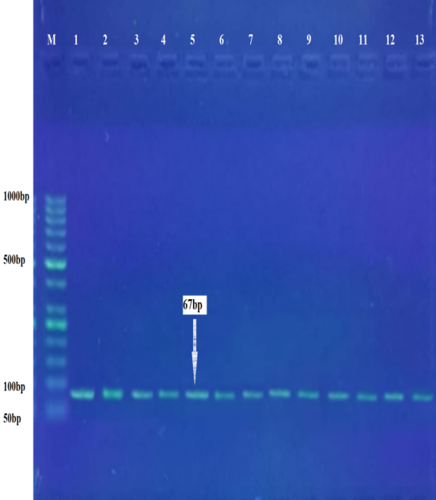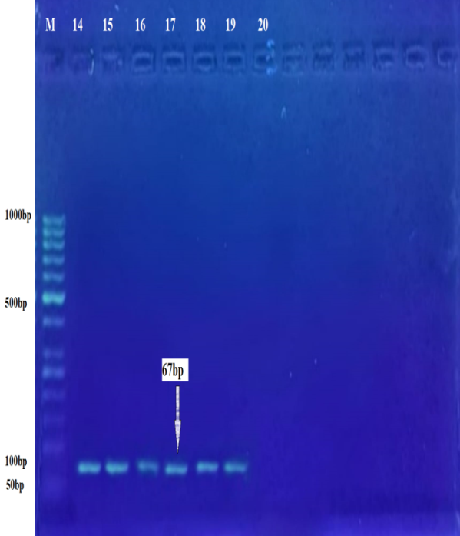

FIGURE 1. Agarose gel electrophoresis showing the 16S rRNA gene (67 bp) amplified from A. baumannii isolates.

Detection of Adhesion Genes (OmpA, CsuC, CsuE)
Using conventional PCR, all three adhesion-related genes were found in most isolates.
• The OmpA gene (531 bp) was found in 100% of isolates.
• The CsuC gene (100 bp) was found in 100% of isolates.
• The CsuE gene (150 bp) was detected in 95% of isolates (19/20).
Representative images of gel electrophoresis are shown in Figs. 2-4.

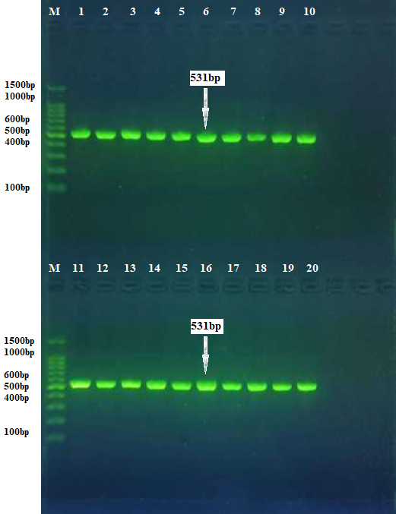

FIGURE 2. PCR amplification of OmpA gene (531 bp) in A. baumannii isolates.

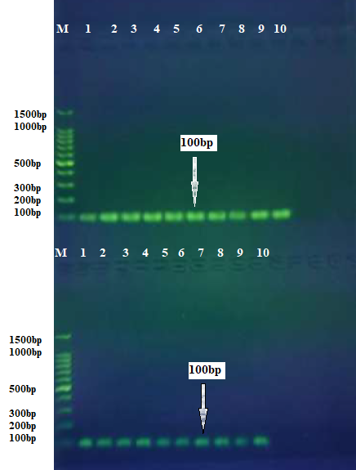
FIGURE 3. PCR amplification of CsuC gene (100 bp) in A. baumannii isolates.

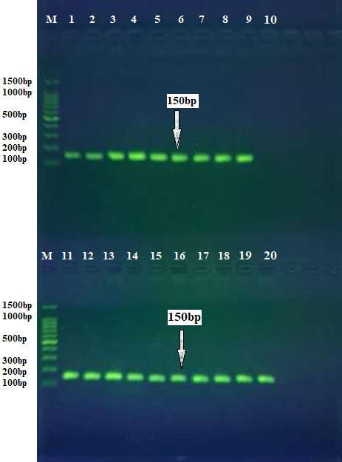
FIGURE 4. PCR amplification of CsuE gene (150 bp) in A. baumannii isolates.

TABLE 1. Detection rate of adhesion genes among A. baumannii clinical isolates.
Gene | Product size (bp) | Positive isolates | Detection rate (%)
OmpA | 531 | 20 | 100
CsuC | 100 | 20 | 100
CsuE | 150 | 19 | 95

Quantitative Gene Expression (qRT-PCR)
The quantitative real-time PCR (qRT-PCR) evaluations depicted a varying expression of the adhesion-related genes OmpA, CsuC, and CsuE after testing on A. baumannii isolates (Table 2). As shown in Fig 5, regardless of initiation source, amplification of OmpA showed little deviation in threshold cycle (Ct) values compared to (CsuC and CsuE) the other genes tested. OmpA showed relative stability in expression among all strains across conditions, with the average fold change being 1.06 ± 0.29. In contrast, CsuC and CsuE expression showed considerable deviation with average fold change mean values being 2.97± 2.42 and 2.60±3.03, respectively, suggesting heterogeneity in the expression of these fimbrial assembly genes. The analysis of comparative relative expression (Fig. 6) agrees, indicating that OmpA is the most stable expressed adhesion gene, while CsuC and CsuE showed differentially high variance between isolates possibly due to gene expression regulation differences or adaptation of clinical strains to their environments.
TABLE 2. Relative expression (mean±SD) of target adhesion genes in A. baumannii clinical isolates.
Gene | Mean ± SD (Fold Change) | Significance (p-value)
OmpA | 0.97 ± 0.08 | ns (p > 0.05)
CsuC | 0.03 ± 0.01 | p ≤ 0.01
CsuE | 0.05 ± 0.01 | p ≤ 0.01

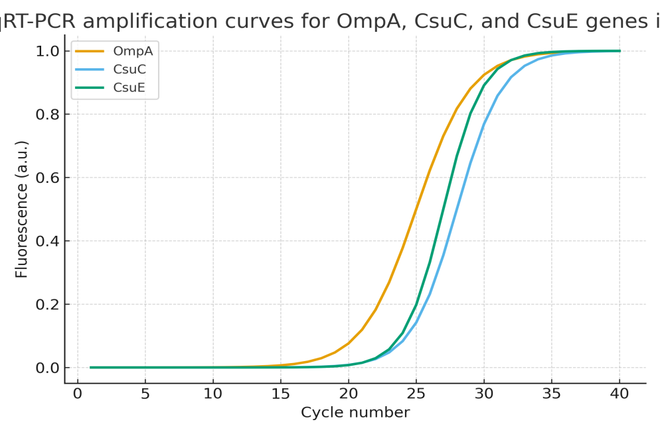
FIGURE 5. qRT-PCR amplification curves for OmpA, CsuC, and CsuE genes in A. baumannii.

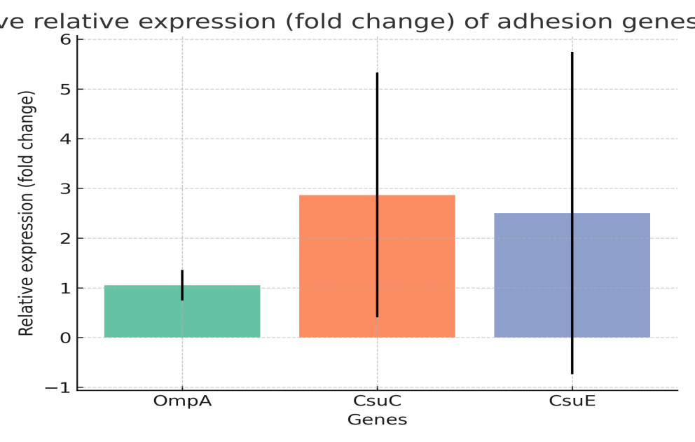
FIGURE 6. Comparative relative expression (fold change) of adhesion genes normalized to 16S rRNA.

Discussion
Molecular screening revealed the ubiquity of the adhesion-related genes OmpA, CsuC, and CsuE in A. baumannii clinical isolates, indicating a conserved role for bacterial adherence and virulence. Both OmpA and CsuC were detected in all isolates as expected based on previous reports [19, 20], which showed that these genes have essential roles in the overall structure of the outer membrane and the lounge of the chaperone-usher pilus system, respectively.
CsuE was also detected in the majority of isolates (95%) which indicates this gene has an important role in bacterial attachment to biotic and abiotic surfaces. CsuE encodes the tip adhesion protein, which is responsible for the initial contact between the bacterium and the surface, whether biotic or abiotic, which leads to biofilm formation [21].
The observations of differential expression in the adherence-associated genes OmpA, CsuC, and CsuE among isolates of A. baumannii suggest the action of different regulatory pathways that control bacterial adherence and biofilm formation. The relatively stable expression of OmpA across isolates is consistent with a key role for OmpA as a constitutively expressed structural and functional component of the outer membrane that is essential for cell integrity and provides a mechanism for adhesion to epithelial surfaces. Alternatively, the variable, or lowered expression of the genes of the Csu operon (CsuC and CsuE), may be suggestive of adaptive regulation in several of the isolates, and may involve regulatory circuits linked to environmental conditions, or to different growth phases. Such down-regulation may be indicative of differential gene regulation including phase variation mechanisms that can influence pilus expression in response to external stimuli [22].
The reduced expression of Csu genes in laboratory culture conditions is likely an adaptive mechanism of A. baumannii to limit unnecessary energy expenditure when adhesin structures are not needed; this is consistent with previous reports that associated Csu expression with surface availability and environmental factors [23]. As a whole, the finding of plasticity in Csu gene regulation highlights the impressive potential for this bacterium to adapt and adjust its tissue adhesion and colonization capacity, enabling A. baumannii persistence in clinical practices, as well as lurking in an opportunistic pathogen. Taken together, these results support that OmpA is a base adhesion determinant while Csu-encoded pili are conditionally expressed virulence factors allowing A. baumannii to appropriately modify its attachment and biofilm development according to environmental and host-associated signals.
In summary, genetic profiling suggests that A. baumannii has a strong underlying molecular architecture for adhesion and persistence that enables it to colonize clinical environments and cause acute infections [24]. Monitoring these genes via qRT-PCR serves as a dependable molecular marker system for evaluating virulence potential and understanding the pathogen's adaptive strategies in clinical contexts [25].

Conclusion
The study confirmed that Acinetobacter baumannii carries key adhesion genes (OmpA, CsuC, CsuE) essential for attachment and persistence. qRT-PCR analysis showed stable expression of OmpA and variable levels of CsuC and CsuE, indicating differential gene regulation. These results suggest that A. baumannii adapts its adhesion mechanisms to environmental conditions, supporting its survival and virulence in clinical settings.

Acknowledgments
We would like to express our sincere gratitude to the College of Education for Pure Science – Ibn Al-Haitham, University of Baghdad, for their valuable support and for providing the opportunity to accomplish this article.

References
- R. M. Abdullah and R. T. A. Ahmed and S. N. A. Al-Azzawi, Indian J. Forensic Med. Toxicol. 13, 934–938 (2019). https://doi.org/10.5958/0973-9130.2019.00418.3.
- W. A. Obaid, Iraqi J. Sci. 2756–2775 (2025). https://doi.org/10.24996/ijs.2025.66.7.9.
- I. H. Al-Abdeli and E. I. Alkhalifawi, Egypt. J. Hosp. Med. 90, 1274–1283 (2023). https://doi.org/10.21608/ejhm.2023.282021
- M. H. Al-Azzawi and E. J. A. Alkalifawi, Ibn Al-Haitham J. Pure Appl. Sci. 36(3), 1–8 (2023). https://doi.org/10.30526/36.3.3090.
- A. A. Mahdi and R. M. Abdullah, Biochem. Cell Arch. 20(1), 1605–1610 (2020). https://doi.org/10.35124/bca.2020.20.1.1605.
- H. D. Salem and W. A. Al-Draghi, Egypt. J. Med. Microbiol. 34(4), 379–387 (2025). https://doi.org/10.21608/ejmm.2025.379342.1594
- A. A. Al-Jumaili and K. K. Ahmed, East. Mediterr. Health J. 30(10), 663–670 (2024). https://doi.org/10.26719/2024.30.10.663
- I. H. Al-Abdeli and E. J. Al-kalifawi, Ibn Al-Haitham J. Pure Appl. Sci. 36(4), 110–126 (2023). https://doi.org/10.30526/36.4.3141.
- O. K. Al-Juboori and S. J. Muhammad, Iraqi J. Biotechnol. 24(SI) (2025). https://jige.uobaghdad.edu.iq/index.php/IJB/article/view/786.
- Ali, Z. K., & Kathier, S. A. (2025), Journal of Physics: Conference Series, 3028(1), 012061. https://doi.org/10.1088/1742-6596/3028/1/012061.
- I. Ahmad, A. Nadeem, F. Mushtaq, N. Zlatkov, M. Shahzad, A. V. Zavialov and B. E. Uhlin, NPJ Biofilms Microbiomes 9(1), 101 (2023). https://doi.org/10.1038/s41522-023-00465-6.
- V. Bhandari, U. Brahma, A. Suresh, A. Kamila, U. S., A. K. S. V. and P. Sharma, bioRxiv (2025). https://doi.org/10.1101/2025.10.02.680171.
- F. Zhao, N. A. Maren, P. Z. Kosentka, Y. Y. Liao, H. Lu, J. R. Duduit and W. Liu, Hortic. Res. 8, 179 (2021). https://doi.org/10.1038/s41438-021-00616-w.
- A. Bogožalec Košir, D. Lužnik, V. Tomič and M. Milavec, Biosensors 13(4), 463 (2023). https://doi.org/10.3390/bios13040463.
- S. L. Rajangam and M. K. Narasimhan, Future Microbiol. 19(10), 941–961 (2024). https://doi.org/10.2217/fmb-2023-0263.
- P. A. A. de Oliveira, J. Baboghlian, C. O. A. Ramos, A. S. F. Mançano, A. D. M. Porcari, R. Girardello and L. F. C. Ferraz, Sci. Rep. 14(1), 3830 (2024). https://doi.org/10.1038/s41598-024-51499-5.
- K. Kim, M. Islam, H. W. Jung, D. Lim, K. Kim, S. G. Lee and M. Shin, Virulence 12(1), 2122–2132 (2021). https://doi.org/10.1080/21505594.2021.1961660.
- K. J. Livak and T. D. Schmittgen, Methods. 25(4), 402–408 (2001). https://doi.org/10.1006/meth.2001.1262.
- A. Van Belkum, H. Sori and J. Hays, Pathog. Dis. 79(2), ftab008 (2021).
- S. Ahmad, A. Alghamdi and M. Khan, Microb. Pathog. 174, 106–146 (2023). https://doi.org/10.1016/j.micpath.2023.106146
- V. Ageorges, R. Monteiro, S. Leroy, C. M. Burgess, M. Pizza, F. Chaucheyras-Durand and M. Desvaux, FEMS Microbiol. Rev. 44(3), 314–350 (2020). https://doi.org/10.1093/femsre/fuaa008.
- Y. I. Mamoori, I. A. Ahmed, M. R. Jaafer, A. M. Ali and S. A. Hadi, Baghdad Sci. J. 22(8), 2619–2628 (2025). https://doi.org/10.21123/2411-7986.5025.
- R. Dehbanipour and Z. Ghalavand, Infect. Genet. Evol. 104, 105386 (2022). https://doi.org/10.1016/j.meegid.2022.105386.
- M. Sholeh, F. Hamidieh, M. Beig and F. Badmasti, Mol. Genet. Genomics 300(1), 1–17 (2025). https://doi.org/10.1007/s00438-025-02265-3.
- V. Vashisht, A. Vashisht, A. K. Mondal, J. Farmaha, A. Alptekin, H. Singh and R. Kolhe, BioMedInformatics 3(4), 1145–1177 (2023). https://doi.org/10.3390/biomedinformatics3040069.

