Analysis and Improvement of the Manufacturing Processes of Electronic Products Necessary for the Automotive
Popescu Liliana Georgeta^{1, a)} and Inta Marinela^{1, b)}
¹Lucian Blaga University of Sibiu, Bd. Victoriei, No. 10, Sibiu, Romania, 550024

^{a)} Corresponding author: liliana.popescu@ulbsibiu.ro
^{b)}marinela.inta@ulbsibiu.ro
Abstract. Electronic products are found today in almost every field, their development being based on electronic packaging. It includes a wide variety of techniques and technologies for the conception, design and testing of electronic modules. But production delays could cause significant problems for companies leading to the loss of customers. These delays can accumulate as a result of insufficient planning of material resources, as well as manufacturing processes not adapted to market requirements. Being an open economic system, the planning of the production process goes in two directions, namely, the internal planning in which the manufacturing tasks are realized at the level of each contractor and the external planning in which the terms and conditions of the auxiliary equipment are established with the suppliers. In this study, we propose the optimization of an automated SMD (Surface Mount Device) assembly line by implementing a two-roll splicing system, called SPLICE, with the aim of reducing the total production time. And at the same time, since the production process is not a constant one, there are certain blockages in the process, we aim to discover and reduce these obstructions within this assembly line.
Keywords: Automotive manufacture, production process improvement; optimization, SPLICE.

Introduction
Electronic products are present today in almost all areas, from consumer goods, telecommunications and information technology, to medicine, aeronautics or automotive playing a crucial role in modern society by enabling innovation and connectivity across industries [1-3]. According to OECD [4], the electronics industry represents one of the main pillars of the global economy, being responsible for a significant part of international value chains. The development of these products is based on electronic packaging, which includes various techniques and technologies for the conception, design and testing of electronic modules and systems. Production is largely carried out through specialized electronic manufacturing services (EMS) companies, which provide design, manufacturing and support, the main activities being the assembly of printed circuit boards (PCBs) and product testing. Since the second half of the 20th century, we have witnessed an accelerated progress in the field of electronics and a continuous race to miniaturize devices. According to ITRS 2023 [5], the miniaturization of electronic components remains aligned with the trend predicted by Gordon Moore in 1965, which predicted that the number of transistors on a chip would double every two years. During the same period, miniaturization became much more important than costs, which led to the development of SMT (Surface Mount Technology). Today, SMT is the most widely used electronic assembly technology globally [6], due to its high level of automation, as well as its adaptability to the requirements of Industry 4.0 [7,8]. It has imposed new standards of quality, reliability and productivity in the industry.
In addition to technological developments, recent research is increasingly focused on optimizing production and reducing lead times [9,10]. The authors of the article [11] discuss order acceptance in production planning, assuming that the ordered quantity is uncertain, and the integrated planning problems are solved by a heuristic algorithm, analyzing MRP, Kanban and OPT, with good results in the absence of bottlenecks. Thürer et al. [12] use simulation to analyze different approaches to production planning and control, evaluating bottlenecks and large waiting lines. Ertogral and Öztürk [13] propose an integrated production planning model for minimizing inventory and labor costs in an airline maintenance company. Techawiboonwong and Yenradee [14] study aggregate production planning for different types of products, comparing solutions with and without moving labor between production lines, highlighting reductions in total cost.
Durdu Hakan Utku [15] analyzes the total delay in the production area and proposes a mathematical model for process optimization by minimizing delays, using discrete event simulation with ARENA software. Hsu et al. [16] develops a mathematical model for reducing the labor cost in chip handling and production control. Diaz-Elsayed et al. [17] investigates a production system integrating Lean strategies in the automotive industry, achieving a production cost reduction of approximately 10.8%. Eberle et al. [18] uses Monte Carlo simulation methods to improve production time in pharmaceutical processes. Lachenmaier et al. [19] analyzes the implementation of cyber-physical systems (CPS) in an automotive production line. Wang et al. [20] investigates production control in a multi-phase process, with the aim of minimizing the average production cost and optimizing inventory and delay management between operations.
Thus, technological evolution and modern approaches to production planning and optimization represent the basis for the efficient development of electronic products in today's industry.

RESEARCH METHODS

Study Area
The research was conducted within a company that provides design, assembly and testing of printed circuit boards (PCB). The study aimed to analyze the technological process in the production stage, aiming to identify the factors that influence product quality and the efficiency of the operations carried out. Experimental measurements were carried out over a week, in order to obtain representative data on the variability of the production process and real operating conditions.
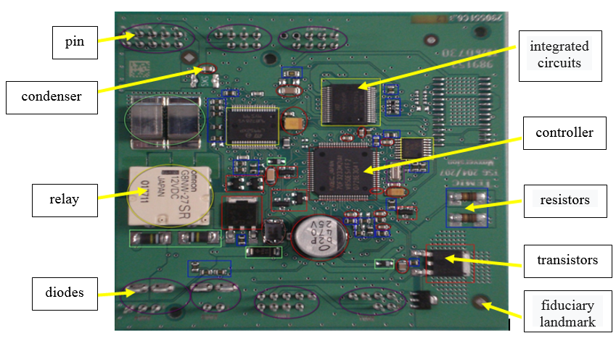

FIGURE 1. PCB populated with components

Surface Mount Technology
SMT (Surface Mount Technology) allows components to be mounted directly on the surface of printed circuit boards, without perforations. It has established itself as the main standard in the manufacture of electronic modules, due to the high level of automation, high integration density, high precision and superior product reliability.
SMT (Surface Mount Technology) technology tends to become widespread in companies that produce printed circuits due to its increased productivity, advantageous costs and superior quality conditions. This technology is automated and allows for series or mass production, under conditions of maximum economic efficiency. Moving from manual electronic assembly to industrialized one, it is necessary for designers to take into account its specifics.
The automatic planting of increasingly miniaturized components with pick-and-place machines requires not only the *.pnp files containing the coordinates of the parts, but also a reference system for the precision of their alignment. For this purpose, fiducial marks are used, the symbols can have different shapes (disk, square, triangle, cross,) used for the recognition by machine vision systems of circuit structures that provide common measurement points for an automated assembly process.
Current research indicates a clear trend towards the integration of Lean principles, digitalization and intelligent automation in electronics manufacturing processes. In particular, in the field of SMT, development directions include reducing process times, using simulation to optimize the flow, implementing adaptive control and cyber-physical systems, reducing energy costs and integrating sustainable solutions. Thus, a transition towards the Smart Factory is emerging, where SMT processes are fully integrated, optimized and digitally connected.

Technological Flow Analysis
The increasing demand for electronic products led the company to conduct an analysis of the PCB manufacturing technological flow, with the aim of identifying and optimizing operations with high execution time, respectively to reduce downtime and improve overall production efficiency. Implementing appropriate technical solutions would allow increasing the efficiency of the process and strengthening the company's position on the electronics market.
This analysis aims to:
- Reducing cycle time by 20%;
- Increasing product productivity by 1000 pieces/week by optimizing the process and reducing non-value-added activities;
- Increasing operational efficiency by reducing unnecessary handling;
- Increasing line flexibility in the face of product or volume changes;
- Reducing production costs by integrating multiple functions into a single piece of equipment;
- Reduction of production line personnel.
The analyzed SMT production line, for the production of PCBs, with reflow soldering, includes the following equipment, arranged in the sequence of the technological process:
- SMT material storage rack;
- Loading equipment (loader) - equipment for taking PCBs from warehouses;
- Equipment for turning (Flip Unit) PCBs populated on the Bottom side;
- Scanning station - PCB pickup and barcode verification equipment;
- PCB cleaning equipment (PCB cleaner);
- MPM or DEK - equipment for printing tin paste on PCB;
- MPM TCU - equipment for maintaining controlled temperature in printing equipment;
- Automatic optical inspection equipment for tin paste after printing (Post Printing Inspection - Koh Young);
- Fuji Loader - equipment for reading barcodes and feeding Fuji with PCB;
- Laser - equipment for PCB serialization with matrix labels;
- Fuji NXT- SMD surface mount component placement equipment;
- Kitting station - station for feeding Fuji with material;
- Rehm Oven - oven for soldering SMD components;
- AOI/X-RAY-automatic optical X-ray inspection equipment;
- Buffer - equipment for storing PCBs;

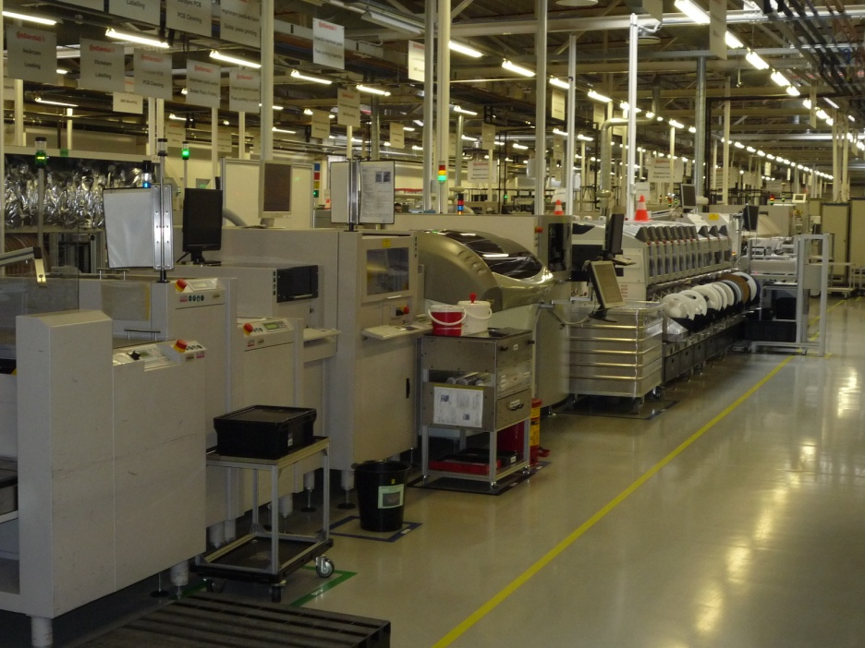

FIGURE 2. Automatic SMT Assembly Line

The PCB manufacturing process is divided into two stages:
- the Front-End part, which includes the following operations: loading the printed circuit board; cleaning the board; serializing the board; printing components on the panel; soldering components on the panel; verification and inspection;

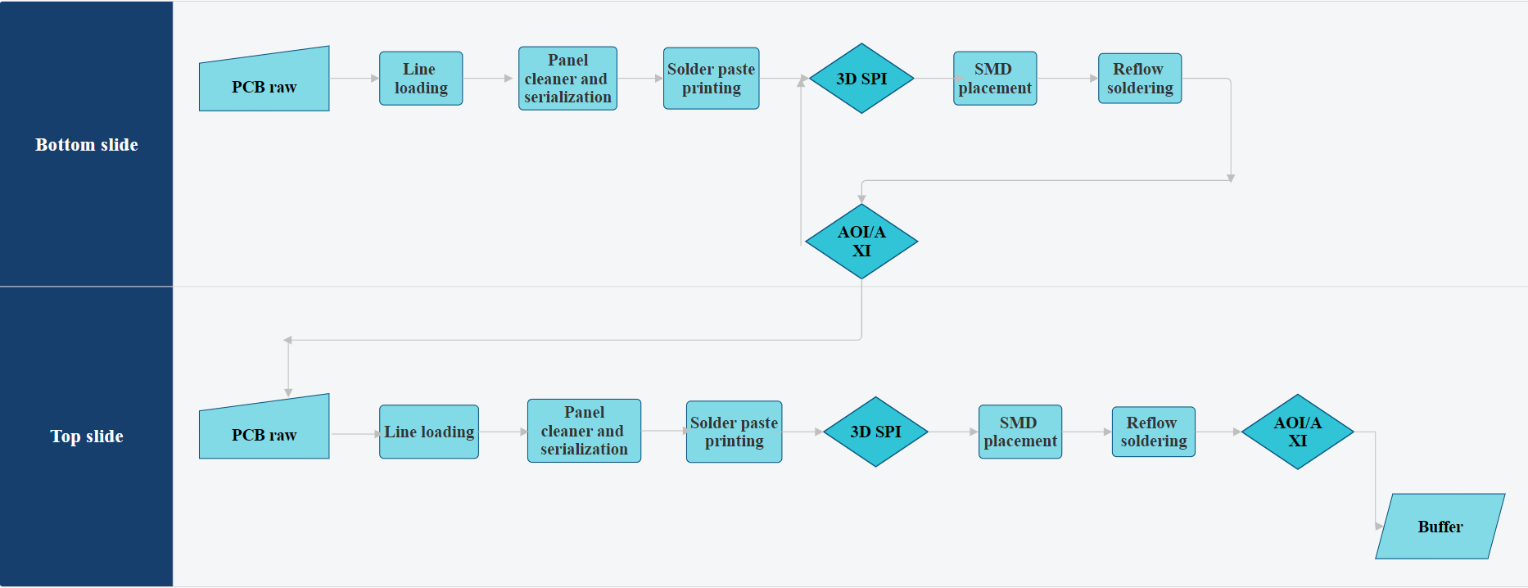

FIGURE 3. Front End PCB
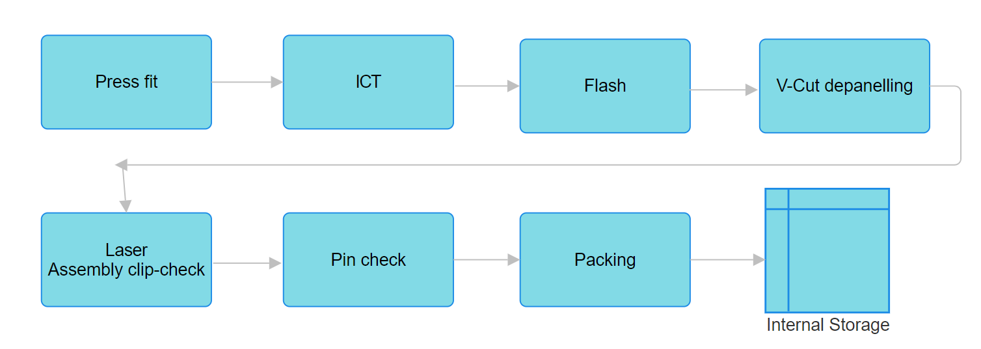
After completing the technological process in the Front End area, the product continues its technological flow in the Back End area by performing the following operations: pressing the pins onto the board; the partially completed electrical board will be transported to the pneumatically operated V-CUT depaneling, where the multipanel is cut into independent pieces; testing of passive components and testing of the unit (according to Fig. 4);
FIGURE 4. Back End PCB

RESULT AND DISCUSSION
To identify the problems, we proceeded to measure the cycle time for each operation, according to table 1, and to calculate the performance indicators - KPIs presented in table 2.

TABLE 1. Current cycle time
Line |  | Operation | Measured time | Cycle Time
SMT | 1 | SMT material storage rack | - | -
SMT | 2 | Loading equipment (loader) - equipment for taking PCBs from the warehouse | 10 sec/PCB | 10 sec / PCB
SMT | 3 | Equipment for turning (Flip Unit) PCBs populated on the Bottom side | 23.49 sec / 4 PCBs | 5.87 sec / PCB
SMT | 4 | Scanning station - PCB pickup and barcode verification equipment | 12 sec/PCB | 12 sec/PCB
SMT | 5 | PCB cleaning equipment (PCB cleaner) | 33 sec/4 PCB | 8.25 sec/PCB
SMT | 6 | MPM or DEK - equipment for printing solder paste on PCB | 21.04 sec / 4 PCBs | 5.26 sec / PCB
SMT | 7 | MPM TCU - equipment for maintaining controlled temperature in printing equipment | - | -
SMT | 8 | Automatic optical inspection equipment for tin paste after printing (Post Printing Inspection - Koh Young); | 5 sec/PCB | 5 sec/PCB
SMT | 9 | Laser - PCB serialization equipment with matrix labels | 200 sec / 28 PCBs | 7.14sec/PCB
SMT | 10 | Fuji NXT- SMD surface mount equipment | 23.51 sec / 4 PCBs = | 5.88 sec / PCB
SMT | 11 | Kitting station - station for feeding Fuji with material | 254 seconds  280 seconds  262 seconds  237 sec  249 sec | 256.4 seconds
SMT | 12 | AOI/X-RAY - automatic optical X-ray inspection equipment | 2.5 sec/PCB | 2.5 sec/PCB
SMT | 12 | Packing | - | -

TABLE 2. Performance indicators - KPI
No. of crt. | KPI indicator | Initial value | Estimated improvement (%)
 | SMT line productivity | 68 PCB/hour | +25%
 | OEE – Overall Equipment Effectiveness | 63% | +25%
 | Series changeover time (Changeover Time) | 35 minutes | -30%
 | Unplanned downtime (Downtime) | 7% of the total time | -43%
 | Equipment utilization rate | 85% | 90%
 | Used space (m²) | 30 m2 | ~ 25 m2

Following the analysis of the cycle time of the current production process on the SMT line, long waiting times between operations can be observed, as well as the lack of continuous supply of components, demonstrating the need to optimize the technological flow and the use of resources.
It was thus proposed to integrate a device assembly line with rotary table, which will replace two distinct pieces of equipment existing in the current flow (equipment for printing tin paste on PCB boards and post-printing optical inspection equipment), as well as the implementation of a SPLICE splicing system used for the rapid connection of component tapes (reel-to-reel).
All of this also aims to modify the layout of the SMT area, in order to achieve Lean Manufacturing principles by minimizing losses, increasing flexibility and reducing costs.
Following the implementation of the two solutions, an improvement in the process resulted (table 3) by:
- reducing cycle time;
- increasing line productivity;
- reducing plate handling errors;
- optimizing quality control by immediately checking the application of the paste;
- saving space on the SMT line;
- ensuring continuity of the feeding process without loss of productivity;
- increasing the availability of SMT equipment;
- cost reduction by using one piece of equipment instead of 2 other pieces of equipment.

TABLE 3. Results obtained following implementation
 | Current | After improvement | BENEFITS
Cycle time | 68 seconds | 52 minutes | >20%
No. Operators | 2 | 1 | 50%
Post-print defect rate | 2.5% | 1.30% | -52%
First Pass Yield | 90% | 95.8% | +5.8 pp
Used space (m²) | 30 m2 | 26m2 | ~ 10%
Total SMT flow lead time | 6 hours | 4.5 hours | -25%

ConCluSIonS
The optimization of the SMT assembly line was achieved by implementing two main solutions: device assembly with a rotary table and a SPLICE splicing system. The device reduced working time, while the SPLICE system simplified the process of changing rolls, facilitating the operator's work.
The implementation of these solutions led to a reduction in board production time and an increase in working space by relocating the feeder trolleys, improving ergonomics and line organization. Also, the number of planned maintenances for the feeders was reduced, requiring intervention only in case of failure, which increased equipment availability and reduced unplanned shutdowns.
Overall, the integration of solutions led to a significant increase in productivity, reduced production times and improved working conditions, demonstrating the effectiveness of the proposed solutions in optimizing the SMT assembly process.

References
- A. Olteanu, C.V. Kifor, M.V. Zerbes, R. Giurea, A. Karaeva and E.C. Rada, Developing a conceptual model for sustainable energy management systems in universities in Advanced Topics on Measurement and Simulation (ATOMS), pp.355-358 (2024).
- L.I. Cioca, R. Giurea, I. Precazzini, M. Ragazzi, M.I. Achim, M. Schiavon and E.C. Rada, AIP Conference Proceedings 1968, 020022 (2018).
- L. Adami, G. Castagna, E. Magaril, R. Giurea, N. Ferronato, G. Ruggieri, V. Torretta and E.C. Rada, E.C., WIT Transactions on Ecology and the Environment, 222, pp.103-115 (2019).
- OECD. “Global Value Chains in the Electronics Industry”, 2022.
- ITRS (International Technology Roadmap for Semiconductors), Edition 2023.
- H. Geng “Manufacturing Engineering Handbook” (Publisher Mcgraw-Hill Education, 2015).
- R. Ernst. Electronics Manufacturing Trends in the Era of Industry 4.0. IEEE Design & Test (2021).
- E.C. Rada, I.C. Nicolae, M.V. Zerbes, A. Tulbure, A. Karaeva, V. Torretta and R. Giurea, R. J. Phys.: Conf. Ser. 2857, 012030 (2024).
- E. Sujová, H. Čierna, Syst. Prod. Eng., 26, pp.88–92 (2018).
- G. Brabie, Optimization of manufacturing technological processes and equipment, (AGIR Publishing House, Bucharest, 2006).
- T. Aouam, K. Geryl, K. Kumar, N. Brahimi, Computers & Operations Research 91, pp. 145–159 (2018).
- M. Thurer, N.O. Fernandes and M. Stevenson, International Journal of Production Research 60, pp. 1036–1050 (2022).
- K. Ertogral and F.S. Öztürk, Computers & Industrial Engineering, Volume 127, pp. 832–840 (January 2019).
- A. Techawiboonwong and P. Yenradee, Prod. Plan. Control, 14(5), pp. 447–458 (2003).
- D.H. Utku, Sustainability, 15(3), 2331 (2023).
- K.S. Hsu, T.S. Lan and S.B. Chang, J. Inf. Optimum. Sci. 2008, 29(1), pp. 163–173 (2008).
- N. Diaz-Elsayed, A. Jondral, S. Greinacher, D. Dornfeld and G. Lanza, CIRP Annals. 62(1), pp. 475–478 (2013).
- L.G. Eberle, H. Sugiyama and R. Schmidt, Computer. Chem. Eng., 68, pp. 255–263 (2014).
- J.F. Lachenmaier, H. Lasi, and H.G. Kemper, CIRP Proceedings, 62, pp. 577–582 (2017).
- Z. Wang, F.T. and Chan, M. Li, IEEE Trans. Eng. Manager, 65, pp.474–486 (2018).

