Evaluation of the Techno-Economic and Environmental Viability of a Solar Energy Initiative Across the Fifteen Counties of Liberia
Prince Adolphus Juah^{1, 2, a)}, Sumo Momolu^{1, b)}, and Masoyi Garba Sanda^{2, 3, c)}
¹Department of Mining Engineering, College of Engineering, University of Liberia, Fendell Campus, Liberia.
²Energy Resource Engineering Department, Egypt-Japan University of Science and Technology (E-JUST), Alexandria, Egypt.
³National Centre for Petroleum Research and Development, Energy Commission of Nigeria, Abubakar Tafawa Balewa University, Bauchi, Nigeria.
^{a)} Corresponding author: prince.juah@ejust.edu.eg
^{b)}momoluss@ul.ed.lr
^{c)}masoyi.sanda@ejust.edu.eg
Abstract. The persistent challenges posed by climate change and the depletion of fossil fuels are alarming, making it imperative to prioritize renewable energy sources. This paper presents a grid-connected photovoltaic system designed to evaluate its techno-economic and environmental viability across the 15 counties of Liberia. Simulations of the system were conducted using PVSyst and visualized in QGIS. The results indicate that Lofa county outperformed the others in terms of key performance indicators. The minimum Levelized Cost of Electricity achieved by the system was $0.0514 per kWh, reflecting the highest useful energy generated by the system, totaling 40,902.3 MWh. Additionally, the system facilitated the savings up to 14,756 tons of emissions. Notably, Lofa County recorded the best overall performance.
Keywords: Solar photovoltaic, Useful energy, Levelized cost of electricity, Performance ratio, Liberia

INTRODUCTION
The challenges arising from the rapid depletion of fossil fuel resources, the pressing issues of climate change and the necessity for environmental conservation have significantly intensified the global movement towards sustainable energy sources [1]. It is increasingly recognized that energy is not merely a commodity; it is a fundamental driver of socio-economic development, playing a pivotal role in enhancing productivity across both the public and private sectors. To foster sustainable economic growth and elevate productivity throughout society, government officials, policymakers, and stakeholders in the private sector must prioritize energy security. This requires a concerted effort to create a stable, reliable, and sustainable energy infrastructure that can support ongoing development initiatives [2]. In Liberia, the government and its policymakers face a critical opportunity to shift their energy strategy. Similar to their counterparts in other developed nations, they must invest in renewable energy projects and accompanying programs aimed at diversifying the nation’s energy sources. Liberia's unique climate, characterized by distinct rainy and dry seasons, presents an advantageous scenario for harnessing solar energy. During the dry season, the country receives abundant sunlight, providing an ideal resource for solar power generation [3].
By capitalizing on this renewable energy potential, Liberia can significantly reduce its dependence on its existing hydropower resources, which are often strained, as well as on nonrenewable energy sources that contribute to environmental degradation. By pivoting towards renewable energy, Liberia can not only enhance its energy security but also contribute to global efforts against climate change, creating a more resilient economy that benefits all citizens [4]. This strategic investment in sustainable energy infrastructure will ultimately foster a cleaner, more sustainable environment while supporting long-term socio-economic growth. Renewable energy, particularly how solar photovoltaic technology, provides numerous benefits for both national governments and its citizens.
Several scholars have previously examined the solar potential of Liberia; for instance, a comprehensive literature survey was conducted by [5] to assess the energy potential of Liberia and establish the roadmap for future projects. The findings from their study indicate that traditional fuels are the primary source of energy in Liberia, comprising 80% of total energy consumption. In comparison, hydropower accounts for 6%, while petroleum products represent 10%. The remaining 4% is attributed to other renewable sources, including solar energy. In a similar vein, a study utilizing the r.sun model examined the horizontal irradiation levels across Liberia over twelve months[6]. The findings indicated that Zwedru recorded the highest Global Horizontal Irradiance (GHI) at 1728 kWh/m², while Greenville documented the lowest at 1673 kWh/m². A thorough assessment conducted by [7] indicates that the challenges stemming from electricity shortages nationwide could be alleviated if the Liberian government prioritizes the integration of a solar farm into the national grid. This would allow for the optimal use of the six months of dry weather, thereby reducing the overreliance on hydropower.
An evaluation of the techno-economic, environmental feasibility and performance efficiency of solar energy systems has been conducted globally using the PVSyst software, among other tools, for instance, A study conducted in Malaysia utilized PVSyst to analyze a system consisting of 16.20 kWp of 405 W monocrystalline solar panels connected to the grid. The result from the study shows that the study achieved a performance ratio of 80.21% while the energy produced was recorded to be 21.59 MWh/yr. The researchers suggest that the reduction in system efficiency can be attributed to various losses, which are typically expected in a photovoltaic system [8]. Similarly, a study conducted in India reported a performance ratio of 79.8% and a specific power production of 1654 kWh/kWp per year [9]. A 77.3% performance ratio was also reported by researchers in Morocco [10]. A detailed techno-economic and environmental study conducted by examined a grid-connected photovoltaic (PV) system at a university in Turkey. The analysis revealed that the PV system achieved a Levelized Cost of Electricity (LCOE) of 0.1892 USD/kWh and an Internal Rate of Return (IRR) of 19.55% [11]. Furthermore, the study highlights the potential for this PV system to reduce CO₂ emissions by 6,852 tonnes. An economic analysis conducted for a 10kW PV capacity achieved a return on investment of 457% within a payback period of 6.3 years [12].
Current literature has evaluated the solar potential of Liberia, along with a review of the techno-economic and environmental benefits of renewable energy, particularly solar energy. However, it is notable that there is limited or no information regarding the techno-economic and environmental viability of solar photovoltaic farms across all 15 counties in Liberia. Therefore, this paper aims to assess the economic and ecological feasibility of solar photovoltaic power plants in each county throughout the country. This assessment aims to provide valuable insights for decision-makers and stakeholders to guide future investments.

SITE LOCATION AND METEOROLOGICAL DATA
Liberia is a nation situated in West Africa, positioned at a latitude of 6.310° and a longitude of -10.805°. It is bordered to the southwest by the Atlantic Ocean and shares land borders with Sierra Leone to the west, Guinea to the north, and Côte d'Ivoire to the east. The country is divided into fifteen political subdivisions known as counties, each boasting its unique cultural heritage and resources as shown in Fig. 1. Liberia experiences a tropical climate, characterized by a notable annual weather pattern that includes distinct wet and dry seasons. This climatic condition influences agricultural practices and presents significant opportunities for harnessing renewable energy sources. Despite having a six-month dry season, the country has yet to capitalize on its solar potential fully. The solar global horizontal irradiance across study locations in the fifteen counties vary from 1,626 to 1,909 kWh/m², as illustrated in Fig. 2. The weather data was sourced from the Global solar atlas and visualized using QGIS [13].

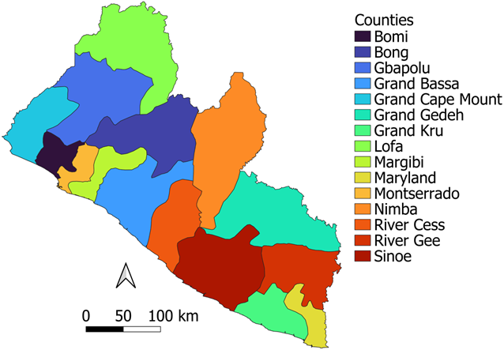 | 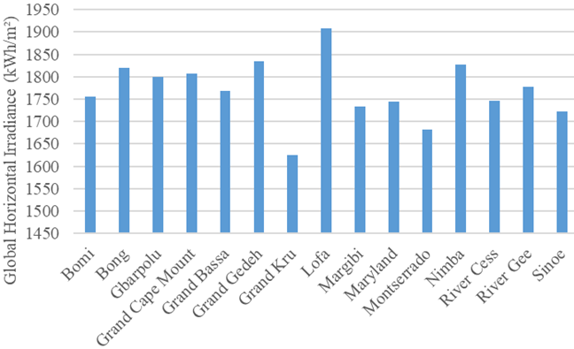
Figure 1. Political subdivision | Figure 2. Global horizontal irradiation

SYSTEM DESCRIPTION AND MODELLING
The system under investigation is a grid-connected solar photovoltaic (PV) system, which has been simulated using PVSyst software for 15 counties throughout Liberia. This study aims to evaluate the techno-economic potential of solar photovoltaic power plants across the country, with the capital city of each county selected as the study location. To ensure the data accurately reflects the selected sites, the latitude of each location was utilized as the tilt angle for the solar panels. Table 1 presents the study locations along with their respective latitudes and longitudes.
TABLE 1. Tilt Angles of selected sites
Counties | Capital Cities | Panel Tilt Angle (°) | Latitude (°) | Longitude (°)
Bomi | Tubmanburg | 6.7 | 6.8687 | -10.8248
Bong | Gbarnga | 7.0 | 6.9963 | -9.4709
Gbarpolu | Bopolu | 7.0 | 7.0667 | -10.4875
Grand Cape Mount | Robertsport | 6.8 | 6.7526 | -11.3670
Grand Bassa | Buchanan | 5.9 | 5.8816 | -10.0444
Grand Gedeh | Zedru | 6.0 | 6.0680 | -8.1343
Grand Kru | Barclayville | 4.7 | 4.6804 | -8.2333
Lofa | Voinjama | 8.4 | 8.4224 | -9.7526
Margibi | Kakata | 6.5 | 6.5323 | -10.3488
Maryland | Harper | 4.4 | 4.3789 | -7.7061
Montserrado | Bensonville | 6.4 | 6.4473 | -10.6143
Nimba | Sanniquellie | 7.4 | 7.3613 | -8.7139
River Cess | Cesstos | 5.5 | 5.4522 | -9.5817
River Gee | Fish Town | 5.2 | 5.1979 | -7.8760
Sinoe | Greenville | 5.0 | 5.0111 | -9.0389

The specifications for the photovoltaic panel employed in the construction of the grid-connected PV system at all the locations examined in this study at a reference temperature of 25⁰C are nominal power at 645 Watts, open circuit voltage at 50.08 Volts, short-circuit current at 16.38 amperes, maximum power point current at 15.57 amperes, and maximum power point voltage at 41.44 volts . The proposed systems are designed to have a power capacity of 1 MW, consisting of 1,600 monocrystalline solar panels (Jinkorsolar: JKM-645N-66HL4-BDV). The total area required for the installation of these solar panels is approximately 4,322 m². The modules configuration was 160 strings and 10 series connections. The plan view of the solar farm with dimensions is shown Fig. 3.

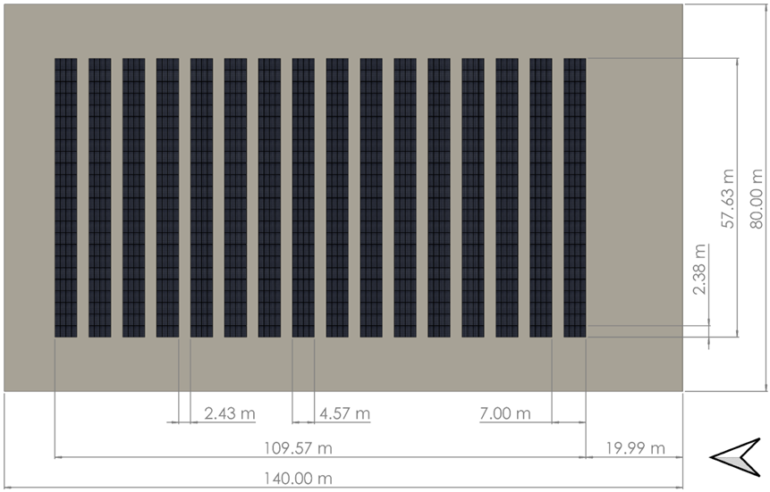
Figure 3. Solar Panel layout
The spacing between each row was assumed to be 0.02 m. Additionally, a total of 10 Growatt inverters (MAX 110KTL3-X LV), with a total capacity of 1,100 kW, were implemented to ensure grid compatibility. The system is grid-connected without a battery energy storage system.

VALIDATION STUDY
An experimental data obtained from an annual study of solar energy generation with and without active cooling in HEnergia in Forli of Italy (44°13'21.0"N 12°02'27.0"E). The experimental data was collected from October 2014 to September 2015. The mean daily array yield for the system without cooling was compared to energy generation simulation using PVGIS and PVSyst software in Fig. 4. The experimental system generated 1,335 Wh/Wp with a performance ratio of about 80%, while the PVGIS simulation generates 1,255 Wh/Wp, and the PVSyst simulation generated 1,178 Wh/Wp with a performance ratio of 74.5%. The PVSyst simulation used a soiling loss of 3% and an annual performance degradation rate of 0.04% using the aging tool. These losses would contribute to lower energy generation by simulation. There was a difference of about 11.8% between the experimental and PVsyst results [14].

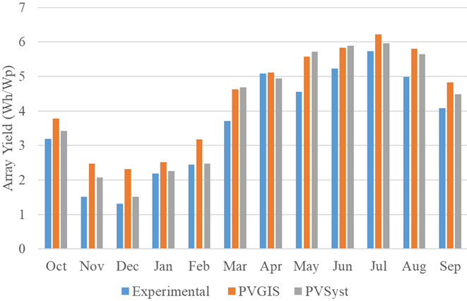
Figure 4. Validation study

MATHEMATICAL MODEL
Some mathematical equations were considered in the simulation of the renewable energy system to give realistic results.

Solar Photovoltaic
The power output for a simple model of a solar photovoltaic module can be expressed as the equation below [15].
$$\begin{aligned}P=V\left(I_{ph}-I_{s}\left\lceil e\frac{qV_{oc}}{N_{s}{KA}_{D}T_{O}}-1\right\rceil \right)\#\left(1\right)\end{aligned}$$
Where, $P$ is the power output of the solar photovoltaic module (W), $V$ is the output voltage (V), $I_{ph}$ is the photo-current (A), $I_{s}$ is the short-circuit current (A), $e$ is the exponential function, $q$ is the charge of an electron ($1.602 × {10}^{-19} {}_{ }^{o}C$), $N_{s}$ is the photovoltaic cells number connected in series, $K$ is the Boltzmann’s constant ($1.380×{10}^{-23} J/K$), $V_{oc}$ is open-circuit voltage (V), $A_{D}$ is diode constant, and $T_{O}$ is real-time temperature (K).

System Losses
The system losses were included in the simulation of the energy generation system. The losses in each study location will be unique due to different climatic conditions. The losses in Lofa county include irradiance loss at 0.3%, IAM factor on global at 2.2%, module degradation loss at 0.4% per annum, soiling loss factor of 3% per annum, PV loss due to irradiance level at 0.5%, PV loss due to temperature at 7.5%, module array mismatch loss at 2%, ohmic wiring loss at 1%, and inverter loss during operation at 1.4%.

RESULTS AND DISCUSSION
A comprehensive simulation using PVSyst software has been conducted across all 15 counties in Liberia. The results presented here are derived from meteorological data obtained from Meteonorm database within PVSyst and are visually represented through maps with QGIS software. The key performance indicators for the system under investigation include useful energy, performance ratio, levelized cost of electricity, internal rate of return, return on investment, project payback period, and CO₂ emissions reduction associated with the project. It is important to note that the project has a lifespan of 25 years.

Useful Energy
The useful energy in a grid-connected system represents the percentage of energy supplied to the grid, reflecting the usable output from the photovoltaic (PV) system after accounting for associated losses. Figure 5 and 6 depict the useful energy generated by the PV system during its first year of operation. The results show that most counties in the northern region performed better, with Lofa reporting the highest level of useful energy in the first year at 1,745 MWh, while River Cess exhibited the lowest energy output at 1,492 MWh. This variation in useful energy generation from the same system across different locations can be attributed to factors such as tilt angle (latitude) and variations in solar radiation within these areas, as detailed in Table 1. It can be noticed that all the counties at the Northern border of the country have a higher energy generation than the counties at the southern border of the country. This has a similar pattern to the global horizontal irradiance map shown in Fig. 2.

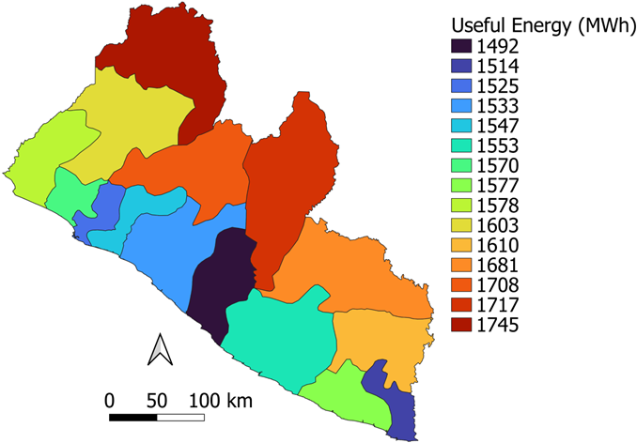 | 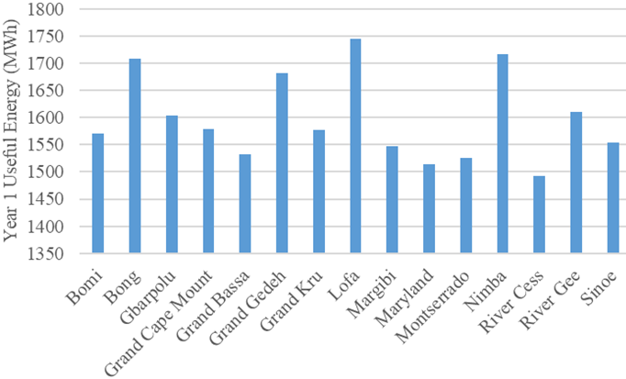
Figure 5. First year useful energy generation | Figure 6. First year useful energy generation graph

Additionally, the cumulative useful energy produced by the system over 25 years is illustrated in Fig. 7 and 8. This value is calculated after considering the degradation of the PV panels over the project's lifetime. Consistent with the findings presented in Fig. 6, Lofa achieved the highest energy output of 40,902 MWh at the end of the project duration. While River Cess achieved the lowest energy output of about 34,828 MWh at the end of the project duration. The standard deviation of the useful energy generated by all the counties over the project lifetime is 1,906 MWh.

System Performance Ratio
The performance ratio measures the actual output of a photovoltaic (PV) system in relation to the output that would be expected if the system were to operate under nominal standard test conditions (STC). This ratio is determined using equation 2. It serves as an indicator of the PV system's performance, regardless of its geographical location. According to [16], a performance ratio of 80% or higher is strongly recommended for better system performance.
$$\begin{aligned}PR=\frac{Actual Energy from Plant \left(KWh\right)}{Calculated Nominal Plant Output \left(KWh\right)}\#\left(2\right)\end{aligned}$$
The Performance Ratio (PR) for the PV system under investigation is illustrated in Fig. 9 and 10. In the first year of operation, the Performance Ratio reached approximately 83.7% to 84.2% across all sites. However, by the end of the project’s lifespan, the performance ratio is ranged between 72.1% to 73.1%. This shows a decline in performance of about 11.4% at the end of year 25, which is because of performance degradation due to aging of the solar PV system. The variations observed in PR may result from factors such as solar radiation levels and the effects of temperature on the PV panels, particularly in relation to specific study locations [17].

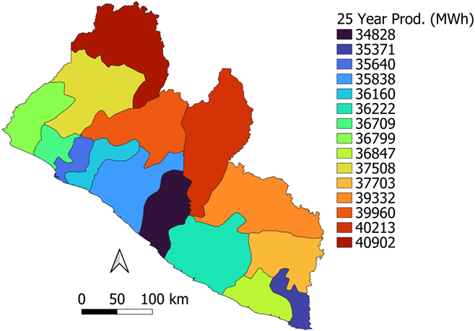 | 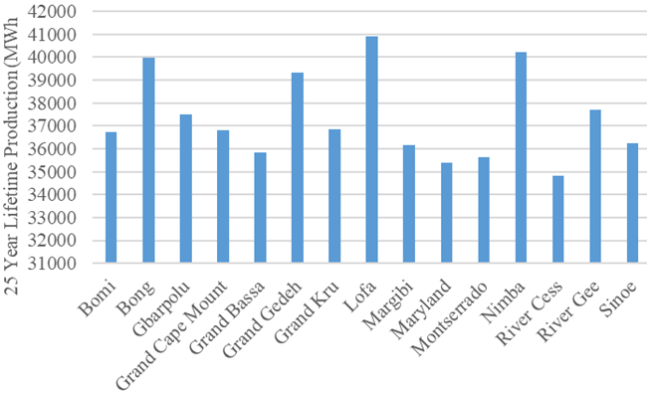
Figure 7. Useful energy over 25 years | Figure 8. Useful energy over 25 years graph

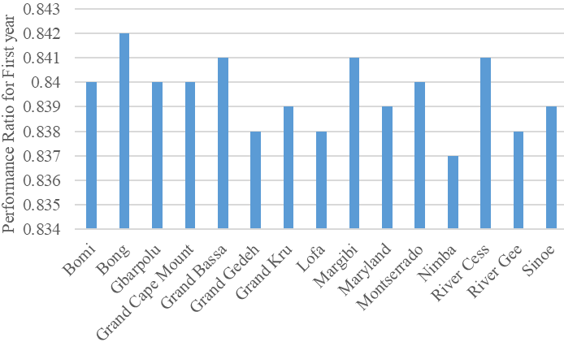 | 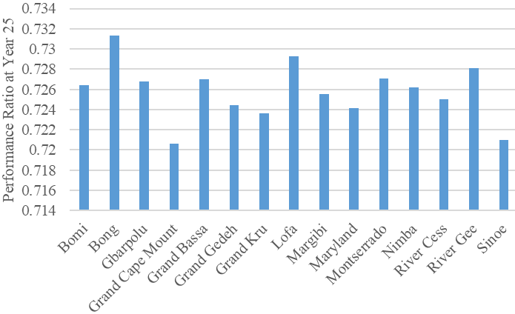
Figure 9. Performance Ratio at Year 1 | Figure 10. Performance Ratio at end of Project Life

Techno-economic Analysis
The economic analysis of this solar energy project encompasses the Levelized Cost of Electricity, the internal rate of return, as well as the project return on investment. The total cost of implementing the project is projected at USD 268,000, while the operation and maintenance cost for the project is estimated to be approximately USD 13,000/year. The Levelized Cost of Electricity, which represents the average net present cost of electricity generation from a power plant, is calculated from equation 3 [18]. The LCOE of the project is presented on Fig. 11.
$$\begin{aligned}LCOE=\frac{\sum{\frac{\left(I+M\right)}{{\left(1+r\right)}^{t}}}}{\sum{\frac{\left(E\right)}{{\left(1+r\right)}^{t}}}}\#\left(3\right)\end{aligned}$$
Where LCOE is the Levelized Cost of Electricity, I is the investment, M is the operational and maintenance expenditure, E is the electricity production while r is the discount rate and t is the project lifetime.
The findings illustrated in Fig. 11 reveal that Lofa County has the lowest Levelized Cost of Electricity (LCOE) value, recorded at $ 0.0514/KWh. This advantage is attributed to the higher power output generated by the plants in these regions, in contrast to River Cess, which has the highest LCOE at $0.0601/KWh. It is noteworthy that the valuation of electricity sales was based at $0.1/kWh, which is lower than the fixed electricity tariff established by the Liberia Electricity Corporation, set at $0.22/KWh.
The internal rate of return (IRR) for all the counties is shown on Fig. 12, while the return on investment (ROI) is shown on Fig. 13. The maximum internal rate of return of 159.9% and the maximum return on investment of 390% were achieved in Lofa County. While the minimum internal rate of return of 126.83% and the minimum return on investment of 312% were achieved in River Cess County. The payback period is the time it takes to recoup the capital investment by the net returns from sales of the energy generated [19]. The payback period for the entire project across all sites investigated was found to be between 3.4 and 4.2 years, with the longest payback periods occurring in areas located along the southern region as shown on Fig. 14.

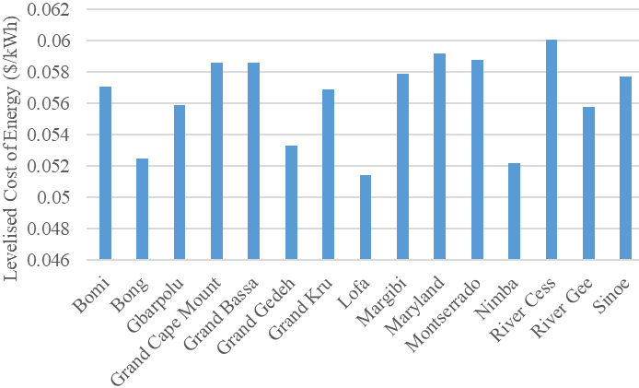 | 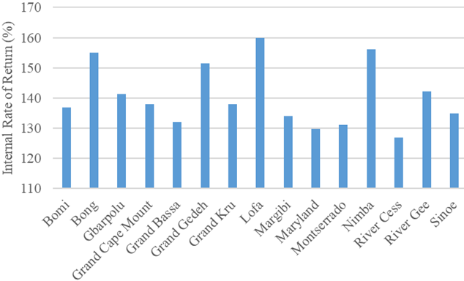
Figure 11. Levelized cost of electricity | Figure 12. Internal Rate of Return
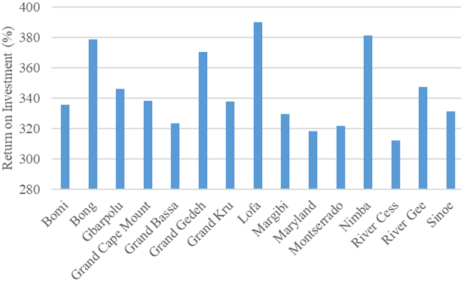 | 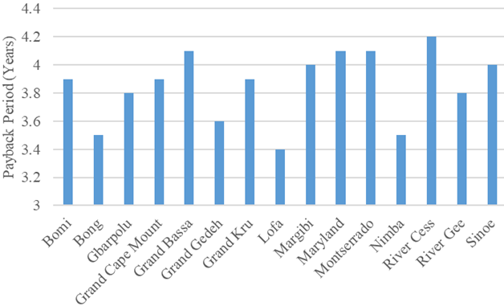
Figure 13. Return on Investment | Figure 14. Project payback period

Environmental Analysis
The performance indicator for the environmental analysis is the CO₂ emission reduction. Lifecycle Carbon Emissions (LCE) from the system with a value of 1842.3 tCO₂ from the simulation run in PVSyst was used within the process of calculating the CO₂ emission saved by the solar project. The overall CO₂ emission of the photovoltaic system was calculated from the below equation.
$$\begin{aligned}E_{total}=E_{grid}×Project Lifespan×Grid LCE-System LCE\#\left(4\right)\end{aligned}$$
The total CO₂ emissions, denoted as E_{total}, are influenced by the average CO₂ emissions from the grid, referred to as Grid LCE, which is assumed to be 479 gCO₂/kWh, the system LCE for the rest of Africa within the PVSyst software [20]. Additionally, System LCE represents the cumulative CO₂ emissions resulting from the construction and operation of the photovoltaic system installation. As illustrated in Fig. 15 and 16, the site with the highest useful energy generation, specifically Lofa, corresponds to the maximum CO₂ emissions reduction.

Comparison to Previous Studies
This study used on solar photovoltaic technology to generate energy in all the counties in Liberia. The results achieved include LCOE from $0.0514/kWh to $0.0601/kWh with payback periods ranging from 3.4 to 4.2 years. A study by White et al. investigated using standalone solar photovoltaic and biomass hybrid renewable energy system in rural community in Liberia. Four system configurations were tested, the best system used solar PV, biomass and battery storage to achieve an LCOE of $0.29/kWh [21]. Another study in Liberia investigated using solar PV and solid biomass hybrid renewable energy system for generation of energy in rural community. Seven configurations were tested, and the best configuration achieved an LCOE of $0.51/kWh [22].

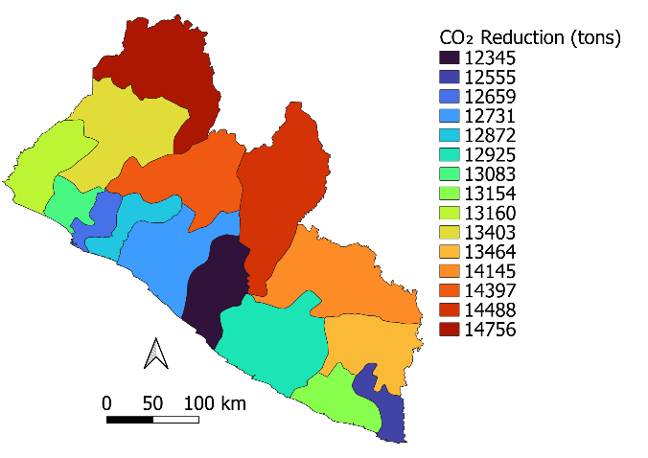 | 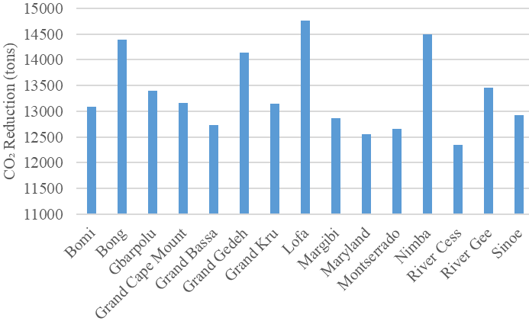
Figure 15. Project CO₂ emission reduction | Figure 16. Project CO₂ emission reduction graph

CONCLUSION
This study shows using a grid connected solar photovoltaic for energy generation is economically feasible in all the counties in Liberia. This is evident by the results obtained by the payback period ranging from 3.4 to 42.3 years, and the LCOE ranging from $0.0514/kWh to $0.0601/kWh. The counties at the Northern border of the country generated more energy than the counties at the southern border due to irradiation level difference. Also, the project had a lifetime of 25 years with an initial capital of $268,000. The country with the best energy generation was Lofa, which had a return on investment of 390% and achieved a carbon dioxide emission reduction of 14,756 tons.

REFERENCES
- M. Coccia, Sustainable Futures 5, (2023).
- J. Charles Rajesh Kumar and M.A. Majid, Energy Sustain Soc 10, (2020).
- A.A. Yusuf, H.F. Kesselly, A. Nippae, C. Asumana, M.O. Kakulu, I.S. Sinneh, S.Z. Gono, and R.B. Mayango, Energy Strategy Reviews 51, (2024).
- J. Delbeke, A. Runge-Metzger, Y. Slingenberg, and J. Werksman, 24 (2019).
- A.A. Yusuf, H.F. Kesselly, A. Nippae, C. Asumana, M.O. Kakulu, I.S. Sinneh, S.Z. Gono, and R.B. Mayango, Energy Strategy Reviews 51, 101295 (2024).
- R.E. Strategy, M. Plan, and D. Gathering, 1 (2016).
- A.G. Wrehyou, (2024).
- N.A. Kadir, A.Z. Abdullah, and N.N. Mohd Hussin, J Phys Conf Ser 2550, 0 (2023).
- M. Ahmad and A.U. Ahmad, 6, 270 (2019).
- B. Belmahdi and A. El Bouardi, Procedia Manuf 46, 738 (2020).
- I.S. Aktas and S. Ozenc, Case Studies in Thermal Engineering 56, 104272 (2024).
- Z. Serat, S.A.Z. Fatemi, and S. Shirzad, Archives of Advanced Engineering Science 1, 63 (2023).
- Global Solar Atlas, Https://Globalsolaratlas.Info/Map (2019).
- Bianchini, A. Guzzini, M. Pellegrini, and C. Saccani, Renew Energy 111, (2017).
- R. Syahputra and I. Soesanti, Energy Reports 7, (2021).
- M. Moustafa, M. Mahmoud, S. Akef, and M. Swillam, J Phys Conf Ser 2689, 0 (2024).
- T. Rahman, A. Al Mansur, M.S. Hossain Lipu, M.S. Rahman, R.H. Ashique, M.A. Houran, R.M. Elavarasan, and E. Hossain, Energies (Basel) 16, (2023).
- Giampieri, J. Ling-Chin, and A.P. Roskilly, Int J Hydrogen Energy 52, (2024).
- K. Mongkoldhumrongkul, Energy Reports 9, (2023).
- International Energy Agency, Https://Www.Iea.Org/Reports/Global-Energy-Review-2025 1 (2025).
- J.G. White, R. Samikannu, M.T. Oladiran, A. Yahya, P. Makepe, G. Gamariel, N.S.D. Ladu, B.A. Tlhabologo, M.B. Kadarmydeen, K. Gunasekaran, and L. Amuhaya, Front Energy Res 12, (2024).
- J.G. White and R. Samikannu, SSRN Electronic Journal (2022).
- P. Juah, S. Momolu, and M. Sanda, Mendeley Data (2025).

